Week 3
Period 8
Teaching date: 20/09/2021

UNIT 2: MY HOUSE
LESSON 1: GETTING STARTED
I.OBJECTIVES:By the end of the lesson, students will be able to:
1. Knowledge:
- Vocabulary: learn some words related to types of the house , the rooms and furniture in the house.
- Grammar: - Is there …./ Are there …. ?
- Possessive case
- Prepositions of place
2. Competence: Sts can talk about their families
3. Educational aims: To teach SS to love their families
II. TEACHING AIDS: Text books, laptop , smart TV , video clips
III. PROCEDURE:
Contents |  | Teacher’s and Ss’activities
I.WARM UP: (5’)
To introduce the topic to lead in the topic of My house.
* Game: Pelmanism  TYPES OF HOUSE :    Villa  1. How is your house?  2. Is your house big or small?  3. How many rooms are there in your house? |  | -T: divides class into 2 teams and asks students to choose a pair of number.  - If students choose the correct number and picture, They get 2 marks.  -The team who has more correct words is the winner.  Lead in: These are types of house  T: asks Ss some questions.  Ss answer  - T: Introduces the topic of the lesson.
II. PRESENTATION:(10’)
To prepare students with vocabulary related to the topic My house .
1.Listen and read:  * Vocabulary  - flat = apartment (n) : căn hộ  - country house (phr. n) : nhà ở quê  - town house (phr. n) : nhà ở phố  - behind (prep) : Ở đằng sau  - cousin (n): anh, chị, em họ  - move (v): di chuyển  - aunt (n): cô,dì,mợ  - uncle (n):chú,bác |  | - Sts listen to the tape  - T:uses different techniques to teach vocab (pictures, situation, realia)  - Repeat in chorus and individually  - Sts copy all the words  * Checking vocab: < matching>
III. PRACTICE: (22’)
Sts can read and understand the meaning of the conversation., then do as directed tasks.
2. Tick the correct answers.  “Which family members does Mi talk about?”  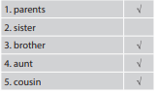  3.Complete the sentences.  * Answers  1. sister  2. TV  3. town  4. country  5. three  4.Complete the word web: Types of house.  * Suggested answers:  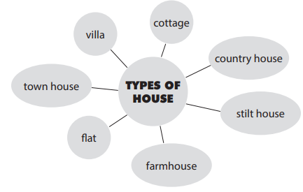 | -Sts listen to the tape twice  -Pair work  -T:asks students “Which family members does Mi talk about?” without reading the conversation again.  -T:tells Sts to read it again individually and tick the correct answers.  -Feed back – Correction  - T: gets sts to work independently to fill each blank with the word from the conversation.  - T:allows sts to share their answers before discussing as a class.  - T: calls some sts to check. Teacher confirms the right answers and writes on the board.  * Game: Networking  - T: divides the class into two teams, then writes the topic “Types of house” on the board and gives them two minutes to discuss.  - After that time, a student from each team one by one runs to the board and writes one word.  - The team which has more correct answers is the winner.
IV. PRODUCTION: (5’)
Sts can ask and answer the questions about their houses and their family members.

- Ask your friends where they live / their family members | - Pair work  - Correcting
* Home work (3’)
- Learn new words by heart .
- Practice reading the dialogue.
- Describe your house and tell your family members .
- Prepare Unit 2 : A closer look 1
+ Vocabulary ( section 2 / page 18 )

