School: ……………………………………… | Date: ………………………………
Class: …………………………….................. | Period: 38

UNIT 4: DISASTERS
Lesson 1: Vocab & Reading, pages 34 & 35

1. Objectives
By the end of this lesson, students will be able to…
1.1. Language knowledge/ skills
- learn and use vocab. related to disasters
- practice reading for gist, reading to recognize correct/incorrect/not given information
1.2. Competences
- improve Ss’ communication, collaboration, analytical, and critical thinking skills.
1.3. Attributes
- love victims of natural disasters.
2. Teaching aids and materials
- Teacher’s aids: Student’s book and Teacher’s book, class CDs, DCR– Phần mềm tương tác trực quan, DHA – Ứng dụng trò chơi tương tác, projector / interactive whiteboard /TV (if any), PowerPoint slides.
- Students’ aids: Student’s book, Workbook, Notebook.
3. Assessment Evidence
Performance Tasks | Performance Products | Assessment Tools
- In pairs: Look at the picture. What do you think happened? What types of disasters happen in your country?  - Match the words with the pictures.  - Use the new words to talk about disasters you read or heard about.  - Read the quick facts on a website about a famous disaster and choose the topic that is NOT mentioned.  - Read and write True, False, or Doesn't say.  - Talk about the most surprising about Typhoon Tip. | - Ss’ answers.  - Ss’ answers.  - Ss’ answers.  - Ss’ answers.  - Ss’ answers.  - Ss’ answers. | - Observation.  - Observation.  - Observation.  - Observation.  - Observation.  - Observation.
4. Procedures
A. Warm up: 5 minutes
a. Objectives: to introduce the topic.
b. Content: Let’s talk.
c. Expected outcomes: Ss can talk about the disasters they see in the picture and some more disasters happening in Vietnam.
d. Organization
Teacher’s activities | Students’ activities
In pairs: Look at the picture. What do you think happened? What types of disasters happen in your country?  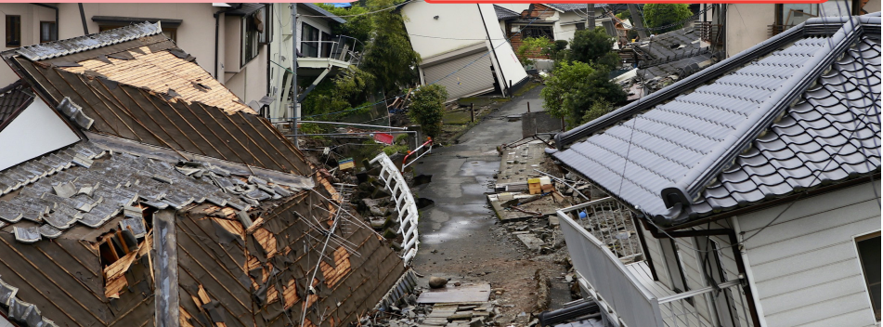  - Ask Ss to work in pairs, look at the picture and answer the questions (using the DCR/ PPTs slides).  - Call some pairs to give their answers.  - Give feedback. | - Work in pairs, look at the picture and answer the questions.  Ss’ own answers
B. New Lesson (35’)
1. Pre-Reading (Vocabulary - 15’)
a. Objectives: to help Ss improve their vocabulary about disasters.
b. Content: tasks a and b.
c. Expected outcomes: Ss can name correct natural disasters.
d. Organization
Teacher’s activities | Students’ activities
Task a: Match the words with the pictures. Listen and repeat.  - Ask Ss to work in pairs and match the words with the pictures (using the DCR).  - Check Ss’ answers around the class.  - Ask Ss to listen and repeat. | - Work with a partner to match the words with the pictures.  - Listen and repeat.  Answer Keys:  1. typhoon 2. earthquake  3. tsunami 4. flood  5. wildfire 6. blizzard  7. heat wave 8. drought  9. landslide 10. avalanche
Task b: In pairs: Use the new words to talk about disasters you read or heard about.  - Ask Ss to work with their partner to talk about disasters they read or heard about, using the new words.  - Go around the class to help if necessary.  - Pick some Ss to talk about their partner.  - Give feedback. | - Work with their partner to talk about disasters they read or heard about, using the new words.  -Share their answers.  Sample answer:  I read about a tsunami in Thailand.
2. Pre & While-Reading (Reading – 15’)
a. Objectives: to help Ss practice reading for main idea and details.
b. Content: tasks a, b, and c.
c. Expected outcomes: Ss can read for main idea and specific information about a famous disaster named Typhoon Tip.
d. Organization:
Teacher’s activities | Students’ activities
Task a: Read the quick facts on a website about a famous disaster. Which of the following topics is NOT mentioned?  A. Where it happened  B. The damage it caused  C. How people stayed safe  - Ask Ss to read the facts about the disaster and choose the topic that is not mentioned.  - Pick some Ss to give the answer and show where the other topics are mentioned.  - Check Ss’ answers. | - Read the facts about the disaster and choose the topic that is not mentioned.  - Give their answers.  Answer Keys: Jess  C. How people stayed safe  (A can be found in “Where was Typhoon Tip?”, and B can be found in “How much damage did Typhoon Tip cause?”)
Task b: Now, read and write True, False, or Doesn't say.  According to the website,  1. Typhoon Tip was the biggest tsunami ever. ______  2. the typhoon affected Japan, South Korea, and Vietnam. _______  3. Typhoon Tip lasted longer than any other storm. ______  4. the storm damaged more than twenty thousand homes. ______  - Ask Ss to read the phrases and underline the key words.  - Get Ss to scan the text to find the key words.  - Ask Ss to read carefully and decide True, False, or Doesn’t say.  - Set the time and monitor the class.  - Pick some Ss to give their answers and evidence for their choices.  - Check Ss’ answers (using the DCR). | - Read the phrases and underline the key words.  - Scan the text to find the key words.  Answer keys:  According to the website,  1. Typhoon Tip was the biggest tsunami ever.  2. the typhoon affected Japan, South Korea, and Vietnam.  3. Typhoon Tip lasted longer than any other storm.  4. the storm damaged more than twenty thousand homes.  - Read carefully and decide True, False, or Doesn’t say.  Answer Keys  1. False (The biggest typhoon was Typhoon Tip.)  2. False (It affected parts of many countries including Japan, the Philippines, North and South Korea, and China.)  3. Doesn't say (Typhoon Tip lasted from October 4 to October 24, 1979.)  4. True (In Japan, floods damaged twenty-two thousand homes.)
Task c: Listen and read.  - Play the CD and ask Ss to listen and read along.  - Pick three Ss to read the three passages aloud and correct their pronunciation if necessary. | -Listen and read along.
3. Post – reading (5’)
a. Objectives: to help Ss to use the language and information in the real situation.
b. Content: similarity and difference in hobbies of the Ss and people in the passages.
c. Expected outcomes: Ss can compare and contrast their hobbies with those of the people in the passages.
d. Organization
Teacher’s activities | Students’ activities
In pairs: What is the most surprising about  Typhoon Tip?  - Ask Ss to work in pairs to say the most surprising about Typhoon Tip.  - Monitor the class and help them if necessary.  - Ask some Ss to share their ideas.  - Give feedback. | - Work in pairs to answer the question.  - Share their ideas.  Sample answer:  I think the amount of damage is the most surprising.

C. Consolidation and homework assignments (5’)
- Vocabulary: typhoon, earthquake, tsunami, flood, wildfire, blizzard, heat wave, drought, landslide, avalanche.
- Do vocabulary and reading exercises in workbook on pages 20&21.
- Prepare the next lesson: Lesson 1.2 – Grammar, pages 35 & 36.
- Do the exercises in Tiếng Anh 8 i-Learn Smart World notebook (pages 28 & 29).
5. Reflection

a. What I liked most about this lesson today:
…………………………………………………………………………………………
b. What I learned from this lesson today:
…………………………………………………………………………………………
c. What I should improve for this lesson next time:
…………………………………………………………………………………………

