**MID-TERM TEST 3 (SEMESTER 1)**

*Time allowed: 15 mins*

**Full name:** ............................................................................. **Grade:** ............. **Mark:** ............. **/ 10**

**I. Listen and circle the correct words. (3 points)**

| E.g. | A. S**u**nday | B. Th**u**rsday | C. j**u**ice |
| --- | --- | --- | --- |
| 1. | A. Sat**u**rday | B. st**u**dy | C. m**u**sic |
| 2. | A. **w**ater | B. **g**rapes | C. **J**anuary |
| 3. | A. **y**es | B. **j**am | C. **W**ednesday |
| 4. | A. Mar**ch** | B. be**d** | C. ge**t** |

**II. Listen and put a (✓) or a (🗴). (3 points)**

| E.g. | 1. | 2. | 3. | 4. |
| --- | --- | --- | --- | --- |
| Unit 10: Favorite food! | Baamboozle - Baamboozle | The Most Fun Classroom  Games! | C:\Users\Admin\AppData\Local\Microsoft\Windows\INetCache\Content.MSO\796B1F98.tmp | Clipart - Ride | Pretty horses, Pony rides, Horses | C:\Users\Admin\AppData\Local\Microsoft\Windows\INetCache\Content.MSO\DC3F162F.tmp | March Stock Illustrations – 218,386 March Stock Illustrations, Vectors &  Clipart - Dreamstime |
| 🗹 | ⬜ | ⬜ | ⬜ | ⬜ |

**III. Tick the correct questions. (2 points)**

| E.g. | Vietnamese Girl In Tradition Costume Illustration Royalty Free SVG, Cliparts,  Vectors, And Stock Illustration. Image 78784414. | – ___________________?  – I’m from Viet Nam.  ⬜ Where is she from?  🗹 Where are you from? |
| --- | --- | --- |
| 1. | May Birthday Cake Clip Art | Printable Clip Art and Images | – ___________________?  – It’s in May.  ⬜ When’s your birthday?  ⬜ What day is it today? |
| 2. | C:\Users\Admin\AppData\Local\Microsoft\Windows\INetCache\Content.MSO\279BBBF0.tmp | – ___________________?  – No, he can’t.  ⬜ Can he cook?  ⬜ Can she cook? |
| 3. | Little Girl Lemonade Stock Illustrations – 87 Little Girl Lemonade Stock  Illustrations, Vectors & Clipart - Dreamstime | – __________________?  – I want some lemonade.  ⬜ What do you want to eat?  ⬜ What do you want to drink? |
| 4. | Child Using Headphones Listening To Music Stock Illustration - Download  Image Now - Child, Music, Listening - iStock | – ___________________?  – I listen to music.  ⬜ What do you do on Sundays?  ⬜ What time do you listen to music? |

**IV. Fill in the blanks. (2 points)**

Hello, my name is Alice. I’m from (1) 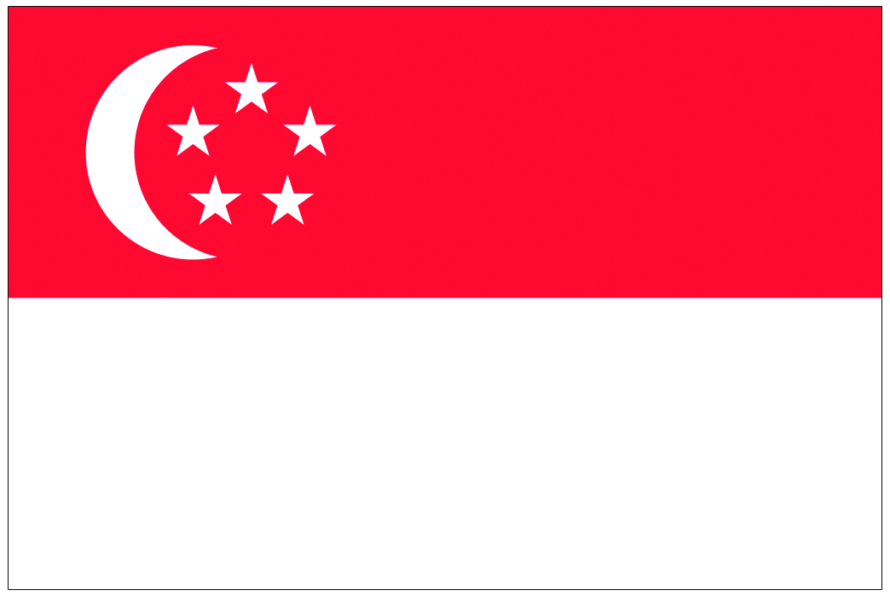____________. I speak English.  
In my country, we like to (2) 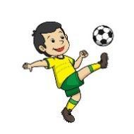 _____________ or baseball. Our favourite food is fish and (3) 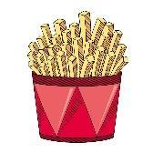 ___________. Most people like tea or coffee, but my favourite drink is (4) 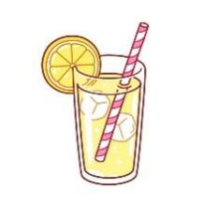 __________.

**ANSWER KEY**

**I.**

***Audio script:***

E.g. /ʌ/ /ʌ/

1. /juː/ /juː/

2. /w/ /w/

3. /j/ /j/

4. /t/ /t/

***Key:***

1. C 2. A 3. B 4. C

**II.**

***Audio script:***

E.g. – What do you want to eat?

– I want some chips.

1. – What do you do on Tuesdays?

– I study at school.

2. – Can she ride a bike?

– Yes, she can.

3. – Where’s he from?

– He’s from Singapore.

4. – When is your birthday?

– It’s in March.

***Key:***

1. **✓**  2. **🗴** 3. **🗴** 4. **✓**

**III.**

1. When’s your birthday?

2. Can he cook?

3. What do you want to drink?

4. What do you do on Sundays?

**IV.**

(1) Singapore (2) play football (3) chips (4) lemonade