SPEAKING ASSESSMENT ENGLISH 6
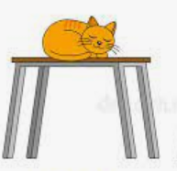  1. | 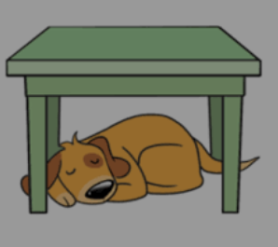  2 | 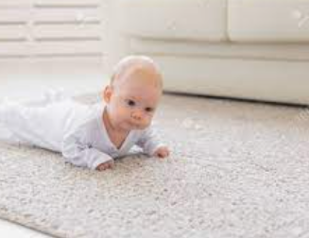  3
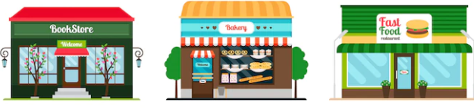  8. | 1.What is this?  2. How do you spell it? 3. Look at picture 1/2/…? Where is the …?  4.-It is a thing that helps keep food fresh. -It is a room where you sleep. -It is a place where a dog lives. -It is a room that has a toilet. |   4
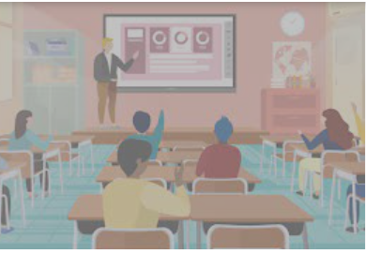  7. | 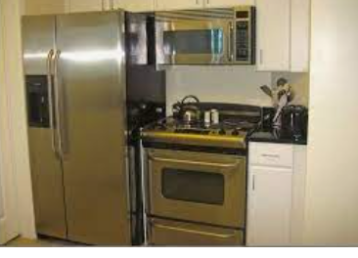  6 |   5
UNIT 2: MY HOUSE
- Introduction - 0.4 pt (~2 ideas):
Share something about your family, school, house, friends, neighborhood,…
- Topic Speaking (Cue pictures) – 1.0 pt (~4 questions):

