School: …………………………………………………..  Class: ……………………………………………………..  Full name: ………………………………………………. | Mark:

SPEAKING TEST 3 (SEMESTER 1)
(Units 5 & 6)

TASK 1 |  |  | Let’s talk about a custom in your family.  The following questions may help you.
 | 1. | Where does your family live?
 | 2. | What custom does your family have?
 | 3. | How does this custom benefit your family?
 | 4. | What do your family members think about this custom?
 | 5. | What will you do to keep this custom?

TASK 2 | Work in pairs. Each of you receives a card. Use the clues on your card to make questions about your friend’s picture. Use the picture on your card to answer your friend’s questions.

CARD A
Ask your friends about his/ her picture. Listen to his/ her answers. |  | 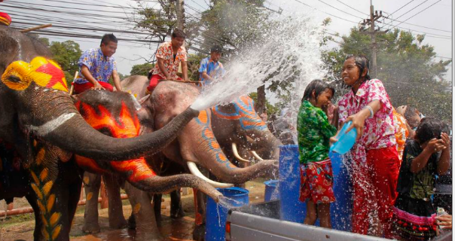
1. | What event/ you/ think?
2. | Where/ you/ think/ celebrate?
3. | When/ you/ think/ happen?
4. | What / people/ do / this event? Why?
5. | If/ you/ at/ event, what/ you/ do?
 |  | Answer your friend’s questions about this picture.

CARD B
Ask your friends about his/ her picture. Listen to his/ her answers. |  | 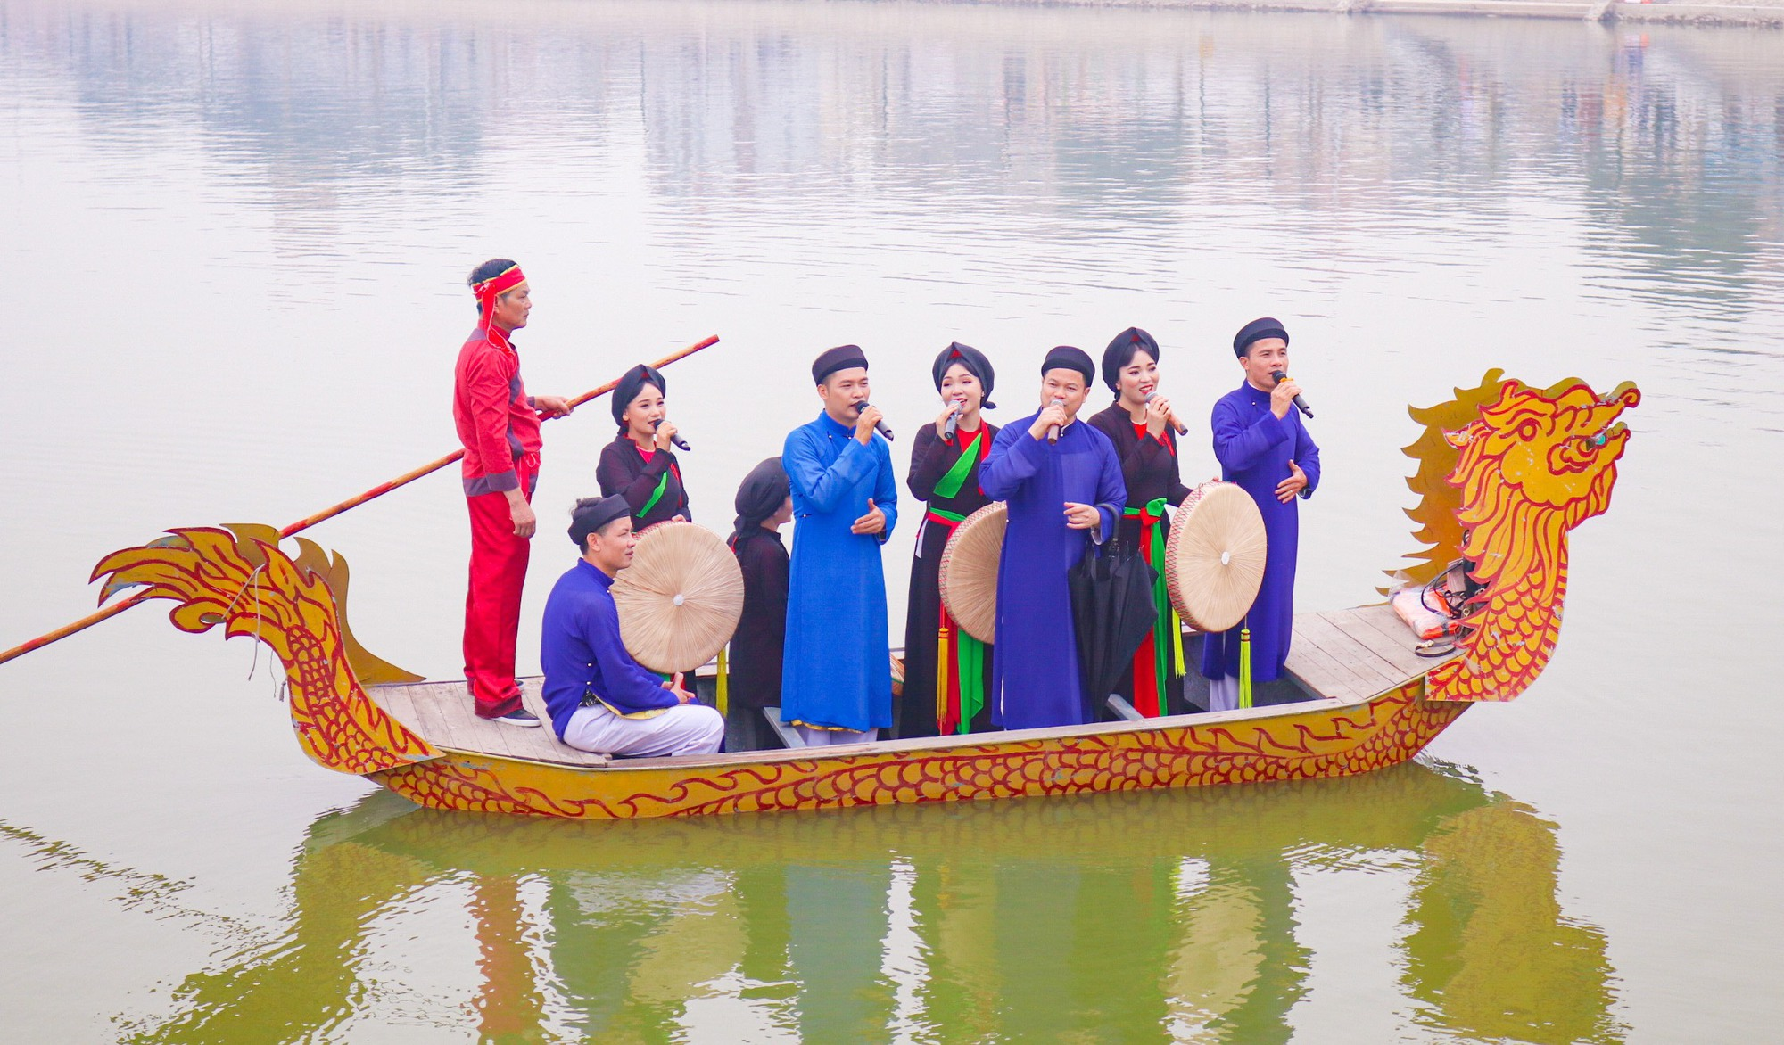
1. | What event/ you/ think?
2. | Where/ you/ think/ celebrate?
3. | When/ you/ think/ happen?
4. | What / people/ do / this event? Why?
5. | If/ you/ at/ event, what/ you/ do?
 |  | Answer your friend’s questions about this picture.

