Unit 9 Test

I. PRONUNCIATION
Find the word which has a different sound in the bold part.
1. A. feast B. clean C. teach D. breakfast
2. A. turkey B. tulip C. pumpkin D. funny
Choose the word that has a different stress pattern.
3. A. costume B. gather C. parade D. candy
4. A. enjoy B. prepare C. decide D. happy
II. LISTENING
PART 1: Listen to the talk about Thanksgiving. Choose the correct answer A, B, or C.
5. When do people celebrate Thanksgiving in the USA?
A. On the third Thursday of November.
B. On the fourth Thursday of November.
C. On the last day of November.
6. Who usually gathers for a feast on this day?
A. Only children. B. Friends and neighbors. C. Family members and friends. 7. Which of the following is a traditional dish for Thanksgiving?
A. Moon cakes B. Cornbread C. Banh chung
PART 2: Listen to the conversation about the Twins Day Festival. Fill in each gap with ONE word or a number.
8. The Twins Day Festival is the largest gathering for twins in the __________.
9. There were twins from many different __________ at the festival.
III. LANGUAGE USE
Choose the best answer A, B, C or D.
10. People usually _______ pumpkins for Halloween.
A. paint B. carve C. eat D. buy
11. _______ you go to the Lim Festival with your parents last year?
A. Do B. Are C. Did D. Were
12. At Easter, children enjoy _______ eggs in bright colours.
A. painting B. cooking C. throwing D. hiding
13. Is he interested _______ joining the festival this year?
A. at B. on C. in D. with
14. The _______ carried the dancers in traditional costumes during the parade.
A. fireworks B. floats C. flowers D. feasts
15. _______ they celebrate the festival in the middle of the eighth lunar month?
A. Do B. Is C. Are D. Does
III. READING ADVERTISEMENTS / NOTICES
Look at the signs/notices and choose the best answer A, B, C or D.
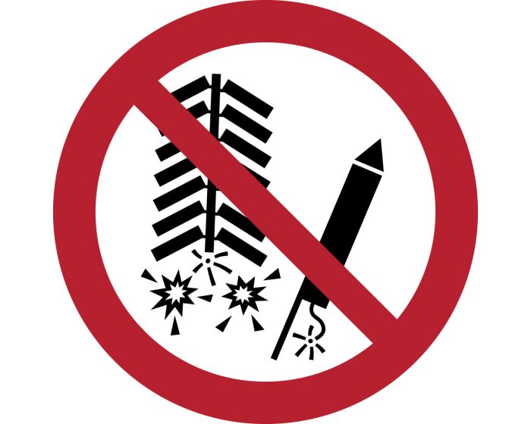
16. Look at the sign at a festival. What does it mean?
A. You can buy fireworks here.
B. You are not allowed to set off fireworks.
C. There is a fireworks display tonight.
D. You should be careful with fire.
17. Read the festival notice. Which statement is TRUE?
FLOWER FESTIVAL NOTICE:
Please do not step on the grass or pick the flowers. Keep the park clean!
A. Visitors can take flowers home.
B. Visitors should walk on the grass.
C. Visitors must protect the flowers and the environment.
D. Visitors are allowed to have a feast on the grass.
18. What does this notice tell you about the parade?
PARADE ROUTE:
The street will be closed from 8 a.m. to 11 a.m. for the Tulip Parade.
A. The parade lasts for 8 hours.
B. You can drive your car on this street at 9 a.m.
C. The street is only for people watching the parade during this time.
D. The parade starts at 11 a.m.
19. Read the advertisement. Where can you see this festival?
LA TOMATINA:
Join the world's biggest food fight! Every August in Buñol, Spain.
A. In Spain. B. In the USA. C. In Vietnam. D. In Australia.
IV. LOGICAL ARRANGEMENT
20. Reorder the sentences to make a complete conversation about Tet.
a. Yes, I do. It’s one of my favourite festivals.
b. Do you celebrate Tet in the middle of the eighth lunar month?
c. No, we celebrate it in late January or early February. Do you like Tet?
d. Really? What do you usually do then?
e. We usually decorate our houses and enjoy a big feast with banh chung.
A. b – c – a – d – e
B. b – a – c – d – e
C. c – b – a – d – e
D. b – c – d – a – e
21. Reorder the sentences to make a complete paragraph about a festival.
a. Finally, they gather for a traditional feast with turkey and cornbread.
b. First, they decorate their houses with autumn fruits and flowers.
c. There are several things people do for Thanksgiving in the USA.
d. Second, many people join or watch a parade on the street.
e. In short, it is a time for family members to be together.
A. c – b – d – a – e
B. b – d – a – c – e
C. c – d – b – a – e
D. c – b – a – d – e
22. Reorder the sentences to make a conversation about a music festival.
a. Because the band was very late. It was a big disappointment.
b. How was the music festival last Sunday, Mark?
c. Oh, I'm sorry to hear that. d. It was disappointing!
A. b – d – a – c
B. b – a – d – c
C. d – b – a – c
D. b – d – c – a
23. Reorder the sentences to make an email invitation.
a. Would you like to come to my house for an Easter party?
b. We are going to paint eggs and have a lot of fun.
c. Hi Nick, how are you?
d. Let me know if you can join us!
A. c – a – b – d
B. c – b – a – d
C. a – b – c – d
D. c – a – d – b
V. READING CLOZE
Read the text and choose the correct answer A, B, or C.
People around the world celebrate many different festivals. In Vietnam, Tet is the (24)______ festival. Before Tet, people often (25)______ their houses with flowers. During Tet, they visit their relatives and (26)______ lucky money to children. In the USA, people celebrate Thanksgiving (27)______ the fourth Thursday of November. They usually have a big (28)______ with their family. Festivals are a great time for everyone to have fun and enjoy traditional food.
- A. largest B. larger C. large
- A. carve B. paint C. decorate
- A. buy B. give C. take
- A. in B. at C. on
- A. feast B. float C. parade
VI. READING COMPREHENSION
Read the following passage and choose the best answer A, B, C, or D.
Every year, thousands of twins gather in Twinsburg, Ohio, for the Twins Day Festival. It is the largest gathering of twins in the world. Twins come from many different countries to join the festival. On the first day, there is a Double Take Parade where twins walk together in uniforms. They also join a Talent Show to show their singing or dancing skills. Many people enjoy the festival because they can meet other twins and take many photos. Mark and his twin sister joined the festival last year and they had a lot of fun.
- Where does the Twins Day Festival take place?
A. In Vietnam B. In Ohio, USA C. In Australia
- What is the Double Take Parade?
A. A food fight.
B. A parade where twins walk in uniforms.
C. A music show.
- What can twins do at the Talent Show?
A. Paint eggs. B. Cook traditional food. C. Sing or dance.
- According to the passage, which of the following is TRUE?
A. Only twins from the USA join the festival.
B. It is a very small festival.
C. Mark went to the festival with his twin sister.
VII. READING AN EMAIL
Read the email and choose the correct answer A, B, C or D.
To: Trang
From: Ms Hoa
Subject: Tulip Festival photos
Hi Trang, I've just posted some photos of the Tulip Festival on my wall. I took them in Australia last September. Mark also went to a tulip festival in the Netherlands two years ago. The flowers and the floats at the parade were beautiful! Have a look and tell me what you think.
- What is the message about?
A. A trip to the Netherlands.
B. Photos of the Tulip Festival.
C. A flower carving competition.
- When did Ms Hoa go to the Tulip Festival?
A. Last September. B. Two years ago. C. This morning.
- What did Ms Hoa see at the festival?
A. Lions and dragons. B. Flowers and floats. C. Fireworks.

VIII. WRITING
Rearrange the words to make complete sentences.
36. flowers / people / On / New Year’s Eve / go / Hoan Kiem Lake / to / to / watch / the / .
> ................................................................................................................
37. Do / prepare / special / people / for / usually / food / Tet / ?
> ................................................................................................................

Rewrite the sentences without changing their meaning.
38. My mother can make a beautiful costume for me. (Change into a Yes/No question)
> Can .........................................................................................................?
39. Is it one of your favourite festivals? (Answer the question with "Yes")
> Yes, ........................................................................................................
40. They celebrate the Mid-Autumn Festival in the middle of the eighth lunar month.
> The Mid-Autumn Festival takes .............................................................

🎙️ AUDIO SCRIPT (Kịch bản để bạn đọc hoặc thu âm)
Part 1 (Dựa trên bài nghe trang 99):
Speaker: Thanksgiving is a seasonal festival. In the USA, people celebrate it on the fourth Thursday of November. It is a time for family. Family members and friends usually gather to have a feast. They prepare a lot of food such as turkey, cornbread, and sweet potatoes. After the feast, they often play board games together.
Part 2 (Dựa trên bài đọc trang 97 & 98):
Mark: Hi Nick. My family and I arrived in Twinsburg, Ohio two days ago. People hold the Twins Day Festival here every year. It’s the largest gathering for twins in the world. Thousands of twins come from different countries. Yesterday, we joined the Double Take Parade. Everyone wore uniforms and walked together. It was amazing!

✅ ĐÁP ÁN (ANSWER KEY)
- Pronunciation: 1.D (âm /e/, còn lại âm /i:/) | 2.B (âm /ju:/, còn lại âm /ʌ/) | 3.C (nhấn âm 2, còn lại nhấn âm 1) | 4.D (nhấn âm 1, còn lại nhấn âm 2)
- Listening: 5.B | 6.C | 7.B | 8.world | 9.countries

10. B (Carve pumpkins: Chạm khắc bí ngô)
11. C (Câu hỏi Yes/No thì Quá khứ đơn: Did + S + V?)
12. A (Painting eggs: Vẽ trứng Phục sinh)
13. C (Interested in: Quan tâm/Hứng thú với)
14. B (Floats: Xe diễu hành/xe hoa)
15. A (Câu hỏi Yes/No thì Hiện tại đơn với chủ ngữ "they")
16. B | 17. C | 18. C | 19. A
• Logic: 20.A | 21.A | 22.A | 23.A
• Cloze: 24.A | 25.C | 26.B | 27.C | 28.A
• Reading: 29.B | 30.B | 31.C | 32.C
• Message: 33.B | 34.A | 35.B
- On New Year’s Eve, people go to Hoan Kiem Lake to watch the flowers. (Lưu ý: "watch the flowers" ở đây ám chỉ xem hoa/pháo hoa hoặc lễ hội hoa tùy ngữ cảnh bài đọc trang 93).
- Do people usually prepare special food for Tet?
- Can your mother make a beautiful costume for you?
- Yes, it is.
- The Mid-Autumn Festival takes place in the middle of the eighth lunar month. (Sử dụng cụm từ "take place" thay cho "celebrate" để làm phong phú vốn từ).

