Họ và tên: ....................................................  Lớp: ............................................................. | PHIẾU GHI BÀI CHUYÊN ĐỀ HÓA HỌC 11  Bài 9: SẢN XUẤT DẦU MỎ VÀ  NHIÊN LIỆU THAY THẾ DẦU MỎ
MỞ ĐẦU
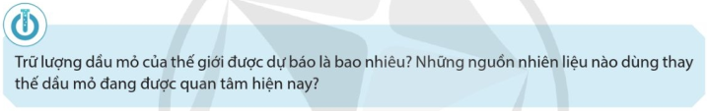
..........................................................................................................................................................................
..........................................................................................................................................................................

I. SẢN XUẤT DẦU MỎ
....................................................................................................................  ....................................................................................................................  ....................................................................................................................  ....................................................................................................................  ....................................................................................................................  ....................................................................................................................  ....................................................................................................................  ....................................................................................................................  ....................................................................................................................  ....................................................................................................................  ....................................................................................................................  .................................................................................................................... | 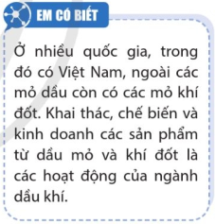  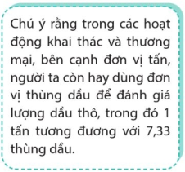
II. SẢN XUẤT VÀ TIÊU THỤ DẦU MỎ Ở VIỆT NAM
....................................................................................................................  ....................................................................................................................  ....................................................................................................................  ....................................................................................................................  ....................................................................................................................  ....................................................................................................................  ....................................................................................................................  ....................................................................................................................  .................................................................................................................... |  | 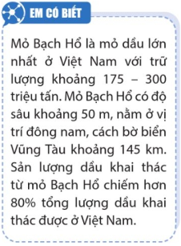
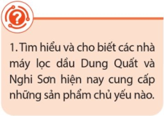 | ....................................................................................................................  ....................................................................................................................  ....................................................................................................................  ....................................................................................................................  ....................................................................................................................
III. SẢN XUẤT DẦU MỎ VÀ VẤN ĐỀ MÔI TRƯỜNG
....................................................................................................................  ....................................................................................................................  ....................................................................................................................  ....................................................................................................................  ....................................................................................................................  ....................................................................................................................  ....................................................................................................................  ....................................................................................................................  ....................................................................................................................  ....................................................................................................................  ....................................................................................................................  ....................................................................................................................  ....................................................................................................................  ....................................................................................................................  ....................................................................................................................  .................................................................................................................... |  | 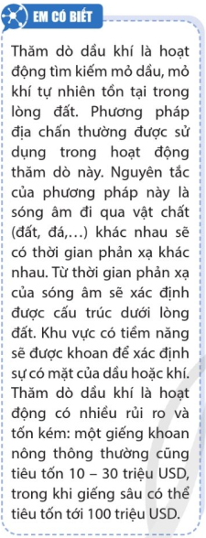
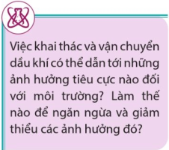 | ....................................................................................................................  ....................................................................................................................  ....................................................................................................................  ....................................................................................................................  ....................................................................................................................
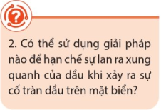 | ....................................................................................................................  ....................................................................................................................  ....................................................................................................................  ....................................................................................................................  ....................................................................................................................

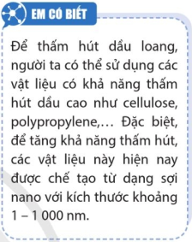 | 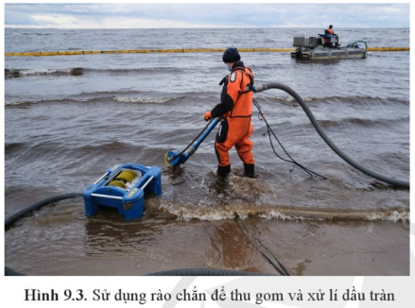
III. MỘT SỐ NGUỒN NHIÊN LIỆU THAY THẾ DẦU MỎ
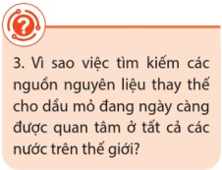 | .....................................................................................................................  .....................................................................................................................  .....................................................................................................................  .....................................................................................................................  .....................................................................................................................
1) Than đá
.....................................................................................................................  .....................................................................................................................  .....................................................................................................................  .....................................................................................................................  .....................................................................................................................  .....................................................................................................................  .....................................................................................................................  .....................................................................................................................  ..................................................................................................................... | 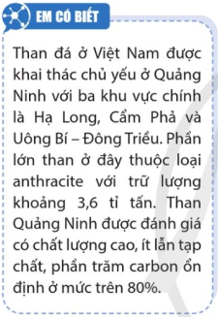
2) Khí thiên nhiên
....................................................................................................................  ....................................................................................................................  ....................................................................................................................  ....................................................................................................................  ....................................................................................................................  .................................................................................................................... ....................................................................................................................  ....................................................................................................................  ....................................................................................................................  ....................................................................................................................  ....................................................................................................................  ....................................................................................................................  ....................................................................................................................  ....................................................................................................................  ....................................................................................................................  ....................................................................................................................  ....................................................................................................................  ....................................................................................................................  .................................................................................................................... | 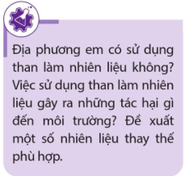  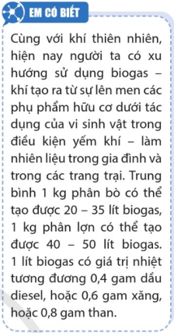
3) Đá phiến
..........................................................................................................................................................................
..........................................................................................................................................................................
..........................................................................................................................................................................
..........................................................................................................................................................................
..........................................................................................................................................................................
..........................................................................................................................................................................
4) Hydrogen
....................................................................................................................  ....................................................................................................................  ....................................................................................................................  ....................................................................................................................  ....................................................................................................................  ....................................................................................................................  ....................................................................................................................  ....................................................................................................................  ....................................................................................................................  ....................................................................................................................  ....................................................................................................................  ....................................................................................................................  ....................................................................................................................  .................................................................................................................... |  |                 
