Mã đề 6.2.63
ĐỀ KIỂM TRA CUỐI KỲ II NĂM HỌC: 2022-2023
MÔN: TIẾNG ANH LỚP 6
Thời gian làm bài: 60 phút
SECTION A: LISTENING (2 point)
A. LISTENING: (2 pts )
Part 1 : Listen and tick () the box . There is one example. (1 point)
Who is Robert going to go swimming with?(NB)
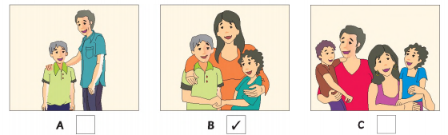
1. What time must Robert come home? ( TH )
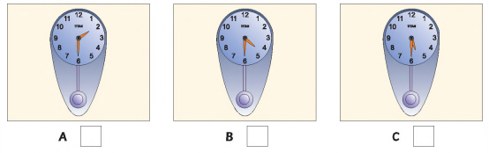
2. How will Robert go to the swimming pool?(TH )
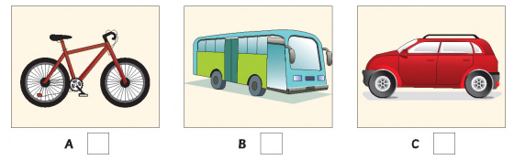
3. Where is Robert’s swimming bag?( NB )
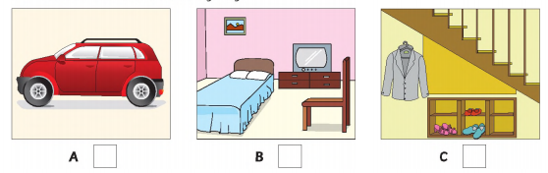
4. What is Robert going to have for lunch? ( VD)
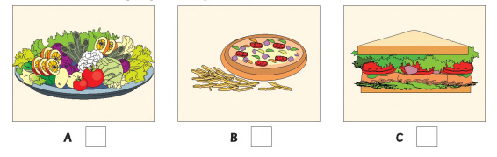
5. What is Robert going to do before lunch? ( VD )
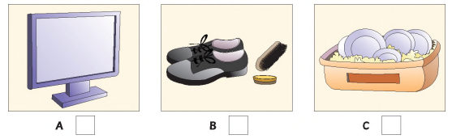

Part 2 : Listen and write . There is one example.(1 point)

SCHOOL VISIT THEATER

Day : Thursday

1. Time leave school : ____________________ p .m ( TH )
2. Name : _________________ the song ( NB )
3. Write name on list in : _____________________ ( NB )
4. Give money to : Mr ____________________ ( NB )
5. Remember to take : some ___________________ ( TH )

SECTION B: LANGUAGE (2 POINTS)
I. Choose the word whose underlined part pronounced differently from that of the others by circling A, B, C or D (0.4 point)
1. A. likes B. knive C. lives D. leaves ( NB)
2. A. dance B. fan C. pagoda D. man ( NB)

II. Choose the best option (A, B, C or D) to complete these sentences. (1.6 point)
1. My sister often ________ badminton in her free time.
A. play B. plays C. playing D. to play ( TH )
2. Our school football team ________ the match with Tran Phu School last Sunday.
A. wins B. won C. scores D. scored( TH )
3. Mount Everest is the highest ________ in the world.
A. forest B. island C. lake D. mountain( NB )
4. Children receive ________ in red envelopes in New Year’s days.
A. food B. lucky money C. clothes D. sweets ( NB )
5. If we ________ waste paper, we will save a lot of trees.
A. repeat B. recycle C. rewrite D. remake ( NB )
6. “What can we do ________ air pollution?”
A. reduce B. to reduce C. reducing D reducing ( TH )
7.Please don’t make so much noise. I ________ to work.
A. is trying B. are trying C. trying D. am trying ( TH )
8. Nam often uses his smart phone to ________ the Internet.
A. contact B. watch C. communicate D. surf ( TH )

SECTION C: READING (2 POINTS)
I. Read the passage and choose the best option (A, B, C or D). (1 point)

Noise pollution has become a serious problem of our days. It is a huge issue to everyone and especially for people who (1) ________ in a big and crowded city. It is not only airports, cars or factories that (2) ________ noise, but also such things as computers or printers can distract people. Even pleasurable things, such as (3) ________ to loud music can (4) _______ our hearing. It is proven that noise has different negative influences (5) on people among other things. It not only damages our hearing but also (5) ________ our behaviour. Big cities are the main sources of noise pollution.
1. A. stay B. live C. leave D. arrive (VD)
2. A. make B. pollute C. do D. get ( TH )
3. A. hearing B. listening C. watching D. seeing (NB )
4. A. damage B. reduce C. make D. get ( VD)
5. A. affects B. affect C. has affect D. affecting ( NB )
II. Read the passage and choose the correct answer for each question (1 point)

Basketball involves two teams of five players each. The players score points by throwing a large round ball into a raised goal called a basket. One basket is at each end of the playing area or court. Players may move the ball towards the basket only by bouncing it on the floor or passing it to another team member. Each team also tries to prevent the other team from scoring. The team that scores the most points is the winner.
Both men and women were playing basketball at schools and sports centers throughout North America. It became so popular that people started paying money to watch basketball games. American soldiers took the game to Europe during World War One.
In 1936, basketball became part of the competition at the Olympic Games. About the same time, college basketball became a major national sport in the United States.
1. How many players are there in a basketball team?(TH )
A. There are two players in a basketball team.
B. There are two basketball teams.
C. There are five players in each basketball team.
D. There are ten players in a basketball team.
2. How do the basketball players score points?(NB )
A. They kick and throw a ball into a raised goal called a basket.
B. They kick the ball into a basket.
C. They throw the ball into a raised goal called a basket.
D. They throw a ball to the goal in the end of court.
3. Why does each team try to prevent the other team from scoring? ( TH )
A. They want the other team to score more points.
B. They don’t want the other team to score more points.
C. They want to throw a ball at the other team.
D. They don’t want to score more points.
4. Who were playing basketball in North America?( NB )
A. Only American men can play basketball at schools and sport centers.
B. Both American men and women were playing basketball at schools and sport centers.
C. American women can play basketball at schools and sport centers.
D. Young people can play basketball at schools and sport centers.
5. When did basketball become part of the competition at the Olympic Games?( NB )
A. In 1936 B. Before 1936 C. In 1956 D. 50 years ago
SECTION D: WRITING (2 POINTS)
I. Find out the mistake in each following sentence. (0.4 point)
1. Last summer I went to Nha Trang but bought a lot of souvenirs.( NB )
A B C D
2. I ate noodles for dinner, but I wasn’t eat anything for lunch.( NB )
A B C D
II. Rewrite the following sentences, beginning with the words given. (0.6 point)
1. We use recycled paper. We save many trees.( TH)
=> If we
2. We will probably go to the moon for our summer holiday in 2030.( TH )
=>We might
3. He was tired last night, but he stayed up late to watch a football match.( TH )
=> Although
III. Put these words or phrases in the correct order. (1 point)
1. will / all our housework/ home robots / In the future / do / be able to. ( VD)

2. I / until / couldn’t / I was three years old / speak. ( VD)

3. be able to / Will robots / talk to us / in 2030? ( VD)

4. the water / If / polluted / fish / is / will die / badly. ( VD)

5. you / to school / will help / If / walk / you / reduce the air pollution. ( VD)

SECTION E. SPEAKING TEST (2 points, approximately 3-5 minutes/ one pair of students)
* Notes: Teacher doesn’t need to ask all questions in task 1.

Task 1. Now let’s talk about your favourite TV programme. Are you ready?
    - Do you like robots? Why/ Why not?
    - What kind of robot will you have in the future?
    - What will your robot look like?
    - What will your robot be able to do?

Task 2: Each of you will now receive a card. On the card there is a picture and clues for five questions. You should use the words to make questions and ask your friends. Your friend will answer the questions based on the picture he/ she has.

Card A  Use the words given below to make questions. Ask your friend about his/ her picture and listen to the answers.  - What/ room?  - How many/ people?  - What/ the woman/ doing?  - What/ in front of/ man?  - What/ kitchen/ your future house/ look like? | 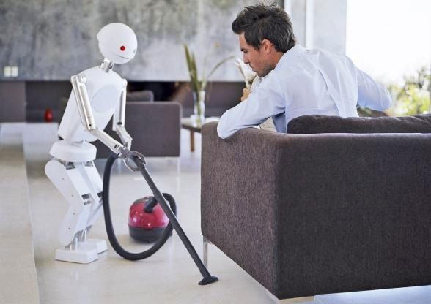  Now, your friends will ask you questions about your picture. Answer his/ her questions.
Card B  Use the words given below to make questions. Ask your friend about his/ her picture and listen to the answers.  - What/ room?  - How many/ people?  - What/ the man/ sitting on?  - What/ the robot/ doing?  - What/you/ think/ robot/ do/ the future? | 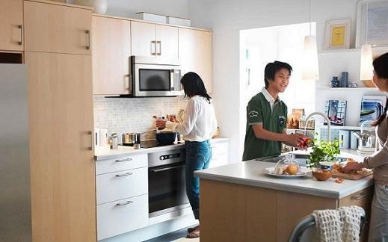  Now, your friends will ask you questions about your picture. Answer his/ her questions.
Giaoandethitienganh.info

KEYS AND MARKS.

SECTION A: LISTENING (2 POINTS)
Part 1 : Listen and tick () the box . There is one example.(1 point)
0,2 point for each correct answer x 5 = 1 point
1. B 2. A 3. C 4. A 5. C
Part 2 : Listen and write . There is one example.(1 point)
0,2 point for each correct answer x 5 = 1 point
1. 2.15/ two fifteen 2. guess 3. the (school) library 4. Neale 5. money
SECTION B: LANGUAGE (2 POINTS)
I. Choose the word whose underlined part pronounced differently from that of the others by circling A, B, C or D (0.4 point)
1. A 2. C
II. Choose the best option (A, B, C or D) to complete these sentences. (1.6 point)
1. B 2. B 3. D 4. B 5. B 6. B 7. D 8. D
SECTION C: READING (2 POINTS)
I. Read the passage and choose the best option (A, B, C or D). (1 point)

1. B 2. A 3. B 4. A 5. A
II. Read the passage and choose the correct answer for each question (1 point)

1. C 2. C 3. B 4. B 5. A
SECTION D: WRITING (2 POINTS)

I. Find out the mistake in each following sentence. (0.4 point)
1.B 2. C
II.Rewrite the following sentences, beginning with the words given. (0.6 point)
1. If we use recycled paper, we will save many trees.
2. We might go to the moon for our summer holiday in 2030.
3. Although he was tired last night, he stayed up late to watch a football match.

III. Put these words or phrases in the correct order. (1 point)

1. In the future, home robots will be able to do all our housework.
2. I couldn’t speak until I was three years old.
3. Will robots be able to talk to us in 2030?
4. If the water is badly polluted, fish will die.
5. If you walk to school, you will help reduce the air pollution.
Transcript listening:
Part 1 : Listen and tick () the box . There is one example
Look at the instructions for part one. Listen and look. There is one example.

Who is Robert going to go swimming with?

Robert: Dad, can I go swimming this afternoon?
Dad: I'm sorry Roberts, but I have to go to the shops.
Robert: That's okay. My friend Michael is going to go with his mom. And I can go with them.
Dad: Fine.
Robert: Thanks, dad.

Can you see the tick? Now you listen and tick the box.
1.What time must Robert come home?
Dad: What time are they going to go swimming?
Robert: At 230.
Dad: Okay, but you must come home at 430. Remember, we're going to go to your grandma's for dinner. And we need to leave at 530.
Robert: Okay, Dad
2.How will Robert go to the swimming pool?
Dad: Can Michael's mom take you in her car?
Robert: She doesn't drive. They sometimes take the bus.
Dad: How will you get to the swimming pool then? By bus?
Robert: No. All ride our bikes there.
Dad: Ah, that's a good idea.
3.Where is Robert’s swimming bag?
Robert: Do you know where my swimming bag is, Dad?
Dad: Isn't it in your bedroom.
Robert: I've looked there. Is it in your car?
Dad: It's not there. What about under the stairs?
Robert: Oh yes. There it is.
4.What is Robert going to have for lunch?
Dad: Okay, I'll make some ham sandwiches for lunch.
Robert: Can we have pizza and chips?
Dad: Why don't we have a salad? It's not a good idea to have a big meal before swimming
Robert: That's great.
5.What is Robert going to do before lunch?
Dad: First, I'd like you to clean your shoes.
Robert: I've already cleaned them. Look. Can I watch some TV?
Dad: No, you can wash these plates for me.
Robert: All right, dad.
Now listen to part four again.

Part 2 : Listen and write . There is one example.(1 point)

Daisy: Oh, Hello, Miss Gray. Can I ask you some questions?
Miss Gray: Yes, of course. Daisy. What do you want to know?
Daisy: What time are we going to the theater on Wednesday?
Miss Gray: Oh, didn't you know? It's on Thursday now?
Daisy: Oh, right.
Miss Gray: The football team needs the school bus that day.
Daisy: Oh, okay.
Can you see the answer? Now you listen. And write.
Daisy: What time are we going to go to the theater?
Miss Gray: Well, we need to be at the theater for 2:45. And so we're going to leave school at 2:15. The theater isn't far from the school.
Daisy: Okay. What are we going to see?
Miss Gray: It's a concert.
Daisy: Oh, is it called? Guess the song?
Miss Gray: Yes, that's right.
Daisy: I'd like to go. What do I need to do?
Miss Gray: You need to write your name on a list today. It's in the school library. Just write your name and your class.
Daisy: Okay. And who do I get the ticket from?
Miss Gray: Mr. Neal. You can give him the money on the day.
Daisy: Sorry, who?
Miss Gray: Mr. Neale. That's N.E.A.L. E. He's the new music teacher.
Daisy: Oh, yes. I've met him. Is he taking us to the theater?
Miss Gray: Yes, he is.
Daisy: Do I need to take anything to the theater?
Miss Gray: Just some money to buy a drink. Remember, you cannot take your camera or your mobile phone with you?
Daisy: Right. Okay. Are you going to come with us? Miss Gray?
Miss Gray: Yes, I am.
Daisy: Great!
Now listen to part two again.

