Date of planning: 13/5/2022  Date of teaching: 17/5/2022 | Peroid 98,99 : UNIT 12: ROBOTS  Lesson 3 : A CLOSER LOOK _2
THIS UNIT INCLUDES:
Vocabulary  - Daily activities  Pronunciation:  - Tones in statement.  Grammar  - Superlative adjectives: short adjectives (smallest, tallest, ect ) | Skills:  - Reading about an Internationa Robot Show.  - Talking about what robots can do.  - Listening about what robots can do.  - Writing a paragraph about a robot you would like to have.  Everyday English  Expressing agreement and disagreement.
I. OBJECTIVE: By the end of this lesson, students will be able to gain the following things :
1. Knowledge:
- To teach a grammar point : Superlative adjectives: short adjectives. To practice doing exercises using superlative form of adjectives.
+ Vocabulary: - Use the words for daily activities;
- Say statements with correct tones;
- Expressing agreement and disagreement about something;
+ Grammar: - Superlative adjectives: short adjectives (smallest, tallest, ect )
- Compare people and things using superlative adjectives;
2. Competence:Students will be able to learn how to use and form superlative form of adjectives. To practise doing exericses with comparative or superlative form of adjectives.
3. Quality/ behavior : The awareness of doing daily activities. Having good attitude to doing the housework. Having serious attitude to working in groups, individual work, cooperative learning and working.
II. TEACHING AIDS:
- Teacher: Text book, laptop, louspeaker, projector…
- Students : Text books, studying equipments….
- Work Arrangements: T_Ss , group works; individual ……
III. PROCEDURE:
1. WARM UP & INTRODUCTION (5’)
Grammar: Superlative adjectives: short adjectives
Aim: To help Ss form and use the superlative form of adjectives: Short adjectives.
- Choose three or more Ss of very different heights and ask them to come to the front and line up. T asks the class: Who is the tallest? Indicate tall and tallest with your hands and arms. Ask Ss to say what tallest is in Vietnamese. T introduces the subject of the lesson: superlative adjectives, and asks for the equivalent in Vietnamese (Cấp so sánh cao nhất của tính từ).
- Have Ss look at the Remember! box about the use of superlative adjectives.
- To explain to them that superlative adjectives are used to compare more than two people or things, expressing the highest degree. Explain that the superlative of short adjectives is constructed in several different ways in English, and that some of those ways are presented in the Grammar box below.

 | Positive | Superlative | Rule
one syllable | fast | fastest | + est
 | large | largest | + st
 | hot | hot | + test
two syllables | noisy | noisiest | y -> iest

* Content: Review the previous lesson or have some warm-up activities to creat a friendly and relaxed atmostphere to inspire Ss to warm up to the new lesson.
* Outcome: Having a chance to speak English and focus on the topic of the lesson..
* Organisation : Teacher’s instructions…

Teacher’s & Student’s activities | Content
+ Greeting  + Revision  - Teacher (T) asks Ss some questions about the previous lessons,  - T may introduce some warm-up activities to creat a friendly and relaxed atmostphere to inspire Ss to warm up to the subject and new class…  - Ask Ss to open their book and introduce what they are going to study…. | + Greeting  + Revision  - T- Ss  - Students (Ss) listen and learn how to do.  - Open their book and write .
2. PRESENTATION/ NEW LESSON (12’)
ACTIVITY 1:
Aim: To help Ss practise forming the correct form of superlative adjectives.
* Content: Introduce the superlative adjectives. Short adjectives. Write the superlative form of adjectives.
* Outcome: Learn how to form and use the superlative adjectives. Short adjectives
* Organisation : Teacher guides.

- Remember!
We use superlative adjectives to compare three or more
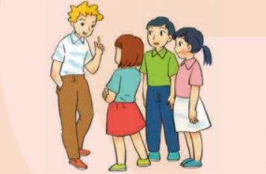
People or things.
Examples: Tom is the tallest in his class
Example: This is the biggest of the three bags.



Teacher’s & Student’s activities | Content
1. Write the superlative form af adjectives in the table below.  - Ask Ss to read the instruction. Tell Ss what they should do. (With a weaker class, do the first word as an example). | 1. Write the superlative form af adjectives in the table below.  - T- Ss  + Students (Ss) listen to the instructions carefully and learn how to do the tasks.  - Answer the teacher’s questions
- Ask Ss to do the exercise individually and then compare their answers with a classmate.  - Check the answers as a class.  - Confirm the correct answers. | * Key :  Adjectives Superlative form  fast fastest  tall tallest  noisy noisiest  nice nicest  hot hottest  light lightest  quiet quietest  heavy heaviest  large largest
3. PRACTICE (18’)
ACTIVITY 2:
Aim: To help Ss practise forming the correct form of superlative adjectives in the sentences.
* Content: Complete the sentences, using superlative adjectives.
* Outcome: Ss can complete the sentences, using superlative adjectives correctly
* Organisation : Teacher’s instructions…

Teacher’s Student’s activities |  | Content
2. Compelte the following sentences with superlative form of adjectives in brackets. 1 is an example  - Ask Ss to read the instruction. Tell Ss what they should do. The first sentence is done as an example.  - Ask Ss to do the exercise individually and then compare their answers with a classmate.  - Check the answers as a class.  - Confirm the correct answers. |  | 2. Compelte the following sentences with superlative form of adjectives in brackets. 1 is an example.  - T- Ss  - Listen carefully and learn how to do.  - Follow the teacher’s instructions  * Key:  2. smartest 3. tallest 4. smallest 5. cheapest
ACTIVITY 3:
Aims:
- To help Ss practise forming the correct form of superlative adjectives;
- To help Ss revise the form and use of comparative adjectives;
- To help Ss distinguish between comparative adjectives and superlative adjectives.
* Content: Complete the sentences using comparative adjectives and superlative adjectives.
* Outcome: Ss can do exercises using comparative adjectives and superlative adjectives correctly.
* Organisation : Teacher’s instructions…

3. Complete the following sentences with comparative or superlative form of adjectives in brackets.  - Have Ss do this exercise individually. Call on two Ss to write their answers on the board.  - Draw all Ss'attention to the board and checkthe answers together. Confirm the correct answers. | 3. Complete the following sentences with comparative or superlative form of adjectives in brackets.  - Ss work individually  - Ss do themselves.  Key :  1. tidier 2. hottest 3. faster  4. tallest 5. smarter
ACTIVITY 4:
Aim: To give Ss further practice on using superlative adjectives
* Content: Further practice . Look at information and talk about them using superlative adjectives
* Outcome: Ss can talk about three robots using superlative adjectives
* Organisation : Teacher’s instructions…

Teacher’s Student’s activities | Content
4. Work in pairs. Look at the informationof the three robots: M10, H9 and A3 to talk about each of them, using superlative adjectives.  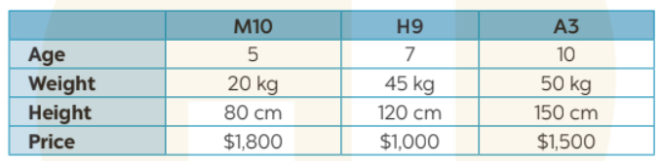  - Ask Ss to look at 4 and explain what they have to do. First, model this activity with a stronger student.  - Remind Ss that they only use the information from the table to describe the three robots using superlative adjectives.  - T may explain the meaning of the words age, weight, height, price and ask Ss to elicit the adjectives they can use to describe each row.  - Have Ss work in pairs to say sentences comparing the three robots. Move around to offer help if needed. | 4. Work in pairs. Look at the informationof the three robots: M10, H9 and A3 to talk about each of them, using superlative adjectives.  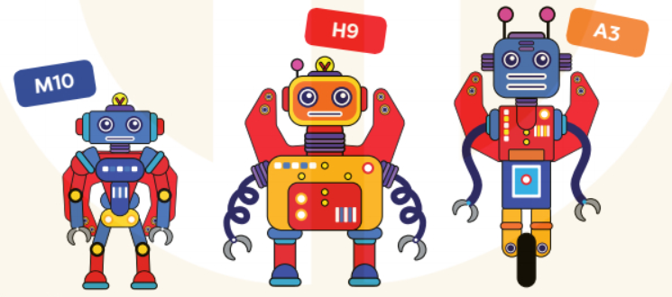  - Work in pairs  - Do the tasks and share the answers.  A. A3 is the tallest of the three robots.  B. M10 is the youngest of the three robots.
4. FURTHER PRACTICE ( 8’)
ACTIVITY 5:
Aim: To give Ss further practice on using superlative adjectives.
* Content: Play GAME. Find some one who …. to practice on using superlative adjectives.
* Outcome: Ss work in pairs and ask the partner to find someone who is …. the tallest/ the oldest/ the shortest….
* Organisation : Teacher’s instructions…

5. GAME. Find someone who….. work inpairs. Ask your partner to find in your class someone who is :  - the tallest . – the shortest  - the oldest. – the biggest ….  - First, model the game Find someone who... with a stronger student.  - Have Ss work in pairs to ask and answer questions to find out the student who is the shortest / tallest / smartest, etc. in their class.  - Move around to offer help if needed.  - If there is enough time, ask Ss to compare their findings with other pairs'.  - T and other Ss give comments. | 5. GAME. Find someone who….. work inpairs. Ask your partner to find in your class someone who is  - T _ Ss  - Listen to the instructions carefully then do the tasks.  - Do the tasks  Key :
5. WRAP-UP & HOME WORK (2’)

* Summarize what they have learnt in the lesson.
Ask Ss to give some sentences with superlative form of short adjectives.
* HOME WORK
- Remember the use of possessive adj and possessive pronouns.
- Do more exercises in workbook.
- Prepare new lesson.
===================================

