**Tiếng Anh 6 i-Learn Smart World - Midterm 1.1  
Time allotted: 60**

**PART 1. Pronunciation (2 questions)**

**Find the word that differs from the other three in the position of primary stress.**

A. laundry B. hometown C. physics D. event

A. fantasy B. adventure C. exciting D. apartment

**PART 2. Use of English (10 questions)**

**Choose the word/phrase that best suits the blank in each sentence.**

3. The plates are dirty. I need to ______________.

A. do the shopping B. do the dishes C. make the dishes D. do the laundry

4. ______________ stories are about magic, kings and queens.

A. Fantasy B. Mystery C. Comic D. Adventure

5. Why don’t you sign ______________ a book club?

A. in B. out C. up for D. for

6. Your desk is very dirty. ______________ is clean and tidy.

A. My B. Me C. Desk D. Mine

7. I enjoy doing ______________ because I can make pretty things from paper.

A. outdoor activities B. arts and crafts C. acting D. in the drama club

8. Can Tho is famous ______________ its floating markets and beautiful rivers

A. on B. for C. in D. with

9. Student A: “Where is your hometown?”  
Student B: “______________”

A. I love my hometown.

B. It’s in the east of Vietnam.

C. My hometown is a big city.

D. My hometown is very good for growing rice.

10. Student A: “What does the new teacher look like?”  
Student B: “______________”

A. He’s very friendly.

B. He teaches literature.

C. He’s tall and has brown hair.

D. He likes playing soccer.

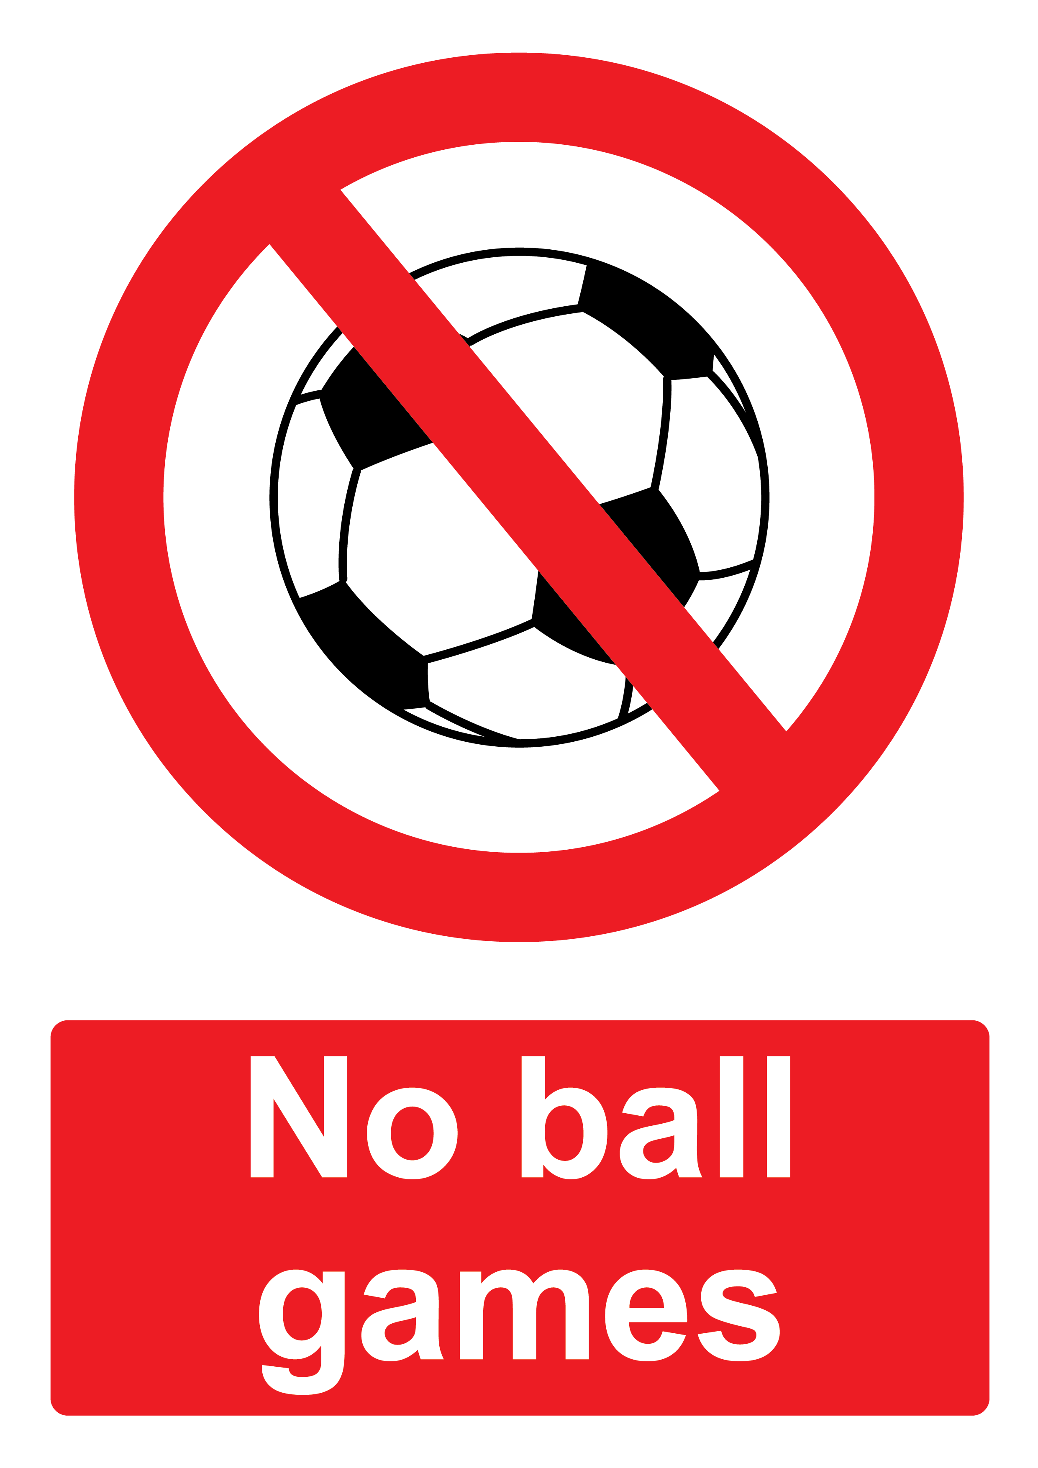

11. What does the sign mean?

A. You cannot play soccer in this area.

B. People don’t have any balls.

C. There isn’t a soccer club.

D. People don’t like soccer.



12. What does the sign mean?

A. People don’t have cell phones here.

B. Please don’t use your cell phone here.

C. Cell phones are not good.

D. Please put your cell phone here.

**PART 3. Reading comprehension. (6 questions)**

**Read the following passage and complete the tasks. (6 questions)**

|  |
| --- |
| WHAT TO DO IN AMSTERDAM  Amsterdam, the capital city of the Netherlands, is a great place to spend time. It is in the west of the Netherlands. It’s easy to travel to this city because it has a big railway station and an airport – and it isn’t difficult to find a hotel. There’s a lot to see and do here. There are shops for people who enjoy shopping and restaurants with typical Dutch food, like stamppot or poffertjes. Or you can go to one of the museums, such as Van Gogh Museum. The best way to travel around Amsterdam is on a bike. There are 747,000 people here and over 600,000 bikes. After a busy day, a lot of visitors enjoy a cup of coffee at one of Amsterdam’s many koffiehuizen (coffee houses). |

**Task 1: Decide whether the statements that follow are True or False**

**Answers** **True** **False**

13. There aren’t any railway stations in Amsterdam **◯** **⦿**

14. It’s difficult for tourists to find a hotel in Amsterdam. **◯** **⦿**

15. Stamppot and poffertjes is typical food in Amsterdam **⦿** **◯**

16. Cycling is the best way to travel around Amsterdam. **⦿** **◯**

**Task 2: Choose the word or phrase that best fits the blank space in each sentence.**

17. Amsterdam is in the ______________ of the Netherlands.

A. north

B. south

C. east

D. west

18. The word ‘koffiehuizen’ in paragraph 2 means ______________.

A. a cup of coffee

B. a place where people drink coffee

C. the name of a boat tour

D. the name of a museum

**PART 4. Cloze test (6 questions)**

**Read the passage, choose the word/phrase that best suits the blank (6 questions)**

I live in Tallinn (19) ___________ the north-west of Estonia. I’m 15 and I live with my parents and brother in a small apartment. On weekdays, I get up at 7 o’ clock in the morning. I walk to school – it’s very near my home and we don’t have a car. School (20) ___________ at 8a.m. and ends at 2p.m. I study math, biology, history, art, music, English and German – and Estonian, of course. My favorite (21) ___________ are English and history. After school, I go home (22) ___________ lunch. I do my homework in the evening and I go to bed at 11p.m. In my free time, I go to the movies, visit friends and (23) ___________ rollerblading. Our summer holiday is in July and August and we go to the Baltic Sea. Everyone (24)___________ swimming.

(19) A. on B. in C. inside D. at

(20) A. start B. begin C. starts D. has

(21) A. clubs B. thing C. subject D. subjects

(22) A. on B. for C. during D. with

(23) A. go B. play C. have D. make

(24) A. like B. don’t like C. loves D. plays

**PART 5. Verb forms and verb tenses (4 questions)**

**Complete the sentences with the correct form of the verbs in brackets.**

25. My house doesn’t have/does not have a garage. ***(not have)***

26. My dad usually does the shopping at the weekend. ***(do)***

27. I really like using computers. ***(use)***

28. I like chatting to my friends and my cousins. ***(chat)***

**PART 6. Rearrange the words (2 questions)**

**Rearrange the groups of words in a correct order to make complete sentences.**

29. Keywords: is/Mary/red T-shirt/wearing/a/black shorts/and/.

→ Mary is wearing a red T-shirt and black shorts ./Mary is wearing black shorts and a red T-shirt .

30. Keywords: doing/I/activities/basketball/love/like/outdoor/.

→ I love doing outdoor activities like basketball .

**PART 7. Make questions (3 questions)**

**Make questions for the underlined part.**

31. My sister Lucy cleans the kitchen.

→ Who cleans the kitchen?

32. John is wearing a shirt and jeans.

→ What is John wearing?

33. The city is famous for beautiful houses and museums.

→ What is the city famous for?

**PART 8. Rewrite the sentences (3 questions)**

**Rewrite the following sentences without changing the meaning.**

34. There are three bedrooms in my house.

→ My house has three bedrooms

35. I like literature and geography.

→ Literature and geography are my favorite subjects.

36. Mrs. Smith has a daughter, Anna.

→ Mrs. Smith is Anna’s mother**.**

**---THE END---**