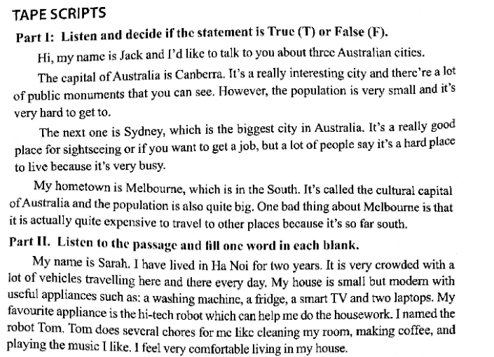

My name is Sarah. I have lived in Ha Noi for (1) years. It is very crowded with a lot of vehicles (2) here and there every day. My house is small but modern with useful appliances such as a washing machine, a (3) , a smart TV, two laptops. My favourite appliance is the hi-tech robot which can help me do the (4) . I named the robot Tom. Tom does several chores for me like cleaning my room, making coffee and playing the music I like. I feel very (5) living in my house.