
PART 1. PRONOUNCIATION

/i/ | /i:/
village/ˈvɪlɪdʒ/ | meal /miːl/
1. Âm /ɪ/
1.1. “a” được phát âm là /ɪ/với những danh từ có hai âm tiết và có tận cùng bằng “age”
Examples | Transcription | Meaning
village | /ˈvɪlɪdʒ/ | làng, xã
cottage | / ˈkɔtɪdʒ/ | nhà tranh, lều tranh
1.2. “e” được phát âm là /ɪ/ trong tiếp đầu ngữ “be”, “de” và “re”
Examples | Transcription | Meaning
begin | /bɪˈgɪn/ | bắt đầu
become | /bɪˈkʌm/ | trở nên
1.3. “i” được phát âm là /ɪ/ trong từ có một âm tiết và tận cùng bằng một hoặc hai phụ âm i + phụ âm.
Examples | Transcription | Meaning
win | /wɪn/ | chiến thắng
miss | /mɪs/ | nhớ
1.4. “ui” được phát âm là /ɪ/
Examples | Transcription | Meaning
build | /bɪld/ | xây cất
guilt | /gɪlt/ | tội lỗi
2. Âm /iː/
2.1. Âm “e” được phát âm là /iː/ khi đứng liền trước hình thức tận cùng bằng phụ âm + e và trong những chữ be, he, she, me ...

Examples | Transcription | Meaning
scene | /siːn/ | phong cảnh
complete | /kəmˈpliːt/ | hoàn toàn
2.2. Âm “ea” được phát âm là /iː/ với những từ có tận cùng là“ea” hoặc “ea” + một phụ âm.
Examples | Transcription | Meaning
tea | /tiː/ | trà
meal | /miːl/ | bữa ăn
2.3. “ee” thường được phát âm là /iː/
Examples | Transcription | Meaning
three | /θriː/ | số 3
see | /siː/ | nhìn, trông, thấy
2.4. “ei” được phát âm là /iː/ trong một số trường hợp:
Examples | Transcription | Meaning
receive | /rɪˈsiːv/ | nhận được
ceiling | /ˈsiːlɪŋ/ | trần nhà
2.5. “ie” được phát âm là /iː/ khi nó là những nguyên âm ở giữa một chữ.
Examples | Transcription | Meaning
grief | /griːf/ | nỗi lo buồn
chief | /tiːf/ | người đứng đầu
Task 1. Put the words into the correct columns.

him ship ceiling begin meal
cottage shortage benzene tea cheese
scene miss become free village
win complete three relieve chief
cheap chick deceive behave remind

receive dream build guitar equivalent
/iː/
………………………………………………………………………………………
………………………………………………………………………………………
…………………………………………………
…………………………………………………
…………………………………………………
………………………………………………….
/ɪ/
………………………………………………………………
………………………………………………………………
………………………………………………………………
…………………………………………………
…………………………………………………
………………………………………………….

Task 2. Circle the word that has the underlined part pronounced differently

1. A. renew B. pea C. three D. key
2. A. wig B. grin C. heat D. fish
3. A fleece B. return C. machine D. scene
4. A. neat B. village C. cottage D. shortage
5. A complete B. cede C. remind D. secede
6. A baggage B. breathe C courage D. damage
7. A. reorganize B. benzene C. kerosene D. Vietnamese
8. A. luggage B. message C. creature D. voyage
9. A. easy B. tea C meal D. represent
10. A. passage B. easy C. begin D. become
.


PART 2: VOCABULARY

ENGLISH | TYPE | PRONUNCIATION | VIETNAMESE
apartment | (n) | /əˈpɑːrt mənt/ | Chung cư
balcony | (n) | /ˈbælkəni/ | Ban công
basement | (n) | /ˈbeɪsmənt/ | Tầng hầm
garage | (n) | /ɡəˈrɑːʒ/ | Nhà để xe, ga-ra
gym | (n) | /dʒɪm/ | Phòng tập thể dục
yard | (n) | /jɑːrd/ | Cái sân
bed | (n) | /bed/ | Cái giường
clean | (v) | /kliːn/ | Dọn dẹp, rửa
dinner | (n) | /ˈdɪnər/ | Bữa tối
dish | (n) | /dɪʃ/ | Cái đĩa
kitchen | (n) | /ˈkɪtʃən/ | Nhà bếp
laundry | (n) | /ˈlɔːndri/ | Việc giặt là (ủi)
shopping | (n) | /ˈʃɒpɪŋ/ | Việc mua sắm
center | (n) | /ˈsentər/ | Trung tâm
city | (v) | /ˈsɪti/ | Thành phố
east | (n) | / iːst/ | Phía đông
north | (n) | / nɔːrθ/ | Phía bắc
south | (n) | / saʊθ/ | Phía nam
town | (n) | / taʊn/ | Thị trấn, thị xã
village | (n) | /ˈvɪlɪdʒ/ | Ngôi làng
west | (n) | /west/ | Phía tây
attention | (n) | /əˈtenʃən/ | Sự chú ý
delta | (n) | /ˈdeltə/ | Đồng bằng
region | (n) | /ˈriːdʒən/ | Vùng
temperature | (n) | /ˈtemprətʃər/ | Nhiệt độ
museum | (n) | /mjuːˈziːəm/ | Viện bảo tàng
college | (n) | /ˈkɒlɪdʒ/ | Cao đẳng/ Đại học
restaurant | (n) | /ˈrestrɒnt/ | Nhà hàng
possession | (n) | /pəˈzeʃən/ | Sự sở hữu
transportation | (n) | /ˌtrænspɔːˈteɪʃən/ | Sự vận tải
breakfast | (n) |  | bữa sáng
sweep | (v) |  | quét(nhà, sàn nhà)
Task 1. Look at the pictures and complete the blanks.

 | 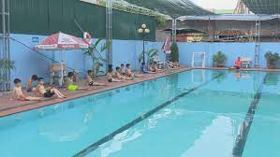 | 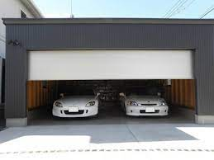
1. …………………………….. | 2. ……………………………… | 3. …………………………………
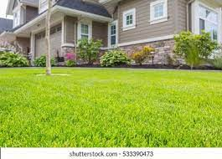 | 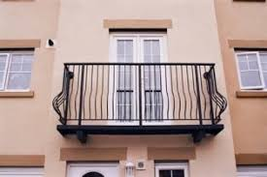 | 
4. ……………………………………. | 5. ……………………………….. | 6. ……………………………….

Task 2. Use the given words to complete the sentences.
5…………………
8…………………
7…………………
6…………………

balcony | village | yard | apartment | village
west | dishes | garage | city | gym
yard | apartment | flowers | pool | balcony

1. I like sitting outside on my _____ when it's hot.
2. North, East, South, and _________ are the four cardinal points of the compass.
3. After eating dinner, I do the _________.
4. I live in the countryside. My __________ is very small. It only has a few houses and one store.
5. My house has a very big __________. I like playing soccer there with my friends.
6. Does your uncle live in a villa in Ha Noi? - No, he doesn’t. He lives in an__________.
7. My mother goes to the__________ twice a week.
8. A__________ is in the countryside and usually has a few houses.
9. Does your apartment have a__________?
10. Did you park the car in the__________?
11. A: Does your house have a big__________?
12. B: Yes, it does. We plant trees and__________ there.
13. We asked for a hotel room with a__________.
14. Our__________ is small and has two bedrooms.
15. A__________ has many big buildings, schools, parks and hospitals.
Task 3. Put the words into the correct groups.

The dishes (x2), the bathroom, lunch, breakfast, the kitche, the shopping, the laudry, dinner, the bedroom.

Task 4. Circle the correct word .
Do | clean | Make
________________  ________________  ________________  ________________  ________________  ________________ | ________________  ________________  ________________  ________________  ________________  ________________ | ________________  ________________  ________________  ________________  ________________  ________________

1. My sister often makes breakfast/ dinner in the morning.
2. The plates are dirty. I need to do the shopping/ dishes.
3. Jenny makes breakfast/ does the dishes after eating lunch.
4. Let’s clean the bathroom/ eat breakfast. It’s so dirty.
5. My mom do the shopping/ laundry. My clothes are always really soft.
6. We’re out of juice. Can you buy some when you do the laundry/ shopping?
Task 5. Parts of the house. Unscramble the letters, then complete the passage
.

1. ergnad 5.nviligomor
2. amrhoobt 6.gnidinrmoo
3. moordeb 7. citta
4. hcnekit 8.ragega
I like my big house. It has got two ______________ upstairs, my parents’ one and mine. Upstairs also there is a ______________ where I wash and brush my teeth. Downstairs there is a ______________ big where my mother cooks and prepares meals, a ______________ to eat altogether and a ______________ where we watch TV or sit and relax. Outdoors my parents park their cars in the ______________, and we have a beautiful ______________ with a lot of flowers and trees. My house also has an ______________ where we store lots of old things.


PART 3: GRAMMAR

1. Present simple (Thì hiện tại đơn)
a. Form
 | Normal verb | Be
(+) | I, you, we, they + V-inf  He, she, it + V(s/es) | I + am  You, we, they + are  He, she, it + is
(-) | I, you, we, they + don’t + V-inf  He, she, it + doesn’t + V-inf | I am not  You, we, they + aren’t  He, she, it + isn’t
(?) | Do + I, you, we, they + V-inf?  Does + he, she, it + V-inf? | Am + I...?  Are + you, we, they ...?  Is + he, she, it...?
b. Usage
- Thì hiện tại đơn dùng để diễn tả một thói quen hoặc một hành động có tính lặp đi lặp lại ở hiện tại.
VD: She often goes to school at seven o’clock in the morning,
(Cô ấy thường đi học vào 7giờ sáng.)
- Thì hiện tại đơn dùng để diễn tả một chân lý hoặc một sự thật hiển nhiên.
VD: The sun rises in the East and sets in the West.
(Mặt trời mọc đằng đông và lặn đằng Tây.)
- Dùng để chỉ một sự việc sẽ xảy ra trong tương lai theo thời gian biểu hoặc lịch trình.
VD: The news programme starts at seven p.m.
(Chương trình thời sự bắt đầu vào lúc 7 giờ tối.)
c. Signals
- Cụm từ với “every”: every day (mọi ngày), every year (mọi năm), every month (mọi tháng), every afternoon (mọi buổi chiều), every morning (mọi buổi sáng), every evening (mọi buổi tối)...
- Cụm từ chỉ tần suất: once a week (1 lần 1 tuần), twice a week (2 lần một tuần), three times a week (3 lần một tuần), four times a week (4 lần một tuần), five times a week (5 lần một tuần), once a month (một lần một tháng), once a year (một lần một năm)...
- Trạng từ chỉ tần suất: always, usually, often, sometimes, never, rarely...
d. How to add “s/es”to verbs
❖ Thông thường ta thêm “s” vào sau các động từ.
listenlistens play plays
❖ Những động từ tận cùng bằng: -s; -sh; -ch; -z; -x; -o ta thêm “es”.
missmisses watch watches mix mixes
wash washes buzz buzzes go goes
❖ Những động từ tận cùng là “y”:
+ Nếu trước “y” là một nguyên âm (a, e, i, o, u) - ta giữ nguyên “y” + “s”
playplays buybuys paypays
+Nếu trước “y” là một phụ âm - ta đổi “y” thành “i” + “es”
flyflies crycries fryfries

2. Adverbs of frequency (Trạng từ chỉ tần xuất)

Usage
- Trạng từ tần suất được sử dụng để diễn tả mức độ thường xuyên của một hành động hay một thói quen. (luôn luôn, thường xuyên, thỉnh thoảng, không bao giờ,…)
Ví dụ:
– He always do morning exercise at 5 a.m. (Anh ta luôn luôn tập thể dục lúc 5 giờ sáng)
- Trạng từ chỉ tần suất dùng để trả lời các câu hỏi về “How often ( Có thường….?)”
Ví dụ:
– How often do you go shopping? (Bạn có thường đi mua sắm không?)
=> I sometimes go shopping. (Tôi thỉnh thoảng mới đi mua sắm)
Các trạng từ chỉ tần suất thường sử dụng

Trạng từ chỉ tần suất | Ý nghĩa
Always | Luôn luôn (ở mức 100%)
Usually | Thường xuyên (mức 90%)
Often | Thường thường (mức 70%)
Sometimes | Đôi khi, đôi lúc (mức 50%)
Never | Không bao giờ (mức 0%)
- She always gets up late. (Cô ấy luôn luôn thức dậy trễ.)
- She often goes to the park. (Cô ấy thường đi công viên.)
- She sometimes eats at home. (Cô ấy thỉnh thoảng mới ăn ở nhà.)
- She seldom goes picnic. (Cô ấy hiếm khi đi dã ngoại.)
- She never plays badminton. (Cô ấy không bao giờ chơi tennis.)

Form :
- Đứng sau động từ “tobe”
Ví dụ: I am never late for school. (Tôi không bao giờ đi học trễ)
2. Đứng trước động từ chính và đứng sau chủ từ
Ví dụ: He sometimes wash his car. (Anh ta thỉnh thoảng mới rửa xe)
3. Đứng giữa trợ động từ và động từ chính trong câu
Ví dụ:
– I have never been abroad. (Tôi chưa bao giờ đi nước ngoài)
– You should usually do your homework before going to school. (Bạn nên làm bài tập về nhà trước khi đến lớp)
Task 1. Put the verbs in brackets into the Present Simple.

- She (walk)___________ to school every morning.
- They (learn) ___________________ how to use the lawnmower in their free time.
- Linda (go) ______________to the supermarket to buy some sugar.
- Sometimes I (feel) _________________________ really lazy to do anything.
- Phong and I (study) _________________________ English in my room.
- I often (have) ____________________ breakfast at 7 am at home.
- She (do)_________________ aerobics every morning to keep fit.
- Nga (like) __________________playing basketball very much.
- What time you (have) _____________________lunch every day?
- She (not have) __________________ any pen, so I lend her one.
11. They ______________ (play) football and basketball at school.
12. My father ______________ (read) the newspaper every morning.
13. We ______________ (have) English, Maths and Science on Monday.
14. She never ______________ (do) her homework.
15. I ______________ (go) swimming twice a week.
16. Cars ______________ (be) more expensive than motorbikes.
17. Jane always ______________ (have) breakfast at 6 o’clock.
18 He usually ______________ (watch) TV after dinner.
19. London ______________ (be) a very big country.
20. I _____________ (be) a student and my parents ___________ (be) teachers.
Task 2. Read the sentences. Underline the correct words.

1. My mother make/ makes breakfast.
2. My sister do/ does the laundry.
3. My brother do/ does the dishes.
4. My father make/ makes the bed.
5. I clean/ cleans the kitchen.
6. Lily do/ does the shopping.
7. Jack and Paul make/ makes dinner together.
8. Lily's dad clean/ cleans the bathroom.
9. Their mom do/ does the most housework.
10. My brother play/ plays football very well.
Task 3. Put the adverb of frequency into the correct place. Then give the correct form of verbs.

1. My brothers (sweep) on the floor. (often)
.
2. He (stay) up late? (sometimes)
.
3. I (make) the dinner with my brother. (always)
.
4. Peter and Mary (do) the dishes together. (never)
.
5. Why Johnson (get) good marks? (always)
.
6. You (go) shopping? (usually)
.
7. She (do) laudry (seldom)
.
8. My father (do) the shopping. (never)
.
Task Task 3. Change these sentences into negative and interrogative form

1. They do the dishes every day.
.
.
2. She cleans the kitchen every afternoon.
.
.
3. We play volleyball every morning.
.
.
4. He does housework every night.
.
.
5. Mary and Peter go to work every day
.
.
6. He gets up at 9.00 every morning.
.


LISTENING

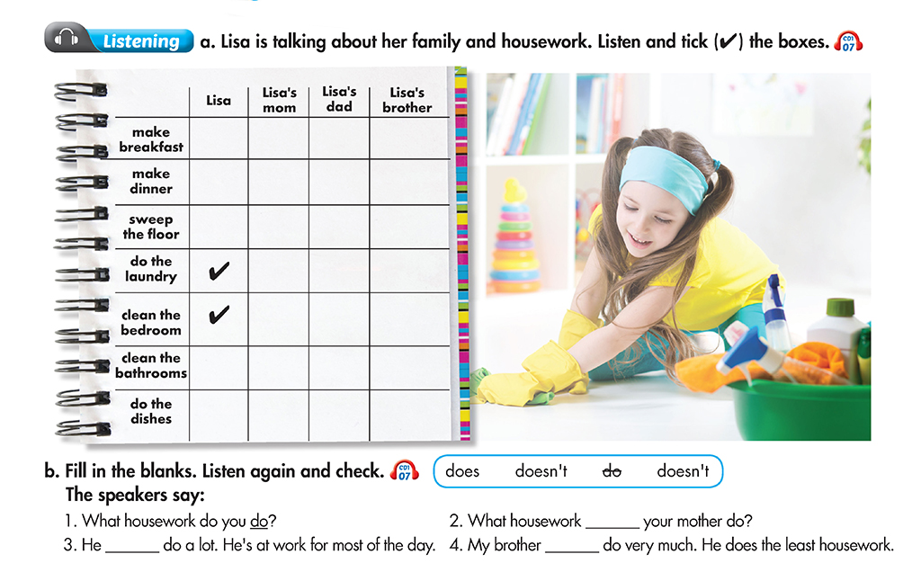


SPEAKING

Task 1. Match the questions and answers. Then practice.

- Where do you live? |  | - There are five.
- Who do you live with? |  | - Between the study and the stairs.
- How many rooms are there? |  | - I live in a town
- What’s in the living room? |  | - Yes. There’s one next to the window
- Where is your room? |  | - My bedroom.
- Is there a television in your room? |  | - Yes. There’s a big one on the wall opposite my bed.
- What is your favourite room? |  | - I live with my parents and sister.
- Are there any pictures in the kitchen? |  | - A sofa set, a television and a lamp.
Task 2. Answer the questions.

- Do you live in a house or an apartment? |  | ………………………………………  ………………………………………
- Where is your house/ apartment? |  | ………………………………………
- What floor is it on? |  | ………………………………………
- What housework does your mother do? |  | ………………………………………  ………………………………………
- How many rooms does it have? |  | ………………………………………
- Dóes it have a gym? |  | ………………………………………
- Who do you live with? |  | ………………………………………
- Are there any super market near your house/ apartment? |  | ………………………………………  ………………………………………


READING

Task 1. Read and answer the questions.

I live in a house in Melaka. It isn’t old or modern. It’s normal Malaysian house. We can say it’s near the sea. It takes about 10 minutes to go to the seaside on foot. We have two bedrooms, one living room and a dining room. Naturally, we also have a kitchen and a bathroom.
We don’t have a garage. I live with my parents.
In addition, our house has a small garden;
my parents spend their time there to
grow vegetables and fruits.



- Where is the house?
……………………………………………………..
- What’s the type of the house?
……………………………………………………..
- What’s the house next to?
……………………………………………………..
- Does the house have the dinining room?
…………………………………………………….
- How many people are there in the house?
…………………………………………………….
Task Task 2. Read Ken's blog post about his family and circle the correct answers.

Today I want to talk about housework in my family. I think I do the most housework in my family. I clean the kitchen every day. I do the dishes, too. My mom does the shopping. She's a teacher in a school. My sister is a college student. She doesn't do anything! She doesn't make her bed or clean her room. My dad cleans her room after work. He's a chef in a restaurant so he makes dinner. He does the laundry and cleans the bathroom, too. Hmm. Now, I really think about it, my dad does the most housework.

1. What does Ken write about? Ken's school/ Ken's family
2. Who does the shopping? Ken's sister/ Ken's mom
3. Who makes dinner? Ken's mom/ Ken's dad
4. Who does the laundry? Ken's dad/ Ken's mom
5. Who does the most housework in Ken's family? Ken/ Ken's dad
Task Task 3. Complete the text using the correct form of the verbs in brackets.

 | Jane__comes___ (come) from the USA. She(live)______with her family in a village. It’s very peaceful and quiet. Her family (be)_______ very friendly and helpful. Her father (work)_______on a construction site and her mother works on a hospital. Jane (go)_______ to school in the mornig and she (play)______ with her friends in the afternoon. In the evening, she _____( clean) her room and (do)_____ her homework. She goes to bed at 10pm.


WRITING

Task 1. Unscramble the questions. Answer the questions using your own ideas.

1.What/do/housework/you/do?
- What housework do you do?
2. housework/ does/ What/ your mother/ do?
……………………………………………………………………………………………
3. does/ your father/ do?/What/ housework
…………………………………………………………………………………………
4. your brother or sister/ does/What/ do? / housework
…………………………………………………………………………………………
5. the most/ Who/ housework?/ does
…………………………………………………………………………………………
6..Where/live/do/you
………………………………………………………………………………………
7. you/live/Who/do/with?
……………………………………………………………………………………………
8. house/ a/ Minh/ lake/ a/ lives/ in/ near.
……

Task 2. Write 10 sentences about your hometown.

……………………………………………………………………………………………………………………………………
……………………………………………………………………………………………………………………………………
……………………………………………………………………………………………………………………………………
……………………………………………………………………………………………………………………………………
……………………………………………………………………………………………………………………………………
……………………………………………………………………………………………………………………………………
……………………………………………………………………………………………………………………………………
……………………………………………………………………………………………………………………………………
……………………………………………………………………………………………………………………………………
……………………………………………………………………………………………………………………………………

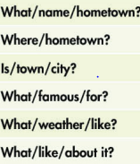


PRACTICE MAKES PERFECT.

