Period
LESSON PLAN
TIẾNG ANH 10 FRIENDS GLOBAL
UNIT INTRODUCTION
LESSON B: GRAMMAR
CONTRAST: PRESENT SIMPLE AND PRESENT CONTINUOUS
I. OBJECTIVES:
By the end of the lesson, Ss will be able to:
1. Knowledge:
- Get some more knowledge to talk about everyday activities
- Vocabulary: everyday activities
- Grammar: Present tense contrast
2. Ability:
- main skills: reading and speaking
- sub skills: listening
- Use present tense contrast to talk about every activity
- Ask and answer about everyday activities
3. Quality:
- have positive attitude in English language learning so that they can participate enthusiastically in all classroom activities, especially with the topic conducted by the teacher
- know how to talk about everyday activities
II. TEACHER AIDS AND LEARNING MATERIALS:
Lesson plan, PPT slides, student’s book, workbook, notebook, personal computer (if any), projector/TV. Speakers, IWB software.
III. PROCEDURES:
A. Warm-up (5’)
a) Objective: Introduce the new lesson and set the scene for Ss to acquire new language; get students' attention at the beginning of the class by means of enjoyable and short activities as well as to engage them in the steps that followed.
b) Content: Warm-up game
c) Outcomes: Students can gain more confidence and interest in the lesson
d) Competence: communication, guessing
e) Organisation of the activity:

TEACHER’S ACTIVITIES | STUDENT’S ACTIVITIES | CONTENTS
Warm-up (5’) T-Ss- T/ Ss – Ss  - Shows students the picture and asks them: “What are the people doing in the picture?”  - Invites randomly some students  - Shows them some possible answers | - Look at the picture and listens to the teacher’s question  - Give out possible answers  - Take notes the suggested answers on the screen | 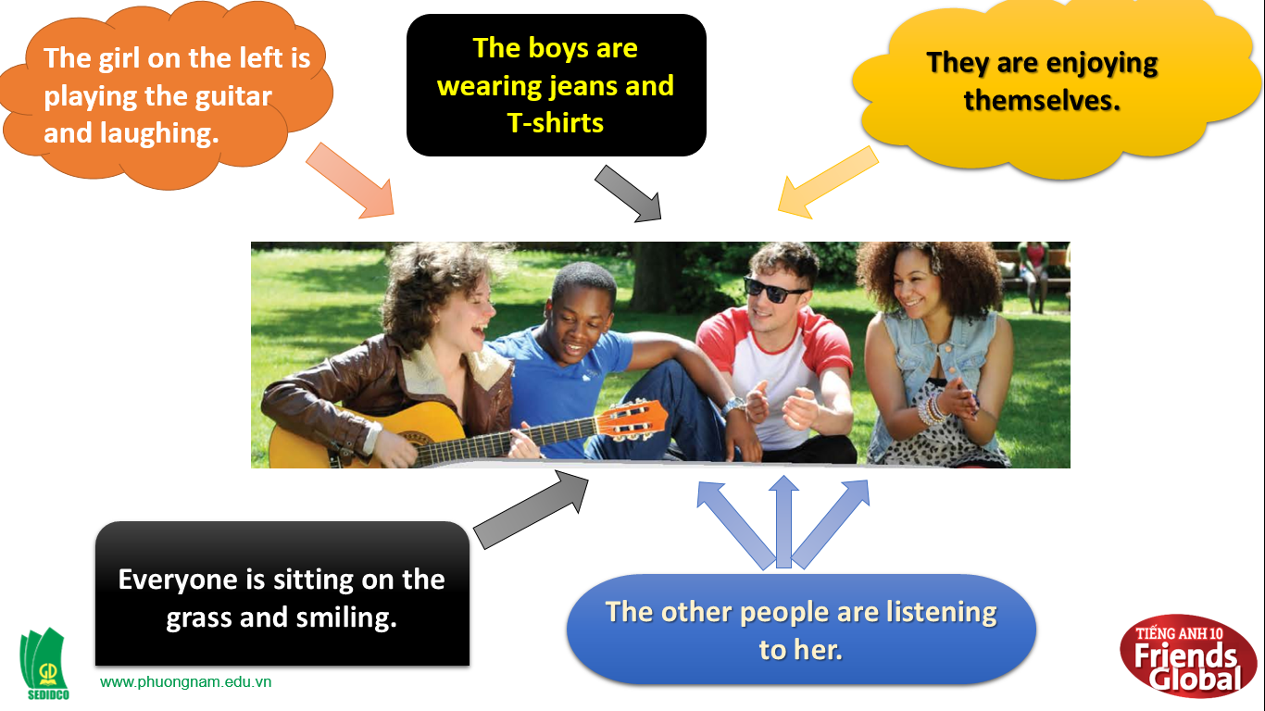

B. New lesson (35’)
- Activity 1: New grammar structures (10’)
a) Objective: Ss know more words about everyday activities
b) Content:
Vocabulary:
Listening
c) Outcomes: Ss know how to pronounce the new words precisely and use them in appropriate contexts.
d) Competence: communication, collaboration, presentation
e) Organisation of the activity:

TEACHER’S ACTIVITIES | STUDENT’S ACTIVITIES | CONTENTS
PRESENTATION. T -Ss- T/ Ss- Ss/ Individual  Activity 2 (3’) Read the messages above. Why does Adam change his mind about going to the park?  - Explain the term “change his mind” first  - Asks students to read and answer the question  - Shows the possible answer  Teaching Grammar point (7’)  - Asks students to look at the two sentences on the board.  - Asks them what the difference of the two sentences  - Shows and explains the structures of the two sentences  - Shows students example for each structure  - After showing slide 5, shows students slide 6  - Use explanation and timeline for present simple and present continuous tenses  - Give them the usages of these two tenses  - Asks them some concept questions to check if they understand | - Listens to teacher’s explanation about new term  - Read and answer the question  - Check the answers with the teacher  - Look at two sentences on the board  - Answer the questions of the teacher  - Listens to explanations of the teacher and take note if needed  - Look at the example that the teacher shows and take note if needed  - Listen to the teacher’s explanation and write it down  - Answer teacher’s concept questions | Suggested answers:  Because he loves volleyball  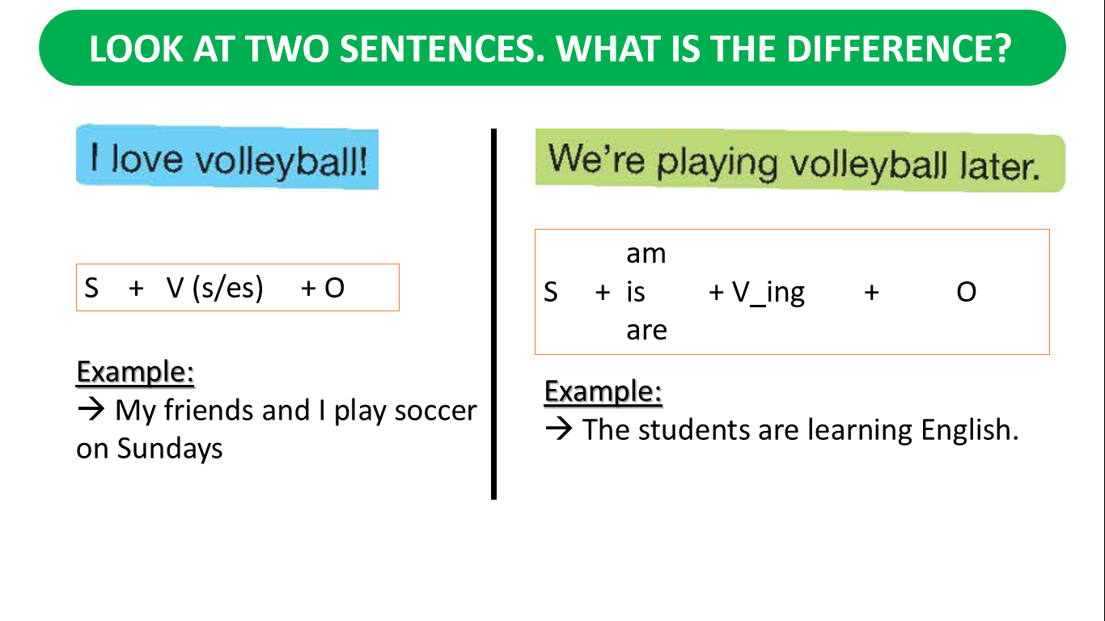  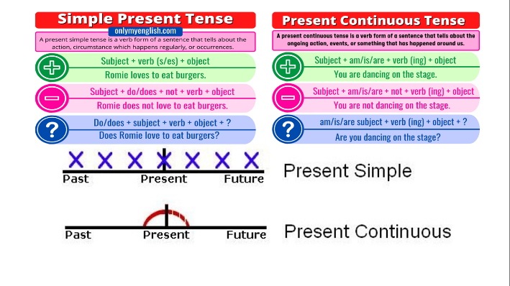
- Activity 2 Practice (19’)
a) Objective: Ss can answer the questions to critical thinking, and they can also finish the tasks in the textbook. Critical thinking skills (guessing/ reasoning) and communication can also be practiced.
b) Content: Students answer questions, classify words, choose the correct answer, read and complete, listen and match.
c) Outcomes: Ss read and listen, and they can apply the useful language in everyday listening and speaking.
d) Competence: collaboration, guessing, matching, communication
e) Organisation of the activity:
TEACHER’S ACTIVITIES | STUDENT’S ACTIVITIES | CONTENTS
PRACTICE. T-Ss- T/ S – S/ Indiv.  Activity 3 (4’) Find examples of the present simple and present continuous in the messages in exercise 2. Then read the Learn this! box and complete the rules.  - Asks students to do the activity 3  - Asks students to work in pairs  - Shows correct answers  Learn Box (2’)  - Asks students to read the LEARN THIS! box and complete the rules  - Have the students to work in pairs  - Shows them the correct answers  Activity 4 (5’) Match each example you found in the messages with the correct rule (a-f) in the Learn this! box.  - Asks students to work in groups  - Goes around to help if needed  - Checks answers as a class  Activity 5 (5’) Work in pairs. Explain the difference between sentences a and b in each pair.  - Asks students to work in pairs  - Check students’ answers.  Activity 6 (3’) Complete the phone dialogue. Use the correct present simple or present continuous form of the verbs in brackets. Then listen and check.  - Asks students to read the conversation before they complete it.  - Checks answers as a class | - Do the task  - Work in pairs  - Check answer with teacher.  - Read the LEARN THIS! box and complete the rules  - Work in pairs  - Work in pairs  - Asks teachers for help  - Check the answers with the teacher.  - Work in pairs  - Check the answers with teacher  - Read the conversation before completing it  - Use only present simple or present continuous form of the verbs  - Check answers with the teacher | Suggested answers:  Present simple examples:  I’m in the park with some friends.  Do you want to join us?  Is she good?  She’s OK.  She has guitar lessons every week.  I don’t know.  I need to help my parents.  I love volleyball.  A game of volleyball doesn’t take long.  Present continuous examples:  What are you doing?  We’re listening to Sue.  She’s playing the guitar.  She’s getting better.  We’re moving house next weekend.  We’re packing boxes today.  Answers of Learn box!  b. present continuous  c. present continuous  d. present simple  e. present simple  f. present continuous  Answers  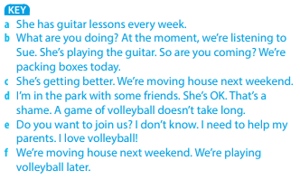  Possible answers:  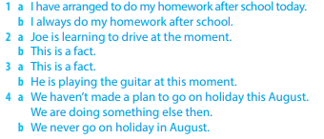  Answers:  - ‘m waiting  - Are you going  - are playing  - play  - is he doing  - don’t know  - isn’t answering  - ‘m not buying  - ‘m / looking  - Do you like  - Do you want  - ‘m not wearing  - Are you wearing  - don’t need

- Activity 3: Outcomes (6’)
a) Objective: Ss can answer the question to describe their daily activities or their future arrangements. Communication is also be practiced.
b) Content: Students work in pairs, speak and discuss
c) Outcomes: Ss speak and listen mutually, they can new words they have learnt in their conversation.
d) Competence: Collaboration, communication
e) Organisation of the activity:
TEACHER’S ACTIVITIES | STUDENT’S ACTIVITIES | CONTENTS
PRODUCT. S – S/ T – Ss  SPEAKING (5’) Work in pairs. Ask and answer questions 1-4.  - Asks students which tense that the question uses.  - Shows students answer of the question about tense  - Show students example of the answer | - Work in pairs, take turn to ask and answer.  - Some can volunteer to present their ideas. | Questions:  1. What do you usually do at the weekend?  2. What are you doing this weekend?  3. What do you usually do during the school holidays?  4. What are you doing next school holiday?
C. Consolidation (3’)
a) Grammar points: Present tense contrast (present simple, and present continuous)
b) Talking about everyday activities
D. Homework (2’)
- Practice using present simple and present continuous tenses
- Practice asking and answering about everyday activities
- Do exercise in the workbook
- Prepare: Unit 0: Introduction – C-Vocabulary (page 7 – SB)

