PHÒNG GD&ĐT YÊN THÀNH | KỲ THI KSCL HỌC SINH GIỎI CẤP HUYỆN  NĂM HỌC 2020 - 2021  MÔN THI: TIẾNG ANH 8  Thời gian: 120 phút
  ĐỀ CHÍNH THỨC

Họ và tên thí sinh: …………………………………….……………
Ngày sinh: …………………..……………………….…….
Học sinh trường: …………………………………….………........
Số báo danh: ……………………………….…………….………..…
Phòng thi: …………………...………………….……..……

Họ tên, chữ ký giám thị số 1: | SỐ PHÁCH  ……………………………...
Họ tên, chữ ký giám thị số 2: | SỐ PHÁCH  ……………………………...

CHỈ DẪN:
- Bài thi gồm 11 trang. Thí sinh đọc kỹ yêu cầu làm bài.
- Thí sinh làm bài trực tiếp lên đề thi.
- Thí sinh giữ gìn cẩn thận bài thi.
- Thí sinh chỉ được dùng một màu mực, xanh hoặc đen để làm bài.
- Khi viết sai, dùng thước gạch. Không dùng bút tẩy trắng.
- Thí sinh không được sử dụng bất kỳ tài liệu nào, kể cả từ điển.
- Thí sinh làm trái với chỉ dẫn, qui chế thi, bài thi sẽ bị loại.

PHÒNG GD&ĐT YÊN THÀNH | KỲ THI KSCL HỌC SINH GIỎI CẤP HUYỆN  NĂM HỌC 2020 - 2021  MÔN THI: TIẾNG ANH 8  Thời gian: 120 phút
  ĐỀ CHÍNH THỨC

ĐIỂM | HỌ TÊN, CHỮ KÍ GIÁM KHẢO | SỐ PHÁCH
Bằng số: ..............................  Bằng chữ. ........................... | 1 ...........................................................  2.............................................................
SECTION A. LANGUAGE USE
Part 1. Choose the best word or phrase to complete the following sentences. Write A, B, C or D on your answer sheet.
1. Of the two geologists, one is experienced and______________.
A. the other are not B. the other is not
C. other lacks experience D. another is inexperienced
2. Mai as well as her friends ___________________ in the field at this time last Sunday.
A. was working | B. were working | C. has worked | D. have worked
3. _______ Paul brings the money for lunch, we’ll go right down to the cafeteria.
A. Since B. As soon as C. Now that D. Until
4. Susan: “This is your first trip abroad, isn’t it?” - Peter: “________”
A. No, I haven’t been there before. B. No, it’s expensive.
C. Yes, it sounds great. D. Yes, so I’m looking forward to it.
5. The more important an exam is, ________.
A. the more you’ll get nervous B. the more nervous will you get
C. the most nervous you’ll be D. the more nervous you’ll get
6. I don’t remember ______ of your decision to change our vocation plan. Nobody told me.
A. to be told B. being told C. telling D. to tell
7. Only when you grow up ______ the truth.
A. will you know B. you will know C. do you know D. you know
8. This is ______ the most difficult job I’ve ever had to do.
A. by chance B. by far C. by heart D. by myself
9. Choose the best option A, B, C or D to indicate the phrase that is CLOSEST in meaning to the underlined part in the following sentence.
- The match has been put off until tomorrow because of bad weather.
A. postponed B. cancelled C. stopped D. continued
10. Choose the best option A, B, C or D to indicate the phrase that is OPPOSITE in meaning to the underlined part in the following sentence
- I lost contact with my family and friends since I lost my mobile phone.
A. look up to B. run out of
C. kept in touch with D. come up with
Your answer:
1. | 2. | 3. | 4. | 5. | 6. | 7. | 8. | 9. | 10.
Part 2. Find and correct one mistake in each sentence below.
1. The telephone rang several times and then stop before I could answer it.
2. The book writing by Jack London is very popular in the world.
3. The trousers are too long for me to wear them.
4. When I entered the laboratory, everyone were doing experiments.
5. There was a very interesting news on the radio this morning about the earthquake in Italy.
6. My brother is always forget his keys and that really annoys me.
7. You must clean the kitchen but you haven’t to sweep the floor.
8. Your grandfather and I are delighting that you passed your English exam.
9. We believe that she feels very badly about her mistake.
10. Your plane will leave at 14.00, so you need to be at the airport at 13.30.
Your Answer:
Mistake | Correction | Mistake | Correction
1. …………………  2……………………  3……………………  4……………………  5……………………. | ……………………..  ……………………...  ………………………  ………………………  ………………………. | 6. ……………..……  7…………………….  8…………………….  9…………………….  10……………………. | ……………………..  ……………………...  ………………………  ………………………  ……………………….
SECTION B. READING
Part 1. Read the text and choose the correct word for each space. For each question, circle the letter next to the correct word- A, B, C, or D.
My Life in Books
It was my parents, of course, who taught me to read. I can’t (1)_________my life before reading, without books. When I started reading, a book was mainly pictures. Now (2)______I am older, a book (3)_______only words in most cases. (4)_______I also love art books, (5)________ the pages to look slowly and hungrily at paintings (6)________the walls of galleries and museums around the planet.
I spend hours and hours reading, lost in other words, travelling, dreaming, imagining people and places. Books (7) _______me smells and sounds I may never experience directly, but (8)_______ seem to make my life more interesting.
This love of books is not without (9)___________own problems. For example, when I go to the cinema to watch a film with friends, I don’t get as excited as they (10)__________. I can’t wait to get back home to my books.
1. | A. repeat | B. register | C. remind | D. remember
2. | A. then | B. so | C. that | D. how
3. | A. counts | B. controls | C. keeps | D. contains
4. | A. But | B. Or | C. And | D. Why
5. | A. changing | B. turning | C. putting | D. placing
6. | A. with | B. in | C. from | D. at
7. | A. move | B. carry | C. bring | D. pull
8. | A. who | B. what | C. where | D. which
9. | A. its | B. their | C. the | D. some
10. | A. be | B. do | C. make | D. go
Your answer:
1. | 2. | 3. | 4. | 5. | 6. | 7. | 8. | 9. | 10.
Part 2. There are five texts about people who all want to do a language course at a college in England and eight advertisements for colleges. Decide which college would be the most suitable for each people.
 | 1. Alma doesn’t like cities and wants to live somewhere quiet with an English family. She wants to do a full-time course.
 | 2. Kostas enjoys city life. He wants to do a part-time course and a part-time job as well. He is not interested in going on trips or doing activities with the college after his classes. He want to rent his own flat.
 | 3. Margarita would like to live in a hostel with other students. She wants to do a full-time course. She likes to play sport in her free time.
4. Tomek is looking for a full-time four-week course at a college which organises social activities for students. He doesn’t mind living in the city or the country but he wants to stay with a family.
5. Hiroki wants to do a part-time course at a college which can arrange his accommodation. He loves walking so he wants to be near the countryside. He doesn’t enjoy organised trips and activities.
A. Langdale College is on the edge of a small town surrounded by hills, twenty kilometres from the city. It offers English lessons in the mornings with activities, sports and trips to other towns and places of interest in the afternoons and at weekends. Courses last six or twelve weeks. All students live with local families. |  |  | E. The Milburn Academy is in the city centre. It offers full-time twelve - week courses. Students are also expected to join in the social and sports events organised for evenings and weekends. The college owns several large houses nearby where students live and prepare their own meals.
B. Anderson College is in the centre of the city. Students can choose from a range of part-time courses – either mornings only, afternoons only or three mornings / afternoons and two evenings. The college has sports facilities, a drama centre, library and a club which students can use if they wish. The college does not arrange accommodation. |  |  | F. The Waterside College is a large city college which has part-time English courses all year round. All students live in college hostels in different parts of the city. The college has its own sports hall and swimming pool and at weekends there are trips to other cities.
C. The Park School is ten kilometres from the city. It is surrounded by wood and there are lots of footpaths through attractive countryside. All students live in a hostel next to the school. There are classes in the mornings and the rest of the time students are free for private study. |  |  | G. The Marlowe School offers two-week and four-week courses all year, full-time. It is situated in a quiet part of the city but there are buses both into the centre and to the nearby countryside. Students stay with local families if they wish. Every evening during the week there is a social event for students and there are trips at weekends.
D. Highcliff College is in the city near the university. It runs four-week and eight-week full-time courses. Students live with families. They spend evenings and weekends with their families learning about English family life and practising their English. |  |  | H. The Beechwood Academy is in a village about 15 km from the city. It offers full-time courses. Students live with families in the village and are enouraged to join in family life as much as possible. The village has a leisure centre.
Your answer:
1. | 2. | 3. | 4. | 5.
Part 3. Read the text and decide if each sentence is TRUE or FALSE. If it is true, write T. If it is false, write F.
Reach Out! Camps
Reach Out! is an organization that runs week-long summer camps, designed to give young people the skills to be the leaders of the future. The camps help to create confident young people who wish to improve not only themselves, but the world around them. Varying in age from 12 to 17, young people come to attend the camps in Canada and the USA from across the world. They spend their time learning leadership skills, considering and discussing important issues such as pollution and health, and helping in the local community. They also meet many other young people who have the same interests and beliefs and they frequently make friendships that will last a lifetime.
There is no average day at the camp and changes are made to the timetable, which is handed out daily, to allow room for exciting events as they come up. However, camp members generally get up at 7.30 a.m. and once they’ve eaten breakfast, start their day with some outdoor games to get them warmed up for the busy day ahead. There are classroom workshops in the morning on skills such as public speaking, then there’s an hour for lunch at noon. From 1-2 p.m., camp members have the opportunity to select from various activities. In recent years these have included dancing, song writing, yoga and basketball.
During the members’ time at camp, there is a day known as Action Day. This is when small groups go out with an adult group leader to work with organization in the neighborhood. Reach Out! arranges the day several weeks before the actual event and matches the interests and skills of the camp members with the organisations needing their help. This can involve organisations dealing with healthcare, housing, journalism or the environment, to name just a few.
Evenings are spent watching documentary films or listening to guest speakers. One of the speakers this year will be Helen Yates, who has worked on social projects around the world and who writes and sings her own songs about the social issues she is most concerned about. Helen has shared the stage with many of the world’s political and religious leaders and has many interesting stories to tell young audiences about them. Helen’s goal is to encourage the young people she meets to go out and make the world a better place.
1. Each Reach Out! summer camp lasts for over a week.
2. Reach Out! camps are held in several countries around the world.
3. Camp members are encouraged to explore environmental and social topics.
4. The timetable is given to the camp members in advance of their stay.
5. Camp members do some activities in the fresh air immediately after breakfast.
6. Lessons how to talk in front of a large audience are offered at the camp.
7. After lunch there is a choice of things for camp members to do.
8. On Action Day, camp members get the chance to visit local organisations on their own.
9. At this year’s camp, Helen Yates will play songs by musicians from different countries.
10. Helen Yates has lots of interesting information about famous world leaders to share..
Your answer:
1. | 2. | 3. | 4. | 5. | 6. | 7. | 8. | 9. | 10.
Part 4. Read the text and think of the word which best fits each space. Use only ONE word in each space.
Many actors do not like working with children or animals. This is probably (1)_______they are afraid that the audience may become (2)______interested in the children and animals than in them.
Actors can have problems of a different kind when they (3)________required to eat or drink on stage. If they have (4)_______much food in their mouths, the words they say may not be clear, and they may even end up coughing and choking.
Other problems can occur with food (5) ________films are being made. In a recent film, during which a family was waiting to have a meal, one of the actors entered with a large roast chicken on a tray and then (6)____________to begin to cut some meat from it while he has speaking. By mistake, the actor cut off a whole leg of the chicken and then completely forgot (7)____his next words were. It was necessary to film the scene (8)_______ This would not really have mattered (8)_______there had been another roast chicken in the studio, but there was not. At first, nobody knew what to do, but eventually the problem was solved (10) ____putting a nail in the leg and attaching it back onto the chicken.
Your answer:
1 | 2 | 3 | 4 | 5
6 | 7 | 8 | 9 | 10
Part 5. Read the following passage and answer the questions by choosing the best answer among A, B, C or D.
Over the past 600 years, English has grown from a language of few speakers to become the dominant language of international communication. English as we know it today emerged around 1350, after having incorporated many elements of French that were introduced following the Norman invasion of 1066. Until the 1600s, English was, for the most part, spoken only in England and had not extended even as far as Wales, Scotland, or Ireland. However, during the course of the next two centuries, English began to spread around the globe as a result of exploration, trade (including slave trade), colonization, and missionary work. That small enslaves of English speakers became established and grew in various parts of the world. As these communities proliferated, English gradually became the primary language of international business, banking, and diplomacy.
Currently, more than 80 percent of the information stored on computer systems worldwide is in English. Two thirds of the world’s science writing is in English, and English is the main language of technology, advertising, media, international airports, and air traffic controllers. Today there are 700 million English users in the world, and over half of these are nonnative speakers, constituting the largest number of nonnative users of any language in the world.
1. What is the main topic of the passage?
A. The number of nonnative users of English.
B. The French influence on the English language.
C. The expansion of English as an international language.
D. The use of English for science and technology.
2. English began to be used beyond England approximately.............................
A. in 1066 B. around 1350 C. before 1600 D. after 1600
3. According to the passage, all of the following contributed to the spread of English around the world EXCEPT .....................................
A. the slave trade B. the Norman invasion C. missionaries. D. colonization
4. Which of the following statements is NOT true?
A. Most of the information stored on computer systems is in English.
B. Only one thirds of the world’s science writing is in languages other than English.
C. English is the only language used in technology, and advertising.
D. International airports and air controllers use mostly English.
5. According to the passage, approximately how many nonnative users of English are there in the world today?
A. A quarter million B. Half a million C. 350 million D. 700 million.
Your answer:
1. | 2. | 3. | 4. | 5.
SECTION C. WRITING
Part 1. Finish each of the following sentences in such a way that it means the same.
1. Unless he phones immediately he won’t get any information.
If ___________________________________________________________
2. “ Would you like to go to the market with me, Mai? ”- Mr. Ha said
Mr. Ha invited ________________________________________________
3. I would prefer you to deliver the sofa on Friday.
I would rather__________________________________________________
4. This city had old buildings, but none can be found nowadays.
There used_____________________________________________________
5. Tuan and his brothers don’t like football.
Neither Tuan nor ________________________________________________
Part 2. This is part of a letter you receive from an English Friend, Peter.
I’ve just finished reading a really good book. What kinds of thing do you enjoy reading? Do you prefer books or magazines? Tell me something about a famous writer from your country.
Now write a letter (80-100 words) answering your friend’s questions. Use your name as Nam.
………………………………………………………………………………………………………………………………………………………………………………………………………………………………………………………………………………………………………………………………………………………………………………………………………………………………………………………………………………………………………………………………………………………………………………………………………………………………………………………………………………………………………………………………………………………………………………………………………………………………………………………………………………………………………………………………………………………………………………………………………………………………………………………………………………………………………………………………………………………………………………………………………………………………………………………………………………………………………………………………………………………………………………………………………………………………………………………………………………………………………………………………………………………………………………………………………………………………………………………………………………………………………………………………………………………………………………………………………………………………………………………………………………………………………………………………………………………………………………………………………………………………………………………………………………………………………………………………………………………………………………………………………………………………………………………………………………………………………………………………………………………………………………………………………………………………………………………………………………………………………………………………………………………………………………………………………………………………………………………………………………………………………………………………………………………………………………………………………………………………………………………………………………………………………………………………………………………………………………………………………………………………………………………………………………………………………………………………………………………………………………………………………………………………………………………………………………………………………………………………………………………………………………………………………………………………………………………………………………………………………………………………………………………………………………………………………………………………………………………………………………………………………………………………………………………………………………………………………………………………………………………………………………………………………………………………………………………………………………………………………………………………………………………………………………………………………………………………………………………………………………………………………………………………………………………………
Part 3. Your English teacher has asked you to write a story. Your story must begin with the sentence: The bus was so late so I decided to walk……
Write your story in about 100-120 words.
…………………………………………………………………………………………………………………………………………………………………………………………………………………………………………………………………………………………………………………………………………………………………………………………………………………………………………………………………………………………………………………………………………………………………………………………………………………………………………………………………………………………………………………………………………………………………………………………………………………………………………………………………………………………………………………………………………………………………………………………………………………………………………………………………………………………………………………………………………………………………………………………………………………………………………………………………………………………………………………………………………………………………………………………………………………………………………………………………………………………………………………………………………………………………………………………………………………………………………………………………………………………………………………………………………………………………………………………………………………………………………………………………………………………………………………………………………………………………………………………………………………………………………………………………………………………………………………………………………………………………………………………………………………………………………………………………………………………………………………………………………………………………………………………………………………………………………………………………………………………………………………………………………………………………………………………………………………………………………………………………………………………………………………………………………………………………………………………………………………………………………………………………………………………………………………………………………………………………………………………………………………………………………………………………………………………………………………………………………………………………………………………………………………………………………………………………………………………………………………………………………………………………………………………………………………………………………………………………………………………………………………………………………………………………………………………………………………………………………………………………………………………………………………………………………………………………………………………………………………………………………………………………………………………………………………………………………………………………………………………………………………………………………………………………………………………………………………………………………………………………………………………………………………………………………………………………………………………………………………………………………………………………………………………………………………………………………
………………………………………………………………………………………………………………………………………………………………………………………………………………………………………………………………………………………………………………………………………………………………………………………………………………………………………………………………………………………………………………………………………………………………………………………………………………………………………………………………………………………………………………………………………………………………………………………………………………………………………………………………………………………………………………………………………………………………………………………………………………………………………………………………

SECTION D. LISTENING
Part 1. There are seven questions in this part. For each question, choose the correct answer (A, B, or C)
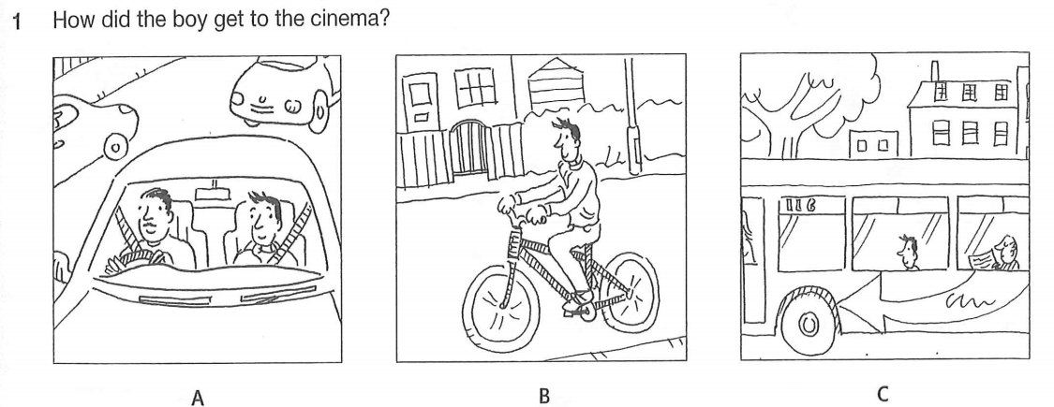
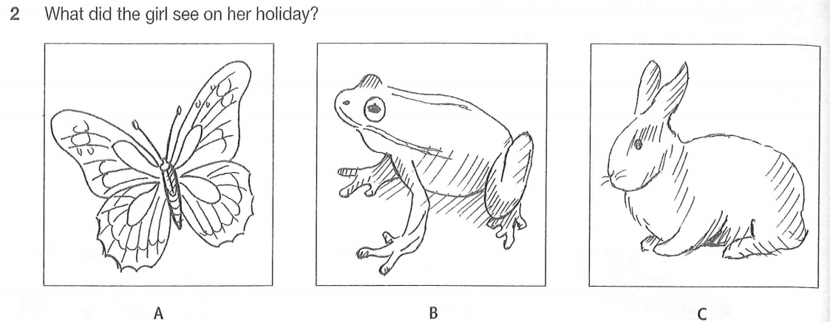
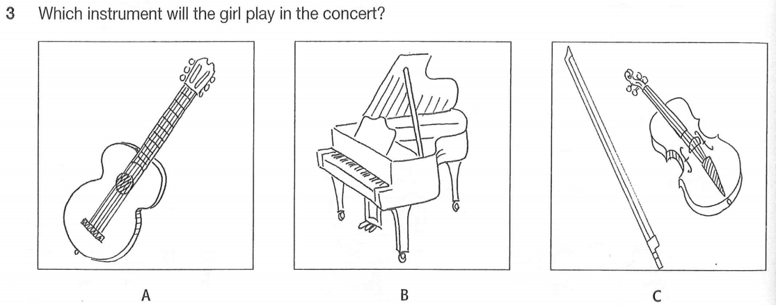
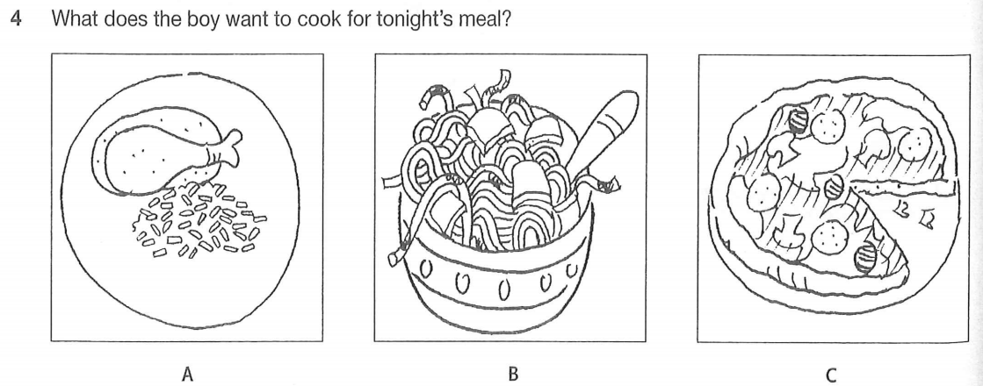
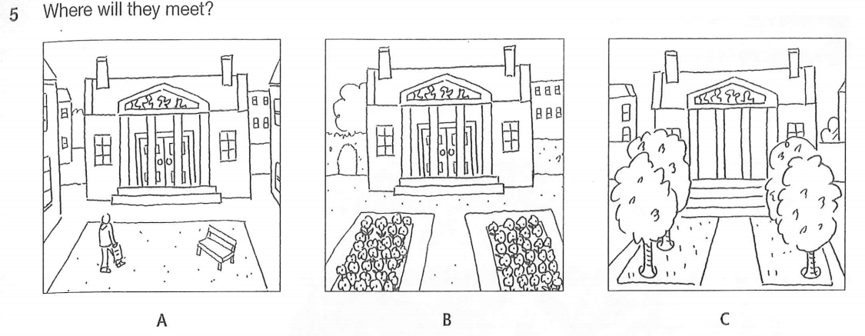
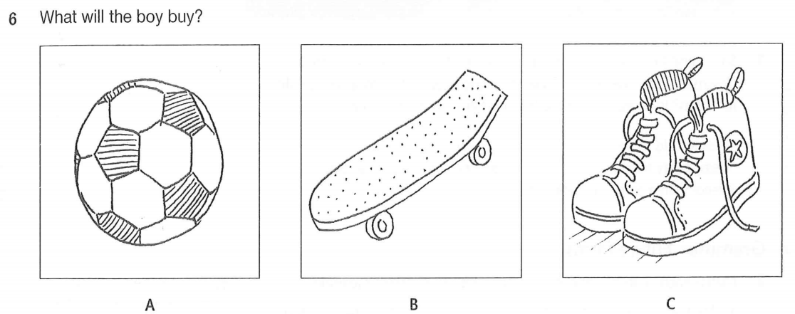
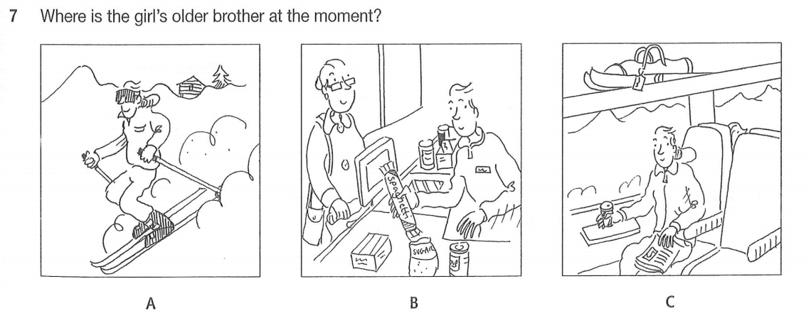
Your answer:
1. | 2 | 3 | 4 | 5 | 6 | 7
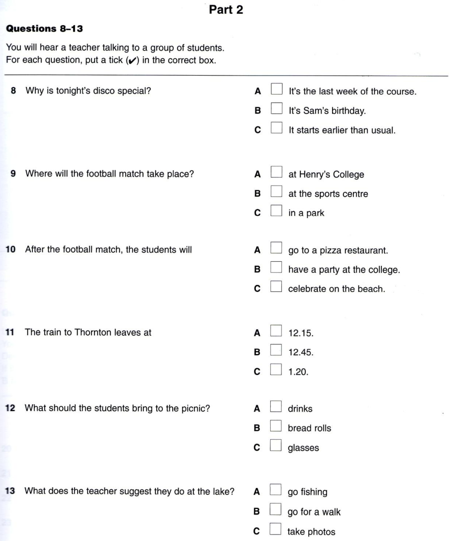
Your answer:
8. | 9. | 10. | 11. | 12. | 13

Part 3. You will hear a conversation between a boy, Sandy, and a girl, Megan, about their jobs. Decide if each sentence is correct or incorrect.
If it is correct, write “A” for YES. If it is not correct, write “B” for NO.
Your answer

14. Megan thinks her new job is perfect.
15. Megan takes photographs of models.
16. Megan agrees that bookshops are depressing.
17. Sandy is looking for a job in a different bookshop.
18. Sandy has studied photography.
19 Megan agrees to ask about a job for Sandy at the magazine.
Part 4. Listen to a man talking about land pollution. Fill in the gaps with the missing words.
Definition
- degradation or (20)…………………of earth’s surface and soil.
- caused by (21) ……………………..
Effects  - lack land for inhabitants because  (22)……………………..keep rising.  - develop serious illnesses like  (23) ……………… | Solutions  - reduce the need for sending waste to landfills by (24)…………………..  - reduce the use of harmful agricultural chemicals thanks to (25)………………… food and farming
Your answer:
20. | 21. | 22.
23. | 24. | 25.

THE END./.

KỲ THI KSCL HỌC SINH GIỎI CẤP HUYỆN
NĂM HỌC 2020 - 2021
MÔN THI: TIẾNG ANH 8
ANSWER KEY AND MARKING SCALE
SECTION A. LANGUAGE USE (10P)
Part 1. (0.5x10=5p)
1 | 2 | 3 | 4 | 5 | 6 | 7 | 8 | 9 | 10
B | A | B | D | D | B | A | A | A | C

Part 2. (0.5x10=5p)
MISTAKE | CORRECTION | MISTAKE | CORRECTION
1. stop | stopped | 6. forget | forgetting
2. writing | written | 7. haven’t | don’t have
3. them | Omitted/ x | 8. delighting | delighted
4. were | was | 9. badly | bad
5. a | Omitted/ x | 10. will leave | leaves

SECTION B. READING (40P)
Part 1. (1x10=10p)PET PRACTICE TEST PLUS 3/ TEST 6
1 | 2 | 3 | 4 | 5 | 6 | 7 | 8 | 9 | 10
D | C | D | C | B | C | C | D | A | B

Part 2. (1x5=5p) EXAM FOLDER 13 PET OBJECTIVE
1 | 2 | 3 | 4 | 5
H | B | E | G | C

Part 3. (1x10=10p)
1 | 2 | 3 | 4 | 5 | 6 | 7 | 8 | 9 | 10
B | B | A | B | A | A | A | B | B | A

Part 4 (1x10=10p)
1 | because | 6 | had/needed
2 | more | 7 | what
3 | are | 8 | again
4 | too | 9 | if
5 | When/while/as | 10 | by

Part 5. (1x5=5p)
1 | 2 | 3 | 4 | 5
C | D | B | C | C

SECTION C. WRIRING
Part 1. (1 x 5 = 5 p)
1. If he phones immediately, he will get information./ if he doesn’t phone immediately, he won’t get any information.
2. Mr. Ha invited Mai to go to the market with him.
3. I would rather you didn’t deliver the sofa on Friday.
4. There used to be old buildings in this city.
5. Neither Tuan nor his brothers likes football.
Part 2. 10 points
+ Organization and style: Informal, ideas are organized and presented with coherence, style and clarity (that are) appropriate to the level of English gifted lower-secondary students: 1 points
+ Length: 80-100 words: 1 points
+ Ideas: Covering all necessary information: 5 points
+ Grammar and vocabulary: a variety of vocabulary and structures are appropriate to the level of English gifted lower-secondary students: 3 points.
Part 3. (10 points)
+ Organization and style: Informal, ideas are organized and presented with coherence, style and clarity ( that are) appropriate to the level of English gifted lower-secondary students: 2 points
+ Length: 100-120 words: 1 point
+ Ideas: Covering all necessary information with an interesting ending: 4 points
+ Grammar and vocabulary: a variety of vocabulary and structures are appropriate to the level of English gifted lower-secondary students: 3 points.
SECTION D. LISTENING
Part 1. (1x7=7p) PET TRAINER / TEST 2/ EXAM PRACTICE/ PART 1
1 | 2 | 3 | 4 | 5 | 6 | 7
B | A | C | B | C | C | A

Part 2. (1x6=6p) CAMBRIDGE EXAM EXTRA PET/ TEST 1/ PART 2
8 | 9 | 10 | 11 | 12 | 13
B | C | C | B | A | C

Part 3. (1x7=7p)
14 | 15 | 16 | 17 | 18 | 19
T | F | F | F | T | F

Part 4. (1x6=6p) BIG 4 - 8
20. DESTRUCTION
21. HUMAN ACTIVITIES
22. POPULATION
23. CANCER
24. RECYCLING
25. ORGANIC

TOTAL MARK: 100 POINTS/5 = 20 POINTS
TAPESCRIPT
Part 1.
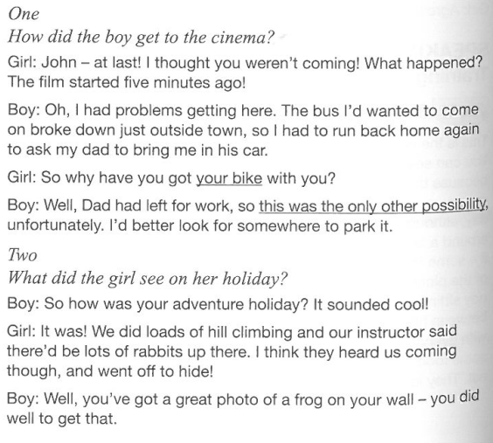
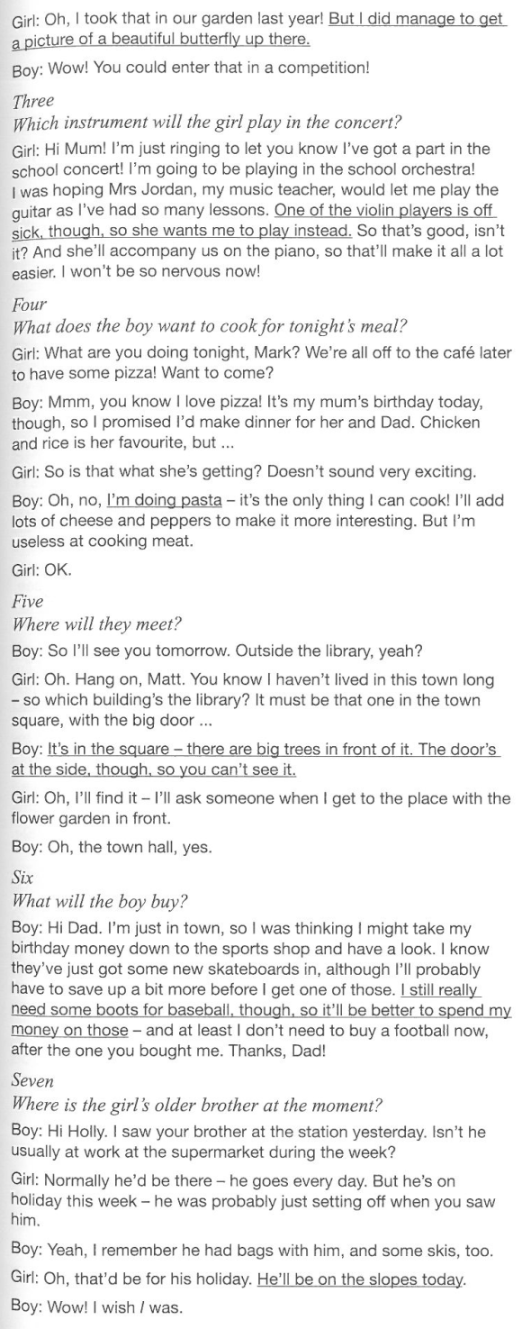
Part 2
