MOCK TEST 3
Mark the letter A, B, C, or D on your answer sheet to indicate the word whose underlined part differs from the other three in pronunciation in each of the following questions.
1. A. adventure B. education C. jurisdiction D. qualification
2. A. allegiance B. aesthetic C. advantage D. banana
Mark the letter A, B, C, or D on your answer sheet to indicate the word that differs from the other three in the position of primary stress in each of the following questions.
3. A. replace B. lifestyle C. campus D. promise
4. A. occupy B. religious C. dependent D. concentric
Mark the letter A, B, C, or D on your answer sheet to indicate the correct answer to each of the following questions.
5. I can’t understand how your father managed to __________ that man. He had deceived all the rest of us.
A. see off B. see through C. see to D. see out
6. An artist does __________ tasks, such as painting or making music.
A. create B. creative C. creation D. creator
7. We __________ each other since we __________ middle school in 2024.
A. haven’t met - left B. meet – left C. met - have left D. haven’t meet – left
8. He didn’t tell me the reason __________ he came late.
A. when B. forwhich C. why D. Both B and C
9. Minh and Jack are doing their homework in a self-study room.
Minh: "Jack, can you give me the textbook?"
Jack: “__________”
Minh: “Can you pass me the textbook next to you?”
A. What? B. I’m coming. C. Never mind. D. Sorry?
10. My mother asked __________ I planned to go climbing in the summer.
A. which B. if C. unless D. what
11. John takes actions __________ in this turn with __________ mistakes than he did in the previous one.
A. more careful/ more B. more careful/ fewer
C. more carefully/ less D. more carefully/ fewer
12. Among its __________ other uses, fresh water is required by humans for drinking and agriculture.
A. many B. more C. less D. each
Read the following announcement and mark the letter A, B, C, or D on your answer sheet to indicate the correct option that best fits each of the numbered blanks from 13 to 16.

COMMUNITY CLEAN-UP DAY
1. Join us for Community Clean-Up Day on Saturday, October 14th, from 9 a.m. to 1 p.m. at Central Park. Supplies will be (13) _________.
2. Bring your friends and family! Everyone is welcome to participate, regardless (14) _________ age or ability.
3. Help improve our neighborhood by picking up litter, planting flowers, and (15) _________ local spaces.
4. Refreshments provided! Enjoy free snacks and drinks for all volunteers. Let’s work together to create (16) _________ cleaner, greener community!

13. A. furnished B. provided C. covered D. delivered
14. A. of B. off C. from D. about
15. A. décor B. decorated C. decorative D. decorating
16. A. the B. an C. a D. ∅
Mark the letter A, B, C, or D on your answer sheet to indicate the correct answer to the questions from 17 to 18.
17. Put the sentences (a-c) in the correct order, then fill in the blank to make a logical text.
I recently took a trip to the enchanting city of Paris, a place that truly has a special spot in my heart. Last summer, I checked out the famous Eiffel Tower and strolled through the delightful streets of Montmartre, soaking in the stunning views and artistic vibe. _________
a. Over the years, I've been lucky enough to visit Paris several times, and each experience has only increased my love for its rich history and lively culture.
b. As I explored its galleries, I realized just how much I’ve learned about art and history since my very first trip.
c. The Louvre Museum, known for its incredible artworks, was definitely a highlight of my visits.
A. b-c-a B. b-a-c C. a-c-b D. c-a-b
18. Choose the sentence that can end the text (in Question 17) most appropriately.
A. Paris is also famous for its cozy cafes, where you can enjoy coffee and pastries.
B. The vibrant street art scene adds a modern touch to the city’s classic charm.
C. Exploring the museums offers a peaceful escape from the city's hustle and bustle.
D. Paris remains a magical destination that has left a lasting impression on my memories.
Mark the letter A, B, C, or D on your answer sheet to indicate the correct answer that best fits each of the numbered blanks.
I’ve had many great moments in class but perhaps the best one took place in my English class about a month ago. I had a (19) ________ presentation and I felt pretty confident. 30 minutes before my presentation, I decided to incorporate an actor for visual appeal, to correspond with my presentation. I felt even more confident, assure that I would (20) ________ and keep the audience engaged.
When my presentation started, I gave a signal to my actor, (21) ________ led me to drop my 8 notecards all over the floor. I was aware that the time was ticking, so I quickly grabbed all the notecards off the floor. I became overwhelmed with embarrassment, listening to the echoing laughter of the audience (22) ________ I tried to rearrange the cards. The cards in my hand then became extremely restraining. My anxiety levels (23) ________, and the disorganized cards just added stress to my emotions. I placed the cards down, and felt a great (24) ________. My words, my explanations, my connections all flowed out my mouth with harmony, and I felt more natural and free as I presented my topic.
19. A. 10-minute B. 10 minutes C. ten-minutes D. ten of minute
20. A. catch the eye B. take notice C. draw attention D. pay attention
21. A. where B. when C. that D. which
22. A. but B. yet C. although D. as
23. A. risen B. rose C. arose D. rise
24. A sense of relief B. state of relief C. state of worry D. feeling of fear
Mark the letter A, B, C or D on your answer sheet to indicate the sentence that is closest in meaning to the original sentence in each of the following questions.
25. Jim: “Why don’t you call a taxi to the ceremony?”
A. Jim hoped that I went to the ceremony by taxi.
B. Jim asked why I didn’t call a taxi to the ceremony.
C. Jim asked for a taxi to the ceremony.
D. Jim suggested that I should call a taxi to the ceremony.
26. John decided to stop playing chess because of his headache.
A. John decided to take up playing chess because of his headache.
B. John decided to give up playing chess because of his headache.
C. John decided to put up with playing chess because of his headache.
D. John decided to cut down on playing chess because of his headache.
Mark the letter A, B, C or D on your answer sheet to indicate the sentence that is best written from the words/phrases given.
27. There/ some/ difference/ vocabulary/ American English/ British English.
A. There are some differences in vocabulary of American English and British English.
B. There are some differences in vocabulary between American English and British English.
C. There are some differences from vocabulary in American English and British English.
D. There are some differences from vocabulary of American English and British English.
28. You/ should/ sleep early,/ eat/ healthy diet/ do/ physical exercise/ regularly.
A. You should sleeps early, eats a healthy diet and does physical exercise regularly.
B. You should sleep early, eat a healthy diet, do physical exercise regularly.
C. You should sleep early, eat a healthy diet and do physical exercise regularly.
D. You should sleep early, eat healthy diet, and do physical exercise regularly.
Read the following sign or notice and mark the letter A, B, C, or D on your answer sheet to indicate the correct answer to each of the following questions.
29. What does the notice say?
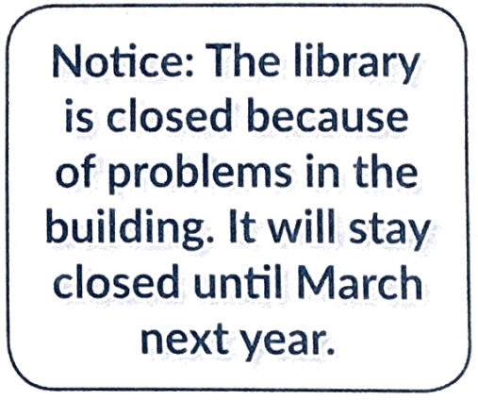 | A. There were problems building the library, so it is not open until next March.  B. The library won’t open until next March due to problems in the building.  C. The library will close next March because of problems in the building.  D. The library is open until next March due to problems in the building
30. What does the sign say?
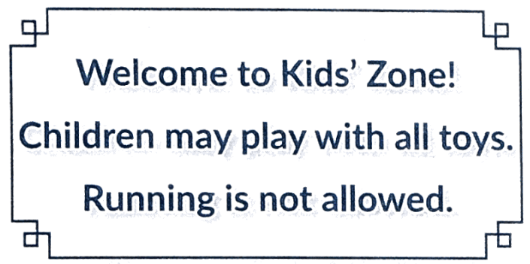 | A. Children can bring all their toys.  B. Children can bring home all the toys.  C. Running in Kid’s Zone is hazardous.  D. Running in Kid’s Zone is forbidden.

Read the following passage and mark the letter A, B, C, or D on your answer sheet to indicate the correct answer to each of the following questions from 31 to 36.
At the World Cities Summit, Resilient Cities Network today released a white paper, titled "Urban Eats: How Cities Leverage Opportunities to Build Resilient Food Systems through Circular Pathways". The report argues that food waste presents an untapped business opportunity that can unlock multiple benefits, such as economic growth and green jobs, improved food security and a healthier planet. Globally, 150 million urban residents are food insecure, while cities generate over 2.8 billion tons of organic waste each year. Only 2% of this waste is captured and recycled to contribute to reduced emissions and increased employment, while also recapturing nutrients for growing food.
“Given that cities will consume 80% of the world's food in 2050 while food insecurity continues to rise, it is clear that action must begin there,” said Lauren Sorkin, Executive Director of the Resilient Cities Network. "By advancing circular practices that both reduce waste and create value from waste, we can unlock multiple resilience benefits, such as reducing carbon footprint of food, improving food distribution, breaking the dependence on non-renewable inputs in food production, generating jobs and boosting food supply efficiency.”
A circular food economy, which builds resilience, would help deliver an adequate food supply to meet global nutritional needs, and support regenerative practices based on reduced waste, recovering nutrients and addressing pollution in the food system.
(Adapted from https://resilientcitiesnetwork.org)
31. What is the main idea of the reading passage?
A. Benefits of a resilient circular food system
B. Benefits of food waste to the economy
C. Actions that people should take to prevent food waste
D. Effects of food waste on the global food consumption
32. According to paragraph 1, which of the following is NOT the benefit of food waste?
A. Encouraging economic development
B. Creating environmentally friendly jobs
C. Causing food insecurity
D. Protecting the Earth
33. How much food waste is not recycled and captured each year?
A. 150 tons B. 2.8 million tons
C. 98% of 2.8 million tons D. 2% of 2.8 million tons
34. What can circular practices do to help the food economy?
A. Increasing carbon footprint for food
B. Reducing waste and creating values
C. Damaging food distribution
D. Using more non-renewable inputs
35. The word "unlock” in paragraph 2 is CLOSEST in meaning to _______.
A. discover B. limit C. open D. strain
36. The word "support” in paragraph 3 is OPPOSITE in meaning to _______.
A. back B. assist C. sustain D. reject
Four phrases/sentences have been removed from the text below. For each question, mark the letter A, B, C, or D to indicate the correct option that best fits each of the numbered blanks from 37 to 40.
Fussy eating in children is largely influenced by genetics rather than parenting, according to recent research. (37) ______. Genetic variation accounted for a significant portion of this behavior, explaining up to 74% of differences in pickiness as children aged. Dr. Zeynep Nas, a behavioural geneticist, emphasizes that food preferences stem from our genetic makeup, though environmental factors also play a role, (38) ______. Analysis of twins revealed that identical twins shared more similar eating habits than non-identical twins, underscoring the genetic link. While genetics is important, parents can still influence their children's diets (39) ______. (40) ______.
A. As children grow, peer influence becomes more significant, but ongoing support from parents can encourage a broader diet throughout childhood and adolescence.
B. by offering a variety of foods, especially during toddler years
C. A study examining eating habits from toddlers to teenagers found that food pickiness remains relatively stable, peaking at age seven.
D. such as family meal dynamics and the foods available at home
37. ___________ 38. ___________ 39. ___________ 40. ___________

