**TIẾNG ANH 9 FRIENDS PLUS**

**BÀI KIỂM TRA ĐỊNH KÌ**

**UNIT 5 – TEST 1 - KEY**

**I. Pronunciation (1-4)**

**Câu 1.** Which word has the underlined part pronounced differently from that of the others?

**A.** m**i**crochip  **\*B.** m**i**asma  **C.** m**i**ce  **D.** m**i**ner

**Câu 2.** Which word has the underlined part pronounced differently from that of the others?

**A.** c**a**psule  **B.** t**a**nner  **\*C.** c**a**pability  **D.** c**a**ncel

**Câu 3.** Which word has a different stress pattern from that of the others?

**A.** adaptable  **\*B.** accidental  **C.** intension  **D.** assistance

**Câu 4.** Which word has a different stress pattern from that of the others?

**\*A.** documentation  **B.** carbohydrate  **C.** invitation  **D.** respiration

**II. Choose the answer (A, B, C or D) that best fits the space in each question. (5-14)**

**Câu 5.** It is ________ to hurt animals for no reason.

**\*A.** cruel  **B.** electric  **C.** extinct  **D.** alternative

**Câu 6.** The astronauts returned to Earth in a small ________.

**A.** gravity  **\*B.** capsule  **C.** radar  **D.** microchip

**Câu 7.** She enjoys ______ in her free time.

**A.** reads  **B.** read  **C.** to read  **\*D.** reading

**Câu 8.** In the science fiction movie, an ________ visited Earth from another planet.

**A.** exploration  **B.** species  **\*C.** alien  **D.** threat

**Câu 9.** They ______ they ______ closer to their family.

**A.** wish / are living  **\*B.** wish / lived  **C.** wish / lives  **D.** wish / live

**Câu 10.** Scientists often ________ with each other to share data and ideas.

**A.** document  **B.** cure  **\*C.** collaborate  **D.** enable

**Câu 11.** “Is she hungry?” – “___________. If so, she’ll tell us.”

**A.** Yes, of course.  **\*B.** I don’t think so.  **C.** Excuse me.  **D.** I’m hungry too.

**Câu 12.** If I ______ rich, I would travel around the world.

**A.** am  **\*B.** were  **C.** was  **D.** will be

**Câu 13.** If water ______ to 100°C, it boils.

**\*A.** heats  **B.** will heat  **C.** heated  **D.** heats up

**Câu 14.** We need an ________ plan in case this one doesn't work.

**\*A.** alternative  **B.** experiment  **C.** capsule  **D.** cure

**III. Look at the signs. Choose the best answer (A, B, C or D). (15-16)**

**Câu 15.** If you arrive at this establishment at 1:30 p.m. on a weekday, what would you expect?

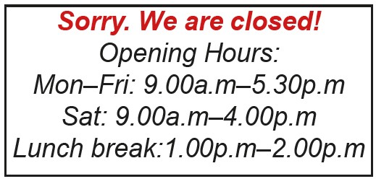

**A.** The place will be closed for the day  **\*B.** You'll find the staff on their lunch break

**C.** You'll have to wait 30 minutes before entering  **D.** You can enter and conduct business as usual

**Câu 16.** What is Ellen primarily seeking from May in this email?

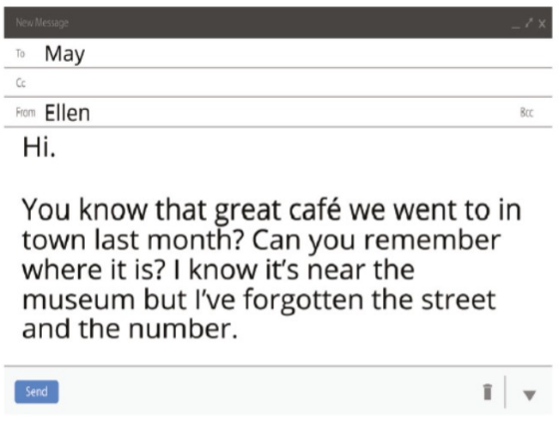

**A.** A recommendation for a new café  **\*B.** Help remembering the café's location

**C.** An invitation to go to the café again  **D.** The museum's opening hours

**IV. Read the following passage and do as direct. (17-22)**

**English is a global language that plays a crucial role in communication around the world. It allows people from different countries to share ideas and information easily. Many international companies employ English as their main language for business. This enables workers to understand each other better and work together more effectively.**

**Learning English can encourage personal growth and open up new opportunities. It can allow you to make friends from other cultures and explore alternative ways of thinking. English is often used in important documentation, such as passports, contracts, and scientific papers. This makes it very useful for travel, work, and study.**

**The internet has made sharing information in English even easier. Many websites, social media platforms, and online courses use English. This enables people to learn and connect with others across great distances.**

**There are many ways to improve your English skills. You can watch movies, read books, or practice speaking with friends. Remember, making mistakes is a normal part of learning. Don't be afraid to try!**

**Câu 17.** English is primarily used for local communication within individual countries.

**\*A.** False  **B.** True

**Câu 18.** Many international companies use English as their main business language.

**A.** False  **\*B.** True

**Câu 19.** Learning English can limit personal growth and opportunities.

**\*A.** False  **B.** True

**Câu 20.** The internet has made sharing information in English more difficult.

**A.** True  **\*B.** False

**Câu 21.** What are some ways to improve your English skills?

**A.** Reading books  **\*B.** All of the above

**C.** Practicing speaking with friends  **D.** Watching movies

**Câu 22.** Why is English useful for travel, work, and study?

**A.** It's the official language of every country

**B.** It's required for all international travel

**C.** It's the only language used in scientific papers

**\*D.** It's used in important documentation like passports and contracts

**V. Choose the word (A, B, C or D) that best fits the blank space in the following passage. (23-28)**

**If we want to ________(23) our environment, we should start making changes today. Many people think that if everyone ________(24) their part, we could make a big difference. For example, if we used ________(25) plastic, there would be less pollution in our oceans. If more people rode bicycles or took public transport, we could reduce air pollution in cities.**

**Some say that if governments invested more in ________(26) energy, we would rely less on fossil fuels. Others believe that if schools taught more about environmental issues, future generations would be better prepared to tackle these problems.**

**________(27) we don't act soon, climate change could have serious consequences. However, if we all work together, we might be able to slow it down. What do you think? If you had the power to make one big change for the environment, what would it be? Remember, even small actions can help. If we all do a little, we ________(28) achieve a lot!**

**Câu 23.** Choose the correct answer.

**A.** destroy  **B.** terminate  **\*C.** protect  **D.** look at

**Câu 24.** Choose the correct answer.

**A.** done  **B.** do  **C.** does  **\*D.** did

**Câu 25.** Choose the correct answer.

**A.** more  **B.** few  **\*C.** less  **D.** much

**Câu 26.** Choose the correct answer.

**A.** non-renewable  **B.** harmful  **C.** limited  **\*D.** renewable

**Câu 27.** Choose the correct answer.

**A.** Unless  **B.** Because  **C.** However  **\*D.** If

**Câu 28.** Choose the correct answer.

**A.** could  **B.** should  **\*C.** can  **D.** would

**VI. Supply the correct form of the word given in each sentence. (29-34)**

**Câu 29.** My brother and I would like to ________ new parks in our city. (discovery)

**Lời giải**

discover

**Câu 30.** Fashion ________ make beautiful clothes for people to wear. (design)

**Lời giải**

designers

**Câu 31.** The little girl talks to her ________ friend during playtime. (imagine)

**Lời giải**

imaginary

**Câu 32.** We can use old boxes ________ to make a fun castle for kids. (create)

**Lời giải**

creatively

**Câu 33.** I need new ________ for my gym class at school. (equip)

**Lời giải**

equipment

**Câu 34.** When people move to a new country, they need time to ________ to the culture. (adaption)

**Lời giải**

adapt

**VII. Rearrange the groups of words in a correct order to make complete sentences. (35-36)**

**Câu 35.** kinds of animals / and plants / Rain forests have / many different / living together.

______________________________________________________

**Lời giải**

Rain forests have many different kinds of animals and plants living together.

**Câu 36.** cold at the top. / the highest mountain in / the world, and it's very / Mount Everest is

______________________________________________________

**Lời giải**

Mount Everest is the highest mountain in the world, and it's very cold at the top.

**VIII. Rewrite each of the following sentences in another way so that it means almost the same as the sentence printed before it. (37-40)**

**Câu 37.** I think you should get involved with this charity project.

If I …

**Lời giải**

If I were you, I would get involved with this charity project.

**Câu 38.** Susan doesn’t have enough time to attend dancing class at the moment.

Susan wishes …

**Lời giải**

Susan wishes she had enough time to attend dancing class at the moment.

**Câu 39.** The astronauts don’t have difficulty working in the weightless conditions.

The astronauts are …

**Lời giải**

The astronauts are used to working in the weightless conditions.

**Câu 40.** Study hard or you will fail the final exam.

If you …

**Lời giải**

If you don't study hard, you will fail the final exam.

**IX. Listening: listen and do as direct. (41-50)**

**Câu 41.** Monica is taking the writing class.

**A.** False  **\*B.** True

**Câu 42.** David has already chosen his English class.

**\*A.** False  **B.** True

**Câu 43.** Monica thinks David should take the beginner class.

**\*A.** False  **B.** True

**Câu 44.** David works part-time.

**A.** False  **\*B.** True

**Câu 45.** Monica can't help David study.

**A.** True  **\*B.** False

***Listen again and match column A to column B:***

| **A** | **B** |
| --- | --- |
| A. David's current English level | 1. not very good |
| B. Class Monica recommends for David | 1. help with studying |
| C. David's concern about taking the advanced class | 1. advanced class |
| D. Monica's offer to David | 1. take the advanced class if he has time |
| E. David's final decision | 1. not having much free time |

**Answers:**

A - 1

B - 3

C - 5

D - 2

E - 4

**----HẾT---**