UNIT 7: TRAFFIC
Lesson 1: Getting started – Meeting in the school yard
I. OBJECTIVES
By the end of this lesson, Ss will be able to gain:
1. Knowledge
- An overview about the topic Traffic
- Vocabulary to talk about means of transport
2. Core competence
- Develop communication skills and cultural awareness
- Be collaborative and supportive in pair work and teamwork
- Actively join in class activities
3. Personal qualities
- Develop awareness of travelling in town/city
- Be concerned to the local traffice

II. MATERIALS
- Grade 7 textbook, Unit 7, Getting started
- Computer connected to the internet
- Projector/ TV/ pictures and cards
- sachmem.vn

Language analysis
Form | Pronunciation | Meaning | Vietnamese equivalent
1. cycle (v) | /ˈsaɪkl/ | to ride a bike/bicycle | đạp xe
2. traffic jam (n.phr.) | /ˈtræfɪk dʒæm/ | a line of vehicles waiting behind something that is blocking the road | tắc đường
3. cross the road (v.phr.) | /krɒs ðə rəʊd/ | pass the road | băng qua đường
4. rush hour (n.phr.) | /ˈrʌʃ aʊə(r)/ | e time, usually twice a day, when the roads are full of traffic and trains are crowded because people are travelling to or from work | giờ cao điểm

Assumptions
Anticipated difficulties | Solutions
- Students may not be able to recognise means of transport and have experience of using them on the road.  - Students may not know how to work in teams. | - Give specific examples and ask questions to activate students’ knowledge.  - Give short, clear instructions and help if necessary.

Board Plan
Date of teaching
Unit 7: TRAFFIC
Lesson 1: Getting started – Meeting in the school yard
* Warm-up: Miming game
I. Vocabulary
- cycle (v) /ˈsaɪkl/: đạp xe
- traffic jam (n.phr.) /ˈtræfɪk dʒæm/: tắc đường
- cross the road (v.phr.) /krɒs ðə rəʊd/: băng qua đường
- rush hour (n.phr.) /ˈrʌʃ aʊə(r)/: giờ cao điểm
II. Practice
Task 1: Read the conversation and choose the correct answer.
Task 3: Write one word from the conversation to complete each sentence.
Task 4: Look at the pictures and write a word under each.
Task 5: Game: Find someone who …
* Homework

III. PROCEDURES
Notes:
In each activity, each step will be represented as following:
* Deliver the task
** Implement the task
*** Discuss
**** Giving comments or feedback

Stage | Stage aim | Procedure | Interaction | Time
Warm-up | - To activate students’ knowledge on the topic of the unit  - To enhance students’ skills of cooperating with team mates | Miming game  * Teacher gives instructions  ** In groups, Ss  - One of the students in the group go to the board.  - Teacher secretly show 1 picture of a mean of transport to that student. He/She has to mime the picture and the other has to guess. Of course the other groups will also be allowed to guess.  - take turns go to the board until finish all the pictures.  **** Teacher checks and corrects if Ss pronounce the words incorrectly. | T-Ss  T-S  S-Ss  T-Ss | 5 mins
Vocabulary - pre-teach | To help students use key language more appropriately before they read and listen | 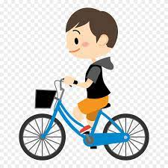  * T asks Ss to look at the photos and answer the question  1. What is he doing?  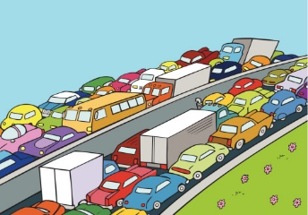  2. What is this?  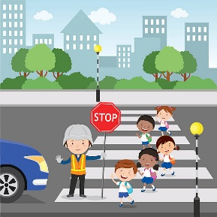  3. What are they doing?    4. Which time of the day usually has traffic jam?  ** Ss say the words.  **** Teacher shows and says the words aloud and asks Ss to repeat them.  * Teacher asks Ss to translate the word into Vietnamese.  Concept check: Slap the board | T-S | 5 mins
Lead-in/ pre-read and listen | - To get students interested in the topic  - To set the context  - To help Ss understand the main idea of the text | Task 1. Exercise 2 (p.74):  * Teacher asks Ss to look at the picture (p.73), answer the question:  + Where are they?  Read the conversation again and choose the correct answer:  1. How does Lan often go to school?  A. By bicycle.  B. By motorbike.  C. On foot.  2. It normally takes Lan ___ to get to school.  A. two minutes  B. ten minutes  C. twenty minutes  3. Lan and Mark agree to go cycling ______.  A. tomorrow  B. every day  C. at the weekend  ** Ss work out and answer questions in pairs.  *** Ss share their answers as a whole class.  **** T asks them to read and listen to the conversation to check their answers. T encourages students to explain where they have found the answers from the conversation. | T-S | 3 mins
Controlled practice | - To practise reading and listening for specific information  - To practise scanning  - To develop Ss' knowledge of vocabulary | Task 2: Exercise 3 (p.74): Write one word from the conversation to complete each sentence.  1. Last Sunday afternoon, Lan ______ round the lake near her home.  2. Mark says to Lan: “You ______ be careful, especially when you cross  the road.  3. Traffic ______ are a problem in big cities.  4. – ______ does your mum go shopping?  – She often walks.  5. This road is very ______ during the rush hours.  * Teacher asks Ss to work individually to read and listen to the conversation and find the words and phrases and then share their answers with their partners who sit next to them. (peer check)  ** Ss do exercise 3 individually  *** Ss share and discuss with their partners to write all words/ phrases down on the notebooks.  **** Teacher corrects their answers as a class.  Answers  1. cycled 2. should 3. jams 4. How 5. crowded | T-S  S-S  T-S | 7 mins
 | - To help Ss deeply understand the text  - To practise reading for details  - To practise scanning and intensive reading | Task 4: Look at the pictures and write a word under each.  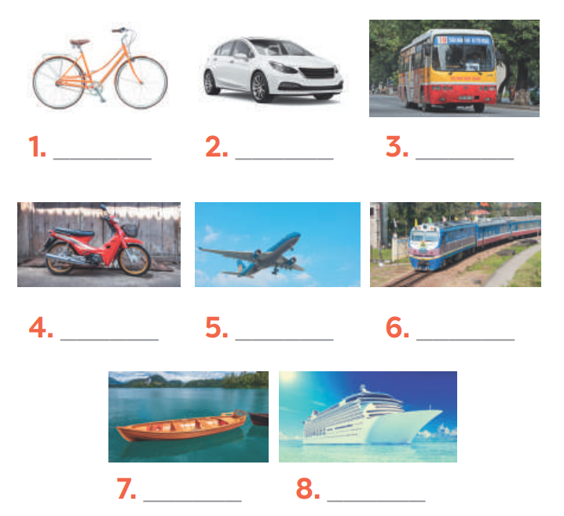  Suggested answers:  1. bicycle 2. car 3. bus 4. motorbike  5. plane/air-plane 6. train 7. boat 8. ship  *** Teacher nominates Ss to read the words aloud and  **** Teacher checks and gives the correct answers. | T-S  S  T-S-S  T-S | 10 mins
Less controlled practice | - To help Ss practising talking about how they go to school  - To practise team working  - To give students authentic practice in using target language | Task 5: Find someone who … Write your friends’ names in the blanks. Then report to the class  * Teacher gives Ss clear instructions in order to make sure Ss can do the survey effectively.  - ask students to look at the survey and think of the needed structures to ask their friends.  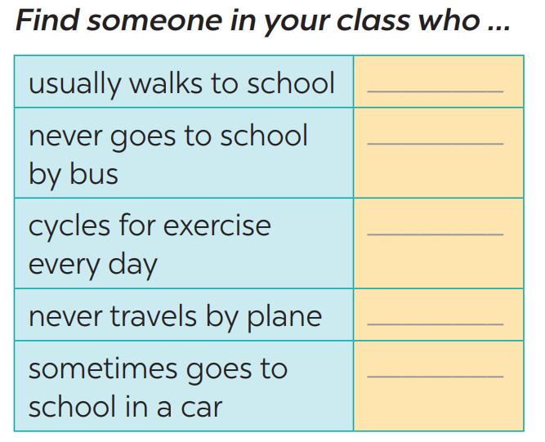  + Students goes around the class and ask at least 20 classmates and ask them (Do you usually walk to school? Have you ever gone to school by bus?…)  - observer Ss while they are role playing, note their language errors  ** Ss do as instructed  **** Teacher gives Ss feedback.  - choose some useful or excellent words/ phrases/ expressions/ word choices Ss have used to suggest other students use them  - choose some typical errors and correct as a whole class without nominating the students’ names | T-S  T  S-S | 10 mins
Wrap up  Homework | To help Ss memorise the target language and skills that they have learned | - Vocabulary of traffic and means of transport.  - Reading for specific information and details  - Scanning  Homework:  - talk about the traffic in your neighbourhood  - Exercises in the workbook | T-Ss

UNIT 7: TRAFFIC
Lesson 2: A closer look 1
I. Objectives
By the end of this lesson, Ss will be able to gain:
1. Knowledge
- Vocabulary about the verbs to use means of transport
- Vocabulary to read the road signs.
- Pronunciation: /aɪ/ and /eɪ/
2. Core competence
- Develop communication skills and cultural awareness
- Be collaborative and supportive in pair work and teamwork
- Actively join in class activities
3. Personal qualities
- Develop awareness of understanding the road signs and obeying the traffic rules.
II. Materials
- Grade 7 textbook, Unit 7, A closer look 1.
- Computer connected to the internet
- Projector/ TV/ small boards, markers.
- sachmem.vn

Language analysis
Form | Pronunciation | Meaning | Vietnamese equivalent
1. road sign (n.phr.) | /ˈrəʊd saɪn/ | a sign near a road giving information or instructions to drivers | biển báo giao thông
2. cycle lane (n.phr.) | /ˈsaɪkl leɪn/ | a part of a road that only bicycles are allowed to use | đường đi riêng cho xe đạp
3. traffic light (n.phr.) | /ˈtræfɪk laɪt/ | a set of lights that controls the traffic on a road. | đèn giao thông

Assumptions
Anticipated difficulties | Solutions
- Students may not be able to recognise the road signs and have experience of using them on the road.  - Students may not know how to work in teams. | - Give specific examples and ask questions to activate students’ knowledge.  - Give short, clear instructions and help if necessary.

Board Plan
Date of teaching
Unit 7: TRAFFIC
Lesson 2: A closer look 1
* Warm-up: Jumbled words
I. Vocabulary
- road sign (n.phr.) /ˈrəʊd saɪn/: biển báo giao thông
- cycle lane (n.phr.) /ˈsaɪkl leɪn/: đường đi riêng cho xe đạp
- traffic light (n.phr.) /ˈtræfɪk laɪt/: đèn giao thông
II. Practice
Task 1: Match the words in A with the phrases in B.
Task 2: Look at these road signs. Then write the correct phrases under the signs.
Task 3: Work in pairs. Take turns to say which of the signs in 2 you see on the way to school.
Task 4: Listen and repeat. Pay attention to the sounds /aɪ/ and /eɪ/.
Task 5: Underline the words with the sound /aɪ/ and circle the words with the sound /eɪ/. Then listen, check and repeat

* Homework

Procedures
Notes
In each activity, each step will be represented as following
* Deliver the task
** Implement the task
*** Discuss
**** Giving comments or feedback

Stage | Stage aim | Procedure | Interaction | Time
Warm-up | - To activate students’ knowledge on the topic of the unit  - To enhance students’ skills of cooperating with team mates | JUMBLED WORDS  * Teacher gives instructions  ** In groups of 5, Ss will be given a small white board and marker.  - Teacher show the jumbled words onto the screen one by one  - Students work in groups to make the correct words and write down onto the small boards. When they finish, they hold it up to show their answers to teacher.  - take turns to write until finish all the words.  Answers:  1- otba -> boat  2- itanr -> train  3- npeilapra -> airplane  4- rsotrpca -> sport car  5- otmiroekb -> motorbike  **** Teacher checks and corrects if Ss write the words incorrectly. | T-Ss  T-S  S-Ss  T-Ss | 5 mins
Vocabulary - pre-teach | To help students use key language more appropriately | * T asks Ss to look at the photos and answer the question  1. What are they?  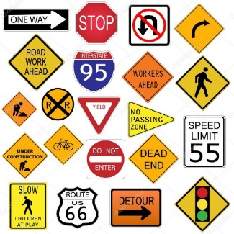  2. What is this?  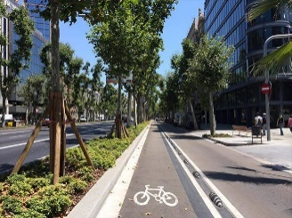  3. What is this?  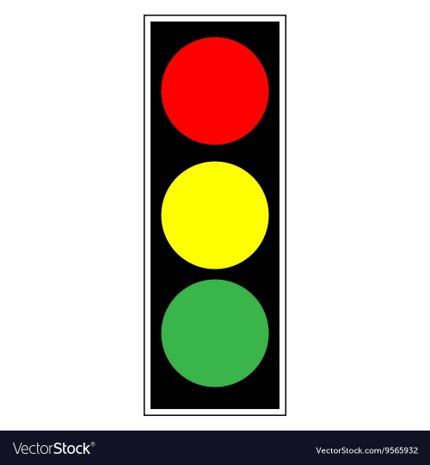  ** Ss say the words.  *** Other Ss correct if the previous answers are incorrect.  **** Teacher shows and says the words aloud and asks Ss to repeat them.  * Teacher asks Ss to translate the word into English  ** Ss says the word | T-S | 5 mins
Lead-in/ pre-read and listen | - To get students interested in the topic  - To set the context  - To help Ss understand the main idea of the text | Task 1. Exercise 2 (p.74): Match the words in A with the phrases in B.  * Teacher asks Ss to look at the table (p.74), identify the form (verbs and nouns – means of transport):  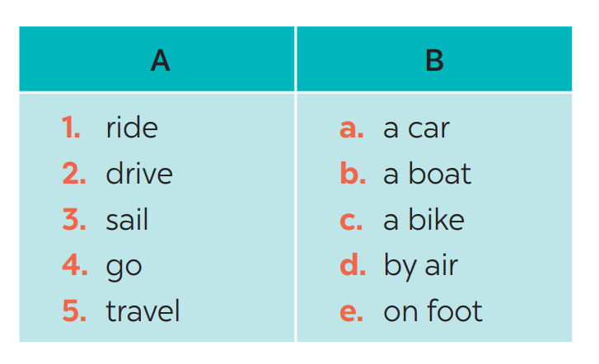  Answers:  1- C 2 – A 3 – B 4 – E 5 – D  ** Ss work out and answer questions in pairs.  *** Ss share their answers as a whole class.  **** T asks them to to check their answers.  * Teacher asks students to make your own sentences with these phrases. Then tell share them to share their sentences with a partner and correct for them. | T-S | 3 mins
Controlled practice | - To practise identifying the meanings of road signs.  - To develop Ss' knowledge of vocabulary | Task 2: Exercise 3 (p.74): Look at these road signs. Then write the correct phrases under the signs.  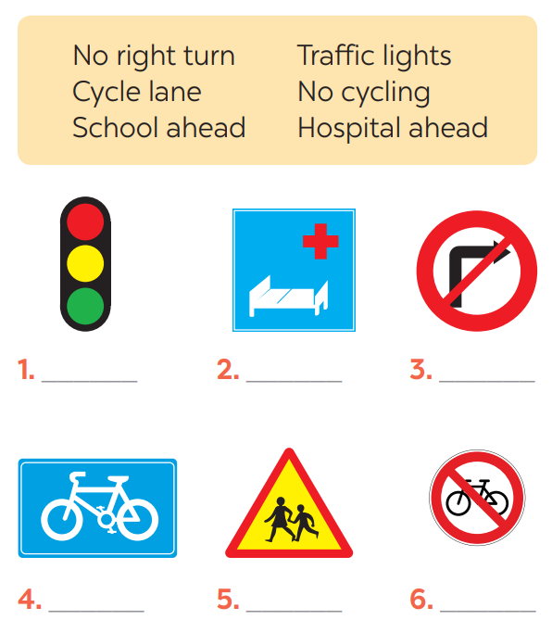  * Teacher asks Ss to look at the road signs and guess their meanings. Then work and share their answers with their partners who sit next to them. (peer check)  ** Ss do exercise 3 in pairs.  *** Ss share and discuss with their partners to write all words/ phrases down on the books.  **** Teacher corrects their answers as a class.  Answers  1. traffic lights 2. Hospital ahead 3. No right turn  4. cycle lane 5. School ahead 6. No cycling | T-S  S-S  T-S | 7 mins
 | - To help Ss deeply understand how to read the road signs  - To practise the targetted language in life context. | Task 3: Work in pairs. Take turns to say which of the signs in 2 you see on the way to school.  * Teacher gives suggestions and asks students to share their sentences.  *** Teacher nominates Ss to say the sentences aloud  **** Teacher checks and gives the corrections if they have mistakes. | T-S  S-S  T-S | 10 mins
Pronunciations | - To help Ss identify the and classify the sounds  - To give students authentic practice in using pronouncing sounds in common words | Task 4: Listen and repeat. Pay attention to the sounds /aɪ/ and /eɪ/.  * Teacher gives Ss time to listen and practice pronouncing the sounds individually and words.  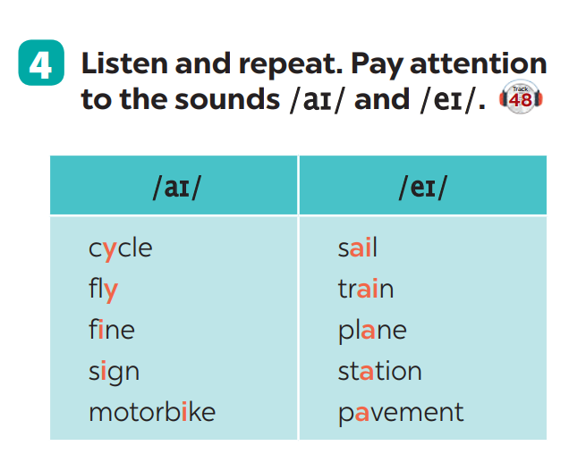  Task 5: Underline the words with the sound /aɪ/ and circle the words with the sound /eɪ/. Then listen, check and repeat  ** Ss do as instructed  **** Teacher gives Ss feedback.  - choose some common mispronounced words that contain the sounds and suggest students practise using them.  - choose some typical errors and correct as a whole class | T-S  T  S-S | 10 mins
Wrap up  Homework | To help Ss memorise the target language and skills that they have learned | - Vocabulary of verbs and road signs  - Pronuciation: : /aɪ/ and /eɪ/  Homework:  - Exercises in the workbook | T-Ss

UNIT 7: TRAFFIC
Lesson 3: A closer look 2
I. Objectives
By the end of this lesson, Ss will be able to gain:
1. Knowledge
Know how to use:
- It to indicate distance
- should and shouldn’t
Structure | Examples
1. It to indicate distance | It is 4 kilometers from my house to school.
2. should | We should eat more vegetables and fruits.
3. shouldn’t | You shouldn’t stay up late everyday.
2. Core competence
- Develop communication skills and cultural awareness
- Be collaborative and supportive in pair work and teamwork
- Actively join in class activities
3. Personal qualities
- Develop awareness of understanding the road signs and obeying the traffic rules.
II. Materials
- Grade 7 textbook, Unit 7, A closer look 2.
- Computer connected to the internet
- Projector/ TV/ pictures.
- sachmem.vn

Assumptions
Anticipated difficulties | Solutions
- Students may not be able to know the distance between different places.  - Students may not know how to work in teams or fully understand the exercises and tasks. | - Give specific examples and facts to activate students’ knowledge.  - Give short, clear instructions and help if necessary.

Board Plan
Date of teaching
Unit 7: TRAFFIC
Lesson 3: A closer look 2
* Warm-up: Slap the board
I. Grammar
- It indicating distance
- Should/shouldn’t
II. Practice
Task 1: Write sentences with It. Use these cues.
Task 2: Work in pairs. Ask and answer questions about distances in your neighbourhood.
Task 3: Choose the correct option in brackets.
Task 4: Complete each sentence, using should / shouldn’t.
Task 5: Look at the pictures. Make sentences, using should /shouldn’t and the cues.

* Homework

Procedures
Notes
In each activity, each step will be represented as following
* Deliver the task
** Implement the task
*** Discuss
**** Giving comments or feedback

Stage | Stage aim | Procedure | Interaction | Time
Warm-up | - To activate students’ knowledge on the topic of the unit  - To enhance students’ skills of cooperating with team mates | SLAP THE BOARD  * Teacher gives instructions and sticks some road signs pictures onto the board.  ** In 2 group, Ss will choose 1 student in each group to go to the board.  - Teacher says a road sign message.  - Student quickly run and slap onto the correct road signs.  - Students take turns until finish all of the signs.  Answers:  1- Cycle lane  2- School ahead  3- No cycling  4- No right turn  5- Schools ahead  **** Teacher checks and corrects if Ss pronounce the signs incorrectly. | T-Ss  T-S  S-Ss  T-Ss | 5 mins
Presentation | To introduce students the form of the key grammar and how to use them appropriately | IT INDICATING DISTANCE  - Teacher says: “This lesson today is going to tell you about “it indicating distance”  * Teacher draws students’ attention to the grammar point and the example  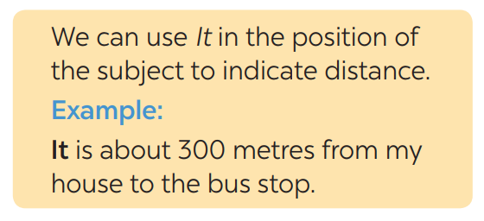  * Teacher asks Ss:  - What does the sentences tell us about?  Answer: Distance from his/her house to the bus stop  - What is the structure using in the sentence?  Answer: It be (about) + distance from A to B.  ** Ss read the grammar explicit and study the example.  *** Ss may discuss within groups/pairs before answering.  **** Teacher shows and says the sentences aloud and asks Ss to make similar sentences. | T-S | 5 mins
Practice/ Controlled practice | - To get students interested in the topic  - To set the context  - To help Ss understand the main idea of the text | Task 1. Ex 1: Write sentences with It. Use these cues.  * Teacher asks Ss to look at the example and the task.  ** Ss work out and answer questions individually.  *** Ss share their answers in pairs.  **** T asks them to to check their answers.  * Then tell share them to share their sentences as a whole in class and correct for them.  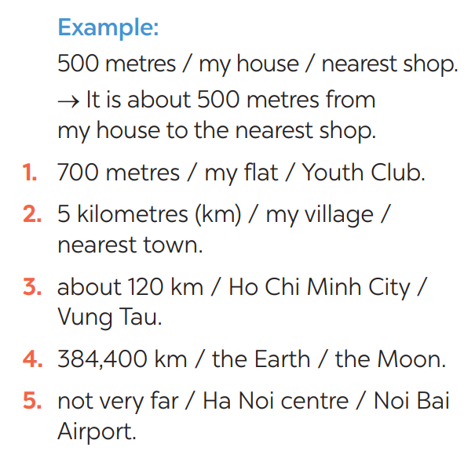  Answers:  1- It is 700m from my house/home to the Youth club.  2- It is 5 kilometres from my village to the nearest town.  3- It is about 120 km from Ho Chi Minh city to Vung Tau.  4- It is 384,400 km from the Earth to the Moon.  5- It is not very far from Hanoi centre to Noi Bai airport. | T-S | 3 mins
Controlled practice | - To practise asking and answering about distance. | Task 2: Exercise 2: Work in pairs. Ask and answer questions about distances in your neighbourhood  * Teacher asks Ss to look at the example and identify the structure of the question: How far is it from … to …?  Then work with their partners who sit next to them to make similar conversations.  ** Ss do exercise 2 in pairs.  *** Ss write all conversations down on the notebooks.  **** Teacher corrects their answers as a class.  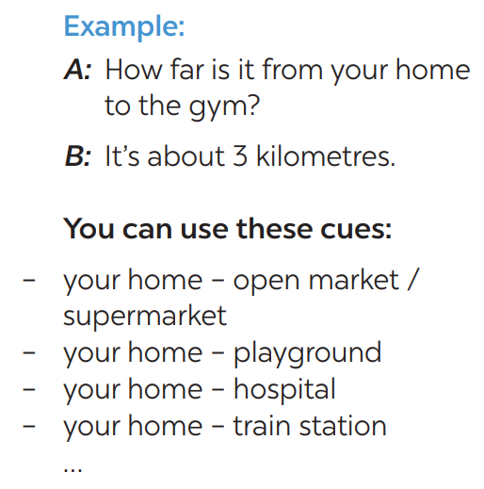  Suggested answer:  1.  - How far is it from your house to the open market?  - km.  … | T-S  S-S  T-S | 7 mins
 | - To practise the using should and shouldn’t. | Task 3: Choose the correct option in brackets.  * Teacher draws students attention to the remember box. Teacher asks them to study the examples and identify the structure: S + should/shouldn’t + Vinf  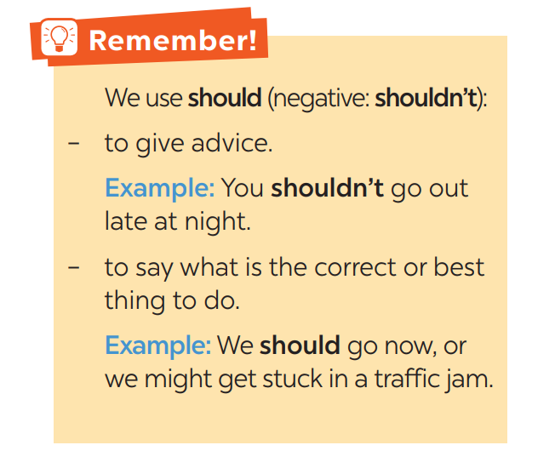  * Teacher gives suggestions and asks students to make some similar sentences using the structures.  *** Teacher nominates Ss to read aloud the sentences.  **** Teacher checks and gives the corrections if they have mistakes.  Task 4: Complete each sentence, using should / shouldn’t.  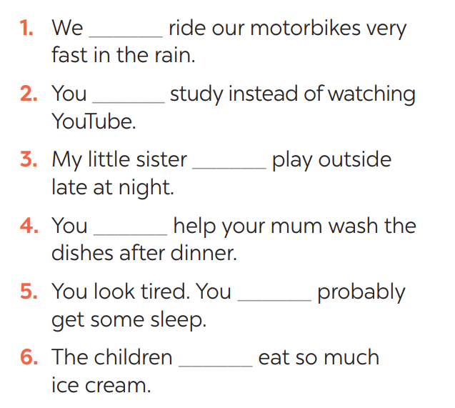  * Teacher gives Ss time to do the exercise individually and peer check with their partner.  *** Teacher nominates Ss to read aloud the sentences.  **** Teacher checks and gives the corrections if they have mistakes.  Answers:  1- shouldn’t 2- should 3- shouldn’t 4- should  5- should 6- shouldn’t  Task 5: Look at the pictures. Make sentences, using should / shouldn’t and the cues  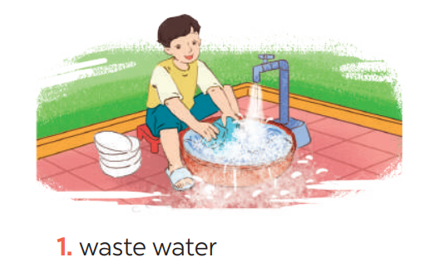  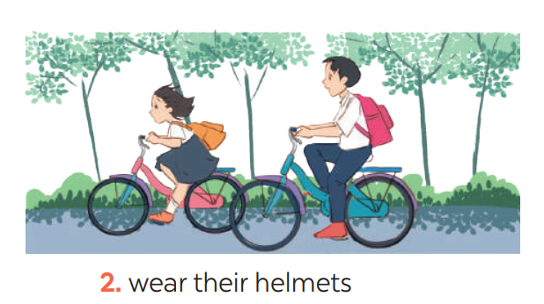  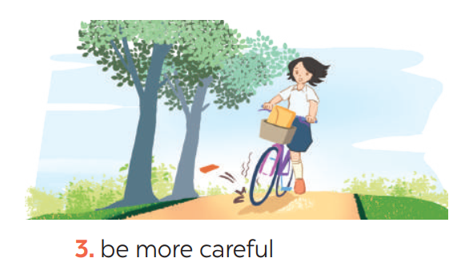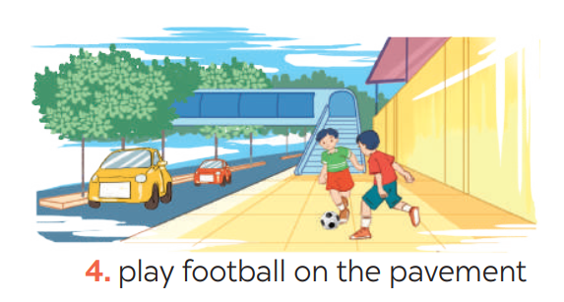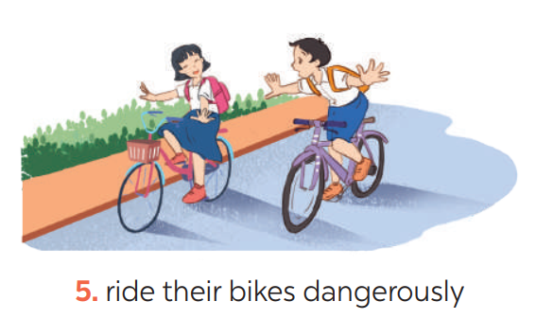  ** Ss do as instructed  **** Teacher gives Ss feedback.  - choose some common mistakes and suggest students how to avoid them.  - choose some typical errors and correct as a whole class  Answers:  1- He shouldn’t waste water.  2- They should wear their helmets.  3- She should be more careful.  4- They shouldn’t play football on the pavement.  5- They shouldn’t ride their bikes dangerously. | T-S  S-S  T-S  T-S  T  S-S  T- Ss | 20  mins
Wrap up  Homework | To help Ss memorise the target language and skills that they have learned | - It indicating distance  - Should/shouldn’t  Homework:  - Exercises in the workbook | T-Ss | 2 mins

UNIT 7: TRAFFIC

Lesson 4: Communication

I. Objectives
By the end of this lesson, students will be able to:
1. Knowledge
- learn how to ask and answer about means of transport and some strange traffic rules.
- practise using some grammar points and vocabulary related to the topic.
2. Core competence
- Develop communication skills
- Be collaborative and supportive in pair work and team work
- Actively join in class activities
3. Personal qualities
- Be benevolent and responsible
II. Materials
- Grade 7 textbook, Unit 7, Communication
- Computer connected to the internet
- TV/ Pictures/ Projector
- sachmem.vn

Language analysis
Anticipated difficulties | Solutions
1. Students may lack knowledge about the topic. | Provide students with information about the knowledges they do not know.
2. Students may have underdeveloped reading, speaking and co-operating skills. | - Encourage students to work in pairs, in groups so that they can help each other.  - Provide feedback and help if necessary.
3. Some students might excessively talk in the class. | - Define expectation in explicit detail. Have excessive talking students practise.  - Continue to define expectations in small chunks (before every activity).

Board Plan
Date of teaching
UNIT 7: TRAFFIC
Lesson 4: Communication
*Warm-up
BRAINSTORMING
I. Everyday English:
Task 1: Listen and read the conversation, paying attention to the highlighted parts.
Task 2: Work in pairs. Take turns to ask and answer about the means of transport your family members use every day.
II. Practice: Strange traffic rules!
Task 3: Which countries below keep to the left? Tick the correct answers.
Task 4: Listen and check your answers in 3. Then listen again and complete the sentence with no more than THREE words
Task 5: Read, discuss which one do is the strangest rule?
* Homework

Procedures
Notes
In each activity, each step will be represented as following
* Deliver the task
** Implement the task
*** Discuss
**** Giving comments or feedback

Stage | Stage aim | Procedure | Interaction | Time
Warm-up | To introduce the lesson. | Game: BRAINSTORMING  HOW DO YOU GO TO SCHOOL?  * Teacher divides class into 2 teams and asks them to think of “MEANS OF TRANSPORTS” (even the strangest ones).  ** Ss have 1 min to think of the words related to the topic or they can discuss with their partners.  *** Each member from each team turn by turn run to the board and write one word.  **** Teacher corrects their answers.  - The team which has more correct words will be the winner  Suggested answers:  Motorbike, bicycle, train, bus, plane, helicopter,… | T-Ss | 5 mins
Lead in | To lead in the lesson. | Teacher leads students into the lesson by telling what they are going to learn: “We are going to learn how to ask and answer about means of transport and some strange traffic rules”. | T-Ss | 1 min
* EVERYDAY ENGLISH
Presentation | To let students know the structure to ask and answer about means of transport. | Task 1: Listen and read the conversation, paying attention to the highlighted parts.  * Teacher plays the record for SS to listen and read the conversation about means of transport. .  ** Ss listen and practice saying with their partners.  *** Teacher calls some pairs to read aloud.  **** Teacher corrects pronunciation if needed.  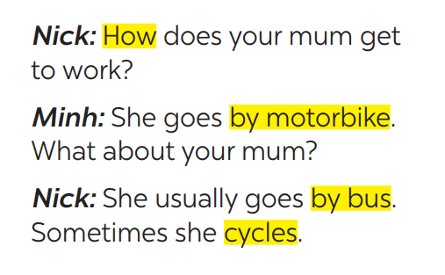  * Teacher asks Ss to pay attention to the highlighted parts and asks them some questions to elicit the new structure:  - Which tense do we use to ask and answer?  - Which question word do we use?  - …..  ** Ss answer teacher’s questions to find out new structure to ask anad answer about means of transport to travel to places  *** Some students give the new structure to the teacher.  **** Teacher corrects and writes on the board:  - Structure:  to ask:  - How do/does + S + go to …?  to answer:  - S + go/goes by …  - S + V | T-Ss | 10 mins
Practice | To help students practise  on how to ask and answer about means of transport. | Task 2: Work in pairs. Take turns to ask and answer about the means of transport your family members use every day.  * Teacher has SS look at the situation in Ex 2 to make similar dialogue:  ** Ss work in pairs to make similar dialogue.  *** Teacher calls some pairs to present it in front of the class.  **** Teacher gives feedback and some comments.  Suggested answers:  A: How does your father go to school?  B: He usually drives his car but sometimes he goes by bus. How about your father?  A: He walks because we live near his office. | Pair work  T-Ss | 8 mins
* STRANGE TRAFFIC RULES
Presentation | - To provide students with more knowledge about strange traffic rules and help them practice the skill of listening for details. | Task 3: Which countries below keep to the left? Tick the correct answers.  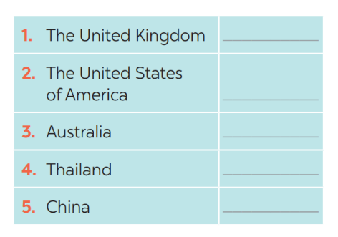  * Teacher asks Ss to discuss in pairs and tick.  ** Ss so the task in pairs  Task 4: Listen and check your answers in 3. Then listen again and complete the sentence with no more than THREE words.  * Teacher plays the recording twice.  *** Teacher calls some Ss to give their answer and explain it.  **** Teacher let Ss listen and confirms the correct answers.  Answer key: - United Kingdom, Australia  - same traffic rules/regulations | T- Ss  S-S  T-Ss | 8 mins
Practice | To help students know more about traffic rules around the world. | Task 5: Read, discuss which one do is the strangest rule?  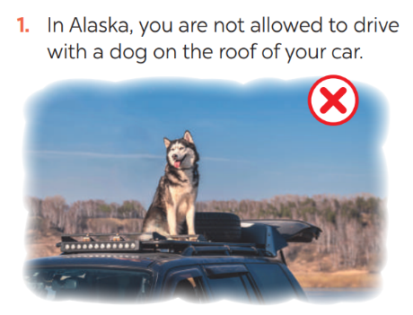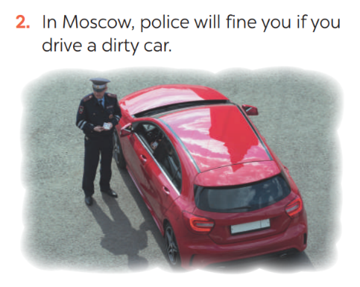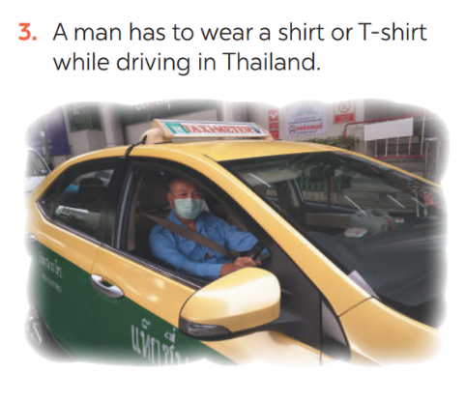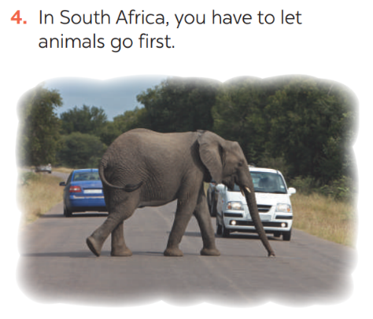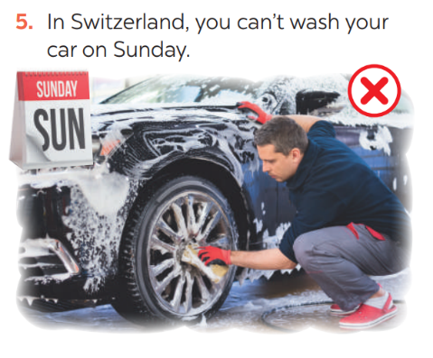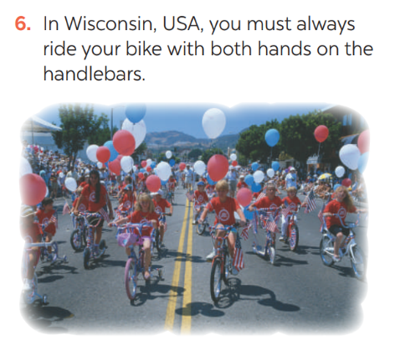  * Teacher has students work in groups to discuss which one they find strangest.  ** Ss work in groups.  *** 2-3 groups share their ides  **** Teacher encourages students to add more if they know. | T-Ss  Group work  T- Ss | 5 mins
Consolidation | To consolidate what students have learnt in the lesson. | Teacher asks students to talk about what they have learnt in the lesson. | T-Ss | 1 min
Homework | To prepare for the next lesson:  Skills 1. | Do exercises in the workbook. | T-Ss | 1 min

UNIT 7: TRAFFIC

Lesson 5: Skills 1

I. Objectives
By the end of this lesson, students will be able to gain:
1. Knowledge
+ Reading:
- read for specific information about some rules about road safety
+ Speaking:
- talk about how to avoid traffic accidents.
2. Core competence
- Develop communication skills
- Be collaborative and supportive in pair work and team work
- Actively join in class activities
3. Personal qualities
Be benevolent and responsible
II. Materials
- Grade 7 textbook, Unit 7, Skills 1
- Computer connected to the internet
- TV/ Pictures, cards
- sachmem.vn

Language analysis
Form | Meaning | Pronunciation | Vietnamese equivalent
1. pedestrian (n) | a person walking along a road/street. | /pəˈdestrēən/ | người đi bộ
2. passenger (n) | a traveler on a public or private vehicle but not the driver, pilot, or crew. | /ˈpasinjər/ | hanh khách
3. (to) obey | comply with the command, direction, or request of (a person or a law) | / ōˈbā/ | tuân thủ
4. seatbelt (n) | a belt or strap securing a person to prevent injury, especially in a vehicle or aircraft. | / ˈsēt ˌbelt/ | dây an toàn

Anticipated difficulties | Solutions
1. Students may lack knowledge about some lexical items. | Provide students with the meaning and pronunciation of words.
2. Students may have underdeveloped reading, speaking and co-operating skills. | - Let students read the text again  (if needed).  - Create a comfortable and encouraging environment for students to speak.  - Encourage students to work in pairs, in groups so that they can help each other.  - Provide feedback and help if necessary.
3. Some students might excessively talk in the class. | - Define expectation in explicit detail.  Have excessive talking students practise.  - Continue to define expectations in small chunks (before every activity).

Board Plan
Date of teaching
Unit 7: Traffic
Lesson 5: Skills 1
* Warm-up
HANGMAN
I. Reading:
1. Vocabulary
- pedestrian (n) /pəˈdestrēən/: người đi bộ
- passenger (n) /ˈpasinjər/: hanh khách
- (to) obey / ōˈbā/: tuân thủ
- seatbelt (n) / ˈsēt ˌbelt/: dây an toàn
2. Discussion: Ex 1: Look at the picture. Can you see anything that is dangerous?
3. Practice
Task 1: Read the following text and choose the correct answer
Task 2: Read the text again and answer the questions:
II. Speaking:
Task 3: Work in groups. Ask and answer the following question. Make a list.
Task 4: Read the following sentences about these people. Then work in groups. Discuss who is being safe, and who isn’t
Task 5: Give the advices on dangerous situations on the road.
* Homework

Procedures
Notes
In each activity, each step will be represented as following
* Deliver the task
** Implement the task
*** Discuss
**** Giving comments or feedback

Stage | Stage aim | Procedure | Interaction | Time
Warm-up | To introduce the topic of reading. | Game: Hangman  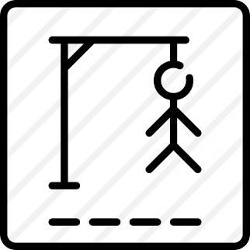  D A N G E R O U S  * Teacher divides class into 2 teams and asks them to think of the word which has 9 letters in it related the topic “ON THE ROAD”.  ** Ss have 1 min to think of the words related to the topic or they can discuss with their partners.  *** Each member from each team turn by turn guesses the letter in the secret word.  **** Teacher corrects their answers.  - The team which can find or guess the secret first will be the winner. | Group work | 5 mins
Lead in | To lead in the lesson about Skills 1. | READING  - Teacher leads students into the lesson by telling what they are going to learn: “We are going to read a passage about some rules about road safety.” | T-Ss | 2 mins
Pre-Reading (Pre-teach vocabulary) | To provide students with some lexical items before reading the text  To introduce words related to skin conditions to Ss and help Ss have a general idea of what they are going to read. | Vocabulary  - Teacher introduces the vocabulary by:  + Providing the synonym or antonym of the words.  + Providing the pictures of the words.  + Providing the definition of the words.  - pedestrian (n) /pəˈdestrēən/: người đi bộ  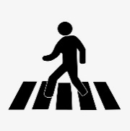  - passenger (n) /ˈpasinjər/: hanh khách  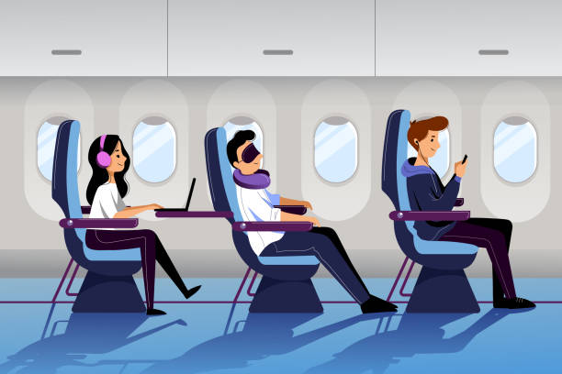  - (to) obey / ōˈbā/: tuân thủ  - seatbelt (n) / ˈsēt ˌbelt/: dây an toàn  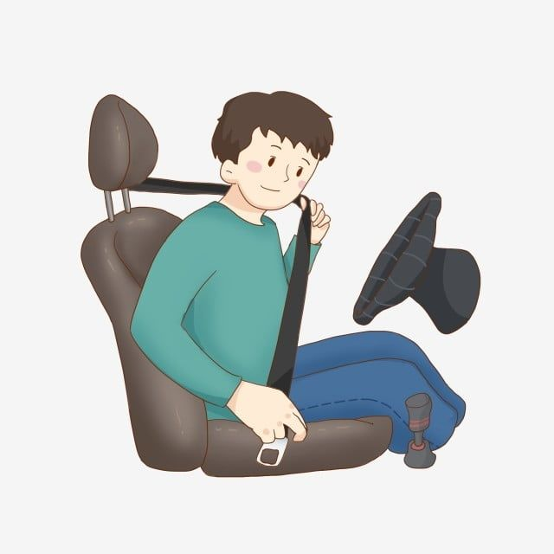  Concept check: Rub out and Remember  DISCUSSION  * Teacher asks Ss to work in pairs to look at the Picture in Ex1 and discuss on what they see that is dangerous?  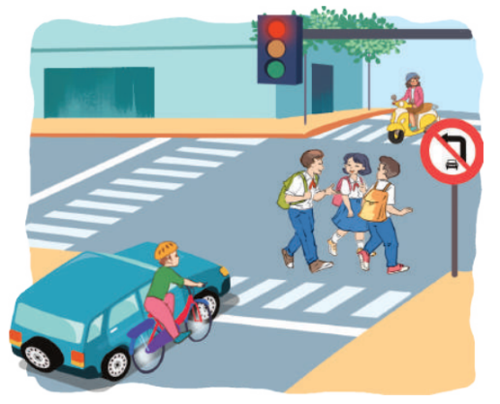  ** Ss work in pairs.  *** Teacher calls some Ss to check what they have discussed.  **** Teacher corrects.  Answer keys:  The students who are crossing the road  Because they do not walk on the right place and they are not careful. | T-Ss  T – Ss  Pair works  T - Ss | 8 mins
While-Reading | To help Ss develop their reading skill for main ideas and specific information (scanning) and help them focus on the road safety rules  To help Ss further develop their reading skill for specific information (scanning). | Task 1: Read the following text and choose the correct answer.  This text is about ______.  A. rules for pedestrians  B. traffic lights  C. traffic rules  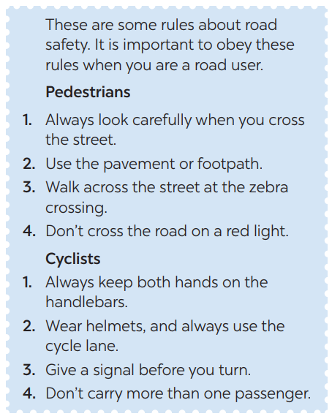  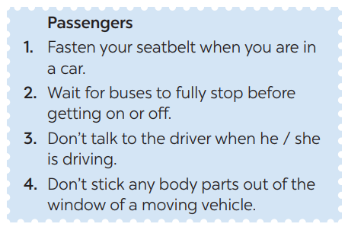  * Teacher has Ss read the first sentence of the text in detail to do the exercise and asks them how to do this kind of exercise.  ** Ss do the task independently  *** Teacher tells Ss to compare their answers in pairs before calling some of them to check.  **** Teacher confirms the correct answer and explains if needed.  Answer key: C  Task 2: Read the text again and answer  the questions:  * Teacher asks Ss: reading each question, locating where the information appears in the text, reading that part carefully and circling the correct answer.  ** Ss do the task independently.  *** Teachers has Ss compare their answers in pairs and call some Ss to give their ideas.  **** Teacher checks and confirms the correct answers.  Answer key:  1. They shoud cross the street at the zebra crossing.  2. We should always use the cycle lane.  3. We should give a signal before we turn while riding a bike  4. We must wait for buses to fully stop when you get on or off a bus.  5. We mustn’t stick any body parts out of the window when you are in a moving vehicle. | T- Ss  S  T- Ss  T- Ss  S  Ss-Ss  T-Ss | 9 mins
Post-Reading  & Pre-Speaking | - To check students’ reading comprehension.  - To help Ss talk about how they apply the rules in the reading to themselves. | Task 3: Work in groups. Ask and answer  the following question:  “When you are a road user, what should you NOT do?”  Make a list in groups. Compare  your list with other groups’.  * Teacher asks Ss to work in groups and tells them to focus on the rules for road users in the text to talk about which one they have to obey everyday.  ** Ss work in groups. Teacher goes around and listens and gives help if needed.  *** Teacher calls on some Ss to share their answers with the class.  **** Teacher listens and gives comment. | T-Ss  Group works  T- Ss | 5 mins
While-Speaking | To provide Ss an opportunity to practise giving advices on dangerous situations on the road. | Task 4: Read the following sentences  about these people. Then work in groups. Discuss who is being safe, and who isn’t  * Teacher has Ss work in groups and asks them to take turns to discuss the situations.  ** Ss work in groups to do the task. Teacher goes around, listens and gives help if needed.  *** Teacher calls on some groups to share their answers with the class.  **** Teacher comments | T- Ss  Group works  T- Ss | 7 mins
Post-Speaking | To help students apply what they have learnt in real life context. | Task 5: Give the advices on dangerous situations on the road.  Structure: S + should/shouldn’t + Vinf  * Teacher has students give advices on how to avoid the dangerous situations on the road.  *** Teacher calls on some groups to share their answers with the class.  **** Teacher comments and corrects if needed. | T-Ss  Ss-Ss | 3 mins
Consolidation | To consolidate what students have learnt in the lesson. | Teacher asks students to talk about what they have learnt in the lesson. | T-Ss | 2 mins
Homework | To prepare for the next lesson Skills 2. | Do exercises in the workbook. | T-Ss | 1 min

UNIT 7: TRAFFIC

Lesson 6: Skills 2

I. Objectives
By the end of this lesson, students will be able to:
1. Knowledge
+ Listening
- use the lexical items related to the topic Traffic
- listen for main ideas and specific information about traffic problems in Mumbai.
+ Writing: write about traffic problems in your area.
2. Core competence
- Develop communication skills
- Be collaborative and supportive in pair work and team work
- Actively join in class activities
3. Personal qualities
Be benevolent and responsible
II. Materials
- Grade 7 textbook, Unit 7, Skills 2
- Computer connected to the internet
- Pictures
- sachmem.vn

Anticipated difficulties | Solutions
1. Students may lack knowledge and experiences about the topic. | Prepare some hand-outs.
2. Students may have underdeveloped listening, writing and co-operating skills. | - Play the recording many times if any necessary.  - Encourage students to work in pairs, in groups so that they can help each other.  - Provide feedback and help if necessary.
3. Some students might excessively talk in the class. | - Define expectation in explicit detail.  Have excessive talking students practise.  - Continue to define expectations in small chunks (before every activity).

Board Plan
Date of teaching
Unit 7: Traffic
Lesson 6: Skills 2
* Warm-up: BRAIN STORMING
I. Listening
Task 1: Discuss: What can you see in this picture? What is special about it?
Task 2: Listen to the recording and choose the correct answer A, B, or C
Task 3: Listen again and write ONE word or number in each gap
Task 4: Discuss: Compare traffic problems in Mumbai to the traffic problems in Hanoi.
II. Writing:
Task 5: Discuss and brainstorm ideas.
Task 6: Write a paragraph of about 70 words about the traffic problems in your town / city.
Peer check and cross check
* Homework

Procedures
Notes
In each activity, each step will be represented as following
* Deliver the task
** Implement the task
*** Discuss
**** Giving comments or feedback

Stage | Stage aim | Procedure | Interaction | Time
Warm-up | To activate students’ prior knowledge and vocabulary related to the lesson | BRAIN STORMING:  * Teacher writes on the board the word “Traffic problems” and asks Ss some questions:  + What does this word mean?  + What do we have to suffer from these problems?  + Can you name some traffic problems?  ** Ss think of these questions and discuss with their partners if needed.  *** Teacher calls some students to give their answers.  **** Teacher listens and give comments. | T-Ss  Group work | 5 mins
Lead in | To introduce the new lesson. | - Teacher introduces students the content of the lesson: “In the lesson today, we are going to listen to a person talking about traffic problems in his city - Mumbai.” | T-Ss | 1 min
Pre-Listening | To help Ss brainstorm the topic and prepare for the listening text.  To help Ss develop their skill of listening for main idea | Task 1: What can you see in this picture? What is special about it?  * Teacher asks Ss to work in pairs to the problems they can find in the picture.  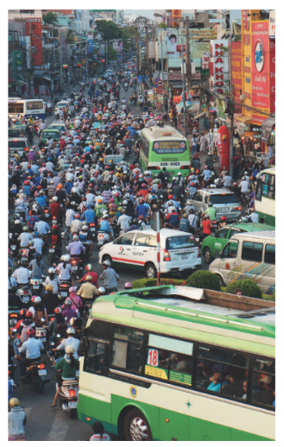  ** Ss work with their partner to do the task.  *** Teacher calls on some Ss to answer.  **** Teacher gives comments and leads Ss to task  Suggested answers: traffic jams, vehicle overload, people’s awareness about traffic rules…  Task 2: Listen to the recording and choose the correct answer A, B, or C  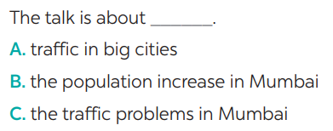  * Teacher asks Ss to read and underline the key words.  ** Ss work independently to guess then listen to the recording once to check their guess.  *** Teacher calls on some students to give the answers the have listened. | T-Ss  Pair work  T- Ss  T- Ss  S  T- Ss | 3 mins
While-Listening | To help students develop their skill of listening for specific information. | Task 3: Listen again and write ONE word or number in each gap  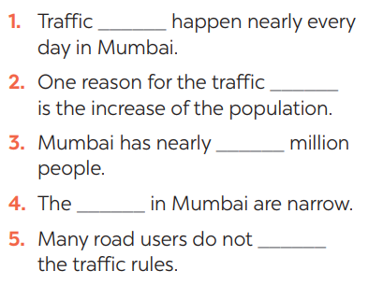  **** Teacher plays the recording again and confirms the correct answers for their prediction.  Answer key: | T-Ss | 10 mins
Post-Listening | To help Ss use what they have listened to life context. | Task 4: Discuss: Compare traffic problems in Mumbai to the traffic problems in Hanoi.  * Teacher tells Ss to work in groups to discuss and compare traffic problems in Mumbai to the traffic problems in Hanoi. Write down onto the notebooks in full sentences  E.g. The traffic jams in Hanoi is as serious and frequent as they are in Mumbai.  ** Ss work in groups. Teacher moves around and offers help if needed.  *** Teacher invites some Ss to share their answers.  **** Teacher corrects if needed. | Group work | 5 mins
Pre-Writing | To help Ss prepare ideas to write a passage. | Task 5: Tick the traffic problems in big cities in Viet Nam  * Teacher writes on the board “Your city’s Traffic Problems” and asks Ss to Tick the traffic problems in big cities in Viet Nam and asks them to give out more problems that they see in their city.  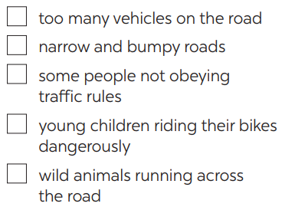  ** Ss think of it and can discuss with their partners.  *** Teacher calls on some Ss to raise their ideas.  **** Teacher listens and confirms.  Suggested answers:  Too many vehicles  Narrow roads  People’s awareness  … | T-Ss | 5 mins
While-Writing | To help Ss practise writing a passage about  70 words about the traffic problems in their town / city. | Task 6: Write a paragraph of about 70 words about the traffic problems in your town / city.  * Teacher tells Ss that they are going to write a passage about the traffic problems in your town / city.  ** Teacher reminds Ss of the structure of a passage and steps to make an outline for the passage.  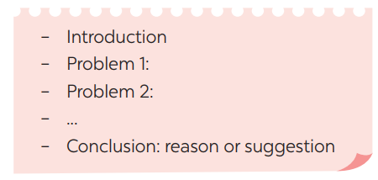  ** Ss work independently to do the task and try to use the notes from the previous tasks.  Teacher goes around and help if necessary. | T-Ss | 10 mins
Post-Writing | To peer check, cross check and final check students’ writing. | Peer check and cross check  *** Teacher asks Ss to share their writing with their partners. Then, call on some Ss to show their writing in front of the class.  **** Teacher checks ideas, grammar, vocabulary and gives comments.  Suggested answers:  The most serious traffic problem in our city – Hanoi is the traffic jams. Although the public transport system in Hanoi is quite modern and covenient, many people prefer using their own motorbikes. The reason for that is because most roads and streets in Hanoi are quite smalls and include many tiny lanes. Therefore, using private vehicles allows them to get there without walking long distance. The situation usually gets worse at rush hours when people all go to work or return home from work and schools. In conclusion, people should try to use public transport more often to reduce the traffic jams and exhaust. | Ss-Ss  T-Ss | 3 mins
Consolidation | To consolidate what students have learnt in the lesson. | Teacher asks students to talk about what they have learnt in the lesson. | T-Ss | 1 mins
Homework | To allow students finalize their passage after being checked by friends and the teacher. | Rewrite the passage on the notebook. | T-Ss | 1 min

UNIT 7: TRAFFIC

Lesson 7: Looking back & Project

I. Objectives
By the end of this lesson, students will be able to:
1. Knowledge
- review the vocabulary and grammar of Unit 7
- apply what they have learnt (vocabulary and grammar) into practice through a project.
2. Core competence
- Develop communication skills and creativity
- Be collaborative and supportive in pair work and team work
- Actively join in class activities
3. Personal qualities
- Be benevolent and responsible
- Develop self-study skills
II. Materials
- Grade 7 textbook, Unit 7, Looking back & Project
- Computer connected to the internet
- TV/ Pictures, A4 cards and colours
- sachmem.vn

Anticipated difficulties | Solutions
1. Students may have underdeveloped speaking, writing and co-operating skills when doing project. | - Encourage students to work in pairs, in groups so that they can help each other.  - Provide feedback and help if necessary.
2. Some students might excessively talk in the class. | - Define expectation in explicit detail.  Have excessive talking students practise.  - Continue to define expectations in small chunks (before every activity).

Board Plan
Date of teaching
Unit 7: Traffic
Lesson 7: Looking back & Project

* Warm-up
QUICK REVISION CHECK
I. Looking back
Task 1: Label each sign. Work in pairs. What does each sign tell us to do?
Task 2: Fill in each gap with one word to complete the sentences.
Task 3: Write complete sentences, using these cues.
Task 4: Choose A, B, or C to complete the sentences.
II. Project
Traffic signs
Task 5: Show the prepared signs. Make your own sign.
Task 6: Traffic signs exhibition
* Homework

Procedures
Notes
In each activity, each step will be represented as following
* Deliver the task
** Implement the task
*** Discuss
**** Giving comments or feedback

Stage | Stage aim | Procedure | Interaction | Time
Warm-up | To help students revise the vocabulary items they have learnt in the unit.  To enhance students’ skills of cooperating with team mates. | Quick revision check  * Teacher asks Ss to think of what they have learnt already in Unit 7.  ** Ss work in pairs to do the task.  ***Teacher calls some students to retell.  **** Teacher confirms and leads them to do all the exercises in books. | T- Ss  Pair work  T - Ss | 3 mins
Looking back | To help Ss revise the vocabulary items (verbs) they have learnt in the unit.  To help Ss revise the vocabulary items (adjectives) they have learnt in the unit  To help Ss revise grammar points.  To help Ss revise the grammar points of the unit | Task 1: Label each sign. Work in pairs. What does each sign tell us to do?  * Teacher has Ss work individually.  ** Ss do this activity individually, then compare their answers with their partners.  *** Teacher asks for Ss’ answers. **** Teacher confirms the correct ones  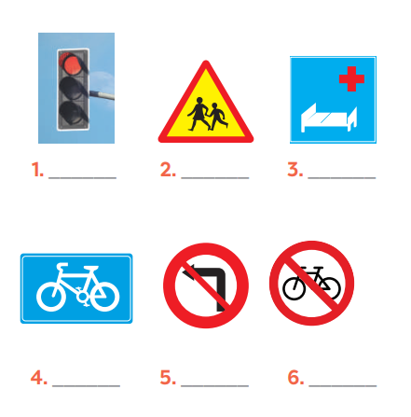  Answer keys:  1. traffic light  2. school ahead  3. hospital ahead  4. cycle lane  5. No left turn  6. Do not cycle  Task 2: Fill in each gap with one word to complete the sentences.  * Teacher has Ss work individually.  ** Ss do this activity individually, then compare their answers with their partners.  *** Teacher asks for Ss’ answers. **** Teacher confirms the correct ones  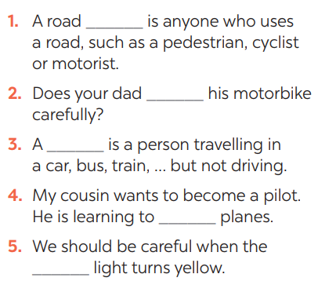  Answer keys:  1. user  2. ride  3. passenger  4. drive  5. see/notice  Task 3: Write complete sentences, using these cues.  * Teacher asks Ss to recall the structures of asking and answering about distance, and tell them to do Ex 3 in the book.  ** Ss do the exercise individually and swap with their partners.  *** Teacher calls some Ss to check their answer.  **** Teacher confirms the correct answer.  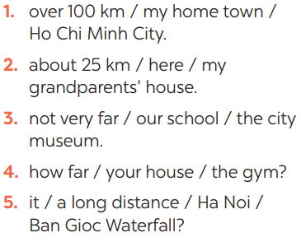  Answer keys:  1- It’s over 100km from my hometown to Ho Chi Minh city.  2- It’s about 25 km from here to my grandparents’ house.  3- It’s not very far from our school to the city museum.  4- How far is it from your house to the gym?  5- Is it a long distance from Ha Noi to Ban Gioc Waterfall?  Task 4: Choose A, B, or C to complete the sentences.  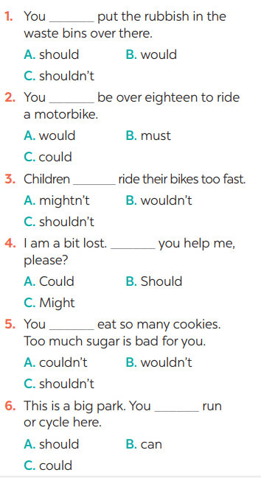  * Teacher asks Ss to do the task.  ** Ss work individually to do the task.  *** Teacher calls Ss to give out their answers.  **** Teacher checks and confirms their answer.  Answer keys:  1. C 2. B 3. C  4. A 5. C 6. B | T-Ss  S  Ss-Ss  T-Ss | 16 mins
Project | To help Ss identify common traffic signs and make their own road signs. | Task 5: Show the prepared signs. Make your own sign.    * Teacher asks Ss to show the signs they have prepared and identify the messages in each of the sign.  * Teacher also has Ss spend some time to make their own signs and practise presenting within their groups.  ** Ss discuss with their partners.  *** Some students raise their ideas and explain their answers.  **** Teacher listens and confirms.  Task 6: Traffic signs exhibition  * Teacher asks Ss to work in groups of 4 – 6 to stick their traffic signs onto the classroom’s wall and present about them.  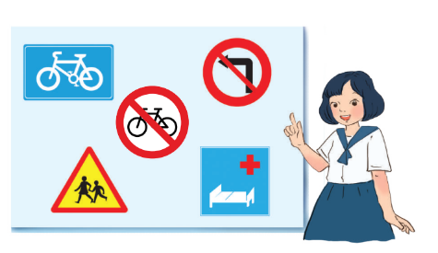  ** Ss work in group to do the task.  *** Teacher calls some groups to present their signs to the class  **** Teacher confirms and corrects. | Group work | 22 mins
Consolidation | To consolidate what students have learnt in the lesson. | Teacher asks students to talk about what they have learnt in the lesson. | T-Ss | 3 mins
Homework | To prepare for the next lesson. | Prepare for the next lesson: Unit 8 – Getting started. | T-Ss | 1 min

