|  |  |  |
| --- | --- | --- |
| **UNITS** | **VOCABULARY** | **GRAMMAR** |
| Unit 3  SHOPPING | - Shopping habits  - Shopping tips  - Make a complaint in a store | - Comparative and superlative adjectives  - When-clause |

**Tiếng Anh 10 – i-Learn Smart World**

# **UNIT 3 TEST**

***Note:*** *Each correct answer earns 0.2 points.*

**I. PRONUNCIATION** **(0.8 points)**

***A. Mark the letter A, B, C or D on your answer sheet to indicate the word whose underlined part differs from the other three in pronunciation in each of the following questions.***

1. A. store B. order C. wrong D. clothes

2. A. battery B. crash C. advice D. damage

***B. Mark the letter A, B, C or D on your answer sheet to indicate the word that differs from the other three in the position of the main stress in each of the following questions.***

3. A. hotline B. complaint C. problem D. service

4. A. disconnect B. warranty C. quality D. customer

**II. USE OF ENGLISH (3.8 points)**

***A. Mark the letter A, B, C or D on your answer sheet to indicate the correct answer to each of the following questions.***

5. The shopping mall sells clothes with __________ quality than the market.

A. the best B. good C. better D. much good

6. This smartphone comes with a full two-year __________. That means if the item becomes faulty, it can be repaired or replaced within two years.

A. warranty B. sale C. service D. quality

7. I like shopping for clothes __________. By choosing to buy second-hand clothing items instead of brand new ones, you can reduce waste and help the planet.

A. on sales B. at shopping malls

C. from local stores D. at thrift stores

8. Do you have a __________ laptop? This one costs too much.

A. more expensive B. less expensive

C. the most expensive D. the least expensive

9. These trainers are __________ of all three that I have tried on.

A. the most comfortable B. more comfortable

C. comfortable D. less comfortable

10. I got this handbag half price when it was __________ last month.

A. in stores B. in offer C. on sale D. on service

11. We can only take the item back if you still have the __________.

A. warranty B. order C. receiver D. receipt

12. We offer top- __________ products at affordable prices.

A. style B. quality C. customer D. service

13. I don’t know much about computers, so I asked the assistant for a little __________.

A. tips B. opinions C. advice D. recommendation

14. Which is _________ when you shop for clothes, style or quality?

A. more important B. most important

C. as important as D. the most important

***B. Mark the letter A, B, C or D on your answer sheet to indicate the word or phrase that is CLOSEST in meaning to the underlined part in each of the following questions.***

15. All camera equipment is **on sale** today and tomorrow. You can get up to 50% discount.

A. offered at a reduced price B. the cheapest

C. on the shelves D. available at the store

16. The printer has just stopped working. Can you **repair** it for me?

A. fix B. restart C. refund D. return

***C. Mark the letter A, B, C or D on your answer sheet to indicate the word or phrase that is OPPOSITE in meaning to the underlined part in each of the following questions.***

17. Don’t forget to **disconnect** the charger when the battery is full.

A. restart B. plug in C. unplug D. turn down

18. My phone **overheats** when I play online games. What should I do?

A. is too hot B. heats up C. works too much D. cools down

***D. Mark the letter A, B, C or D on your answer sheet to show the underlined part that needs correction in each of the following exchanges.***

19. If your camera is still on warranty, we will repair the faulty parts free of charge.

A B C D

20. My sister often says she dresses up much trendy than me, but I think she has no sense of style.

A B C D

***E. Mark the letter A, B, C or D on your answer sheet to indicate the sentence that best completes each of the following exchanges.***

21. Student A: “What do you spend most of your money on?”  
Student B: “__________”

A. I don’t have much pocket money.

B. I often spend a lot of money.

C. Clothes and accessories, of course.

D. I often shop for clothes on the weekend.

22. Customer: “I’d like to speak to the manager, please?

Sales assistant: “__________”

A. Sure, one moment, please. B. Thanks for calling.

C. Who are you talking to? D. No, you won’t.

23. Store assistant: “What’s wrong with your computer?”

Customer: “_________”

A. I bought it yesterday. B. The screen is blank.

C. I want to buy a new computer. D. My computer cost a lot of money.

**III. WORD FORMATION (0.4 points)**

***Write the correct form of the words in brackets.***

24. When shopping online, you should pay __attention________ to the item description, or you may end up getting something you don’t want. **(ATTEND)**

25. I will never return to that store again. The sales _assistants_________ were so rude and they kept talking to each other when I asked for help. **(ASSIST)**

**IV. READING (3.0 points)**

1. ***Read the following passage and fill in each of the numbered blanks from 26 to 30 with a suitable word/ phrase from the box. There are THREE words/ phrases that you don’t need.***

less tendency thrift on traditional more brand pressure

**GEN Z SHOPPING HABITS**

Generation Z (or Gen Z in short) are people who were born after 1996. They are more or less born with a phone in their hand. Three-quarters of Gen Z shop on their smartphones – more than any other generation. They search for products on sales through the (26) __brand________’s app or website and receive discounts or coupons on their mobile devices. Unlike older age groups, Gen Z shoppers are (27) ____less______ likely to trust companies. Instead, they choose to follow influencers on Instagram, Tik Tok or YouTube. Since they frequently document their life on social media, lots of Gen Z feel a (28) __pressure________ to always have new clothes. They look for unique items that can set them apart, but they don’t have much money. That’s why one-third of Gen Z like shopping at (29) __thrift________ stores where they can buy clothes with better materials, trendier styles and lower prices. Teenage boys tend to spend most of their money (30) __on________ video games and food, while teenage girls pay a lot of money for clothes and beauty products. They still seek out in-person experiences, too. In fact, Gen Z prefer to shop in a physical store for certain items like electronic devices and clothing.

1. ***Read the following email and complete the table with suitable information.***

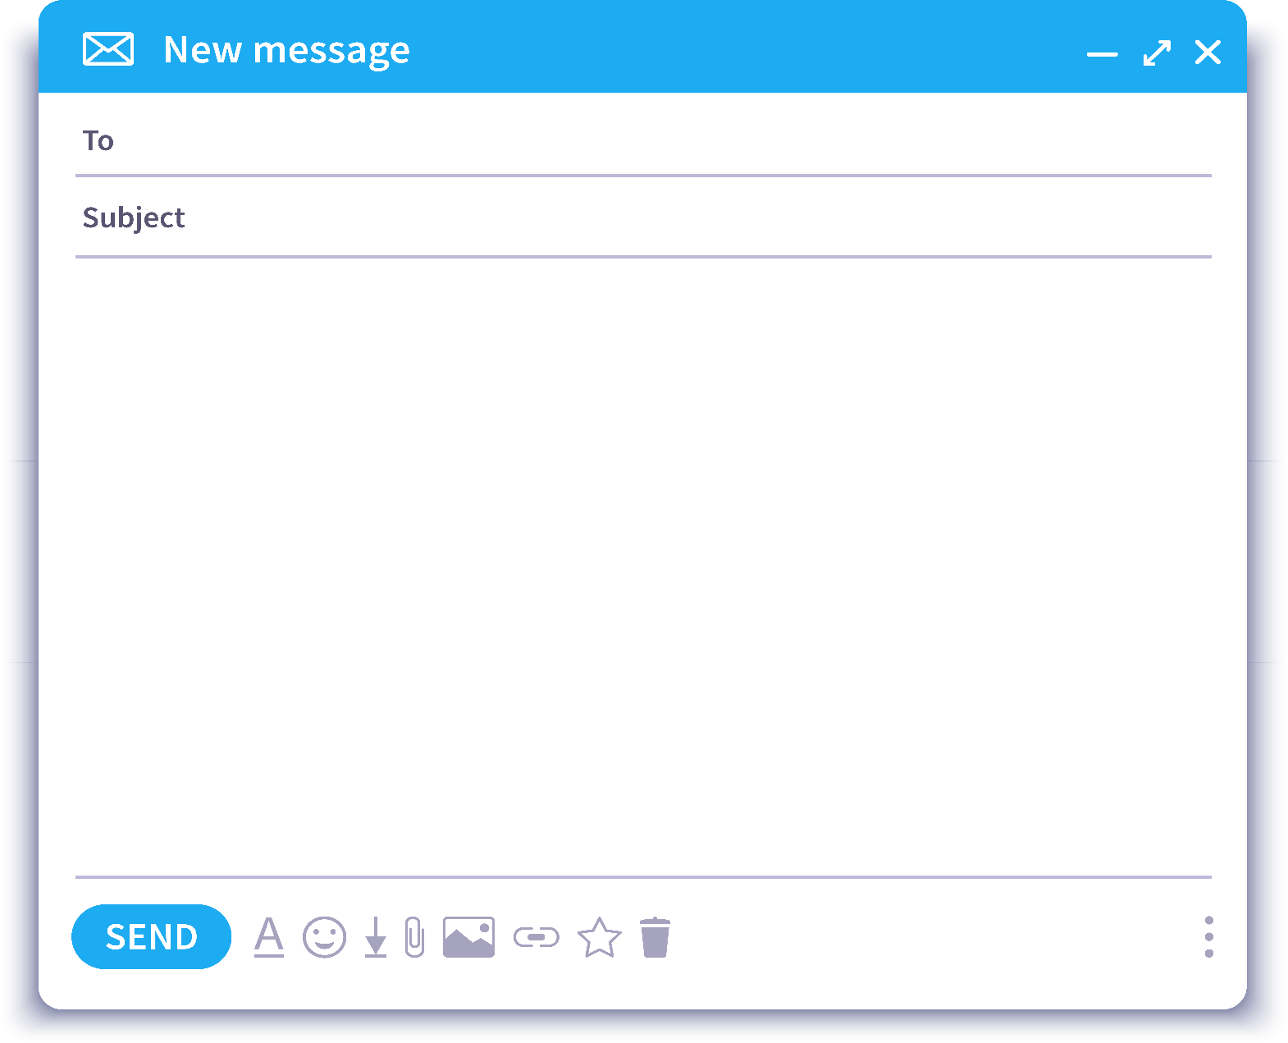

Dear Sir or Madam,

I am writing to complain about the tablet that I bought from your website on April 10th. It’s a gold Galaxy Tab A7 and my order number is 256748. Unfortunately, there were some problems with the product.

First of all, I waited two weeks for the delivery, but you had promised it would be only 3 days. Secondly, when I opened the package, I realized that the color was wrong. I received a silver Galaxy Tab instead of the gold one. And there was a crack on the screen. Someone might have dropped the package. When I checked the accessories, I noticed that the USB wire was missing. Moreover, when I installed the apps to the tablet, it kept restarting many times. That was so annoying.

I would like Smart Tech to exchange it or send me a refund as soon as possible.

I have enclosed a copy of my receipt. I look forward to hearing from you soon.

Your faithfully,

Noah Diogo

|  |  |  |
| --- | --- | --- |
| Customer name: | Noah Diogo | |
| Order No.: | (31) _256748_____________ | |
| Product name: | Galaxy Tab A7 | |
| Day of purchase: | April 10th | |
| Problems: | With the delivery: | Took (32) _two/ 2 weeks____________ |
|  | With the item: | * wrong (33) _color____________  **\*** a crack on the screen  **\*** no (34) USB wire_____________  **\*** restart many times when installing apps |
| Requirements: | Exchange item or get a (35) _refund____________ | |

1. ***Read the following passage and mark the letter A, B, C or D on your answer sheet to indicate the correct answer to each of the questions from 36 to 40.***

Online shopping can certainly be an awesome way to go. No lines, no traffic, no crowds of people. But is online shopping safer?

Experts says that online consumers may now be better protected than traditional shoppers, especially if they follow a few useful tips. First of all, make sure that you are on the site of a real company. Some thieves have created websites that look like the real one just to get your information and money. The best way to check if a site is real is to look for the “s”, which stands for “secure”, in the “https” part of the website address bar. Another indication of a safe website is a special icon in the shape of a padlock which you can find on the browser bar. And it is better to shop with online companies that you know and trust.

Secondly, make sure your computer has a firewall and up-to-date antivirus software. Updating your software is one of the easiest things you can do to stop hackers from attacking your system and protect your personal information. Moreover, **beware** of links to deals that are too good to be true on social networking sites. If you have doubts, contact the sellers directly. Finally, keep the details of your purchase in a safe place. Save or print the receipt, your order confirmation number and the tracking number. If you have a problem with the order, this information will help you solve the problem quickly.

36. What is the best title of the passage?

A. Online shopping, pros and cons

B. How to be a smart online shopper

C. Online vs traditional shopping

D. Steps to shop online

37. According to the passage, how do people check if the website is real?

A. The website should start with *https://* and should have a padlock symbol.

B. The website should have a firewall.

C. The website should be from a real company.

D. The website should be updated.

38. What does the letter “s” in “*https://*” stand for?

A. safe B. strong C. secure D. shopping

39. Which of the following statements is NOT true?

A. You should keep your antivirus program updated.

B. You shouldn’t believe deals on social networking sites.

C. You should keep records of your confirmation number, tracking number and receipt.

D. You should shop on online stores that you know or trust.

40. The word ‘**beware**’ in the last paragraph is closest in meaning to ______.

A. look for B. doubt C. click on D. be careful of

**V. WRITING (1 point)**

***A.*** ***Rewrite the following sentences without changing their meaning. Use the given word(s) if any.***

41. None of the sofas in the shop are more comfortable than this one.

→ This is the most comfortable sofa in the shop.

42. I have never seen a more beautiful dress than this one.

→ It’s the most beautiful dress (that) I have ever seen.

43. These sunglasses cost less than my last pair.

→ These sunglasses were cheaper than my last pair.

→ These sunglasses were not as expensive as my last pair.

→ These sunglasses were less expensive than my last pair.

***B. Combine the sentences using the given words in bracket.***

44. I was doing my homework. My computer crashed. **(WHEN)**

→ I was doing my homework when my computer crashed.

→ When my computer crashed, I was doing my homework.

45. I will finish the book. Then, I will lend it to you. **(WHEN)**

→ When I finish the book, I will lend it to you.

→ I will lend the book to you when I finish it.

**VI. LISTENING (1 point)**

***You will hear a conversation between a customer and a shop assistant. For each number from 46 to 50, complete the form with suitable information.***

|  |
| --- |
| **SMART ELECTRICALS**  Customer name: Sophia (46) __ Yorke ___________  Phone number: (47) _0781-233-452____________  Item: A laptop  Problems: (48) _overheated____________ and made strange noise.  Battery lasts two hours.  Date of purchase: Monday, (49) _21st February ____________  Warranty: Yes/ No  Note: Need it by (50) _Thursday____________ |

**EXTRA QUESTIONS (1 point)**

***Mark the letter A, B, C or D on your answer sheet to indicate the sentence that is closest in meaning to each of the following questions.***

51. I returned the dress to the shop because it was badly made.

A. They made the dress badly so I put it back to the shop.

B. When I returned the dress, the shop made it badly.

C. The dress was badly made because I took it back to the shop.

D. Because the dress was badly made, I took it back to the shop.

52. The new shopping mall is really big. I thought it was smaller.

A. The new shopping mall is bigger than I thought.

B. The new shopping mall isn’t as big as I thought.

C. The new shopping mall is the biggest one that I’ve thought.

D. The new shopping mall is smaller than I thought it was.

***Mark the letter A, B, C or D on your answer sheet to indicate the option that best completes each of the following*** ***questions.***

53. We will contact you when ________.  
A. the item is back in stock

B. the item will be back in stock

C. we will restock the item

D. we restocked the item

54. Coco Chanel was one of __________ in the world.

A. the talented designer

B. talented designers

C. the most talented designers

D. the best talented designers

55. Contact the customer service department _________.

A. if you complained about the business

B. when you want to make a complaint

C. in case you are making a complaint

D. so you want to complain

*\*\*\*****End – Of – Test****\*\*\**

**Audio script:**

Man: Good morning, welcome to Smart Electricals. How can I help you?

Woman: Good morning, I’ve recently bought this laptop from your store and there are some problems.

Man: I see. Do you have the receipt?

Woman: Yes, here it is.

Man: OK, I’ll check the laptop to find out what the problems are, so we can fix them for you.

Woman: Great, thanks.

Man: First, I need some details. Can I take your name, please?

Woman: Yes, it’s Sophia Yorke. Y-O-R-K-E.

Man: Ok, Ms. Yorke. And your phone number, please?

Woman: It’s 0781-233-452.

Man: Thank you. So, what’s the problem with the laptop?

Woman: Yesterday, while I was doing my homework, it overheated and made a weird noise. And the battery is draining so fast. It lasts only two hours.

Man: Hmm… I see. When did you buy the laptop?

Woman: I bought it last Monday, on the 21st of February.

Man: OK, it’s still under warranty. We can repair it for free.

Woman: Great!

Man: Alright, we’ll call you when your laptop is ready. Probably on Saturday.

Woman: Saturday? Oh no sorry, could you finish it by Thursday? I need to finish my assignment by Friday.

Man: OK, I will speak to the staff and make sure your laptop is ready on Thurday afternoon. Is it OK?

Woman: Great, thanks a lot.