

Tiết thứ
REVIEW 1
Language
Class | Date of teaching | Attendence
7A | ..../09/2022
7B | ..../09/2022
7C | ..../09/2022

I. OBJECTIVES: By the end of this review, Ss will have revised the language they have learnt and the skills they have practised in Units 1 -3.
1. Knowledge: - To revise the language and skills they have learnt in Unit 1-2-3; To revise the words related to hobbies and verbs of liking and disliking; healthy activities and health problems; and words related to community activities; Revise the present simple tense, past simple to talk about past activities; Revise how to ask for and give health tips; how to give compliments.
+ Vocabulary: Ss revise the words related to hobbies and verbs of liking and disliking; healthy activities and health problems; and words related to community activities;
+ Grammar : Revise the present simple tense, past simple to talk about past activities;
Revise how to ask for and give health tips; how to give compliments.
+ Pronuncation: the sounds /ə/, /ɜ:/, /f/, /v/, /t/, /d/, /ɪd/ correctly in isolation and in context;
2. Competence:
a) General competencies:
Develop communication skills and cultural awareness’ Be collaborative and supportive in pair work and teamwork; Actively join in class activities.
b) Specific competencies:
- Group work and independent working, pair work, linguistic competence, cooperative learning and communicative competence.
- Ability of using Present Simple Tense, some popular verbs of liking.
- Raise students’ awareness of the need to keep their neighbourhood green.
3. Qualities: - Raise students’ awareness of the need to keep their neighbourhood green; Have the good attitude to working in groups, individual work, pair work; cooperative learning. Develop self-study skills.
II. PREPARATIONS
Teacher: Grade 7 text book, laptop, TV, pictures and realia, Computer connected to the Internet. Sach mem.vn
Students: Text books, pencils, pics, blank papers, realia,….
III. PROCEDURE:
In each activity, each step will be represented as following:
* Task delivering
** Task performance
*** Report and discussion
 Judgement

Activity 1. WARM UP (5’-IW, GW)
Aim: Introduction
- By the end of this review, students will have revised the language they have learnt and the skills they have practised in Units 1 – 3.
- Ss revise what they have learnt so far in terms of language and skills.
- Summarise their answers in notes and write them in a top corner of the board. Briefly revise some important / difficult ones before starting the review.
* Content: Having some warm-up activities to create a friendly and relaxed atmosphere to inspire Ss to warm up to the new lesson.
* Product:Having a chance to speak English; Revision.
* Implementation: Teacher’s instructions…...
Teacher’s & Student’s activities | Content
+ Greeting  + Revision on the old lessons  GAME: FINDING KEYWORDS  * Teacher shows 3 sets of pictures (taken from Project lessons of Unit 1-2-3) and asks students to find a keyword for each set of pictures.  ** Students raise hands to answer.  *** Teacher and students discuss the answers.   Teacher checks the answers as a class. | GAME: FINDING KEYWORDS    Set 1: HOBBIES  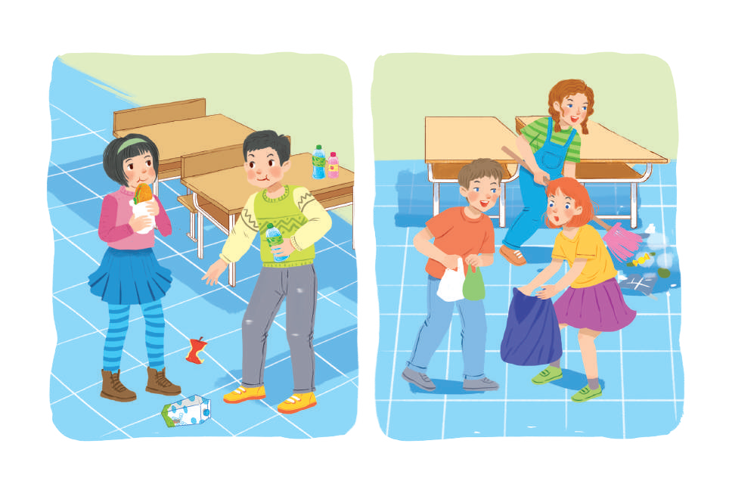  Set 2: HABITS  (bad habits, good habits, healthy habits)  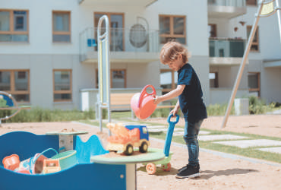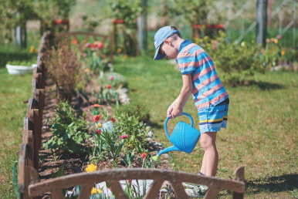  Set 3: COMMUNITY SERVICE
Activity 2. KNOWLEDGE FORMATION (10'- PW, IW)
A. LANGUAGE:
* Pronunciation
* Aim: To help Ss review the pronunciation of the sounds learnt in Units 1 - 3.
* Content: Review the pronunciation of the sounds. Choose the words …
* Product: Pronouncing the sounds correctly.
* Implementation: Teacher’s instructions…..
Teacher’s & Student’s activities | Content
1. Choose the word whose underlined part is pronounced differently  * Teacher writes the sounds /ə/ and /ɜː/; /t/, /d/ and /ɪd/; /f/ and /v/ on the board.  - Teacher writes one word containing the sound below each of them.  - Teacher asks students to read the words aloud.  ** Students do the task by reading aloud each group and circling the odd one out.  *** Teacher can invite some pairs of students to read aloud.   Teacher check students’ pronunciation ad give feedback. | 1. Choose the word whose underlined part is pronounced differently (Ex 1, P ₃₈)  * Key: 1. A 2.C 3. B 4. A 5. B
Activity 3. PRACTICE (15’-IW, PW, GW)
* Aim: To help Ss revise the phrases showing activities and identify if they benefit oneself or the community; To help students revise more words from Units 1 - 3 and use them in context; To help Ss revise the use of the present and past simple.
* Content: Review the pronunciation, the vocab. Put the phrases in the correct column; Complete the sentences; Review the grammar points. Do the filling
* Product:Remember the words . Put the phrases in the correct column correctly; Do the filling correctly; Ss will be able to revsie more words and do exercises correctly.
* Implementation:
2. Put the phrases below in the correct columns.  * Teacher tells students to read the phrases carefully and make sure they remember their meanings.  ** Students do this exercise individually by categorising the activities as they do them for their own sake or for the benefit of the community.  *** Teacher allows students to share their answers before discussing as a class and encourages them to pronounce the words / phrases correctly.   Teacher checks the answers as a class and gives feedback. | 2. Put the phrases below in the correct columns. (Ex 2, P ₃₈)  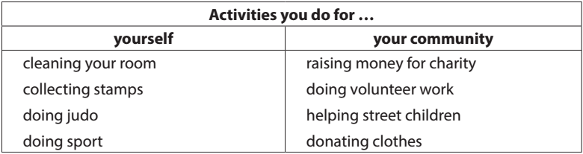
3. Complete the sentences with the words and phrases below.  * Teacher asks students to work individually to complete the sentences with the given words and phrases.  ** Students work individually to complete the task.  *** Teacher allows students to share answers before discussing as a class.  ****Teacher asks students to say the sentences aloud and makes sure they pronounce the words and phrases correctly. Teacher can ask for translation to check their understanding. | 3. Complete the sentences with the words and phrases below. (Ex 3, P ₃₈)  1. coloured vegetables  2. mountainous areas  3. hobby 4. chapped lips  5. community 6. taking photo
4. Fill in the blanks with the correct tense of the verbs in brackets. (Ex 4, P ₃₈)  * Teacher asks students to work independently to fill in the blanks with the correct tense of the verbs in brackets.  ** Students read the sentences first and underline the clues that help them decide if the verbs are used in the present or past simple tense.  *** Teacher reminds students to use the correct forms of the verbs (positive/ negative statements, or questions) as requested in each sentence then allows them to share answers before discussing as a class.   Teacher can ask students to read aloud the full sentences and correct their pronunciation if necessary. | 4. Fill in the blanks with the correct tense of the verbs in brackets. 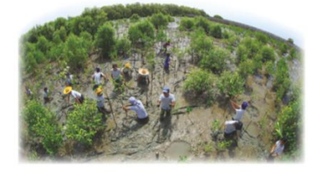  1. reads 2. Do... do  3. need 4. could not  5. did not / didn't volunteer 6. joined
Activity 4. APPLICATION (10’-IW, PW, GW) Grammar
* Aim: To help Ss practise the present simple and past simple of verbs; To consolidate what students have learnt in the lesson.; To prepare vocabulary for the next lesson.
* Content: Review grammar elements taught in Units 1-3. Turn the sentences into negative. Home assignment.
* Product: Remember how to form and use them. Do exercises correctly; take home assignment.
* Implementation:
Teacher’s & Student’s activities | Content
5. Look at the picture of a classroom. Choose the best answers A, B, C.  * Teacher asks students to read the sentences first and underline the verb in each sentence, then look at each verb and note if it is used in the present simple or past simple tense.  ** Students do the task individually.  *** Teacher reminds students to pay attention to the request of each sentence (change it into a negative statement or a question) then allows them to share answers before discussing as a class.   Teacher can ask students to read aloud the full sentences and correct their pronunciation if necessary.  * Home assignment  - T assigns the homework.  - Ss copy their homework.  - T explains it carefully | 5. Look at the picture of a classroom. Choose the best answers A, B, C.  1. She didn't like exercising.  2. My family doesn't always spend time doing housework together on Sundays.  3.I didn't use a lot of suncream during my holiday.  4. Did your community organise a fair to raise money for the homeless last week?  5. Does Tim make beautiful pieces of art from dry leaves and sticks?  * Home assignment  - Read again the conversation  - Do more exercises in workbook.  - Prepare for Review 1 – Skills.
V. FEEDBACK:
With 7A ……………………………………………………………………………..…
With 7B …………………………...……………………………………..……………
With 7C ………………………………………………………………………….……
Activity 5. WRAP-UP & HOME WORK (2’)
* Aim: To consolidate what students have learnt in the lesson.; To prepare vocabulary for the next lesson.
* Content: Home assignment.
* Product: Take home assignment.
* Implementation:
- Ask Ss what they have learnt so far. Have them recall the important grammar points.
+ Words / phrases . Vocabulary; The grammar points.
* HOME WORK
- Read again the conversation
- Do more exercises in workbook.
- Make more sentences using adverbs of frequency.

