Period
LESSON PLAN
TIẾNG ANH 10 FRIENDS GLOBAL
UNIT 4: OUR PLANET
LESSON 4B: COMPARISON
I. OBJECTIVES:
By the end of the lesson, Ss will be able to make comparison
1. Knowledge:
- Comparing types of weather
- Grammar: comparatives
2. Ability:
- main skills: reading and writing skills
- sub skills: listening and speaking skills
- Make comparison properly in exercises as well as everyday conversations.
3. Quality:
- have positive attitude in English language learning so that they can participate enthusiastically in all classroom activities, especially with the topic conducted by the teacher
- know how to make comparison precisely
II. TEACHER AIDS AND LEARNING MATERIALS:
Lesson plan, PPT slides, student’s book, workbook, notebook, personal computer (if any), projector/TV, speakers, IWB software.
III. PROCEDURES:
A. Warm-up (5’)
a) Objective: Introduce the new lesson and set the scene for Ss to acquire new language; get students' attention at the beginning of the class by means of enjoyable and short activities as well as to engage them in the steps that followed.
b) Content: Task 1 page 48
c) Outcomes: Students can gain more confidence and interest in the lesson.
d) Competence: communication, collaboration, critical thinking
e) Organisation of the activity:
TEACHER’S ACTIVITIES | STUDENT’S ACTIVITIES | CONTENTS
WARM-UP. T- Ss/ S – S/ Indiv.  Exercise 1 page 48  - Ask students to read the text and answer the question: “What is a shooting star?”  - Have students underline and count all the adjectives that end in –ER  - Use some comparative adjectives to introduce the new lesson  - Lead in the topic of the lesson | - Read the text on the screen or in the book and answer the question  - Underline and count  - Listen to the teacher and take notes  - Open the course book page 48 | 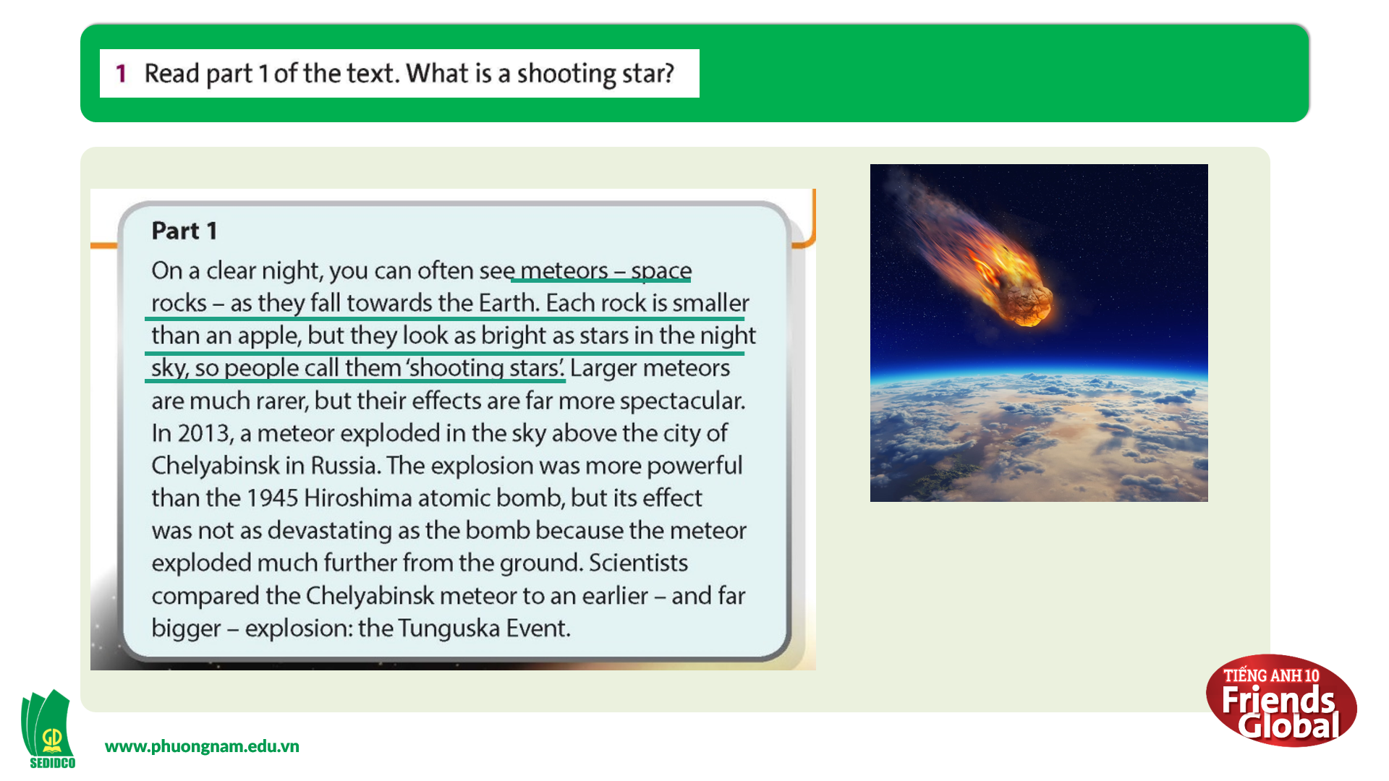  Suggested answer:  A shooting star is a meteor (a space rock) that is falling towards the Earth.  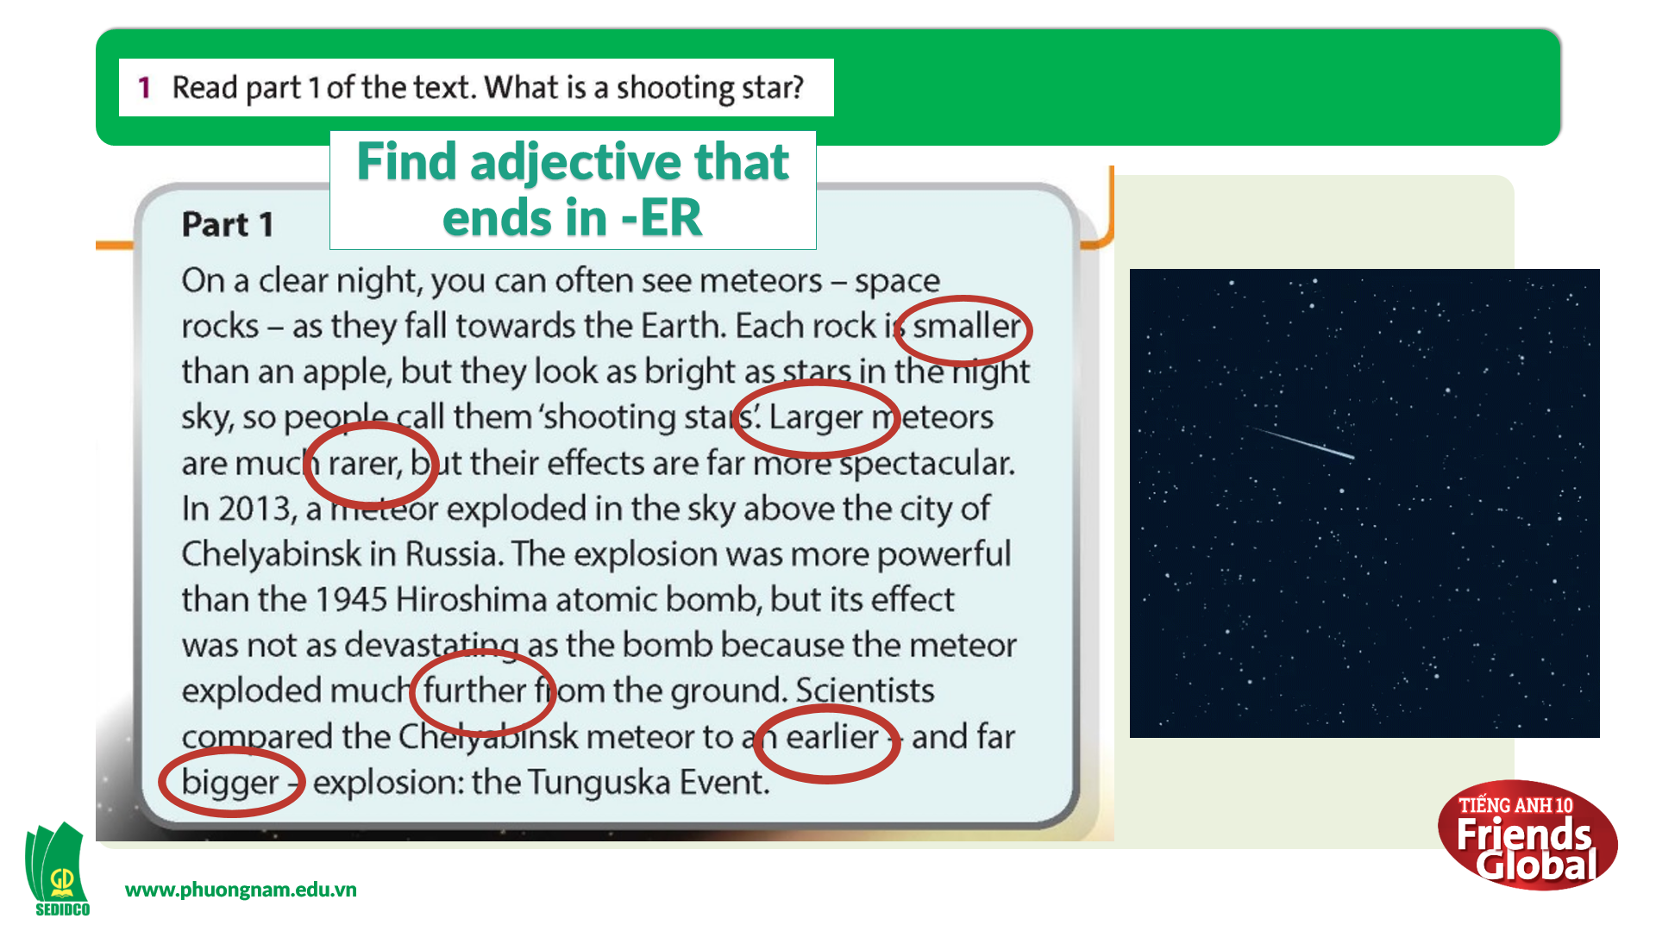  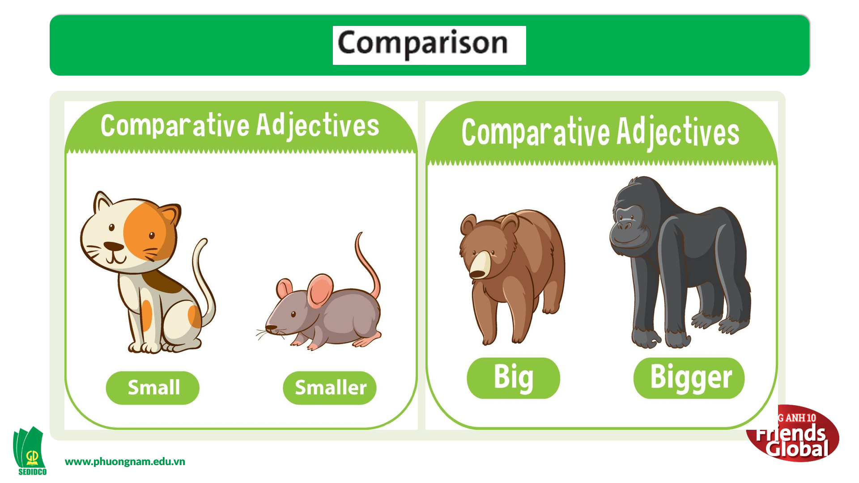  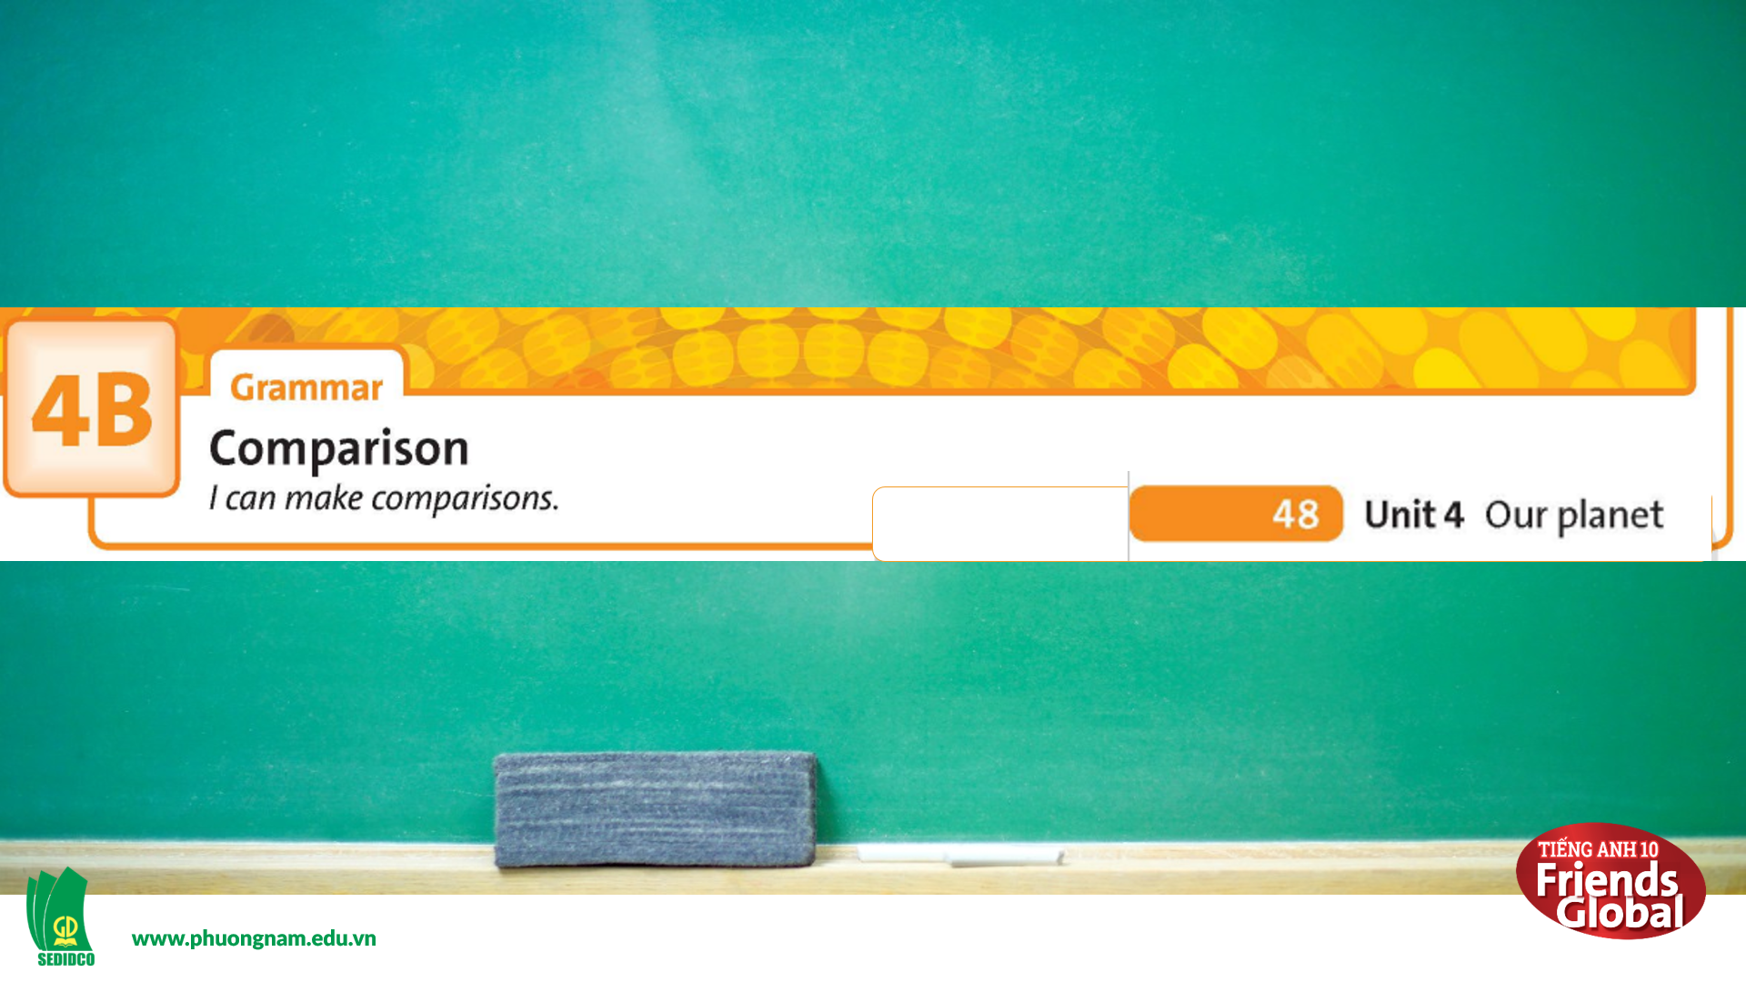

B. New lesson (35’)
- Activity 2: Presentation (5’)
a) Objective: Review student usage of the comparative adjectives
b) Content: Students review how to use long, short form of adjectives and irregular adjectives.
c) Outcomes: Students can apply the useful language in everyday reading and writing.
d) Competence: communication, presentation
e) Organisation of the activity:

TEACHER’S ACTIVITIES | STUDENT’S ACTIVITIES | CONTENTS
PRESENTATION. T-Ss/ S-S/ Indiv.  Exercise 2 page 48  - Ask students to complete the table with comparative adjectives from the text in Ex1  - Review the usage of comparative adjectives | - Work in pairs to complete the task  - Listen to the teacher and take notes | 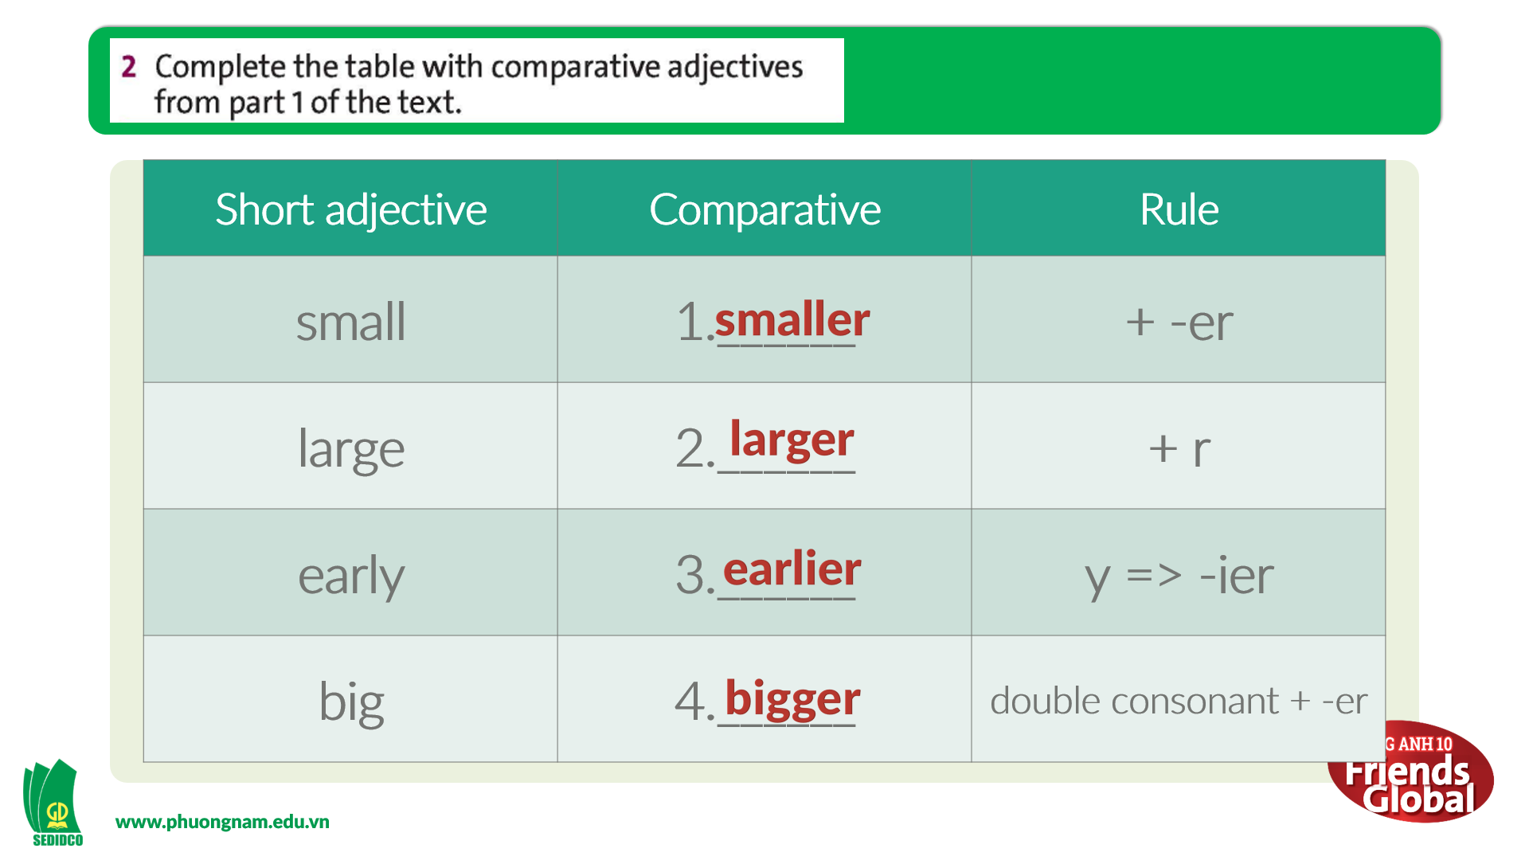  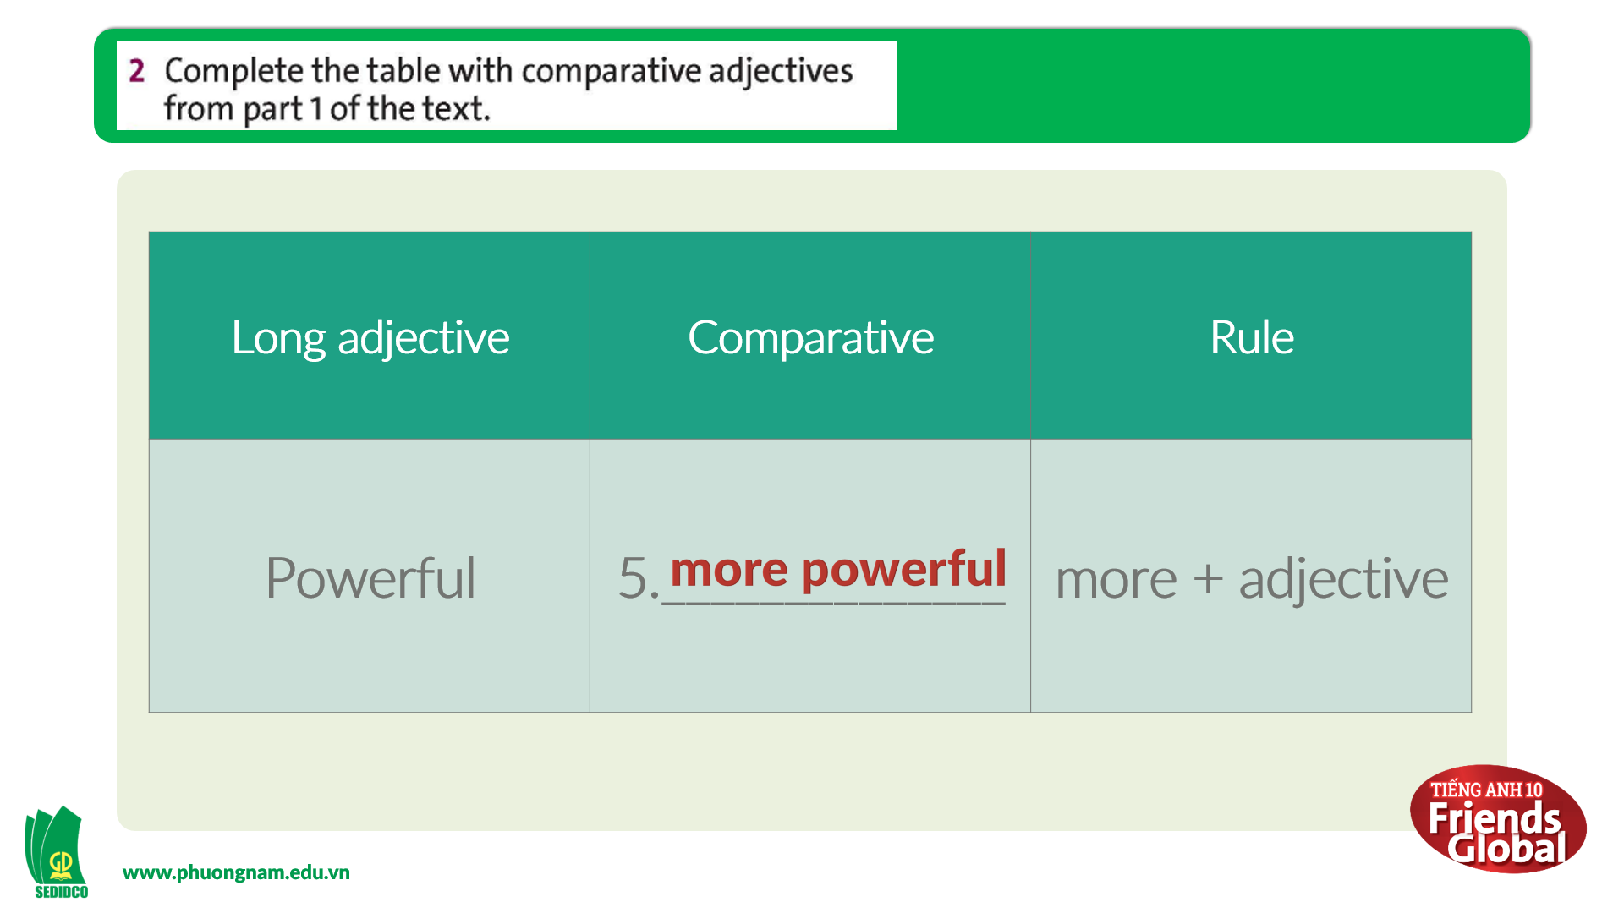
- Activity 3 Practice (20’)
a) Objective: Students know more about comparison adjective.
b) Content:
Grammar study
Writing
c) Outcomes: Ss how to use irregular and regular verbs in past simple properly.
d) Competence: communication, collaboration, presentation
e) Organisation of the activity:
TEACHER’S ACTIVITIES | STUDENT’S ACTIVITIES | CONTENTS
PRACTICE. T-Ss/ S-S/ Indiv.  Activity 1 (5’): Exercise 3 page 48  - Go through the Learn this! box together  - Ask students to highlight some main ideas  - Ask students to read the text again quickly to find examples for each rule  - Check the answers and show students where to get the answers  Activity 2 (5’): Exercise 4 page 48  - Ask students to listen to the examples and answer the questions given  - Play the audio again to check the answers  Activity 3 (5’): Exercise 5 page 48  - Go through the Look out! box together  - Ask students to read the text quickly and fill in the blanks with the comparative form of the words in brackets  - Check the answers  Activity 4 (5’):  - Ask students to rearrange to make questions beginning with Which…? using the comparative form of the adjectives  - Check the answer | - Read the Reading Strategy  - Highlight or underline main ideas  - Work in pairs to complete the task  - Listen to the teacher carefully and take notes  - Listen carefully and complete the task  - Listen to the teacher carefully and take notes  - Read the Reading Strategy  - Work in pairs to complete the task  - Listen to the teacher carefully and take notes  - Work in pairs to complete the task  - Check the answer with the teacher and take notes | 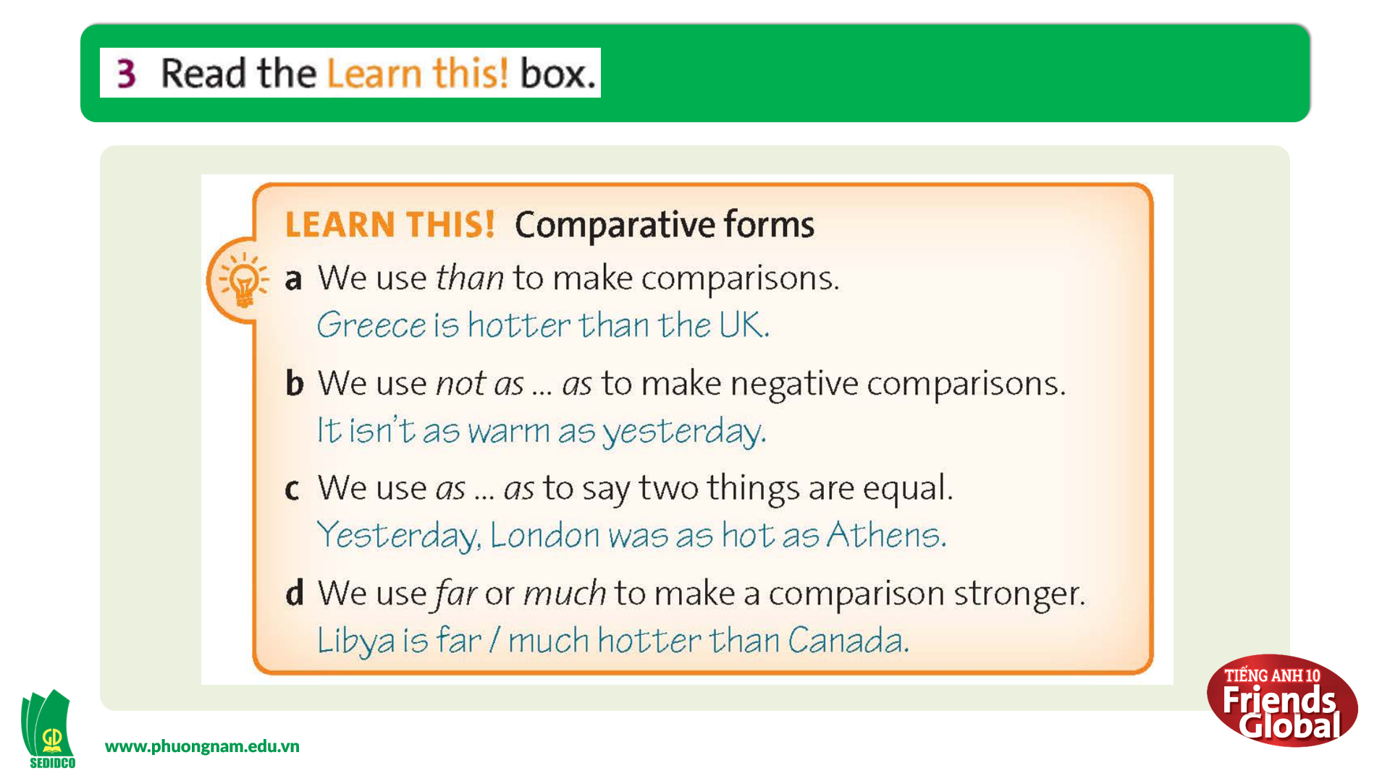  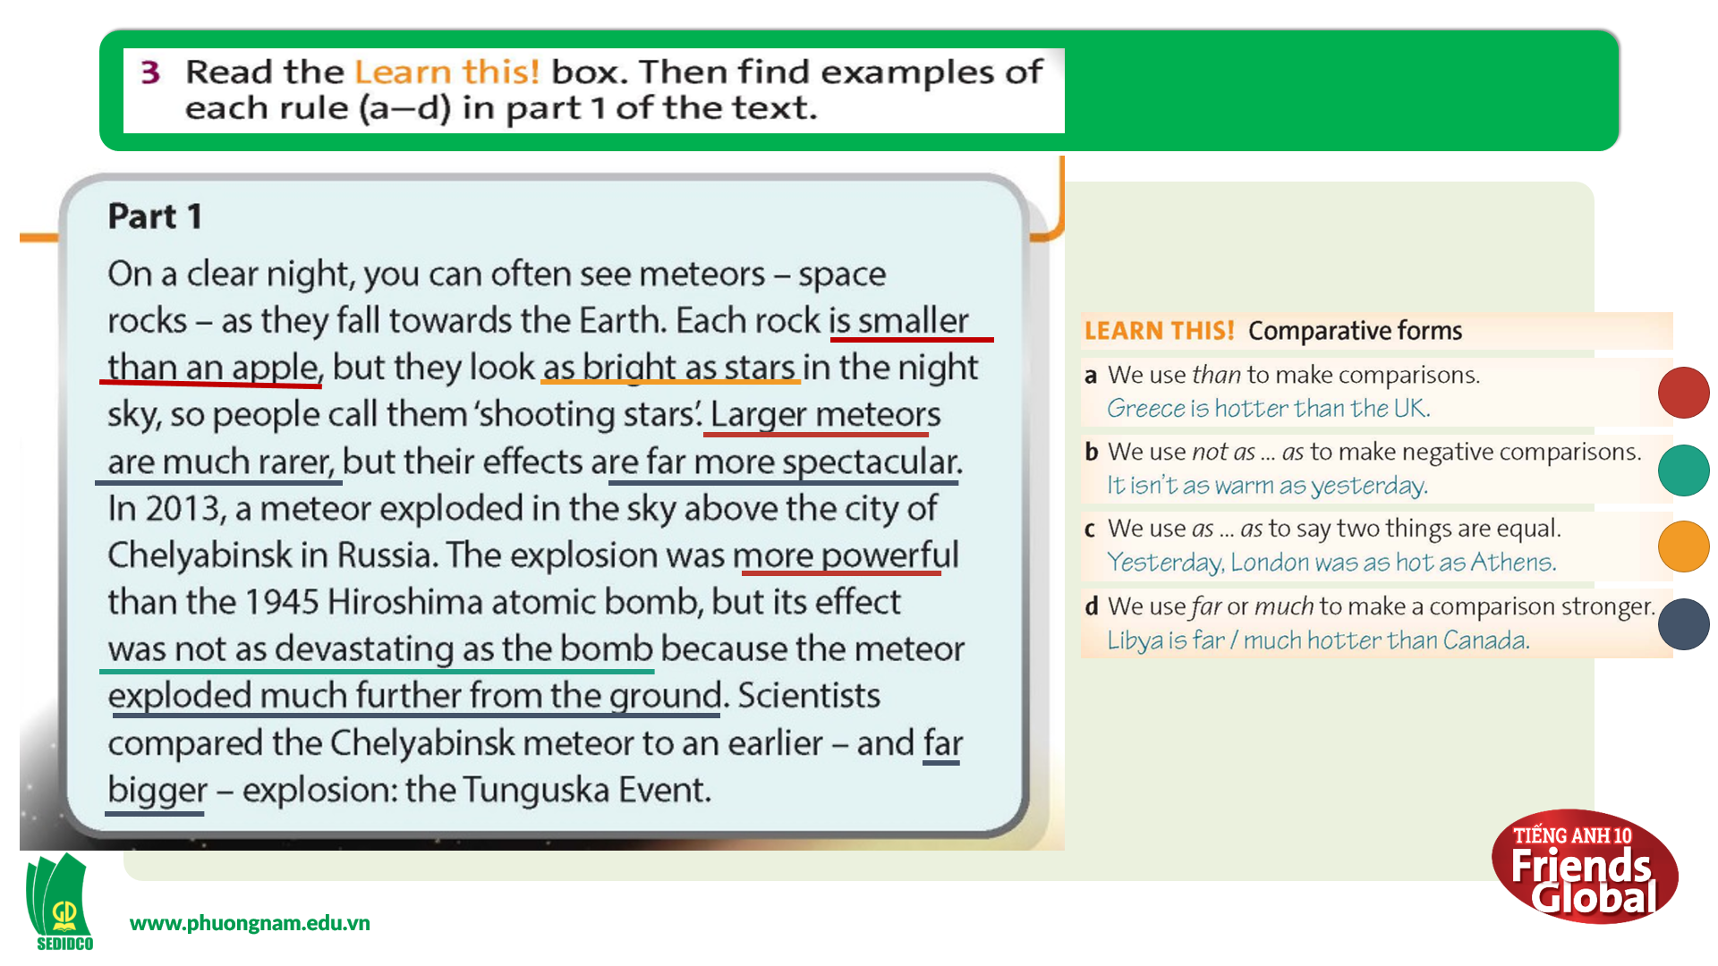  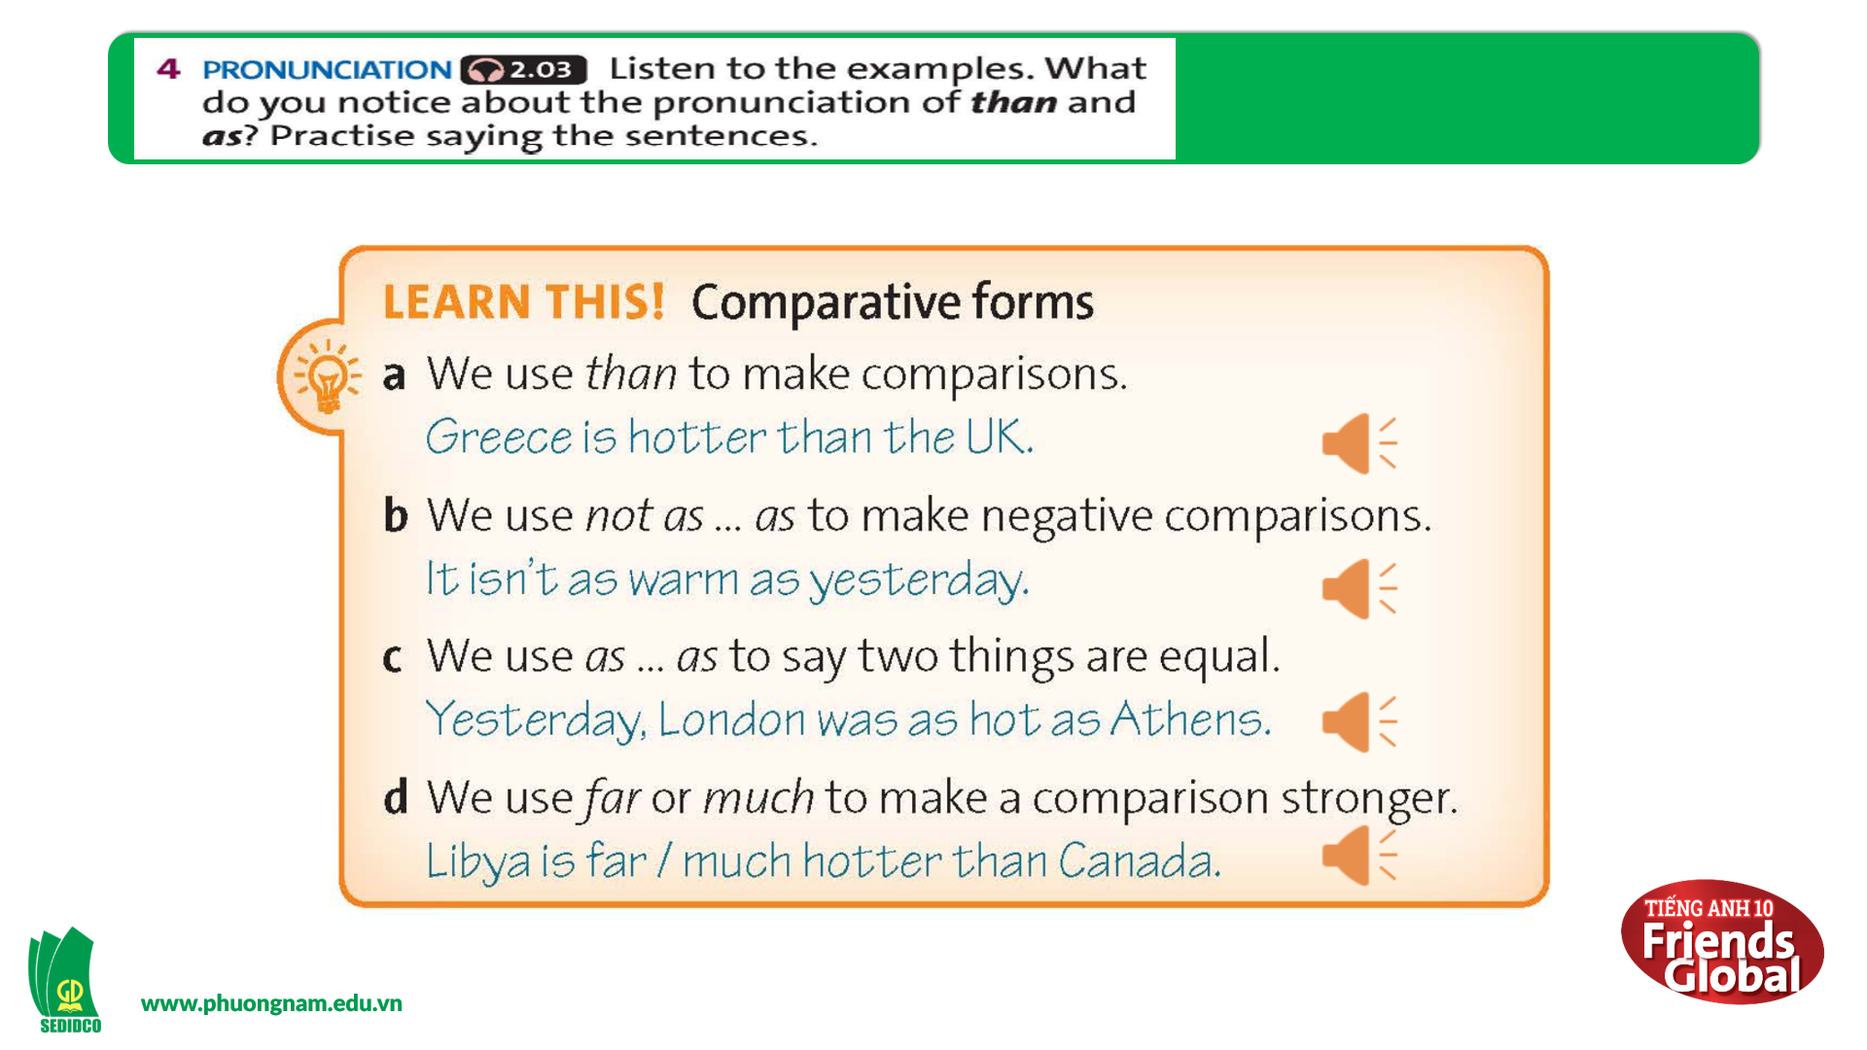  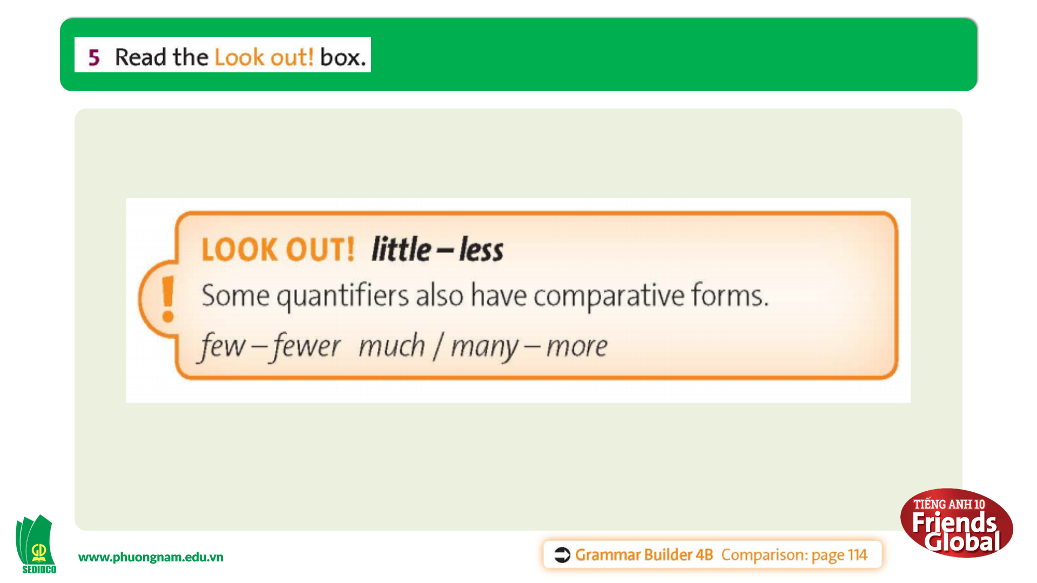  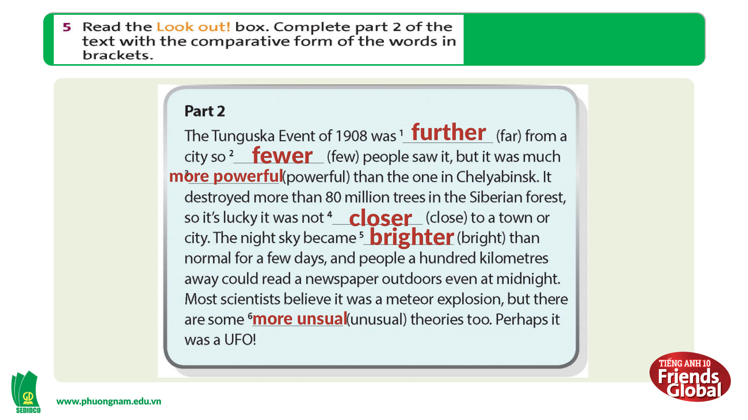  Answer:  1. further 2. fewer  3. more powerful 4. closer  5. brighter 6. more unusual  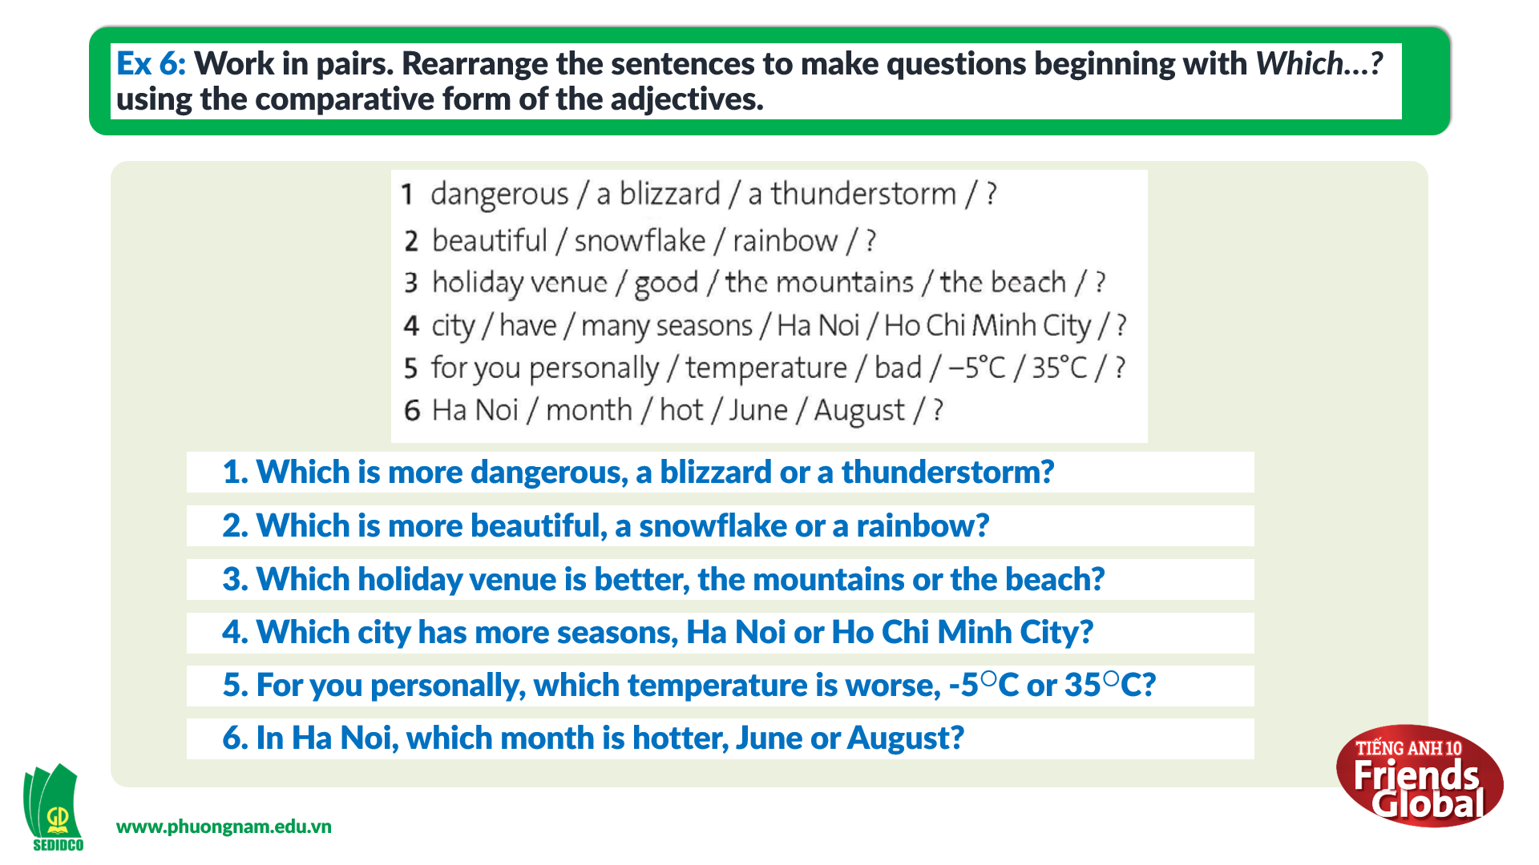  Answer:  1. Which is more dangerous, a blizzard or a thunderstorm?  2. Which is more beautiful, a snowflake or a rainbow?  3. Which holiday venue is better, the mountains or the beach?  4. Which city has more seasons, Ha Noi or Ho Chi Minh City?  5. For you personally, which temperature is worse, -5C or 35C?  6. In Ha Noi, which month is hotter, June or August?

- Activity 3: Outcomes (10’)
a) Objective: Ss can answer questions to ask questions about conditions using which. Communication is also be practiced.
b) Content: Mina’s birthday Game
c) Outcomes: Ss speak and listen mutually, they can apply the structure of past simple or some adjectives to their conversations.
d) Competence: Collaboration, communication, guessing
e) Organisation of the activity:
TEACHER’S ACTIVITIES | STUDENT’S ACTIVITIES | CONTENTS
PRODUCT. T- Ss/ S-S  GAME “THINK FAST”  - Ask students to work in groups, ask and answer six questions they have completed above in a limited time  - Monitor and help with grammar and vocabulary where necessary | - Work in groups and practice speaking together  - Take notes their friends’ answers while listening |   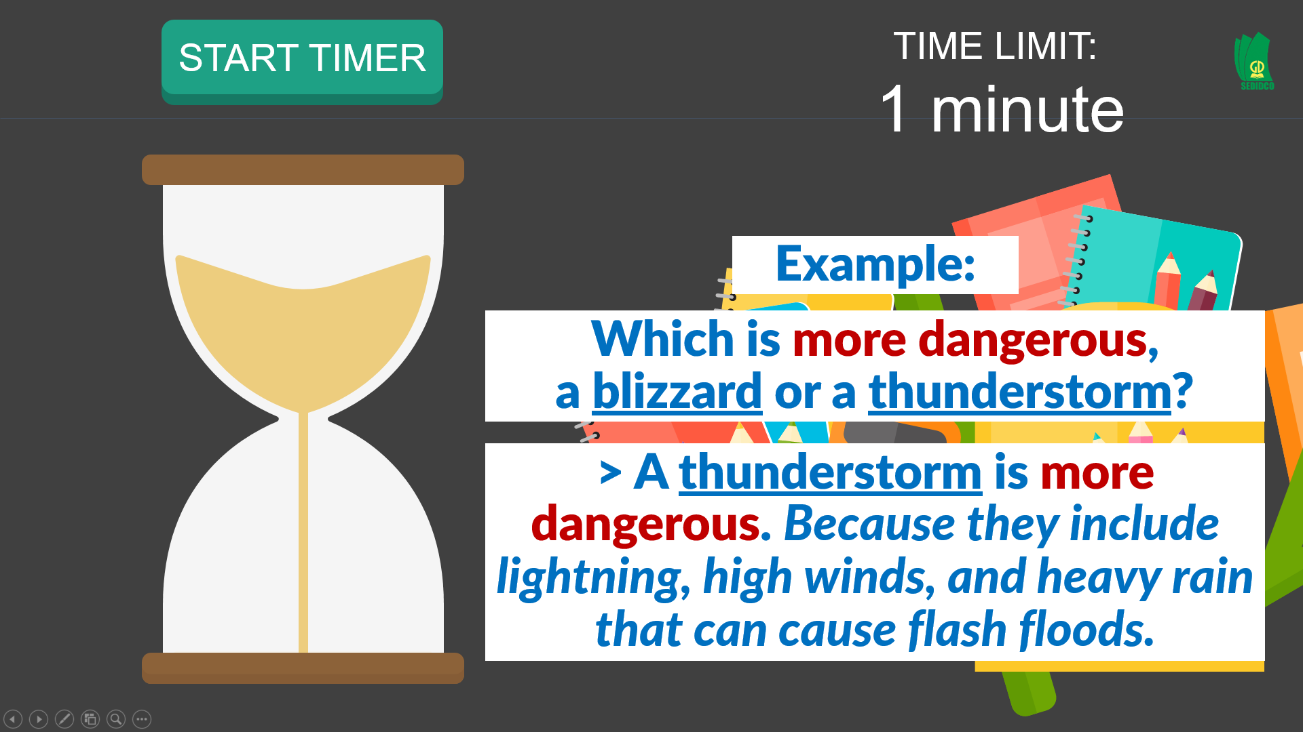  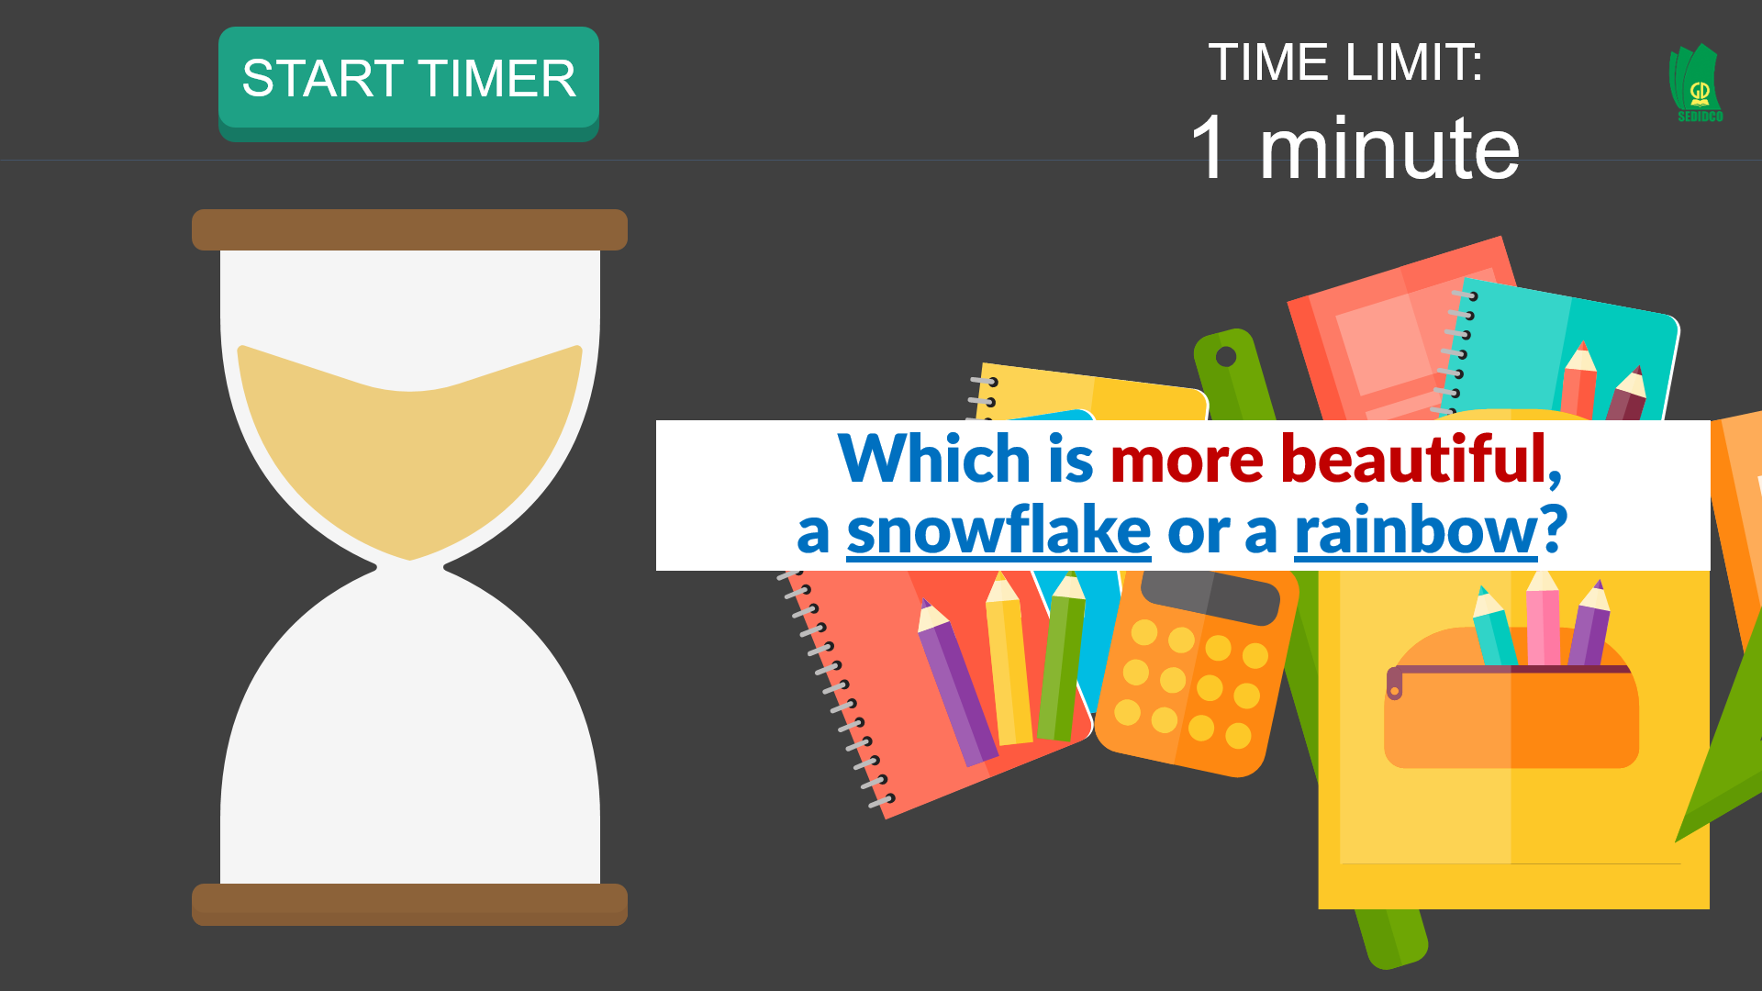
C. Consolidation (3’)
a) Vocabulary: irregular comparative adjectives/nouns about the weather
b) Grammar: Comparatives
D. Homework (2’)
- Learn by heart how to use comparison
- Review comparative adjective
- Do exercise
- Prepare: Unit 4 – C-Listening

