

Tiết thứ ....
UNIT 7: TRAFFIC
Lesson 3: A closer look 2

Class | Date of teaching | Attendence
7A | ..../09/2022
7B | ..../09/2022
7C | ..../09/2022
I. OBJECTIVES: By the end of this unit, students will be able to gain the following things:
1. Knowledge:
Know how to use:
- It to indicate distance
- should and shouldn’t
+ Pronunciation:
+ Vocabulary: Use the words about means of transport.
+ Grammar:
Structure | Examples
1. It to indicate distance | It is 4 kilometers from my house to school.
2. should | We should eat more vegetables and fruits.
3. shouldn’t | You shouldn’t stay up late everyday.
2. Competence:
a) General competencies:
- Students will be able to know more words and phrases about means of transport.
- Develop communication skills and cultural awareness
- Be collaborative and supportive in pair work and teamwork
- Actively join in class activities
b) Specific competencies:
- Group work and independent working, pair work, linguistic competence, cooperative learning and communicative competence.
- Sts can introduce themselves or one another fluently.
3. Qualities: The love of traffic; The awareness about importance of trafffic; Be ready to talk about means of transport; Know some daily activities in the street.
- Develop self-study skills.
II. PREPARATIONS
Teacher: Grade 7 text book, laptop, TV, pictures and realia, Computer connected to the Internet, Sach mem.vn
Students: Text books, pencils, pics, blank papers, realia,….
III. PROCEDURE:
In each activity, each step will be represented as following:
* Task delivering
** Task performance
*** Report and discussion
 Judgement
Activity 1. WARM UP (5’-IW, GW)
* Aim:
- To activate students’ knowledge on the topic of the unit
To enhance students’ skills of cooperating with team mates
* Content: SLAP THE BOARD
* Product: Having a chance to speak English and focus on the topic of the lesson.
* Implementation: Teacher’s instructions…
Teacher’s & Student’s activities | Content
SLAP THE BOARD  * Teacher gives instructions and sticks some road signs pictures onto the board.  ** In 2 group, Ss will choose 1 student in each group to go to the board.  - Teacher says a road sign message.  - Student quickly run and slap onto the correct road signs.  - Students take turns until finish all of the signs.   Teacher checks and corrects if Ss pronounce the signs incorrectly. | SLAP THE BOARD  Answers:  1- Cycle lane  2- School ahead  3- No cycling  4- No right turn  5- Schools ahead
Activity 2. KNOWLEDGE FORMATION (15'- PW, IW)
* Aim:
To introduce students the form of the key grammar and how to use them appropriately
* Content: Teach some new words, some action verbs go with nouns.
* Product: Ss learn how to use them.
* Implementation: Teacher’s instructions…
Teacher’s & Student’s activities | Content
IT INDICATING DISTANCE  - Teacher says: “This lesson today is going to tell you about “it indicating distance”  * Teacher draws students’ attention to the grammar point and the example  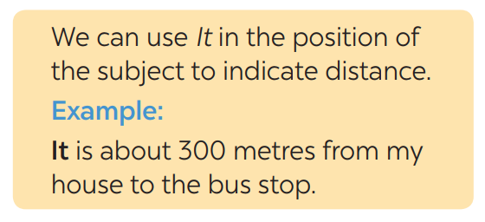  * Teacher asks Ss:  - What does the sentences tell us about?  Answer: Distance from his/her house to the bus stop  - What is the structure using in the sentence?  Answer: It be (about) + distance from A to B.  ** Ss read the grammar explicit and study the example.  *** Ss may discuss within groups/pairs before answering.   Teacher shows and says the sentences aloud and asks Ss to make similar sentences. | IT INDICATING DISTANCE  - What does the sentences tell us about?  Answer: Distance from his/her house to the bus stop  - What is the structure using in the sentence?  Answer: It be (about) + distance from A to B.
Activity 3. PRACTICE (15’-IW, PW, GW)
* Aim:
- To get students interested in the topic
- To set the context
- To help Ss understand the main idea of the text
- To practise asking and answering about distance.
- To practise the using should and shouldn’t.
* Product: Students’ answers.
* Implementation:
Teacher’s Student’s activities | Content
Task 1. Ex 1: Write sentences with It. Use these cues.  * Teacher asks Ss to look at the example and the task.  ** Ss work out and answer questions individually.  *** Ss share their answers in pairs.   T asks them to to check their answers.  * Then tell share them to share their sentences as a whole in class and correct for them. | Task 1. Ex 1: Write sentences with It. Use these cues.  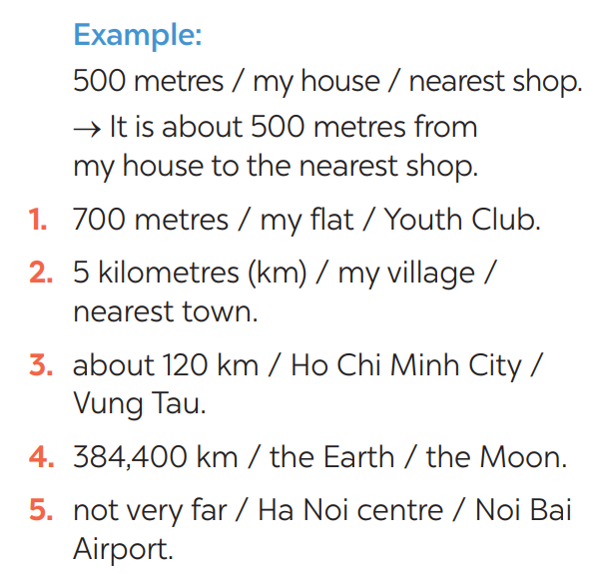  Answers:  1- It is 700m from my house/home to the Youth club.  2- It is 5 kilometres from my village to the nearest town.  3- It is about 120 km from Ho Chi Minh city to Vung Tau.  4- It is 384,400 km from the Earth to the Moon.  5- It is not very far from Hanoi centre to Noi Bai airport.
Task 2: Exercise 2: Work in pairs. Ask and answer questions about distances in your neighbourhood  * Teacher asks Ss to look at the example and identify the structure of the question: How far is it from … to …?  Then work with their partners who sit next to them to make similar conversations.  ** Ss do exercise 2 in pairs.  *** Ss write all conversations down on the notebooks.   Teacher corrects their answers as a class.  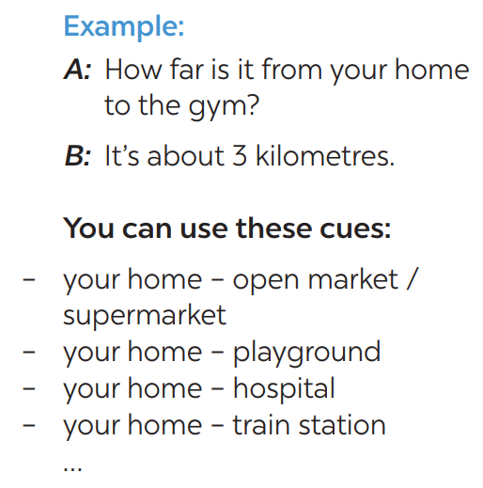 | Task 2: Exercise 2: Work in pairs. Ask and answer questions about distances in your neighbourhood  Suggested answer:  A: How far is it from your home to your school?  B: It's about 3 kilometers from my home to my school.  A: How far is it from your school to the station?  B: It's about 1 kilometer from my school to the station.
Task 3: Choose the correct option in brackets.  * Teacher draws students attention to the remember box. Teacher asks them to study the examples and identify the structure: S + should/shouldn’t + Vinf  * Teacher gives suggestions and asks students to make some similar sentences using the structures.  *** Teacher nominates Ss to read aloud the sentences.   Teacher checks and gives the corrections if they have mistakes. | Task 3: Choose the correct option in brackets.  Structure: S + should/shouldn’t + Vinf  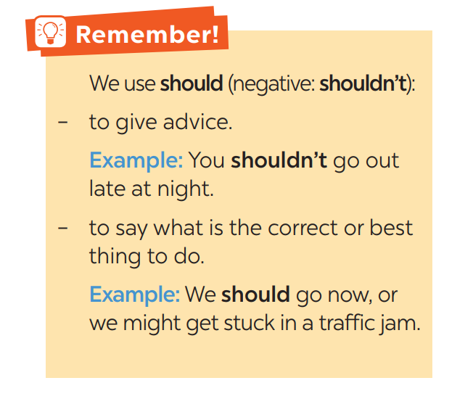  * Answer:  1. That's an interesting book. You should read it.  2. You nearly fell off your bike! You really should be more careful.  3. We shouldn't go swimming right after eating.  4. I think that he should eat less. He's becoming overweight.  5. There are a lot of cars out today. He shouldn't drive so fast.
Task 4: Complete each sentence, using should / shouldn’t.  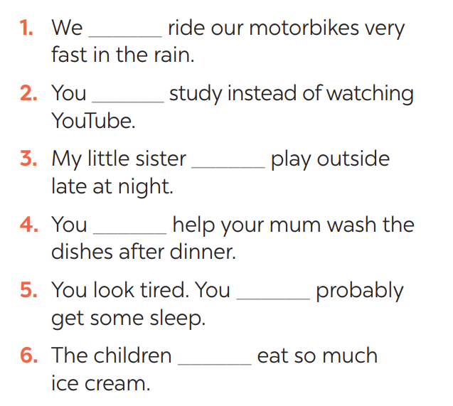  * Teacher gives Ss time to do the exercise individually and peer check with their partner.  *** Teacher nominates Ss to read aloud the sentences.   Teacher checks and gives the corrections if they have mistakes. | Task 4: Complete each sentence, using should / shouldn’t.  Answers:  1- shouldn’t  2- should  3- shouldn’t  4- should  5- should  6- shouldn’t
Activity 4. APPLICATION (7’-IW, PW, GW)
* Aim:
- To practise the using should and shouldn’t.
* Content: Using should and shouldn’t.
* Product: Students’work.
* Implementation: Teacher’s instructions
Task 5: Look at the pictures. Make sentences, using should / shouldn’t and the cues  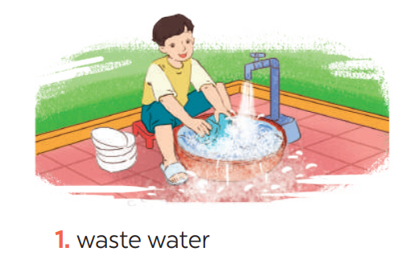  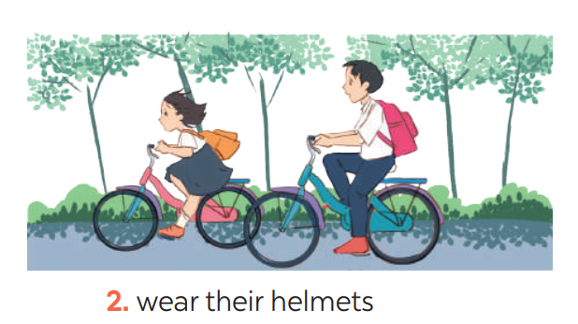  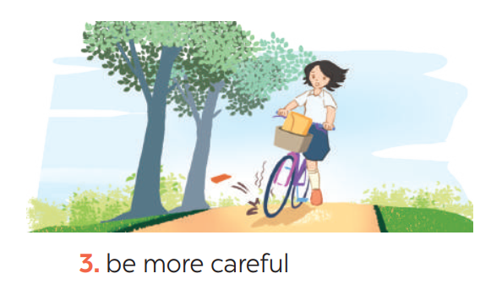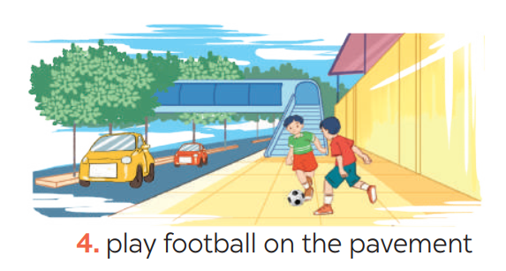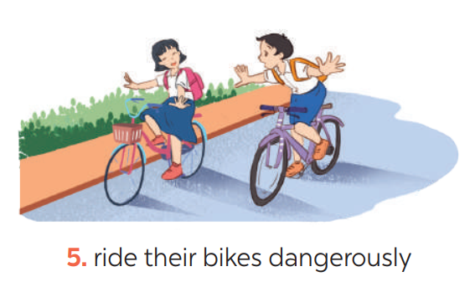  ** Ss do as instructed   Teacher gives Ss feedback.  - choose some common mistakes and suggest students how to avoid them.  - choose some typical errors and correct as a whole class | Task 5: Look at the pictures. Make sentences, using should / shouldn’t and the cues  Answers:  1- He shouldn’t waste water.  2- They should wear their helmets.  3- She should be more careful.  4- They shouldn’t play football on the pavement.  5- They shouldn’t ride their bikes dangerously.
* Wrap up  To help Ss memorise the target language and skills that they have learned  * Homework:  - Exercises in the workbook | * Wrap up  - It indicating distance  - Should/shouldn’t  - Scanning  * Homework:  - Exercises in the workbook
V. FEEDBACK:
With 7A ……………………………………………………………………………..…
With 7B …………………………...……………………………………..……………
With 7C ………………………………………………………………………….……

