Tiếng Anh 8 – i-LEARN SMART WORLD
UNIT 1 TEST - KEYS
I. PRONUNCIATION
A. Choose the word whose underlined part differs from the other three in pronunciation in each of the following questions.
1. A. task B. scooter C. school D. science
2. A. films B. sports C. runs D. flowers
3. A. shops B. books C. actors D. chats
B. Choose the word whose primary stress is NOT placed on the second syllable.
4. A. competition B. competitor C. afternoon D. economic
5. A. vacation B. become C. design D. cycling
II. USE OF ENGLISH
Choose the best option (A, B, C or D) to complete each of the following questions.
6. Henry usually plays badminton _____________ Sundays.
A. in B. at C. on D. into
7. The train to Texas ____________ at 9:45 every morning.
A. depart B. departs C. departing D. is departing
8. Her friends usually go __________ when they have free time.
A. shopping B. to shop C. shop D. the shops
9. Jane: What do you like doing in your free time? Mary: _____________.
A. I dislike swimming. B. Oh, that’s good.
C. Let’s go out for dinner. D. Going out for a walk.
10. ____________ is the sport of moving over the ground wearing shoes with wheels.
A. Cycling B. Roller skating C. Skiing D. Karate
11. Sue likes _______________ activities, such as playing soccer, cycling and camping.
A. outdoors B. indoor C. outdoor D. indoors
12. Alex loves doing arts and crafts, and he likes ____________ clothes, too.
A. designing B. to designing C. designs D. designed
13. Jack: __________ Jimmy: I played in the park with my classmates.
A. What do you do on Mondays? B. What did you do last Monday?
C. What are you doing on Monday? D. Are you playing in the park on Monday?
14. They dislike watching a movie ________ because the movie theater is often too crowded.
A. on the weekend B. in the weekend C. in weekend mornings D. at weekend mornings
15. My little sister loves indoor ____________, she seldom goes out.
A. activity B. active C. action D. activities
16. You should wear a helmet if you’re going ____________.
A. out for a walk B. swimming C. skateboarding D. fishing

17. We won’t leave the movie theater ___________ the action movie ends.
A. until B. during C. to D. from
III. WORD FORMATION
Write the correct form of the words in brackets.
18. What is the difference between roller skating and skateboarding? (DIFFERENT)
19. Before joining the cycling club, my daughter wasn’t an active girl. (ACTION)
20. My dad gave me this bicycle last week, he wants me to become a good cyclist. (CYCLE)
IV. ERROR RECOGNITION
Find the underlined part that needs correction in each of the following questions.
21. Outdoors activities can make people healthier.
A B C D
22. Julia usually watches action movie when she feels sad.
A B C D
V. READING
Read the three texts. For each question, choose the correct person.
Drew | 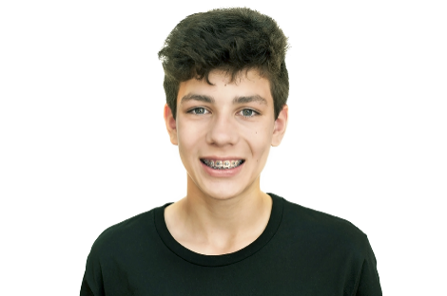  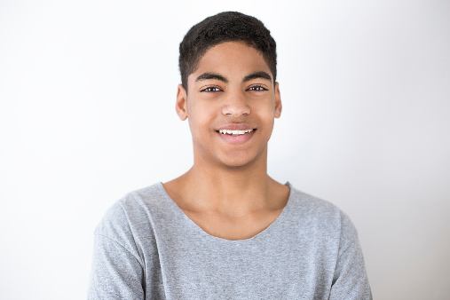 | - Drew has lots of hobbies, but they are all the same in one way. He doesn’t do any of them at the sports center or in the local park. He can do all of them in his bedroom while he watches TV or listens to music. In his room he has many of the things from his hobbies – a sweater, a scarf, a model boat, and lots of drawings of animals. He spends all his pocket money on his hobbies.
Don |  | - Don loved making models of ships for many years. He has many of them on the shelves of his bedroom. But he made nearly all the ships he was interested in. He still makes models when people give them to him as presents, but now he prefers playing board games online with his friends. Sometimes they have competitions.
Edward | 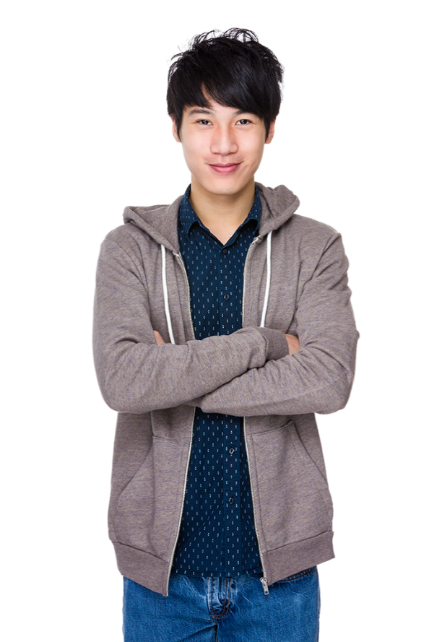 | - In the past, Edward’s parents got angry with him about his hobbies. ‘We buy you all the things for soccer, table tennis, or drawing, and then you say you are not interested in those hobbies anymore.’ Edward still starts new hobbies all the time, but now his parents think it’s good, because a hobby website pays him to write about each new hobby. He pays for the things he needs now himself.

 |  | Drew | Don | Edward
23. | Who earns money from his hobby? | A | B | C
24. | Who has a different favorite hobby from in the past? | A | B | C
25. | Who prefers making things to playing sport? | A | B | C
26. | Who doesn’t buy the things for one of his hobbies? | A | B | C
27. | Who writes a blog for a hobby ezine? | A | B | C

VI. LISTENING
You will hear a girl talking to her friend about her favorite hobby. Listen and write T (True) or F (False) for each statement.
The girl thinks her hobby …
28. | is exciting. | F
29. | is useful. | F
30. | is cheap to do. | T
31. | takes a lot of time to learn. | T
32. | is good for making friends. | F

VII. WRITING
A. Rewrite the following sentences without changing their meaning. Use the given word(s) if any.
33. When did you start to bake chocolate cookies? (AGO)
→ How long ago did you start to bake chocolate cookies?
34. My sister likes watching basketball better than playing it. (TO)
→ My sister prefers watching basketball to playing it.
35. We studied in the library from 9.30 to 11 o’clock yesterday. (BETWEEN)
→ We studied in the library between 9.30 and 11 o’clock.
36. It takes them 45 minutes to play table tennis every Saturday morning.
→ They spend 45 minutes playing table tennis every Saturday morning.
B. Use the given words or phrases to make complete sentences.
37. Mary/ like/ dance/ her friends/ her / free time / .
→ Mary likes dancing with her friends in her free time.
38. The action film / start / 7 p.m. / tomorrow / .
→ The action film starts at 7 p.m. tomorrow.
C. Put the words in the correct order to make correct sentences.

39. Vietnam / their / baseball / in / in / Children / dislike / playing /free time / .
→ Chidren in Vietnam dislike playing baseball in their free time.
40. practice / yesterday / jewelry / Jane / didn’t / designing / .
→ Jane didn’t practice designing jewelry yesterday.

*Audio script*
I do a hobby which is different from all my friends. Some of them do exciting things like rock climbing or extreme sports, but you can’t call my hobby exciting. Some of them do useful things like knitting or sewing. They make things which they can give to people in their family. I don’t think my hobby is useful in that way. Some friends have expensive hobbies like skiing. Well, it is expensive if you live in my country, because we don’t have any mountains or snow, so you have to travel to other countries to do your hobby. I don’t have that problem. I just need my eyes, my ears, and a good camera – oh, and a lot of knowledge about the difference between, for example, a hawk and a falcon. Luckily, you can find out all the information on the web now if you spend enough time. I love my hobby, but there is one bad thing about it. I do the hobby of bird watching on my own. You cannot talk to a friend while you are lying quietly in a bush waiting for a hawk or a falcon to fly over.

