SPEAKING ASSESSMENT ENGLISH 6
UNIT 7: TELEVISION
- Introduction - 0.4 pt (~2 ideas):
Share something about your family, school, house, friends, neighborhood,…
- Topic Speaking (Cue pictures) – 1.0 pt (~4 questions):
  1 |   2 |   3
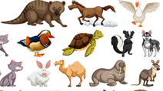  8 | - - What programme is it?  - - How do you spell it?  - - What are they doing?  - What animals are they?  - – Who/ What?  - An animal or person in a film?  - A programme which teaches Maths, English,..?  - A film/ show which makes people laugh?  - A person who watches TV? |   4
  7 |   6 |   5

