Full name: …………………………………………………………  Class: ………………………………………..………………………  School: …………………………………………………………….. | Mark:

SPEAKING TEST 1 (UNITS 1 & 2)

TASK 1 |  |  | Let’s talk about what students should do to have a green lifestyle. The following questions may help you.
 | 1. | What activities do you think can help you live green?
 | 2. | How can old things around your house be reused or recycled?
 | 3. | What will you do when you see someone drop litter on the street?
 | 4. | What green event are you going to attend this summer?

TASK 2 | Work in pairs. Each of you receives a card. Use the clues on your card to make questions about your friend’s picture. Use the picture on your card to answer your friend’s questions.

CARD A
Ask your friends about his/ her picture. Listen to his/ her answers.

1. | How old/ the student in the picture? | 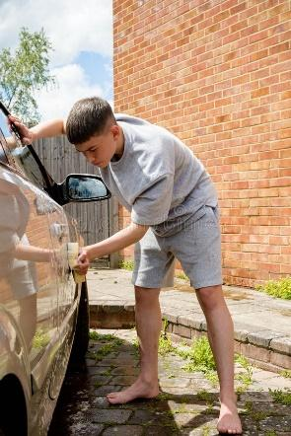
2. | What/ she/ doing?
3. | What/ should/ she/ do?
4. | How often/ should/ she?
5. | What/ can/ she/ learn from this?
 |  | Answer your friend’s questions about this picture.

CARD B
Ask your friends about his/ her picture. Listen to his/ her answers.

1. | How old/ the student in the picture?
2. | What/ he/ doing? | 
3. | What/ should/ he/ do?
4. | How often/ should/ he?
5. | What/ can/ he/ learn from this?
 |  | Answer your friend’s questions about this picture.

