SPEAKING ASSESSMENT ENGLISH 6
UNIT 9: CITIES OF THE WORLD
- Introduction - 0.4 pt (~2 ideas):
Share something about your family, school, house, friends, neighborhood,…
- Topic Speaking (Cue pictures) – 1.0 pt (~4 questions):
  1 | 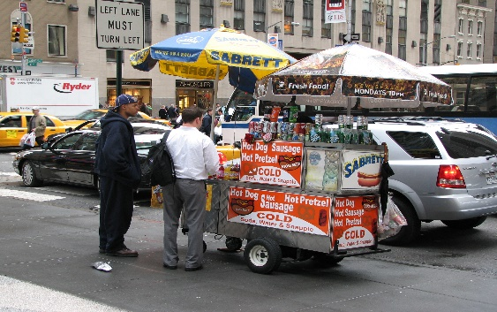  2 | 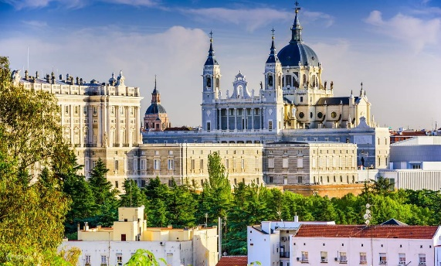  3
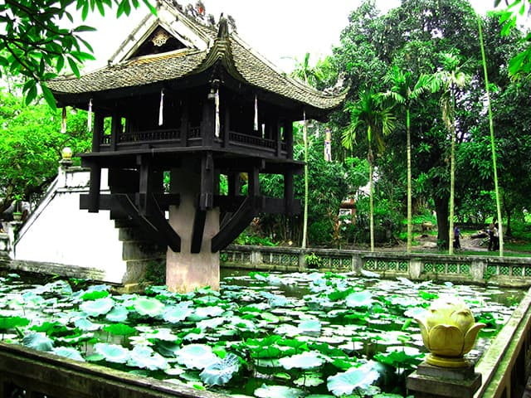  8 | - - What is this? / What is the name of this place?/ What city is it?  - What do you see in the picture?  - - How do you spell it?  - - What is the capital of Viet Nam?  - Which place do you go there by boat to buy or sell something?  - - It’s a big city. It has the statue of liberty.  8  7 | 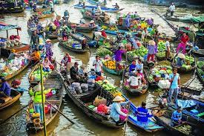  4
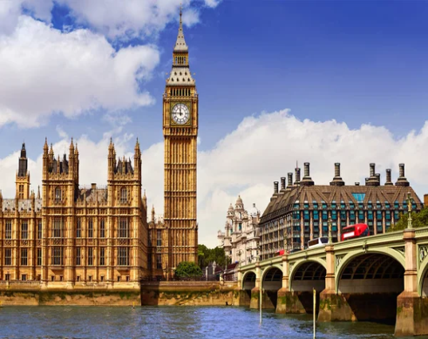  7 | 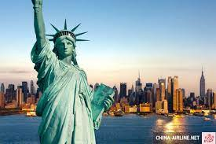  6 | 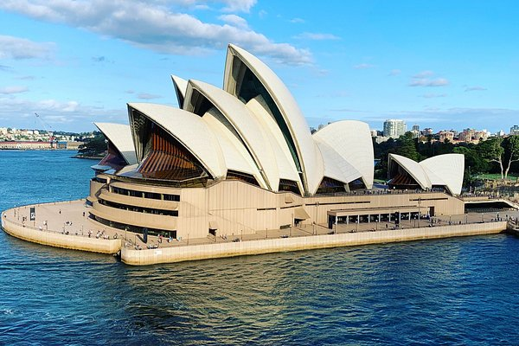  5

