Period
LESSON PLAN
TIẾNG ANH 10 FRIENDS GLOBAL
UNIT 1: FEELINGS
LESSON 1G: SPEAKING – NARRATING EVENTS
I. OBJECTIVES:
By the end of the lesson, Ss will be able to:
1. Knowledge:
- review some extreme sports and narrate events in the past
- Grammar: past simple tense
2. Ability:
- main skills: listening and speaking skills
- sub skills: reading and writing skills
- React and show interest to past events.
3. Quality:
- have positive attitude in English language learning so that they can participate enthusiastically in all classroom activities, especially with the topic conducted by the teacher
- know a structure for narrating events
II. TEACHER AIDS AND LEARNING MATERIALS:
Lesson plan, PPT slides, student’s book, workbook, notebook, personal computer (if any), projector/TV, speakers, IWB software.
III. PROCEDURES:
A. Warm-up (5’)
a) Objective: Introduce the new lesson and set the scene for Ss to acquire new language; get students' attention at the beginning of the class by means of enjoyable and short activities as well as to engage them in the steps that followed.
b) Content: Game ‘Hidden Pictures’
c) Outcomes: Students can gain more confidence and interest in the lesson.
d) Competence: communication, collaboration, guessing
e) Organisation of the activity:

TEACHER’S ACTIVITIES | STUDENT’S ACTIVITIES | CONTENTS
WARM-UP. T-Ss/ S-S  Game ‘Hidden Pictures’  - Divide class into groups to answer. Invite some students to guess extreme sports. Click on some colored boxes to give students hints about the word. If students get the correct answer before the teacher showing the hidden picture, they can get bonus. If students don’t get it, click ‘Show’ to share the answer.  - Have students read aloud the words.  - Lead in the lesson ‘Narrating events’ | - Play in groups.  - With one correct answer, students will get one point.  - Read aloud.  - Open book page 18. |     

B. New lesson (35’)
- Activity 1: Pre (10’)
a) Objective: Students get to know some words about accidents and injuries.
b) Content:
Grammar study
Speaking
c) Outcomes: Students review how to use affirmative or negative past simple form of the verbs correctly.
d) Competence: communication, presentation, guessing
e) Organisation of the activity:

TEACHER’S ACTIVITIES | STUDENT’S ACTIVITIES | CONTENTS
PRE. T-Ss/ S-S/ Indiv.  Activity 1 (6’): Task 2 page 18. Complete the dialogue with the correct affirmative or negative past simple form of the verbs below.  - Review students about affirmative and negative form of regular/ irregular and ‘to be’ verbs.  - Ask students to complete exercise 2.  - Let the students listen to check answers themselves.  - Check the answers.  Activity 2 (2’): Task 3 page 18. Does the photo go with the first or second half of the dialogue? How do you know?  - Ask the student guess if the photo on page 18 goes with the first or the second half of the dialogue.  - Invite some students to present their ideas.  - Give the answer to the class.  Activity 3 (2’): Show Speaking Strategy box for narrating events.  - Present Speaking Strategy box to students. Focus on what they should follow to tell events. | - Listen carefully to the teacher.  - Do the exercise.  - Listen to the recording t correct.  - Check the answer with the teacher.  - Do what the teacher said.  - Volunteer to share ideas.  - Check the answer with the teacher.  - Listen to the teacher and take note. | 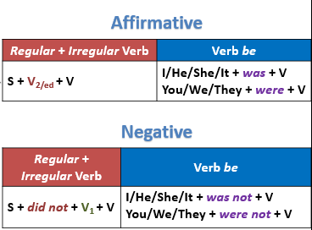  Answers:  1. learned  2. loved  3. wasn’t  4. got  5. spent  6. didn’t leave  7. watched  Answer:  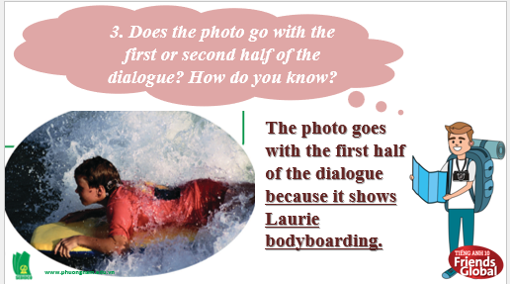  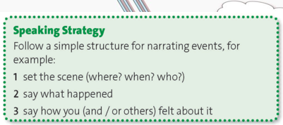
- Activity 2: While (18’)
a) Objective: Students can answer the questions to critical thinking, and they can finish the tasks in the textbook. Critical thing skills (guessing/ reasoning) and communication can also be practiced.
b) Content: Students match and circle. Then , find the phrases and practice.
c) Outcomes: Students read and write, and they can apply the useful language in everyday conversations.
d) Competence: communication, collaboration, presentation
e) Organisation of the activity:
TEACHER’S ACTIVITIES | STUDENT’S ACTIVITIES | CONTENTS
WHILE. T-Ss/ S-S/ Indiv  Activity 1 (5’): Listen to three girls talking about their summer holidays. Match each speaker (1-3) with an event (a-c) and circle the correct adjective to describe how she felt about it.  - Ask them to match and circle. Play the audio for students.  - Check the answers.  Activity 2 (5’): Show Reacting and showing interest box.  - Introduce the box to the students.  - Highlight how to use these phrases with a higher voice to show interest.  Activity 3 (3’): Find three more phrases for reacting and showing interest.  - Ask students to find in the dialogue three phrases for reacting and showing interest.  - Give the answers to the class.  Activity 4 (5’): Practice saying the phrases above and the dialogue. Try to sound interested!  - Ask students to practice saying the phrases and the dialogue and try to sound interested.  - Call out some pairs to read aloud and check their pronunciation. | - Listen to the audio. Match and circle.  - Check the answers with the teacher.  - Listen to the teacher and take note.  - Find three phrases in the dialogue.  - Check the answers with the teacher.  - Practice the phrases and dialogue.  - Volunteer to say. | Answers:  a. 2 (worried)  b. 1 (surprised)  c. 3 (envious)  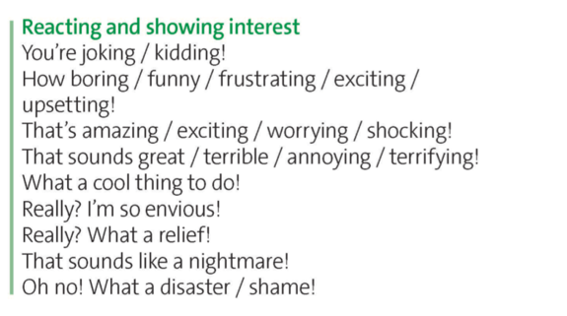  Answers:  Wow!  Oh dear! How awful!

- Activity 3: Outcomes (7’)
a) Objective: Ss work in pairs to take turns to say a sentence from the list below using the correct past simple form of the verbs in brackets and react with a suitable phrases form exercise 5.
b) Content: Game ‘Doraemon English’
c) Outcomes: Ss speak and listen mutually, they can apply new words and phrases they have learnt in their daily conversations.
d) Competence: Collaboration, communication, guessing
e) Organisation of the activity:
TEACHER’S ACTIVITIES | STUDENT’S ACTIVITIES | CONTENTS
POST. T-Ss/ S-S  Game ‘Doraemon English’  - Ask students to work in pairs, pick a letter from A to I to answer the questions with hints. If students get the correct answer, they can get points from their choice. Click on ‘Exit’ to end the game.  - Suggestive answers:  “I learnt to play a new song on the guitar”- How exciting! | - Work in pairs and pick a letter on the screen.  - With correct answer, students can get points. | 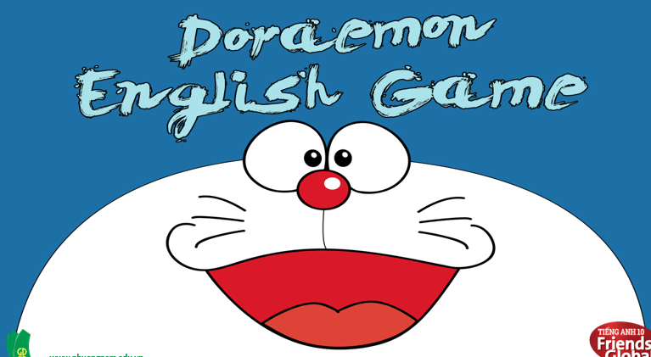  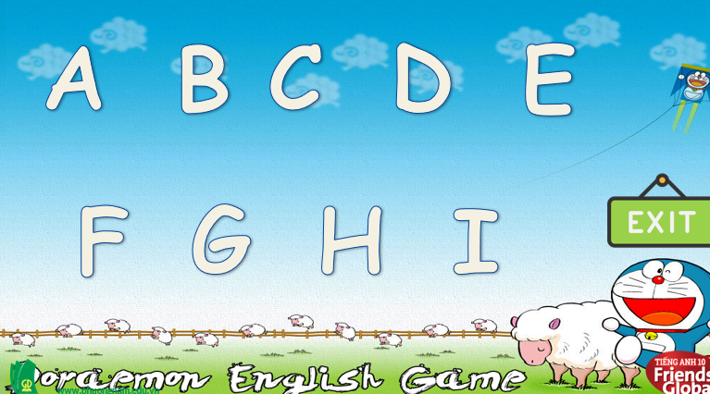  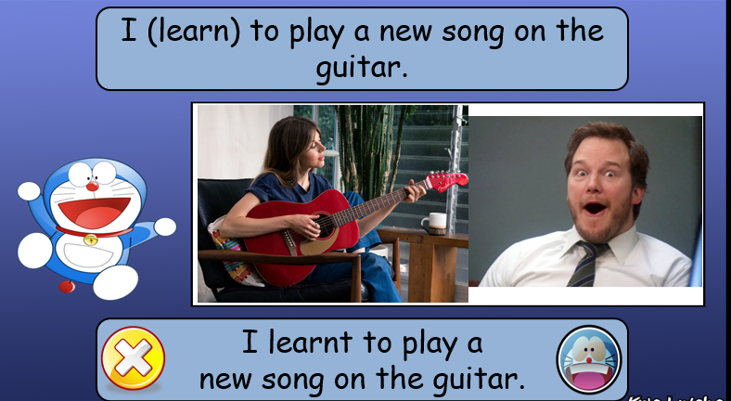
C. Consolidation (3’)
Grammar: past simple tense with affirmative and negative form
Ways to narrate events and react to show interest.
D. Homework (2’)
- Practice telling an event from your last summer and reacting to the story.
- Do exercise
- Prepare: Unit 1 – H- Speaking (page 19– SB)

