READING
PART 1
Look at the picture. Read the words. Which words go with the picture? Fill in the correct circles on your answer sheet.
1.

(A) The boy is drawing a picture. | (B) The boy is taking a photo. | (C) The boy is talking on the phone
The answer is “B”. Fill in “B” on your answer sheet.
2.
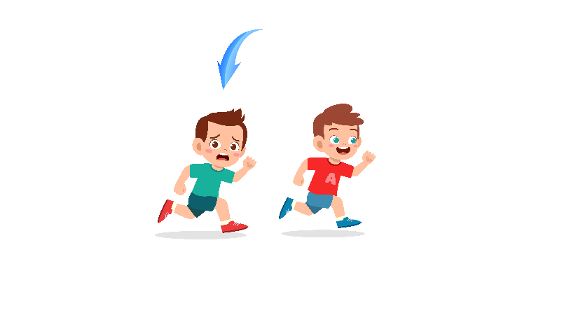
What does the arrow show?
The boy with the arrow is ahead of the other boy.
(A) Ahead | (B) Beside | (C) Under
The answer is “A”. Fill in “A” on your answer sheet.

3.
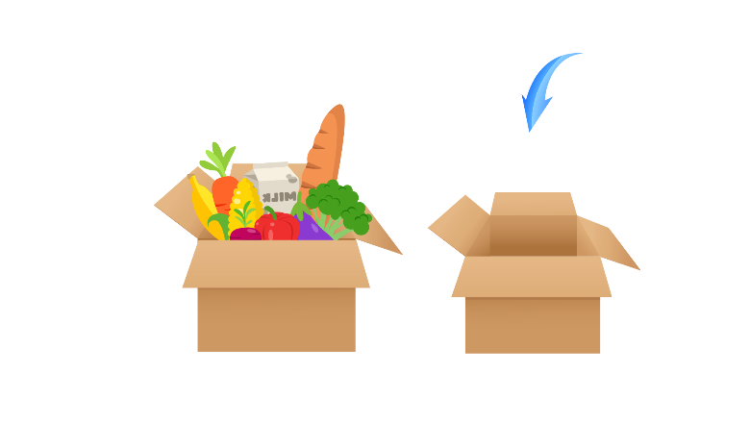
(A) Empty | (B) Full | (C) Noisy
4.
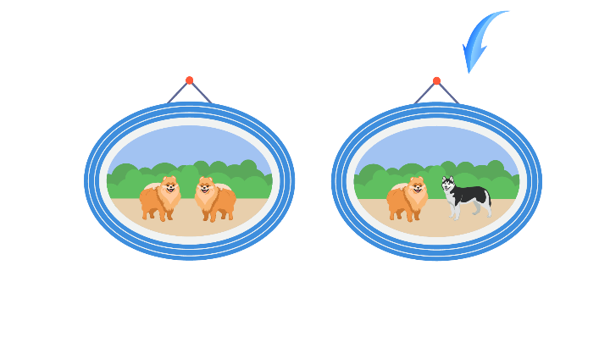
(A) Alone | (B) Same | (C) Different
5.
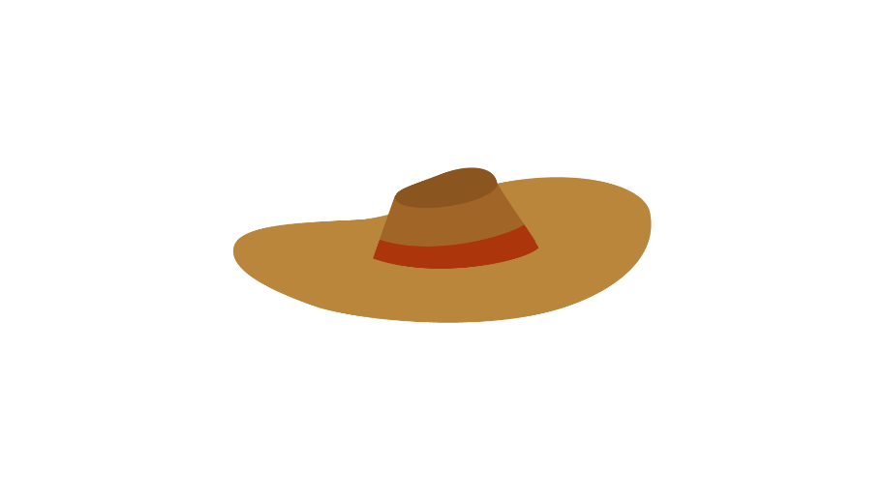
(A) A hat | (B) A basket | (C) A baseball bat
6.
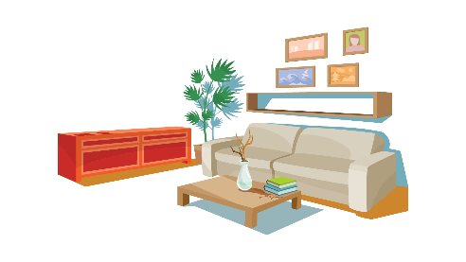
(A) bedroom | (B) kitchen | (C) living room
7.
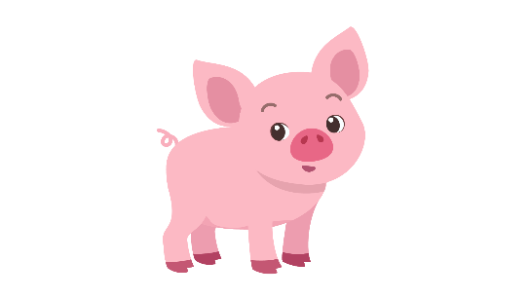
(A) cat | (B) pig | (C) sheep
8.

(A) Carrot | (B) Bean | (C) Corn
9.
(A) In front of | (B) Next to | (C) Opposite
10.
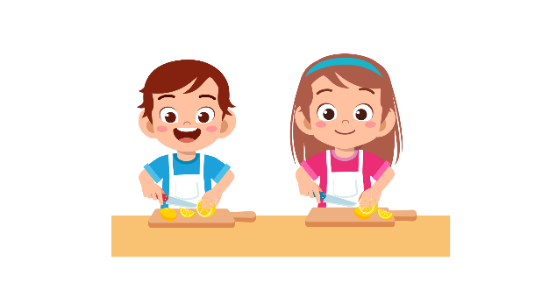
(A) They are buying lemons. | (B) They are cutting lemons. | (C) They are throwing lemons.
11.
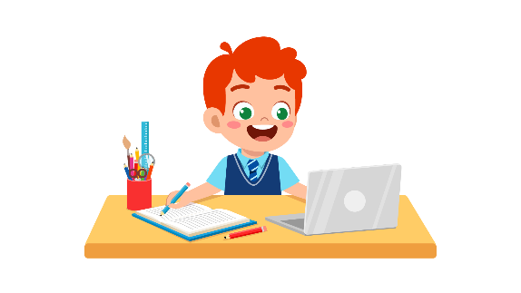
(A) The boy is watching TV. | (B) The boy is studying. | (C) The boy is eating.
12.
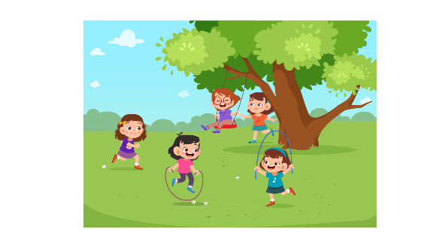
(A) The girls are folding papers. | (B) The girls are playing in the playground. | (C) The girls are sitting in class.
13.
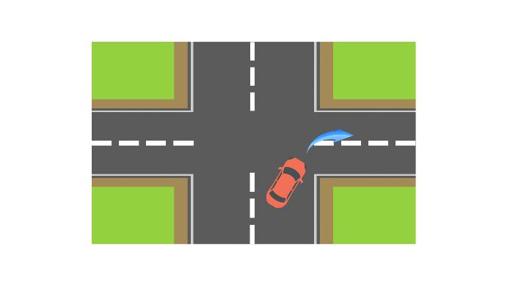
(A) The car is turning left.  14. | (B) The car is turning right.  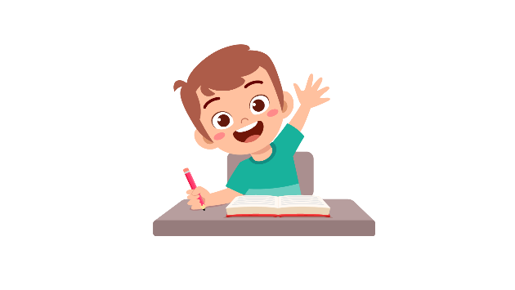 | (C) The car is stopping.
(A) The boy is raising his hand. | (B) The boy is standing. | (C) The boy is taking notes.
15.
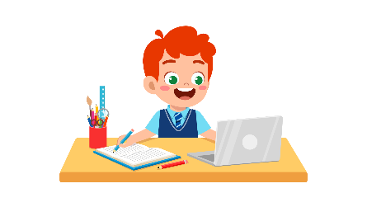
(A) They are dancing. | (B) They are listening to music. | (C) They are writing in the notebook.
16.
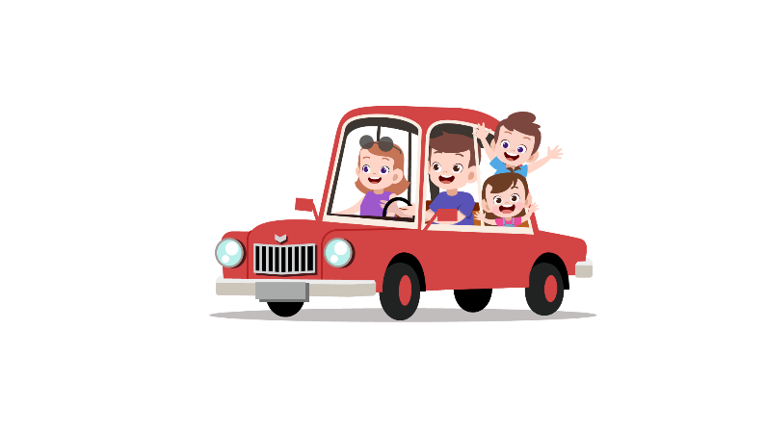
(A) The family is in the car. | (B) The family is on the car. | (C) The family is out of the car.
17.
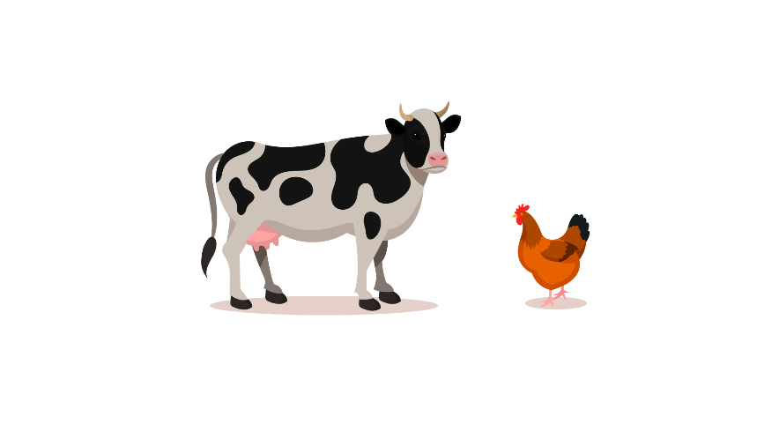
(A) The chicken is bigger than the cow. | (B) The cow is bigger than the chicken. | (C) The cow is smaller than the chicken.

PART 2
Read and find the answer.
Fill in the correct circles on your answer sheet.
Let’s do an example.
- Students go to class here. Teachers work here. It has many desks. What is it?
  - (A) A house
  - (B) A school
  - (C) A bank
The correct answer is a school. Fill in "B" on your answer sheet.

- It is a huge place. Kings and queens live here. It is beautiful.
Where is it?
(A) A castle
(B) A bookstore
(C) A hospital

- This is a school object. You write chalk on it. The teacher writes on it for the class.
What is it?
(A) A paper
(B) A notebook
(C) A board

- This takes people from one place to another. You need tickets for it. This travels on rivers.
(A) A bike
(B) A taxi
(C) A boat

- You can’t talk. Your throat hurts a lot. You can’t swallow. You have a _________.
(A) broken leg
(B) sore throat
(C) runny nose

- You do this when you want to know the meaning of letters. The letters are on the textbooks or magazines.
You _________ .
(A) listen
(B) read
(C) speak

- You go outside and it is really sunny. You sweat a lot. It is _________.
(A) warm
(B) wet
(C) hot

- The girl eats little. She doesn’t have body fat. She is __________.
(A) short
(B) tall
(C) thin

PART 3
Read Henry’s to-do list. Answer questions 26 to 29.
Fill in the correct circles on your answer sheet.
Henry’s To-do list
Clean the floor □
Empty the trash bin ☑
Take Alex (my dog) out for a walk □
Do my homework ☑
Write a letter to Amy ☑
Watch a new cartoon episode □

26. Henry has a dog. Its name is ____________.
(A) Henry
(B) Amy
(C) Alex

27. Henry writes letters. He is writing to ____________.
(A) Henry
(B) Amy
(C) Alex

28. In the list, Henry has finished ____________.
(A) cleaning the floor
(B) watching a new cartoon episode
(C) doing his homework

29. In the list, Henry hasn’t finished ____________.
(A) taking his dog out
(B) writing a letter
(C) emptying the trash

Read the cinema timetable. Answer questions 30 to 33.
OUR PARAGRAPH
 | Introduction | Body | Conclusion
Pete | Yes | No | No
Nian | Yes | Yes | No
Winston | No | Yes | Yes
Liliana | No | No | Yes

30. What are these students preparing for?
(A) A talk
(B) A game
(C) A paragraph

31. Which part does Pete get?
(A) Introduction
(B) Body
(C) Conclusion

32. Who gets the body part?

(A) Nian
(B) Pete
(C) Liliana
33. How many people are there in the conclusion part?
(A) 1
(B) 2
(C) 4

Read the letter. Answer questions 34 to 35.

Dear Father,

This is Dane. I am writing this to tell you about my first day at school. I was really nervous, but school was fun. I talked to new friends, and the teachers were nice to me.

In the Science class, we learnt how to build a water rocket. It worked. It flied in the air in front of our eyes. In the English class, we sang the school song. My singing was not good. I really hope that you will return home soon.

Sincerely,
Dane

34. Why does Dane write to his father?
(A) To ask him about the gifts.
(B) To talk about his best friends.
(C) To tell him about his first day at school.
35. What is probably true about Dane’s father?
(A) He is a teacher.
(B) He is a funny person.
(C) He isn’t at home with Dane.

Read the email. Answer questions 36 to 37.
To: Mrs. Smiths
From: Olivia
Subject: The soup

Dear Mrs. Smiths at the canteen. This is Olivia, a student at our school. This email is to tell you about the soup. It has too much salt. I wish to have less salt in our soup. Don’t worry, your other dishes are really tasty. Thank you very much for preparing our meals everyday. Your smiles are beautiful, too.

The student,
Olivia

36. What is probably true about Mrs. Smiths?
(A) She doesn’t smile.
(B) She works at the office.
(C) Her soup has much salt.

37. Why does Olivia write to Mrs. Smiths?
(A) To thank her for preparing their meals.
(B) To compliment her dishes.
(C) To complain about the soup.

Read the information on the ID card. Answer questions 38 to 39.

HOW TO MAKE LEMONADE
Prepare 1 lemon, a cup of water and sugar!
Step 1. Cut the lemon in half.
Step 2. Squeeze the lemon juice into water.
Step 3. Put some sugar in the water.
Step 4. Stir the cup.
Enjoy your lemonade!

38. Which ingredient do we need to make lemonade?
(A) Sugar
(B) Orange
(C) Milk

39*. What is the last step of making a lemonade?

(A) Squeeze the lemon juice
(B) Put in some sugar
(C) Stir the cup

You finished the reading test.
LISTENING
PART 1
Listen to the words. Look at the pictures.
Fill in the correct circles on your answer sheet.
1.
 | 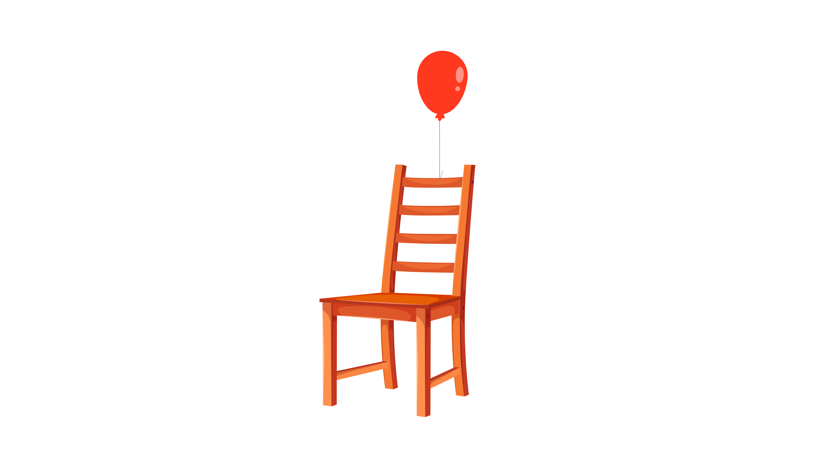 | 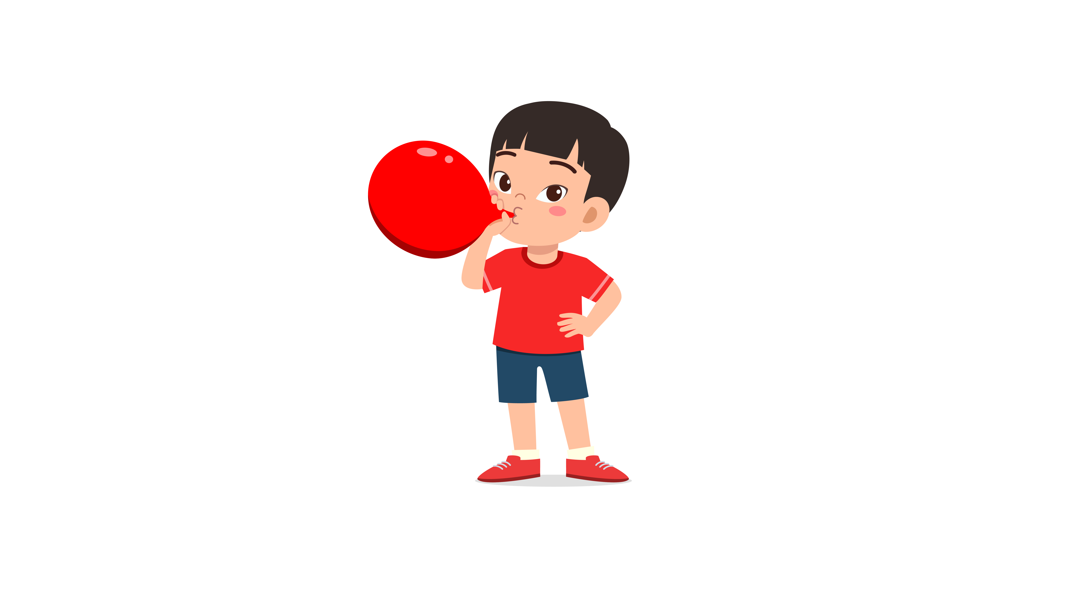
(A) | (B) | (C)
2.
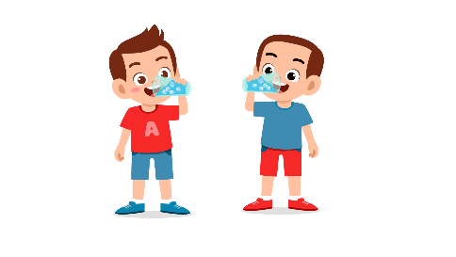 | 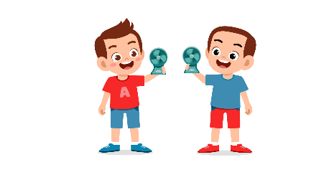 | 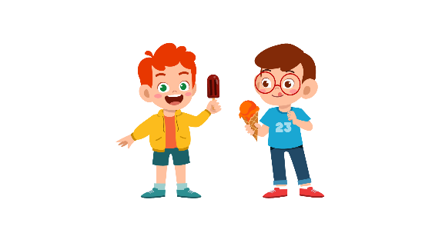
(A) | (B) | (C)
3.
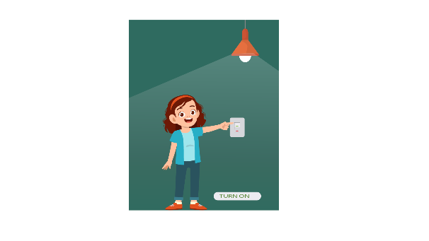 | 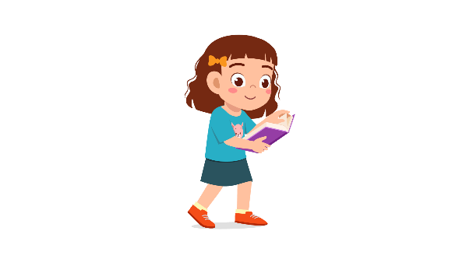 | 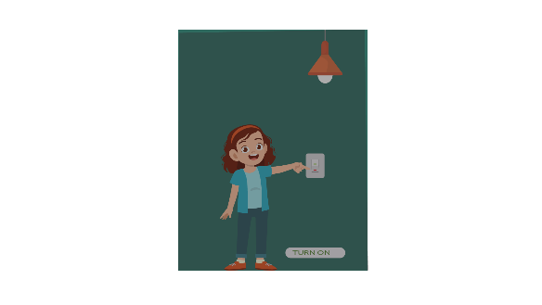
(A) | (B) | (C)
4.
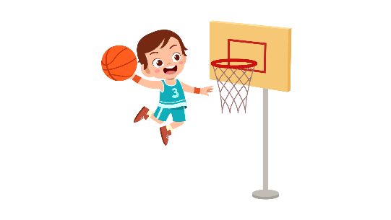 | 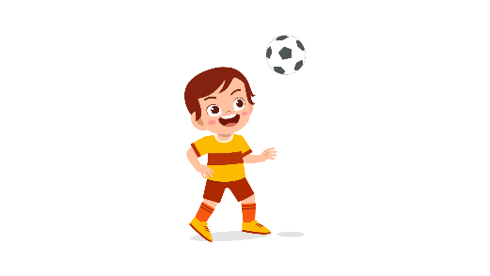 | 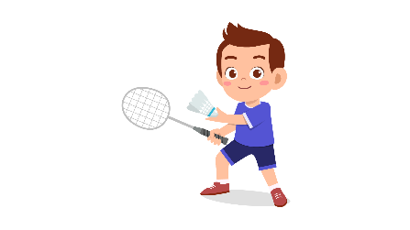
(A) | (B) | (C)
5.
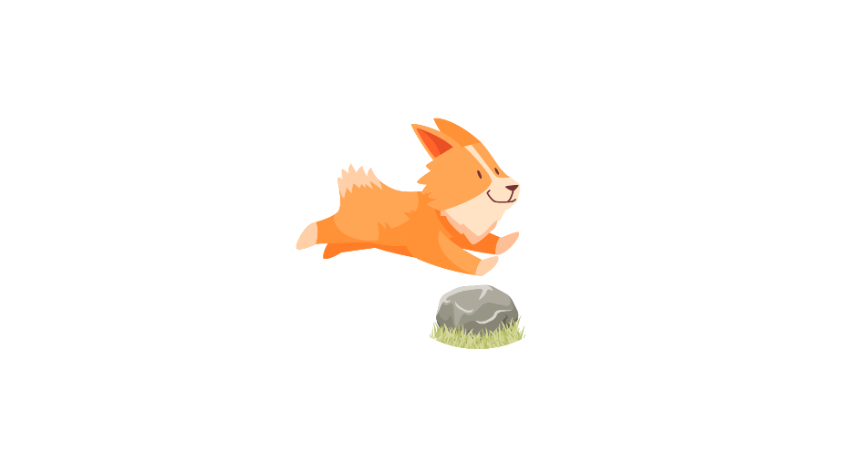 | 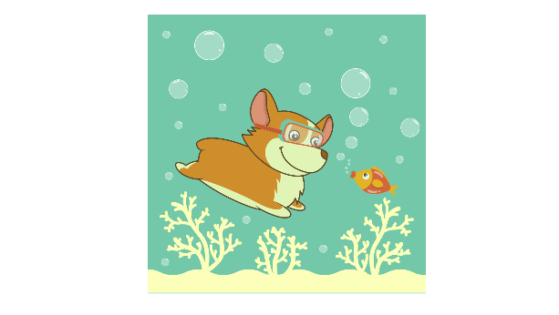 | 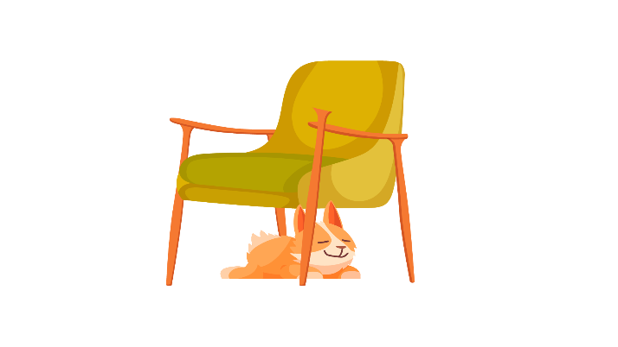
(A) | (B) | (C)
6.
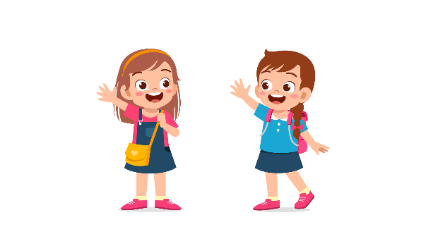 | 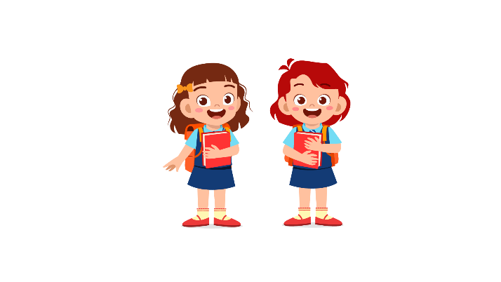 | 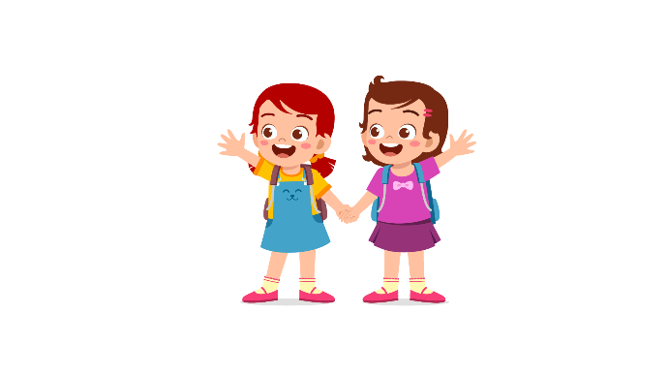
(A) | (B) | (C)
7.
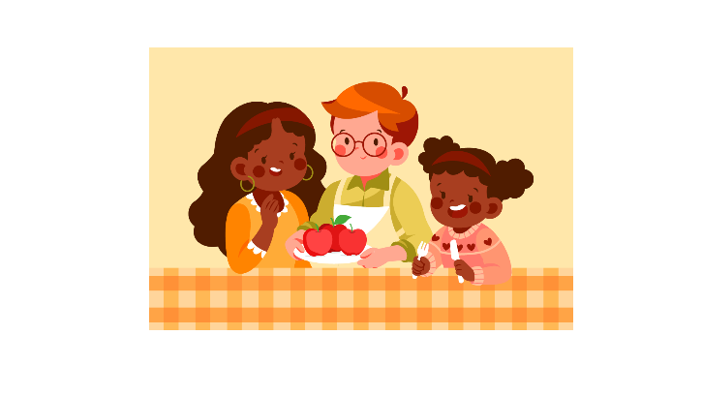 | 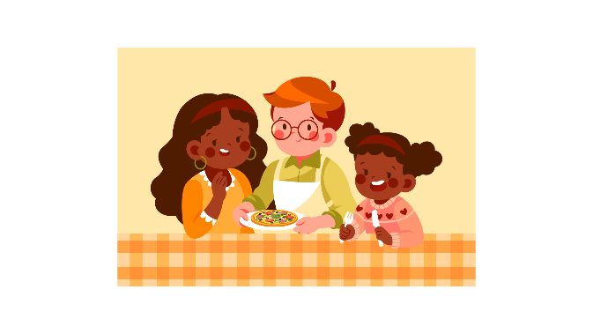 | 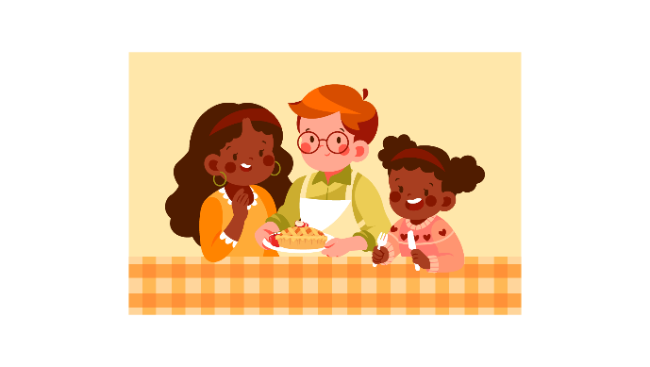
(A) | (B) | (C)
8.
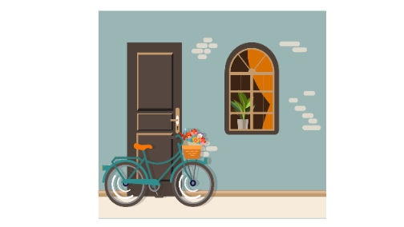 | 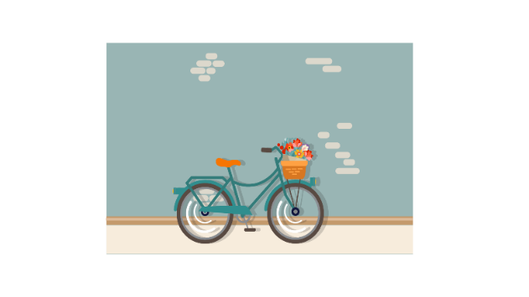 | 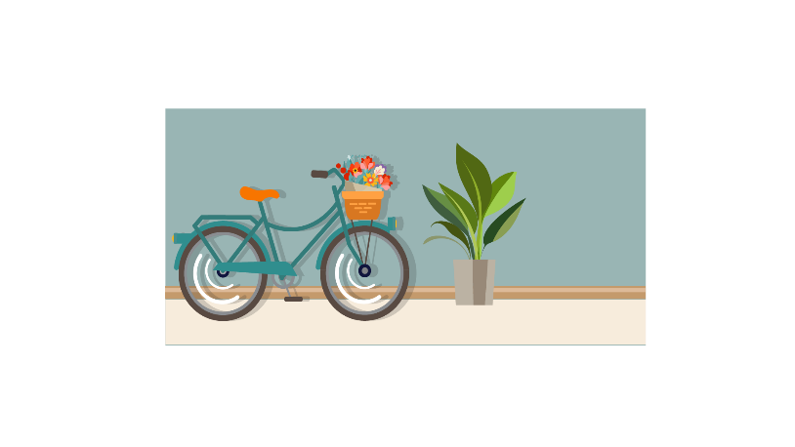
(A) | (B) | (C)

PART 2
Fill in the correct circles on your answer sheet.
9.
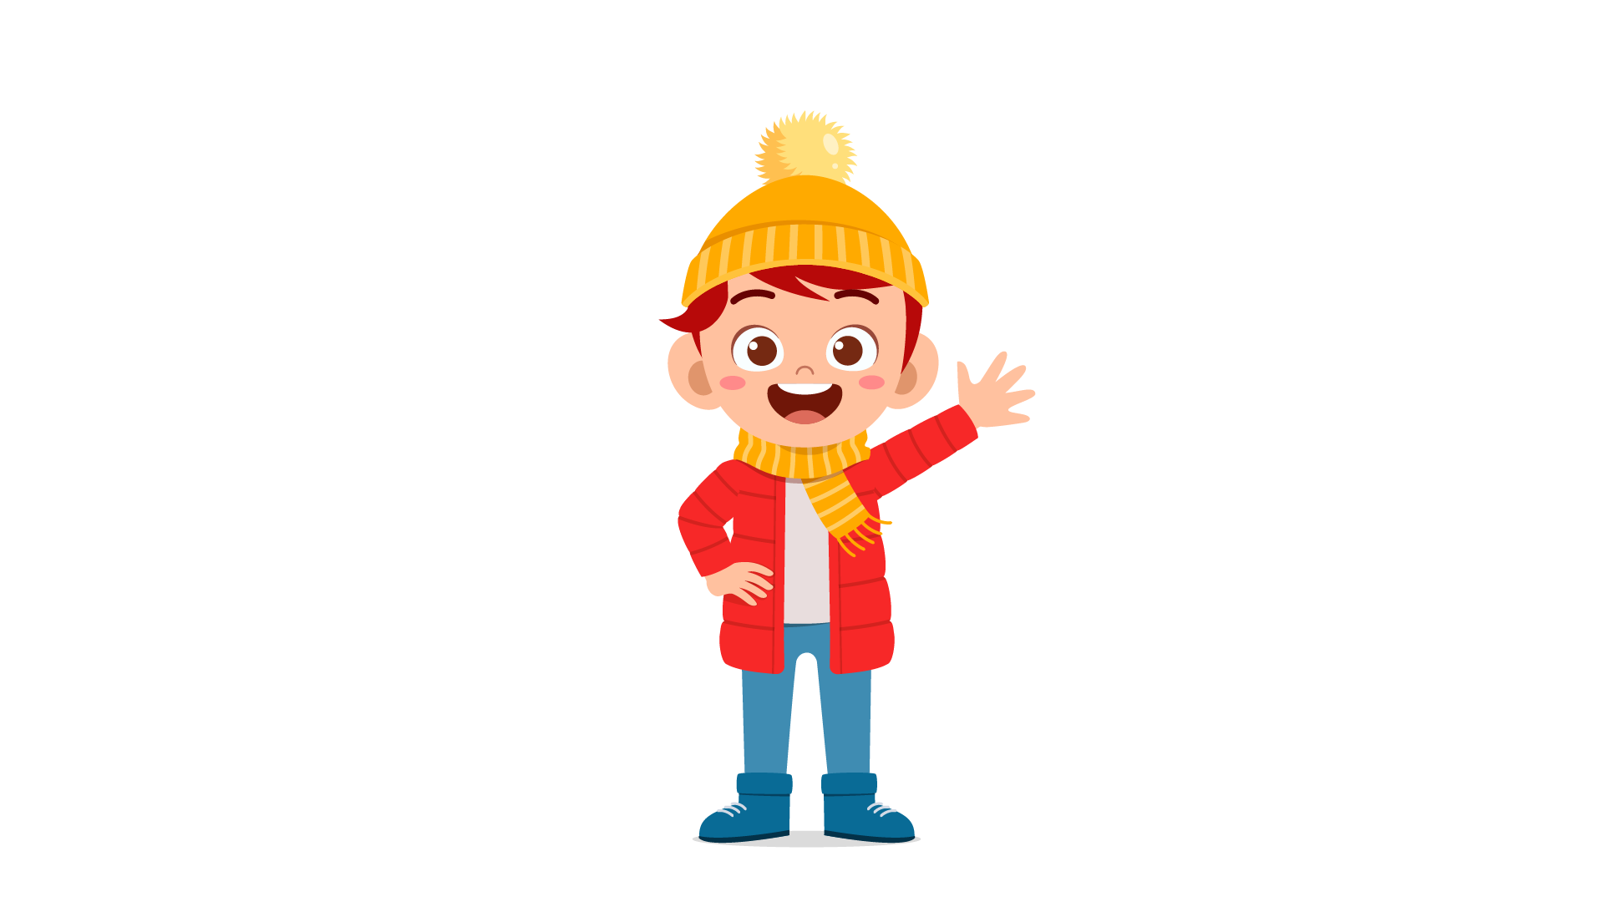 | 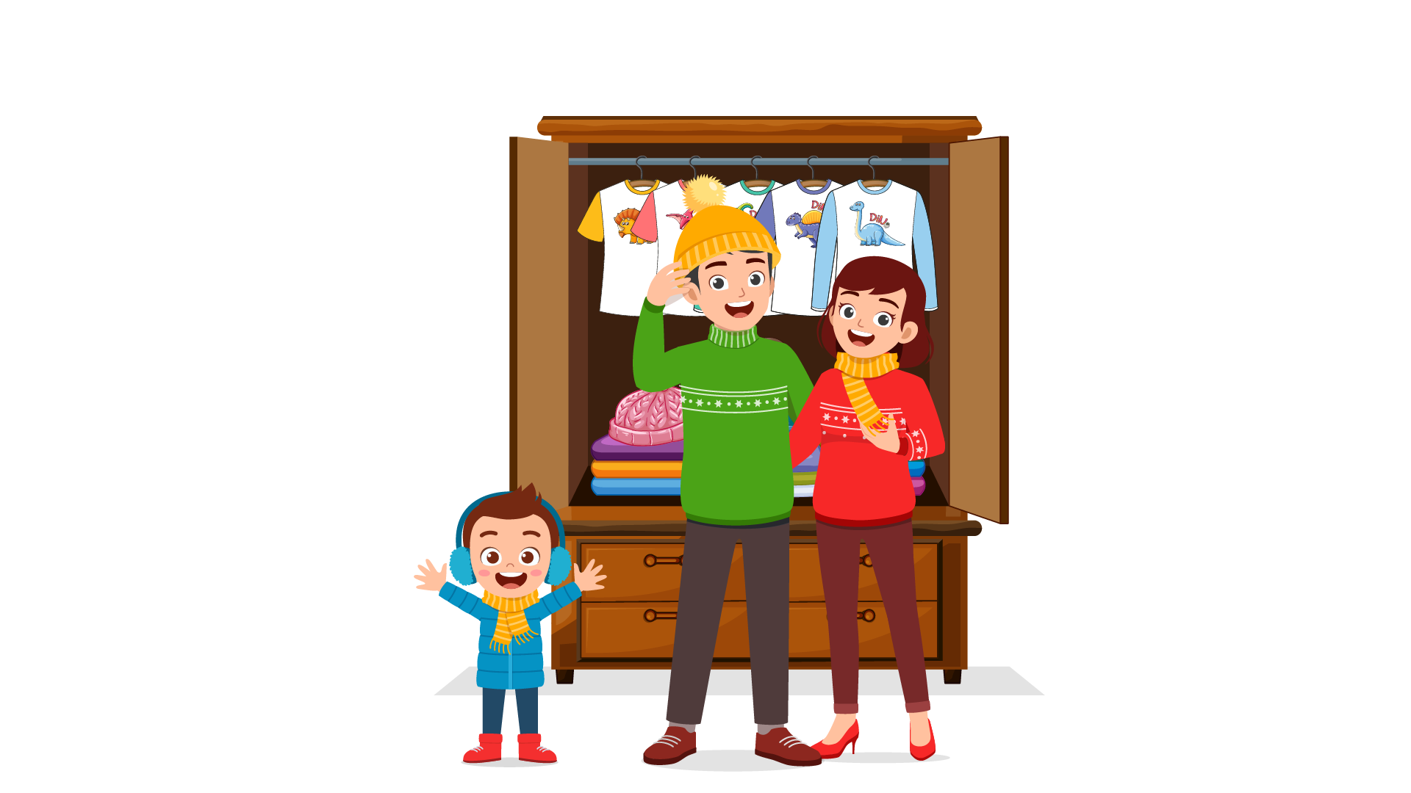 | 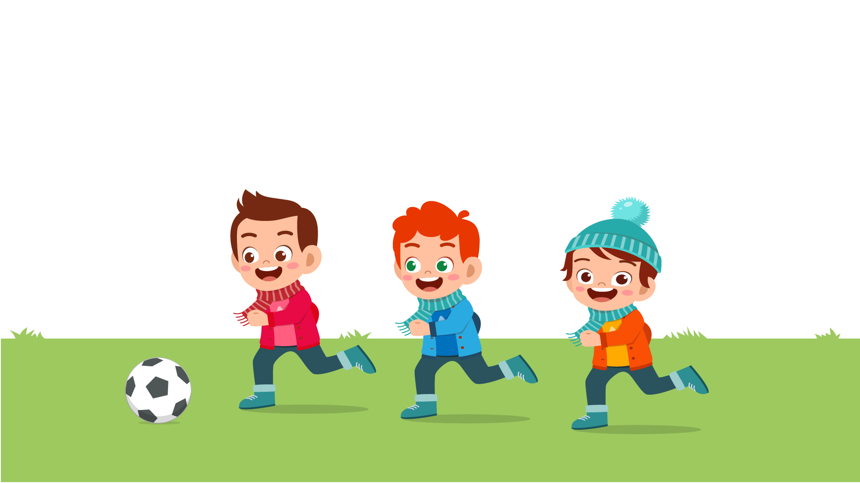
(A) | (B) | (C)
10.
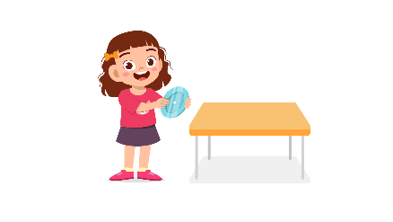 | 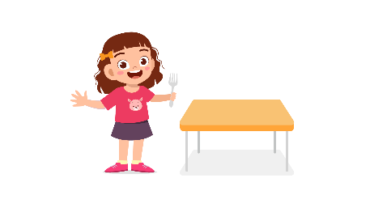 | 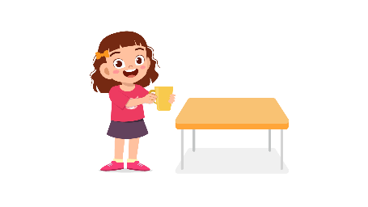
(A) | (B) | (C)
11.
Tranh A: Khách hàng ký tên ở cuối thẻ | 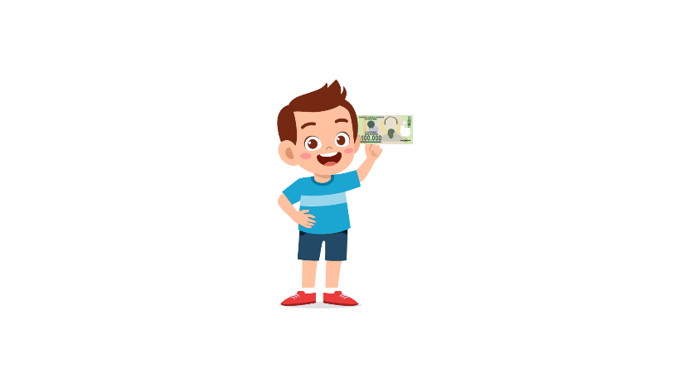 | 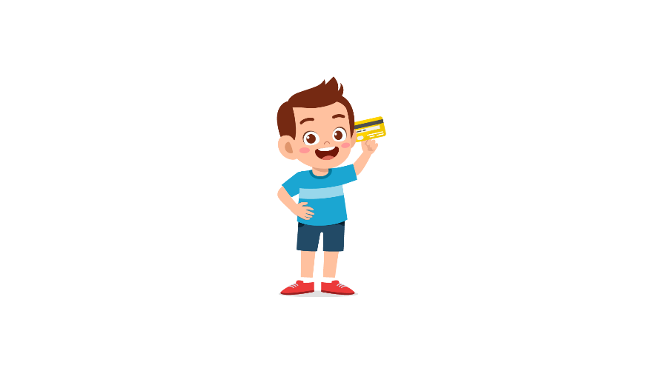
(A) | (B) | (C)
12.
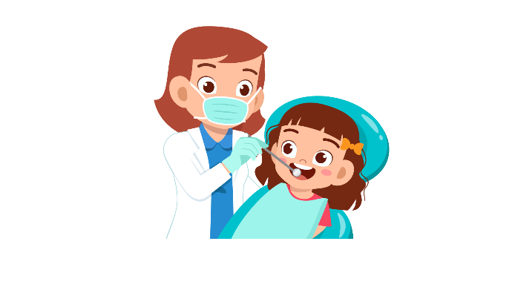 | 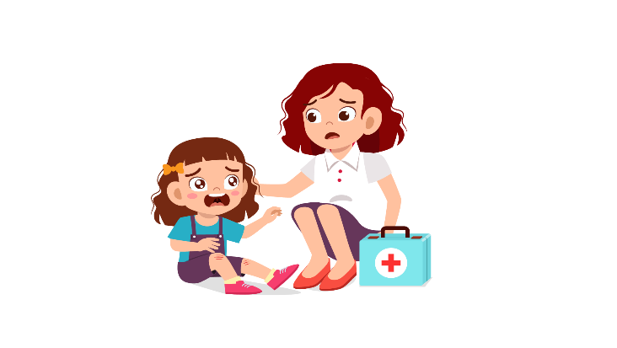 | 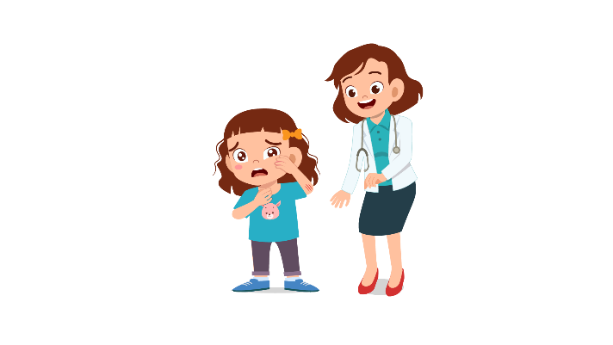
(A) | (B) | (C)
13.
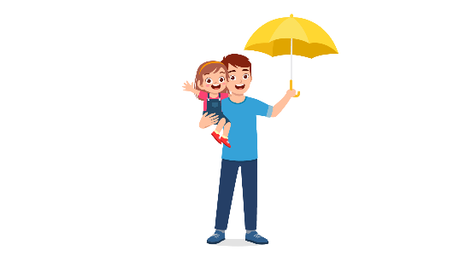 | 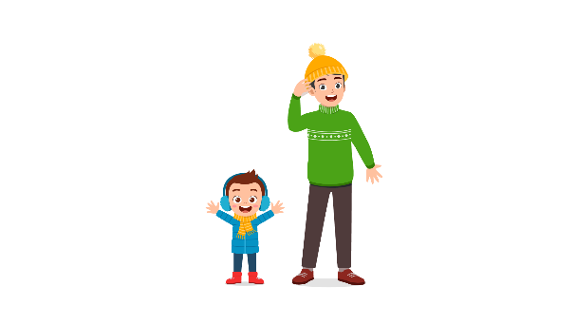 | 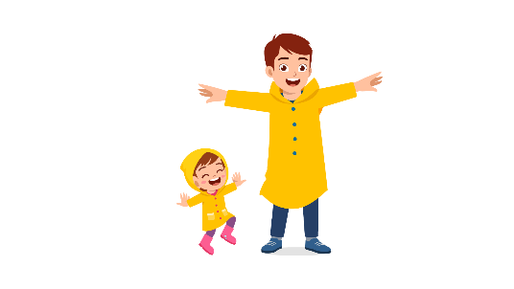
(A) | (B) | (C)
14.
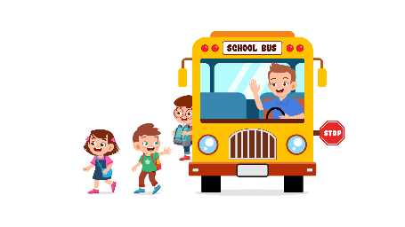 | 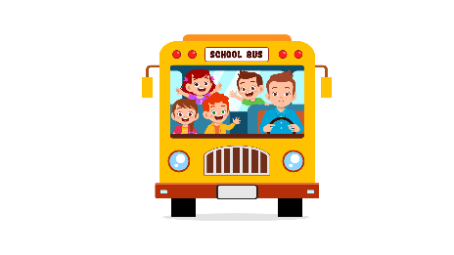 | 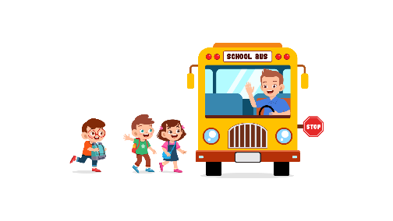
(A) | (B) | (C)
15.
 | 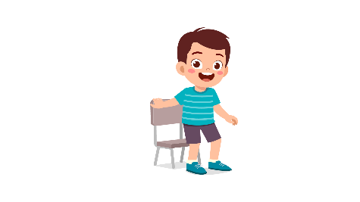 | 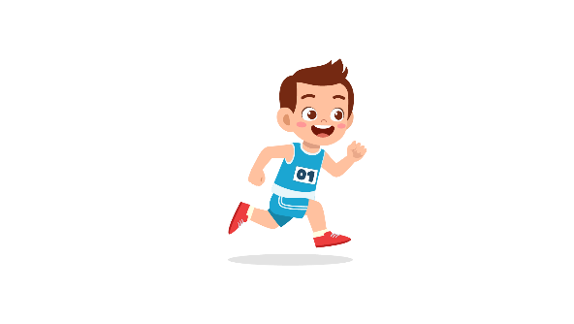
(A) | (B) | (C)
16.
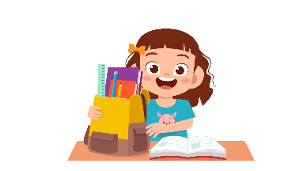 | 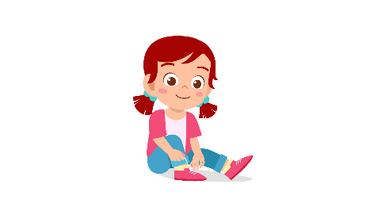 | 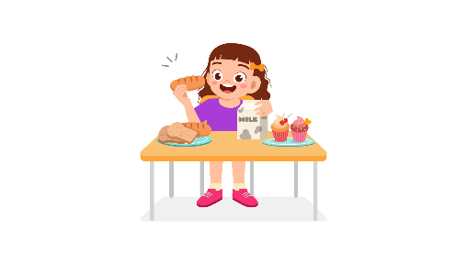
(A) | (B) | (C)
17.
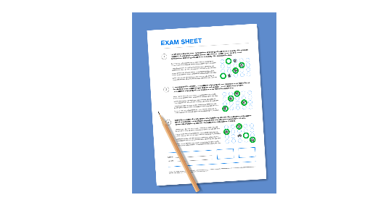 | 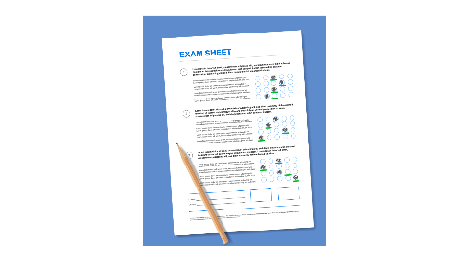 | 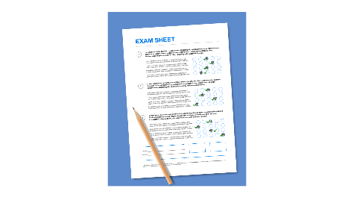
(A) | (B) | (C)

PART 3
Fill in the correct circles on your answer sheet.
Look at your answer sheet. Listen to a conversation. Which conversation sounds correct?
Let’s do an example.
(Narrator): A
(Boy): Hello. What’s your name?
(Girl): I’m fine, thanks.
(Narrator): B
(Boy): How are you today?
(Girl): I’m six years old.
(Narrator): C
(Boy): Nice to meet you!
(Girl): Nice to meet you, too!
The answer is "C." Fill in "C" on your answer sheet. Now, you do it.
18.
(A) | (B) | (C)
19.
(A) | (B) | (C)
20.
(A) | (B) | (C)
21.
(A) | (B) | (C)
22.
(A) | (B) | (C)
23.
(A) | (B) | (C)
24.
(A) | (B) | (C)
25.
(A) | (B) | (C)
26.
(A) | (B) | (C)
27.
(A) | (B) | (C)

PART 4
Listen to a conversation and answer the question. Fill in the correct circle on your answer sheet.
Let’s do an example.
28. When is the girl's party?
(A) Tonight
(B) Next week
(C) This weekend
The answer is "C." Fill in "C" on your answer sheet. Now, you do it.
29. What does the girl do in her free time?
(A) Listen to music
(B) Play chess
(C) Read comic books
30. What do they want to buy?
(A) Some bread
(B) Some juice
(C) Some strawberry
31. How do they go to the park?
(A) By taxi
(B) By bus
(C) On foot
32. Who is Jim talking to?
(A) A parent
(B) An officer
(C) A teacher
33. What is the girl trying to do?
(A) ask her mother about the TV channels
(B) tell her mother to focus
(C) ask her mother to turn the TV down
34. What are the friends planning to do?
(A) eat cheese cakes
(B) meet their teacher
(C) go home

PART 5
Listen and answer the question.
Fill in the correct circle on your answer sheet.
Let’s do an example.
- What did Mike call about?
(A) Homework
(B) A movie
(C) A library book
The answer is "B." Fill in "B" on your answer sheet. Now, you do it.

36. Why did Tom call?
(A) To invite his friend to join a club
(B) To tell his friend he can’t join the club
(C) To remind his friend about joining a club
37. Why did Lindsay call?
(A) To describe the blue skirt
(B) To tell the story about twins
(C) To ask what to wear to the party
38. Why did the neighbor call?
(A) To tell the news that they are moving
(B) To ask about the landlord
(C) To greet his new neighbor
39. Why did the teacher call?
(A) To invite Milly to join a competition
(B) To tell Milly’s mother about the grades
(C) To talk about how Milly is at school
40. Why did the shop assistant call?
(A) To ask the customer to buy a purse
(B) To talk about a new product through phone call
(C) To give information about the lost purse
41. Why did Helen’s father call?
(A) To pick Helen up right now
(B) To ask Helen the pickup time
(C) To ask what time it is

