School: ……………………………………….. | Date: ………………………………..
Class: ……………………………..................... | Period: ………………………….........

UNIT 8: FESTIVALS AROUND THE WORLD
Lesson 3.2 – Speaking and Writing (page 67)

I. OBJECTIVES
By the end of the lesson, Ss will be able to:
1.1. Language knowledge and skills
- know the format of a festival blog post.
- talk about their favorite festival ( name, time, place, reasons to celebrate, activities in the festival, feelings about the festival).
- write an blog post about a festival.
1.2. Competences
- improve communication, collaboration, writing and critical thinking skills.
1.3. Attributes
- respect cultures and tradition of many provinces around Vietnam.
- be active to take part in social activities.

II. TEACHING AIDS AND LEARNING MATERIALS
1. Teacher’s aids: Student book and Teacher’s book, class CDs, Digital Book (DCR phần mềm tương tác SB, DHA (từ vựng/ cấu trúc) phần mềm trò chơi tương tác), projector/interactive whiteboard / TV (if any), PowerPoint slides, handouts.
2. Students’ aids: Student’s book, workbook, notebook.

III. ASSESSMENT EVIDENCE
Performance Tasks | Performance Products | Assessment Tools
- Speaking: You want to know which festival your friend likes. In pairs: Ask your partner about their favorite festival. Use these questions. | - Ss’ answers / presentation. | - T’s feedback/Peers’ feedback.
- Think about your favorite festival. Make notes in the table below. | - Ss’ answers / presentation. | - T’s feedback/Peers’ feedback.
- Writing: Read about writing festival blog posts. Then, read the blog post about the Khánh Hạ Festival again and circle the information about the festival's history. | - Ss’ answers. | - T’s feedback/Peers’ feedback.
- Reorder this festival blog post. Use the skill box to help you. | - Ss’ answers. | - T’s feedback/Peers’ feedback.
- Now, write a blog about your favorite festival. Use the Feedback form to help you. Write 60 to 80 words. | - Ss’ answers. | - T’s observation and feedback.

IV. PROCEDURES
A. Warm up: (5’)
a) Objective: Introduce the new lesson and set the scene for Ss to acquire new language; get students' attention at the beginning of the class by enjoyable and short activities as well as to engage them in the follow-up steps.
b) Content: Introduce some basic information of the festival blog post / Introduce some festivals in Vietnam.
c) Expected outcomes: Ss know about the topic that they are going to talk and write about in new the lesson.
d) Organization of the activity:
TEACHER’S ACTIVITIES | STUDENTS’ ACTIVITIES
Option 1: Matching  - Have Ss do the matching activity in pairs (in 2 minutes).  - Call Ss to give answers.  - Give feedback and evaluation.  - Lead to the new lesson: Writing festival blog post.  *Illustration:  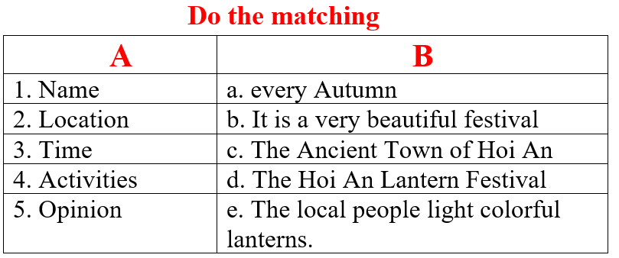  - Option 2: Kim’s Game  - Have Ss close books.  - Show some pictures of some famous festivals in Vietnam.  - Have Ss look at the pictures and try to remember the festival names as many as possible.  - Hide the pictures one by one, have Ss tell the names of the festivals again.  - Lead to the new lesson.  *Illustration:  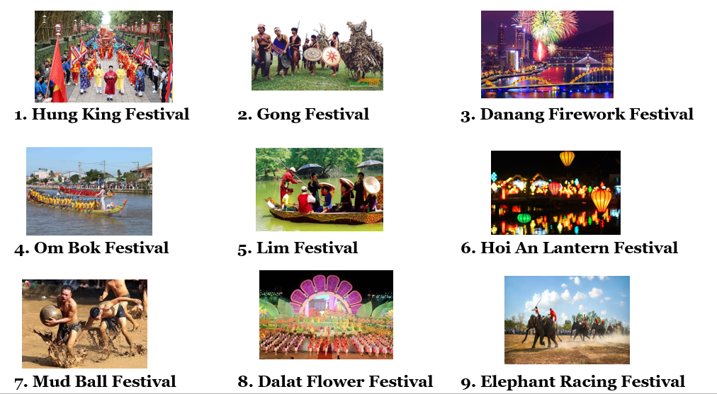 | - Work in pairs.  - Read answers.  - Listen  Answer keys  - d  - c  - a  - e  - b  - Close books.  - Look at the pictures and try to remember the festival names.  - Listen.

B. New lesson (35’)
- Activity 1: Pre-Writing (Speaking) (8’)
a) Objective: Ss prepare for what they are going to write about.
b) Content:
- Speaking: You want to know which festival your friend likes. In pairs: Ask your partner about their favorite festival. Use these questions.
- Think about your favorite festival. Make notes in the table below.
c) Expected outcomes: Ss have more ideas and language for their writing.
d) Organization of the activity:
TEACHER’S ACTIVITIES | STUDENTS’ ACTIVITIES
Task a. You want to know which festival your friend likes. In pairs: Ask your partner about their favorite festival. Use these questions.  - Divide the class into pairs.  - Have students take turns to ask and answer about their favorite festival.  - Go round and support Ss if necessary.  - Have some students share their ideas with the class.  - Give feedback and evaluation.  Task b. Think about your favorite festival. Make notes in the table below.  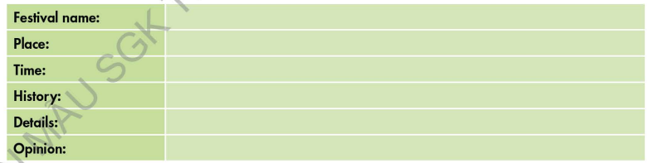  - Have students think about their favorite festival. Then, make notes in the table below.  - Go round and give help if necessary.  - Have Ss exchange their answers with another pair. | - Work in pairs.  - Present.  - Fill in the table.  - Exchange.
- Activity 2: While - Writing (22’)
a) Objective: Students can develop their writing skill.
b) Content: - Read about writing festival blog posts. Then, read the blog post about the Khánh Hạ Festival again and circle the information about the festival's history.
- Reorder this festival blog post. Use the skill box to help you.
- Now, write a blog about your favorite festival. Use the Feedback form to help you. Write 60 to 80 words.
c) Expected outcomes: Students can write a festival blog post, using right format, structures and rich words.
d) Organization of the activity:
TEACHER’S ACTIVITIES | STUDENTS’ ACTIVITIES
Task a. Read about writing festival blog posts. Then, read the blog post about the Khánh Hạ Festival again and circle the information about the festival's history.  -Briefly explain the Writing skill box using DCR and have some Ss read it aloud.  - Have Ss read the blog post about the Khánh Hạ Festival again (page 66) and circle the information about the festival's history.  - Have Ss check their answers with a partner.  - Call Ss to give answers.  - Check answers as a whole class using DCR.  Task b. Reorder this festival blog post. Use the skill box to help you.  - Have students read the sentences.  - Have students reorder this festival blog post.  - Remind Ss to use information in the skill box.  - Have students check their answers with a partner.  - Check answers as a whole class using DCR.  *Let’s Write: Write a blog about your favorite festival. Use the Feedback form to help you. Write 60 to 80 words.  - Draw Ss’ attention to the feedback form.  - Have Ss use their notes in speaking part and the instruction in the Writing box to write a blog about their favorite festival.  - Go round, observe and give help if necessary.  - Have some Ss write their paragraph on the board. | - Listen and read.  -Work in pairs.  - Exchange their answers with a partner.  - Give answers.  Answer keys  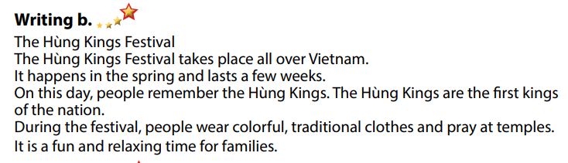  - Read the sentences and reorder this festival blog post.  - Exchange answers.  - Read answers.  Answer keys  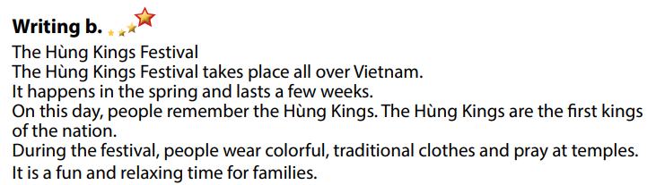  - Do the writing part.  -Write.

- Activity 3: Post - Writing (5’)
a) Objective: Help Ss realize their mistakes in writing and correct them.
b) Content: Correcting Ss’ writings.
c) Expected outcomes: Students know whether their writings follow the model and use the correct structures and language, whether their writings are interesting and understandable or not.
d) Organization of the activity:
TEACHER’S ACTIVITIES | STUDENTS’ ACTIVITIES
- Give feedback, correct Ss’ mistakes.  - Use the feedback form to give evaluation. Focus on:  + the format, the structures  + the understandability  + the coherence and cohesion  + the punctuation and the spelling | - Look, listen and correct mistakes.  Suggested writing  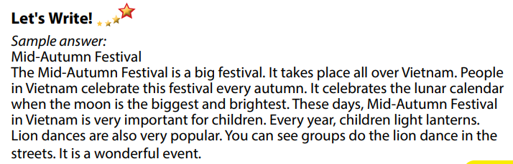

C. Consolidation and homework assignments (5’)
* Consolidation:
- Writing Skill:
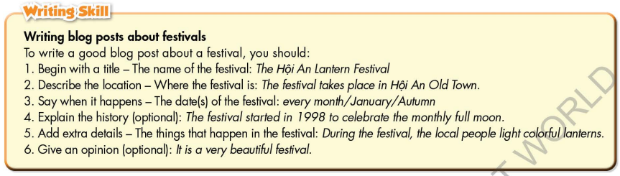

* Homework
- Remember how to write a festival blog post.
- Finish the writing part.
- Do the exercises in WB: Writing part, page 49.
- Complete grammar notes in Tiếng Anh 7 i-Learn Smart World Notebook (page 53).
- Play consolation games in Tiếng Anh 7 i-Learn Smart World DHA App on www.eduhome.com.vn
- Prepare: Unit 8 – Review, pages 104, 105.

D. Reflection
a. What I liked most about this lesson today:
…………………………………………………………………………………………
- What I learned from this lesson today:
…………………………………………………………………………………………
c. What I should improve for this lesson next time:
…………………………………………………………………………………………

