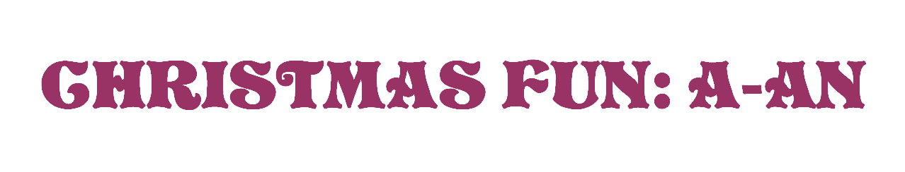
Look at the pictures and circle the correct word.
Holly
Angel
Bell

Horn
Ball
Elf

Wreath
Candle
Bell
Candle
Cracker
Candy Cane
Lantern
Drum
Reindeer

Tree
Elf
Ornament

Horn
Star
Present

Cracker
Lantern
Stocking

Ornament
Sack
Ball

Robin
Peacock
Partridge

Robin
Reindeer
Snowman

Wreath
Present
Tree

Stocking
Cracker
Tree

Sack
Star
Stocking

Star
Horn
Ball

Snowman
Angel
Elf

Wreath
Sack
Present
Cracker
Garland
Candy Cane

Mistletoe
Stocking
Cracker

Sack
Star
Horn

