|  |  |
| --- | --- |
| **Tiếng Anh 8 Friends Plus** | **FP 8 - REVIEW 1 - TEST 2**  **Test for Unit**  *-------------------------* |

**I. Pronunciation (1-4)**

**Câu 1.** Which word has the underlined part pronounced differently from that of the others?

**A.** hearing  **B.** blind  **C.** activist  **D.** indigo

**Đáp án đúng**: B

**Câu 2.** Which word has the underlined part pronounced differently from that of the others?

**A.** lasagne  **B.** sensation  **C.** resident  **D.** desert

**Đáp án đúng**: A

**Câu 3.** Which word has a different stress pattern from that of the others?

**A.** hardly  **B.** different

**C.** successful  **D.** every

**Đáp án đúng**: C

**Câu 4.** Which word has a different stress pattern from that of the others?

**A.** prefer  **B.** anything  **C.** listening  **D.** popular

**Đáp án đúng**: A

**II. Choose the answer (A, B, C or D) that best fits the space in each question. (5-14)**

**Câu 5.** He ______ (just/finish) his homework.

**A.** just finish  **B.** had just finished

**C.** has just finished  **D.** just finished

**Đáp án đúng**: C

**Câu 6.** She ______ (work) at that store from 2012 to 2017.

**A.** has worked  **B.** worked

**C.** had worked  **D.** work

**Đáp án đúng**: B

**Câu 7.** I cannot hear anything because I am ______.

**A.** anosmic  **B.** mute  **C.** deaf  **D.** blind

**Đáp án đúng**: C

**Câu 8.** The ______ sense allows us to perceive the flavour of food and drinks.

**A.** sight  **B.** taste  **C.** touch  **D.** hearing

**Đáp án đúng**: B

**Câu 9.** I ______ (not try) bungee jumping before.

**A.** had not tried  **B.** tried not

**C.** did not try  **D.** have not tried

**Đáp án đúng**: D

**Câu 10.** What do you like to eat for breakfast?

**A.** It's a rainy day today.

**B.** My favourite season is winter.

**C.** I enjoy eating pancakes and drinking coffee.

**D.** I have two cats.

**Đáp án đúng**: C

**Câu 11.** They ______ (not visit) their grandparents for a long time.

**A.** did not visit  **B.** have not visited

**C.** had not visited  **D.** visited not

**Đáp án đúng**: B

**Câu 12.** A ______ is a person who is skilled in the art of painting.

**A.** dancer  **B.** painter  **C.** writer  **D.** singer

**Đáp án đúng**: B

**Câu 13.** I ______ (study) at this university for three years.

**A.** studied  **B.** had studied

**C.** study  **D.** have studied

**Đáp án đúng**: D

**Câu 14.** We ______ (not speak) to each other since last month.

**A.** have not spoken  **B.** did not speak

**C.** had not spoken  **D.** spoken not

**Đáp án đúng**: A

**III. Look at the signs. Choose the best answer (A, B, C or D). (15-16)**

**Câu 15.**

What is the offer at the Tennis Club?

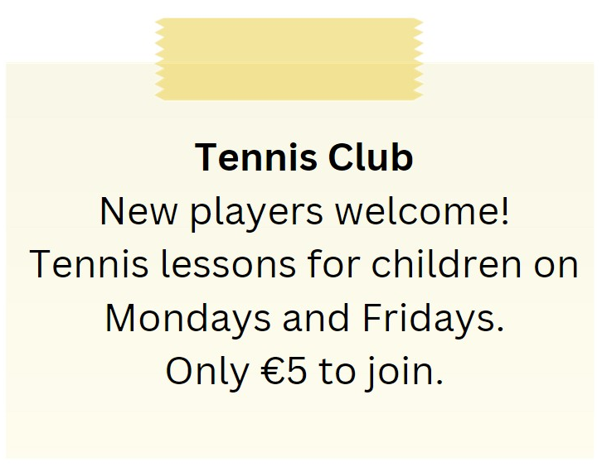

**A.** €10 to join the club

**B.** Tennis lessons for adults on Mondays and Fridays

**C.** Tennis lessons for children on Tuesdays and Thursdays

**D.** Tennis lessons for children on Mondays and Fridays for €5 to join

**Đáp án đúng**: D

**Câu 16.**

What is the offer for the swim class?

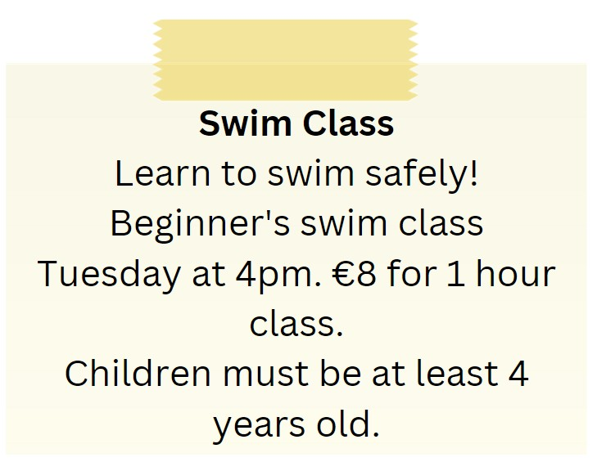

**A.** Beginner's swim class on Tuesday at 4pm for €8

**B.** Beginner's swim class on Tuesday at 5pm for €10

**C.** Advanced swim class on Tuesday at 4pm for €8

**D.** Beginner's swim class on Wednesday at 4pm for €8

**Đáp án đúng**: A

**IV. Read the following passage and do as direct. (17-22)**

A traditional Japanese robe is called a kimono. In Japan, both men and women wear it. Kimonos come in a lot of different colours and designs. Most of the time, flowers or waves are used. Silk is what most kimonos are made of. The silk makes them look nice and costs a lot.

Some kimonos have bands called obi that go around the waist. Like the kimono, the obi can also be decorated to match. Kimonos are only worn for special events. People in Japan today usually wear clothes from the West to work and school. But they still wear kimonos to events like weddings, tea ceremonies, and fairs. Japanese culture includes wearing a kimono. Kimonos are hard to put on correctly. They have to wear special underwear called Nagarjuna, which is tied around the waist.

Even so, kimonos are beautiful and easy to wear. Putting on a kimono makes a lot of people feel happy and connected to their past.

**Câu 17.** Only women wear kimonos in Japan.

**A.** False  **B.** True

**Đáp án đúng**: A

**Câu 18.** Kimonos are usually made of silk.

**A.** False  **B.** True

**Đáp án đúng**: B

**Câu 19.** Kimonos are worn for everyday activities.

**A.** False  **B.** True

**Đáp án đúng**: A

**Câu 20.** Kimonos are easy to put on correctly.

**A.** True  **B.** False

**Đáp án đúng**: B

**Câu 21.** What are common designs on kimonos?

**A.** Stripes and polka dots  **B.** Flowers and waves

**C.** Animals and trees  **D.** Stars and moons

**Đáp án đúng**: B

**Câu 22.** What is the name of the special underwear worn with a kimono?

**A.** Yukata  **B.** Nagajuban  **C.** Haori  **D.** Obi

**Đáp án đúng**: B

**V. Choose the word (A, B, C or D) that best fits the blank space in the following passage. (23-28)**

If you're **___23___** for a delicious and healthy snack, I highly **___24___** trying hummus. Hummus is a popular Middle Eastern dip made from chickpeas, tahini, olive oil, lemon juice, and garlic. It has a creamy texture and a tangy, nutty **___25___** that goes well with crackers, pita bread, or vegetables. Hummus is also high in protein, fibre, and healthy fats, making it a great **___26___** for vegetarians and vegans. You can find hummus at most grocery **___27___** or make it yourself at home using a food processor. With so many different variations and flavours, hummus is a versatile snack that you can enjoy any time of day. Give it a try and see for yourself how tasty and **___28___** it is!

**Câu 23.** If you're ___ for a delicious and healthy snack, I highly recommend trying hummus.

**A.** looking  **B.** watching  **C.** pointing  **D.** finding

**Đáp án đúng**: A

**Câu 24.** I highly ___ trying hummus.

**A.** propose  **B.** recommend  **C.** advise  **D.** refuse

**Đáp án đúng**: B

**Câu 25.** It has a creamy texture and a tangy, nutty ___ that goes well with crackers, pita bread, or vegetables.

**A.** taste  **B.** aroma  **C.** smell  **D.** flavour

**Đáp án đúng**: D

**Câu 26.** Hummus is also high in protein, fibre, and healthy fats, making it a great ___ for vegetarians and vegans.

**A.** options  **B.** choice

**C.** selections  **D.** another

**Đáp án đúng**: B

**Câu 27.** You can find hummus at most grocery ___ or make it yourself at home using a food processor.

**A.** stalls  **B.** stores  **C.** pubs  **D.** bars

**Đáp án đúng**: B

**Câu 28.** Give it a try and see for yourself how tasty and ___ it is!

**A.** terrible  **B.** nutritious

**C.** feeding  **D.** awful

**Đáp án đúng**: B

**VI. Supply the correct form of the word given in each sentence. (29-34)**

**Câu 29.** The ________ of the product was very detailed and informative. (describe)

**Đáp án đúng**: description

**Câu 30.** He was ________ in cooking, but he was eager to learn. (experience)

**Đáp án đúng**: inexperienced

**Câu 31.** She trained hard to beat her ________ in the race. (competition)

**Đáp án đúng**: competitor

**Câu 32.** He writes in his journal ________ to keep track of his thoughts and feelings. (day)

**Đáp án đúng**: daily

**Câu 33.** The doctor suggested that he ________ the font on his computer screen to reduce eye strain. (large)

**Đáp án đúng**: enlarge

**Câu 34.** She leads an ________ lifestyle and exercises every day. (activist)

**Đáp án đúng**: active

**VII. Rearrange the groups of words in a correct order to make complete sentences. (35-36)**

**Câu 35.** on smartphones / We can send / texts and photos / to our friends / easily.

…

**Đáp án đúng**: We can send texts and photos to our friends on smartphones easily.

**Câu 36.** Have you / before? / a museum / ever visited

…

**Đáp án đúng**: Have you ever visited a museum before?

**VIII. Rewrite each of the following sentences in another way so that it means almost the same as the sentence printed before it. (37-40)**

**Câu 37.** You are not allowed to smoke in this area.

Smoking …

**Đáp án đúng**: Smoking is not allowed in this area.

**Câu 38.** Jane has been studying French for 5 years.

Jane started …

**Đáp án đúng**: Jane started studying French 5 years ago.

**Câu 39.** Why don't we go for a walk in the park?

How …

**Đáp án đúng**: How about going for a walk in the park?

**Câu 40.** Don't forget to turn off the lights when you leave the room.

Remember …

**Đáp án đúng**: Remember to turn off the lights when you leave the room.

**IX. Listening: listen and do as direct. (41-50)**

***A dialogue between two friends talking about food:***

**Câu 41.** Friend 1 asked Friend 2 if they have tried any new restaurants lately.

**A.** True  **B.** False

**Đáp án đúng**: A

**Câu 42.** Friend 2 went to a new Italian restaurant last week.

**A.** False  **B.** True

**Đáp án đúng**: A

**Câu 43.** Friend 2 had Pad Thai at the Thai restaurant.

**A.** False  **B.** True

**Đáp án đúng**: B

**Câu 44.** The noodles in the Pad Thai were overcooked.

**A.** True  **B.** False

**Đáp án đúng**: B

**Câu 45.** Friend 1 usually goes for Thai food.

**A.** False  **B.** True

**Đáp án đúng**: A

**Câu 46.** Friend 1 is getting bored of Italian food.

**A.** False  **B.** True

**Đáp án đúng**: B

**Câu 47.** Friend 2 loves Italian food but sometimes wants to try something different.

**A.** True  **B.** False

**Đáp án đúng**: A

**Câu 48.** There is a new sushi place that Friend 2 wants to try.

**A.** False  **B.** True

**Đáp án đúng**: B

**Câu 49.** Friend 1 does not like sushi.

**A.** True  **B.** False

**Đáp án đúng**: B

**Câu 50.** Friend 2 invited Friend 1 to go to the sushi place with them.

**A.** True  **B.** False

**Đáp án đúng**: A

**----HẾT---**