UNIT 9: FESTIVALS AROUND THE WORLD
Lesson 2: A closer look 1

I. OBJECTIVES
By the end of this lesson, Ss will be able to gain:
1. Knowledge:
- Vocabulary: types of festivals and festival activities.
- Pronunciation: pronounce two-syllable words with correct stress.
2. Core competence
- Develop communication skills and creativity
- Be collaborative and supportive in pairwork and teamwork
- Actively join in class activities
3. Personal qualities
- Develop self-study skills
II. PREPARATIONS
1. Teacher
- Grade 7 textbook, laptop, TV/Projector/ pictures and cards, speakers, lesson plan, sachmem.vn…
2. Students
- Grade 7 textbook, notebooks, school things….
III. TEACHING PROCEDURES
Notes
In each activity, each step will be represented as following
* Deliver the task
** Implement the task
*** Discuss
 Giving comments or feedback
ACTIVITY 1 – WARM – UP & INTRODUCTION (5’)
a) Aims:
- To review the previous lesson and activate students’ knowledge.
- To activate students’ knowledge
- To get students interested in the topic
b) Contents: Play the game “Hot seat”
c) Products: Ss’ answers
d) Teaching steps:
Teacher’s and students’ activities | Content
* Teacher divides the class into 2 teams. Each team will send a leader to play the game on the board.  - Teacher explains the instructions of the game:  - Each leader stands against the board.  - Teacher shows/ writes the names of the festivals (exercise 5 – page 93).  - Other members from each team describe the festivals and let the leader guess the names of the festivals.  - The team with more correct answers is the winner.  ** Students play in teams.  *** Students give the correct answers.   Teacher confirms the answers and gives feedback. | Game: Hot seat  

ACTIVITY 2 – PRESENTATION (15’)
a) Aims:
- To introduce new words.
- To present some types of festivals
b) Contents:
- Teach the vocabularies
- Listen and read
- Match the phrases with the pictures. Then listen, check, and repeat the phrases.
c) Products:
- Lists of vocabularies
- Answer key
d) Teaching steps:
Teacher’s and students’ activities | Content
* Teacher introduces the vocabulary.  ** Teacher introduces the vocabulary by:  - providing the pictures  - providing the definition/example of the words.  *** Teacher asks students to repeat.   Teacher rubs out and checks.  * Teacher has students to look at the pictures and asks them if they know the names of the festivals.  ** Teacher gets students to do the exercise in individuals.  *** Ask them to share their answers in pairs before checking the answers as a class.   Teacher then encourages students to explain their answers. Correct if necessary. | * Vocabulary  - Cannes Film Festival  - Mid-Autumn Festival  - Thanksgiving (n)  - Easter (n)  - carve (v)  - perform (v)  Task 1: Write under each picture a festival name from the box (p.94).  Answer key:  1. Halloween  2. Christmas  3. Mid-Autumn Festival  4. Cannes Film Festival  5. Easter  6. Thanksgiving
ACTIVITY 3 – PRACTICE (15’)
a) Aims:
- To present some festival activities
- To give Ss further practice with words related to festivals and festivals activities.
- To help Ss identify how to pronounce two-syllable words with correct stress.
- To help Ss pronounce two-syllable words with correct stress in sentence.
b) Contents:
- Complete the table below with the phrases from the box.
- Fill in each blank with a word or phrase from the box.
- Listen and repeat. Then underline the stressed syllable in each word.
- Listen and repeat the sentences. Underline the stressed syllables in the bold words
c) Products:
- Answer key
- The role of marking stress in two-syllable words
d) Teaching steps:
Teacher’s and students’ activities | Content
* Teacher tells Ss that people celebrate festivals with different food and activities.  ** Teacher asks them to do the task individually.  *** Teacher asks students to share their answers in pairs before checking the answers as a class.   Teacher then encourages students to explain their answers. Correct if necessary.  * Teacher asks Ss to work in pairs to complete the sentences with the words/ phrases given.  ** Ss work in pairs.  *** Teacher allows students to cross check first.   Teacher invites some pairs to share their answers and gives feedback.  * Teacher helps Ss to understand what a syllable is. Explain to them that a syllable is a unit of pronunciation having one vowel sound, with or without surrounding consonants, forming the whole part of a word. Give some examples of one-, two- and three-syllable words.  - Tell them that in this lesson, they just focus on two-syllable words and their common stress pattern. Have Ss name some more two-syllable words.  ** Teacher has Ss listen and repeat out the words in the table. Play the recording again for them to underline the stressed syllable in each word.  *** Teacher allows students to cross check first.   Teacher lets Ss share their answer and gives feedback. Ask Ss if they recognize any rules related to stress in two-syllable words. Share with them the most common rules.  * Teacher has Ss read quickly the sentences and plays the recording. Ask them to pay attention to the bold words and underline the stressed syllables.  ** Students practice in pairs or in groups.  *** Teacher goes around to offer help or correct pronunciation, if necessary.   Teacher calls some students to say the sentences in front of the class. Check their pronunciation if necessary. | Task 2: Complete the table below with the phrases from the box (p.94).  Answer key:  Task 3: Fill in each blank with a word or phrase from the box (p.94).  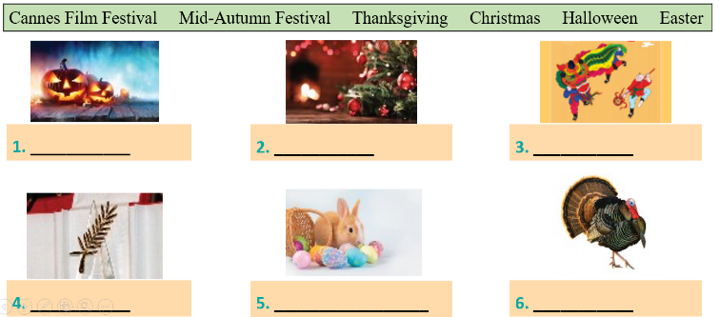  Answer key:  1. Christmas  2. painting eggs  3. candy apples  4. Cannes Film Festival  5. Mid-Autumn Festival  6. turkey  Task 4: Listen and repeat. Then underline the stressed syllable in each word. (p.94).  Pronunciation: Stress in two-syllable words  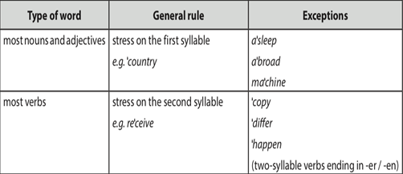  Answer key:  Task 5: Listen and repeat the sentences. Underline the stressed syllables in the bold words (p.94).  Answer key:  - We’re going to attend an Easter party at Nick’s house.  - The dancers will perform traditional dances at the festival.  - At Christmas, people usually buy presents for their family.  - Did you go to the Da Lat Flower Festival with your parents?  - My aunt is clever and patient.
ACTIVITY 4 – PRODUCTION (7’)
a) Aims:
- To test students' quick reaction to the targeted sounds.
b) Contents:
- Play the game “Up and down”
c) Products:
- Ss’ answer
d) Teaching steps:
Teacher’s and students’ activities | Content
*Teacher explains the rules:  Teacher says 1-15 words containing two-syllable words. Students stand up for the ones with first main stress pattern, sit down for the second main stress pattern.  ** Students play the game in teams.  *** Teacher helps students in the game.   Teacher gives feedback. | Game: “Up and down”
IV. WRAP-UP & HOMEWORK (3’)
- Teacher asks Ss to summarise what they have learnt in the lesson by asking them some questions.
- Teacher asks Ss to do exercises in workbook.
- Teacher asks Ss to prepare the next lesson “Unit 9 – A Closer look 2”
V. FEEDBACK

……………………….…, ngày………….tháng…………..năm 2022
Duyệt của Tổ chuyên môn

