**Mã đề 6.2.76**

**BÀI KIỂM TRA CUỐI HỌC KÌ II**

**MÔN: TIẾNG ANH 6 (Right on!)**

*Thời gian làm bài: 60 phút*

**A. LISTENING: (2.0 points)**

**Part 1: Listen and complete ( 1 point)**

The (1)__________ is the king of the beasts. **(nhận biết)**

The (2)______________ has a long neck. **(nhận biết)**

The (3)______________is very large. **(nhận biết)**

(4) _____________ are black, brown and even white. **(thông hiểu)**

You would find a kangaroo in Australia, or in a (5)____________ **(vận dụng)**

**Part 2: Listen and complete ( 1 point)**

My favorite films are (1)__________________. **(nhận biết)**

I also like (2)_______________________ movies. **(nhận biết)**

My mother likes dramas.

She likes many actors and (3)________________. **(thông hiểu)**

She laughs out loud because a comedy is very (4)__________________. **(thông hiểu)**

She (5)___________ when she watches sad movies. **(vận dụng)**

**B. VOCABULARY – GRAMMAR – LANGUAGE FUNCTION (2.0 points)**

**Part 1: Choose the word having the underlined part pronounced differently in each line. ( 0,4 points)**

**1. A.** promised **B.** hoped **C.** wanted **D.** looked**(nhận biết)**

**2. A.** light **B.** sink **C.** might **D.** shine **(nhận biết)**

**Part 2: Choose the correct answer ( 1,6 points)**

**1.** It’s very grey and ________ today. I can’t see the sun. **(thông hiểu)** (TV)

**A.** cloudy **B.** sunny **C.** hot **D.** warm

**2.** I like picking____________. **(nhận biết)** (TV)

**A.** museum **B.** barbecue **C.** pumpkins **D.** picnic

**3.** A lion has got a thick_______. **(thông hiểu)** (TV)

**A**. tail **B**. mane **C**. beak **D.** neck

**4.** You can see a sports event at a_____. **(thông hiểu)** (TV)

**A**. stadium **B**. theater **C**. circus **D.** concert hall

|  |  |
| --- | --- |
|  | **5.** What is this? **(nhận biết)**  **A**. car **B**. bike **C**. plane D. tram |

**6.** Nam _______ going camping at the momment. **(nhận biết)** (NP)

**A**. am **B**. am not **C**. are **D.** is

**7.** Bridget _______ to the cinema last night. **(nhận biết)** (NP)

**A.** didn’t went **B.** doesn’t go **C.** didn’t go **D.** don’t go

**8.** If it _______, we ________ to the zoo tomorrow. **(thông hiểu)**  (NP)

**A.** rain / will go **B.** will rain / go **C.** don't rain / go **D.** doesn't rain / will go

**C. READING (2 points)**

**Part 1. Read the following passage and choose the word or phrase that best fits the blank space in each sentence. (1 point)**

My name is Karen and I’m from Britain. The weather in Britain is often (1)________, but in the (2)_______ it’s also very cold and snowy. You can’t imagine how cold it is here. Yesterday it rained a lot but it is snowing heavily today. We have to (3)____ heavy jackets and gloves to keep us warm. My sisters are making a snowman in the garden at the moment. I am in the living room with my parents. They are (4)____ the Christmas tree. In the autumn and spring, it can be quite windy but it’s not very cold. The summer can be warm. My favourite season is spring because the trees are green and there are (5)_____ flowers. I often go for a walk in the park.

**1. A**. rainy **B**. raining **C**. rain **D.** rains **(nhận biết)**

**2. A**. summer **B**. autumn **C**. winter **D.** spring **(thông hiểu)**

**3. A**. wears **B**. wear **C**. wearing **D.** wore **(nhận biết)**

**4. A**. dancing **B**. playing **C**. celebrating **D.** decorating **(thông hiểu)**

**5. A**. many **B**. much **C**. little **D.** a little **(nhận biết)**

**Part 2: Read the passage and choose the correct answers A, B or C for each question. ( 1 point)**

**My Town – Newquay**

*by Alex Howarth, 14*

I live in Newquay. It’s a small town on the Atlantic coast in the south of England. It has got great beaches and is the best place to surf in the UK. There are lots of surf schools where you can learn how to surf. I go surfing with my friends every weekend. My favourite place is Fistral Beach.

I love Newquay because there are lots of other things to do as well as surfing. If you like water sports, you can go kayaking, water-skiing or coasteering. Coasteering is different because it is rock climbing, jumping into the sea and swimming in the same activity, but you should always go with a special instructor.

If you like animals you can also visit the Blue Reef Aquarium and see lots of different fish and even sharks. You can also go horse riding on the beach or visit Newquay Zoo. There are lots of other attractions too like mini golf and bowling. Come and see for yourself!

**1.** Where does Newquay? **(nhận biết)**

**A.** north of England **B.** south of England **C.** east of England **D.** west of England

**2.** What is “**it**” means? **(vận dụng)**

**A.** Newquay **B.** UK **C.** England **D.** Atlantic

**3.** What sport activity that you should go with a special instructor? **(thông hiểu)**

**A.** go kayaking **B.** water skiing **C.** swimming **D.** coasteering

**4.** Where can you see fish and sharks? **(thông hiểu)**

**A.** Fistral Beach **B.** Newquay Zoo **C.** Blue Reef Aquarium **D.** Atlantic coast

**5.** What is the passage about? **(vận dụng)**

**A.** the writer’s holiday

**B.** the writer’s hometown

**C.** the writer’s daily routines

**D.** the writer’s hobbies

**D. WRITING (2 points)**

**I. Choose the underlined part that needs correcting. ( 0,4 points)**

1. They are going to staying in France next summer. **(nhận biết)**

**A B C D**

1. Do you visit Hanoi last week? **(nhận biết)**

**A B C D**

**II. Rewrite the following sentences without changing the meaning. ( 0,6 points)**

**1.** Your house is bigger than mine. **(vận dụng)**

🡪 My house___________________________________________________

**2.** I don’t work hard so I get bad marks. **(vận dụng)**

🡪 If I don’t______________________________________________________

3. I’m not sure that I’ll go out this evening. **(vận dụng)**

🡪 I might_____________________________________________________

**III. Use the word given to complete the sentences. ( 1 point)**

**1.** What/ you/ have/ dinner/ last night. **(VẬN DỤNG CAO)**

____________________________________________________________

**2.** We/ going to/ visit/ grandparents/ this weekend. **(VẬN DỤNG CAO)**

____________________________________________________________

**3.** If/ I/ tired/ I/ go/ home. **(VẬN DỤNG CAO)**

____________________________________________________________

**4.** We/ have/ barbecue/ garden/ now. **(VẬN DỤNG CAO)**

____________________________________________________________

**5.** Tet/ their/ usually/ on/ People/ relatives/ visit/ holiday./ usually **(VẬN DỤNG CAO)**

____________________________________________________________

**E. SPEAKING( 2 points)**

**1. Introduction:**

**Introduce yourself with basic information (name, class, age, hobby, family, etc.)(0.5 points)**

**2. Each of you will now receive a card. On the card there is a picture and clues for five questions. You should use the words to make questions and ask your friend. Your friend will answer the questions based on the picture he/she has. (0.5 points)**

*Use the words given below to make questions. Ask your friend about his/her picture and listen to the answers.*

1. How many people/ there?
2. Where/they?
3. What/there/in the picture?
4. What/they/do?
5. You/like the picture? Why/Why not?



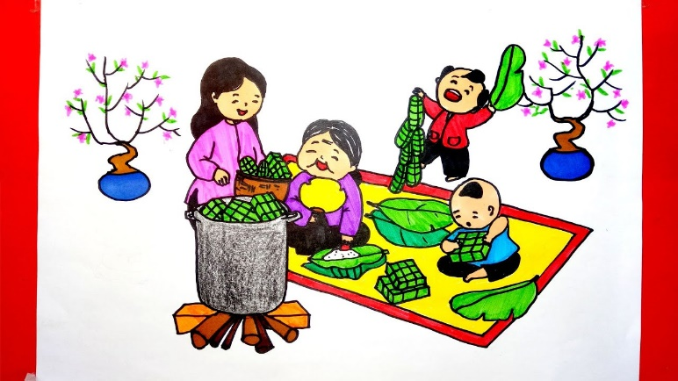

**3. Answer further questions (1 point)**

1. Do you like joining parties? Why? Why not?

2. What do you do on Tet holiday?

3. What do you do in your free time?

4. Do you like watching TV?

5. What kinds of TV programme do you like most? Why?

**KEY**

**SECTION A: LISTENING (2 point)**

**Task1: Listen and complete**

*1. lion*

*2. giraffe*

*3. elephant*

*4. bears*

*5. zoo*

**Task 2: Listen and complete**

*1. action film*

*2. science fiction*

*3. actresses*

*4. crys*

*5. funny*

**SECTION B: LANGUAGE (2 POINTS)**

**I. Choose the word whose underlined part pronounced differently from that of the others by circling A, B, C or D (0.4 point)**

1. C

2. B

**II. Choose the best option (A, B, C or D) to complete these sentences. (1.6 point)**

|  |  |  |  |
| --- | --- | --- | --- |
| 1. A | 3. B | 5. B | 7. C |
| 2. C | 4. A | 6. D | 8. D |

**SECTION 3: READING (2 POINTS)**

**I. Read the passage and then choose the correct answer to each question. (1 point)**

1. A

2. C

3. B

4. D

5. A

**II. Read the passage and choose the correct answer for each question (1 point)**

1. B

2. A

3. D

4. C

5. B

**SECTION D: WRITING (2 POINTS)**

**I. Find out the mistake in each sentence. (0.4 point)**

1. C

2. A

**II. Rewrite the following sentences as directed ( using the suggested words) so that the meanings stay the same. (0.6 pt)**

**1.** Your house is bigger than mine.

🡪 My house is bigger than my house./ My house is bigger than yours.

**2.** I don’t work hard so I get bad marks.

🡪 If I don’t work hard, I will get bad marks./ If I don’t work hard, I won’t get good marks

3. I’m not sure that I’ll go out this evening.

🡪 I might not go out this evening.

**III. Use the word given to complete the sentences. ( 1 point)**

1. What did you have for dinner last night?

2. We are going to visit our grandparents this weekend.

3. If I am tired, I will go home

4. We are having a barbecue at the garden now.

5. People usually visit their relatives on Tet holiday.