Week 13
Period 38
Teaching date: 29/11/2021

UNIT 5: NATURAL WONDERS OF VIET NAM
LESSON 5: SKILLS 1
I.OBJECTIVES: By the end of the lesson, students will be able to:
1. Knowledge:
- Vocabulary: Review some words related to travel activities .
- Grammar: Review modal verbs
2. Competence: Ss can talk about natural wonders of Viet Nam .
3. Educational aims: To educate SS to love and conserve the nature .
II. TEACHING AIDS: Text books, laptop , smart TV , video clips
IV. PROCEDURES:
Contents |  | Teacher’s and Ss’activities
I.PRE-READING: (10’)
- To review knowledges what they have learnt and to lead in the the lesson
-To provide students with some lexical items before reading the text
-Game: Hidden picture.  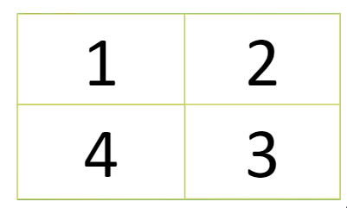  * Vocabulary  - tourist attraction (n) : điểm thu hút khách du lịch , danh lam thắng cảnh  - attract (v): thu hút  -attractive (a) : hấp dẫn  - popular (adj): phổ biến, ưa chuộng  - landscape (n) : phong cảnh  - slope (n) : dốc, sườn  - sand dune (n) : cồn cát  - have a picnic (v): đi dã ngoại  - umbrella (n): cái ô  -join in (v): tham gia vào  1.Look at the pictures and make predictions about the reading.  1. What is the reading about?  2. What do you know about these places?  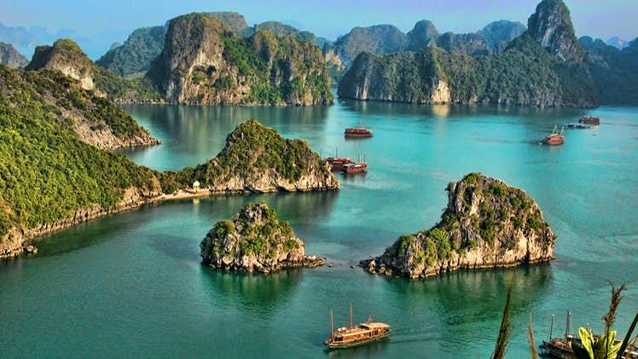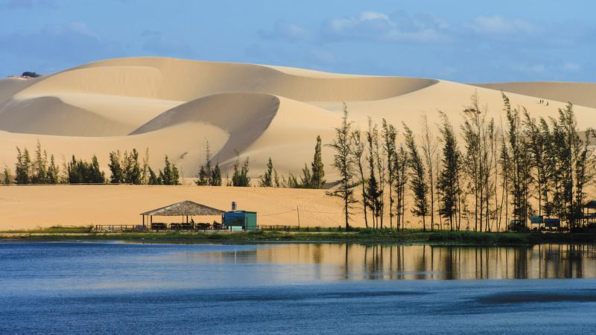 |  | -T: sets the scene: “Next month, I am going travelling. Guess where I will visit.”  -T:Lets Ss guess the places by opening the boxes one by one. The pictures are hidden behind the boxes.  -T:shows the pictures on the screen.  -T: leads in the lesson by asking questions:  1- Have you ever been to these places?” 2-What do you do there ?  - T: uses different techniques to teach vocab (pictures, situation, explaination…..)  -Ss: Repeat in chorus and individually  - Ss:Copy all the words  *Checking vocab: “Matching”  -T asks students to close the book.  -T:shows the pictures of the places and asks Ss to answer the guiding questions:
II. WHILE-READING: (10’)
To develop reading skill for general and specific information to complete the tasks
2. Complete the sentences, using the words from the box.  * Answers:  1. islands 2. wonder 3. desert  4. remember 5. visit  3. Read the text and answer the following questions.  * Answers:  - Ha Long Bay is in Quang Ninh.  - You can enjoy great seafood and join in exciting activities.  - No, there isn’t. It’s like a desert, not a real desert.  - You can have a picnic in Mui Ne by the beach.  5. The best time to visit the Mui Ne and Dunes is early morning or late afternoon. |  | -T: has Ss read the text to check the predictions answers  - T: asks students to do Exercise 2 individually  -T: lets Ss swap their answers with their partner.  - T: gives the answers and corrections  -T: gets Ss to read the text silently  - Ss : work in pairs  - T: calls some pairs to practice asking & answering before the class  - T: corrects while practising
III. POST-READING AND PRE-SPEAKING :(10’)
To check students’ reading comprehension and prepare for the next part.
4.Work in pairs. Make notes about one of the places in the reading. You can add your own ideas. | - Ss: tell some things about HLB and Mui Ne  -T: asks Ss to work in pairs and make notes about one place in the reading.  - Ss compare the notes with other pairs.  - Feed back - Correction  -T: gets Ss to tell their partner about the place by looking at the notes.
  Ha Long Bay | Mui Ne
  - interesting islands  - many islands and caves  - beautiful beaches  - great seafood  - exciting activities | - a beautiful places  - amazing landscapes  - different colour  - like a desert  - many activities
I IV. WHILE – READING : (5’)
To help students form the ideas for their speaking.
Ha Long Bay has a lot of interesting islands. It also has many caves and beautiful beaches. You can enjoy great seafood here and take part in exciting activities. | -T: gets Ss to tell their partner about the place by looking at the notes.  -Ss: practice
V. POST-SPEAKING :(8’)
Students can use what they have learnt so far to talk about a famous place
*Talk about a famous place you like . | - Individually  - Correction
IV. Homework: (2’)
- Learn new words by heart .
-Talk about a famous place you know.
- Prepare Unit 5: SKILLS 2 (page/55)

