Tiếng anh 8 i-Learn Smart World_Unit 1.2
Time allotted: 45

PART 1 PRONUNCIATION (5 questions)
Choose the word whose underlined part differs from the other three in pronunciation in the following question.
1. A. stops B. talks C. chats D. reads
2. A. cinemas B. games C. sports D. friends
3. A. scarf B. scene C. scissors D. scientist
Choose the word that differs from the other three in the position of the main stress in the following question.
4. A. basketball B. competition C. shuttlecock D. badminton
Choose the word whose primary stress is placed on the first syllable.
5. A. descriptive B. recipe C. supporting D. concluding

PART 2 USE OF ENGLISH (12 questions)
Choose the option that best completes the following sentence.
6. Duc Anh and his friends like to ______________ board games in their free time, and he often wins.
A. do B. go C. play D. design
7. Anna's hobby is to design ______________ from seashells.
A. jewelry B. sports C. photography D. crafts
8. The activity of making or fixing things made of cloth is called ______________
A. knitting B. sewing C. skating D. cycling
9. Rock ______________ is her favorite sport.
A. climbing B. fishing C. hanging D. chatting
10. Giang learns how to make things from paper in her ______________ and crafts club.
A. games B. hands C. lessons D. arts
11. Jess is not an active person, so she hates ______________.
A. playing sports B. watching TV C. reading books D. doing arts and crafts
12. We have English classes ______________ Tuesday and Thursday.
A. in B. on C. at D. from
13. Classes start ______________ 7.15 a.m. every day, so students have to get up early.
A. in B. on C. at D. from
14. Binh enjoys ______________ to the gym.
A. go B. goes C. going D. went
15. Our favorite TV show is from 8 p.m. ______________ 10 p.m.
A. in B. from C. on D. until
16. Photography is his hobby, so he ______________ traveling and taking photos.
A. really likes B. really like C. doesn't really like D. would like
17. Their flight to Da Lat ______________ at 6.50 a.m. tomorrow.
A. leaves B. will leave C. leave D. is leaving

PART 3 WORD FORMATION (3 questions)
Write the correct form of the given word.
18. Jane is really interested in ______________. She does it during every break at school. (KNIT)
19. Annabelle is a very ______________ character in that horror movie. (SCARE)
20. Ms. Trang keeps her rings and necklaces in a ______________ box. (JEWEL)

PART 4 ERROR IDENTIFICATION (2 questions)
Find the underlined part that needs correction in the following question.
21. Quynh Nhu doesn’t has an English class at school tomorrow.
A. has B. an C. at D. tomorrow
22. Do you want to play shuttlecock on the schoolyard tomorrow on around 5 p.m.?
A. Do B. to C. shuttlecock D. on

PART 5 READING (5 questions)
Read the website article. Choose the best word or phrase for each space. (5 questions)
What kind of hobby do you have?
There are three main types of hobbies. In the first type, you play something, like a sport, a board game, or a video game. Many people in the USA play soccer, baseball, and basketball. In sports, people are usually in (23)___________, but sometimes one person plays against another person, in tennis, for example. Chess is a popular (24)___________ game with many people. Many teenagers and younger children love playing games on their computers. In all of these hobbies, there is a competition between people.
In the second type of hobby, people do an activity outside on their own, for example, skateboarding, cycling, or rock climbing. There is no (25)___________ here. People do the activities because they are fun.
In the third type of hobby, people make something, such as a model plane, a cake, or a piece of clothing. Most people do this kind of hobby on their own, but in the end, they can show their parents and their friends. Some people collect interesting things, like stamps or money from (26)___________ countries. They put the things in a book or in a drawer. In the past, people collected insects like butterflies in this way, but that is not a (27)___________ hobby now.
(23) A. sides B. teams C. classes D. groups
(24) A. boring B. bored C. board D. born
(25) A. competition B. play C. competitors D. players
(26) A. strange B. old C. those D. foreign
(27) A. interested B. popular C. extreme D. present

PART 6 LISTENING (5 questions)
Listen to five short texts. Choose the correct picture for each question. (5 questions)
28. What is the boy’s favorite hobby?
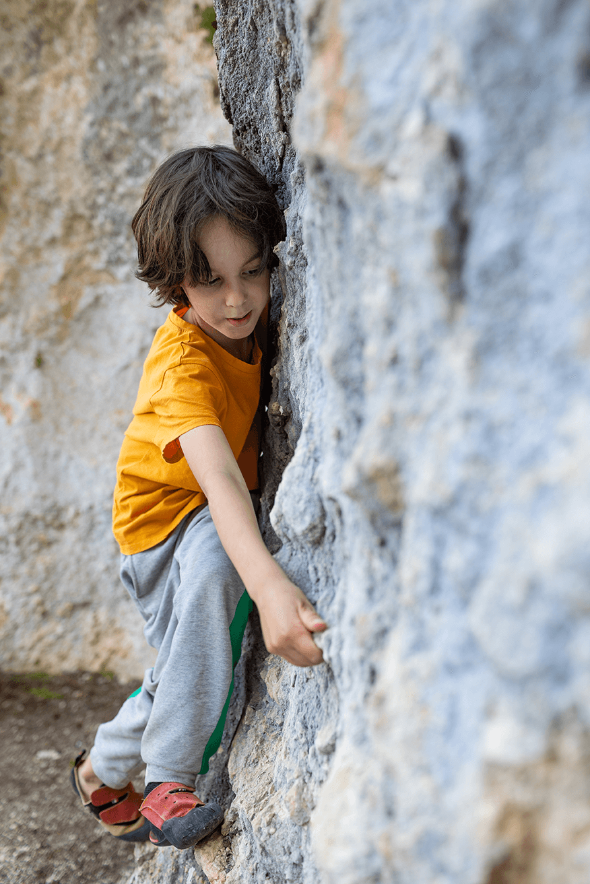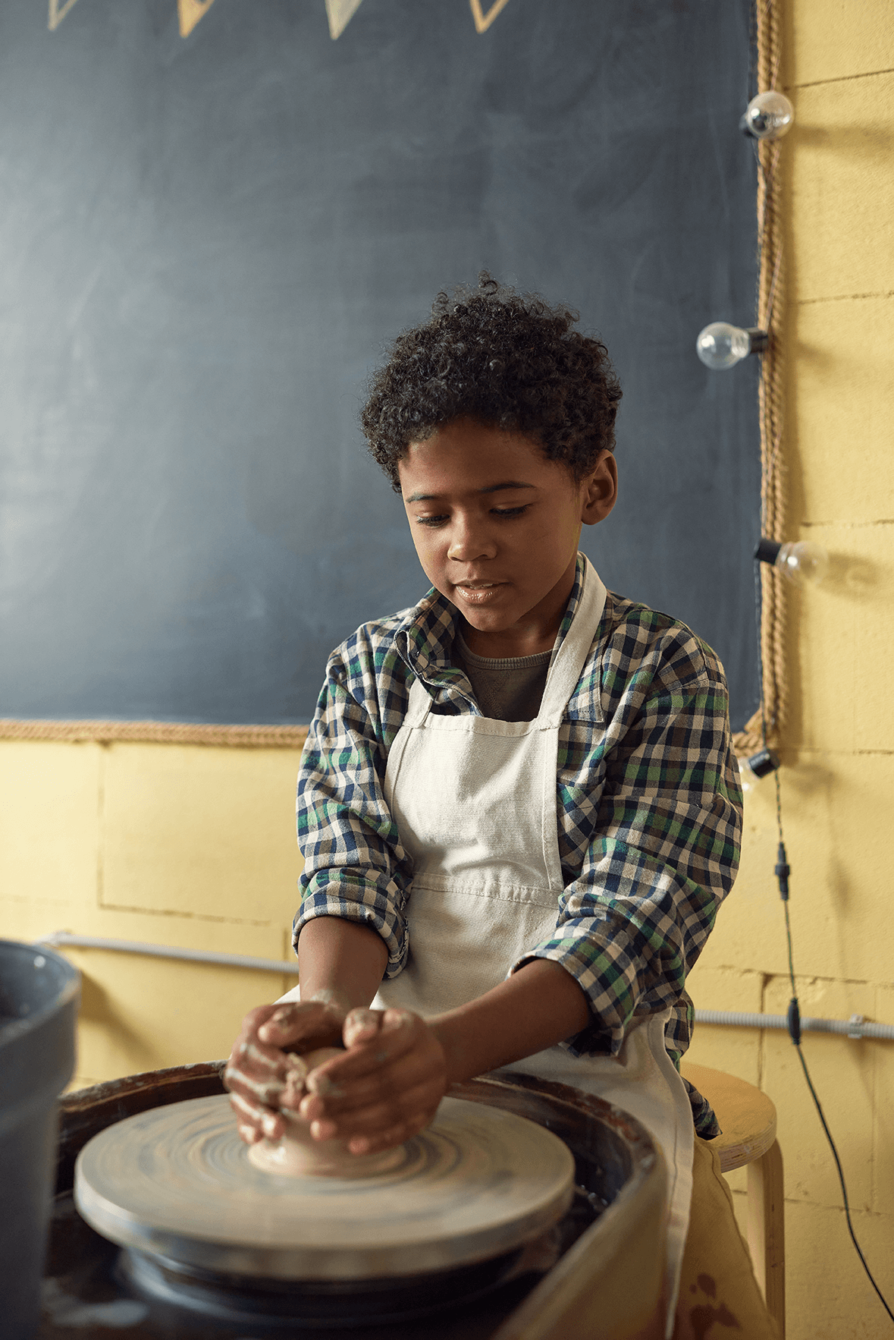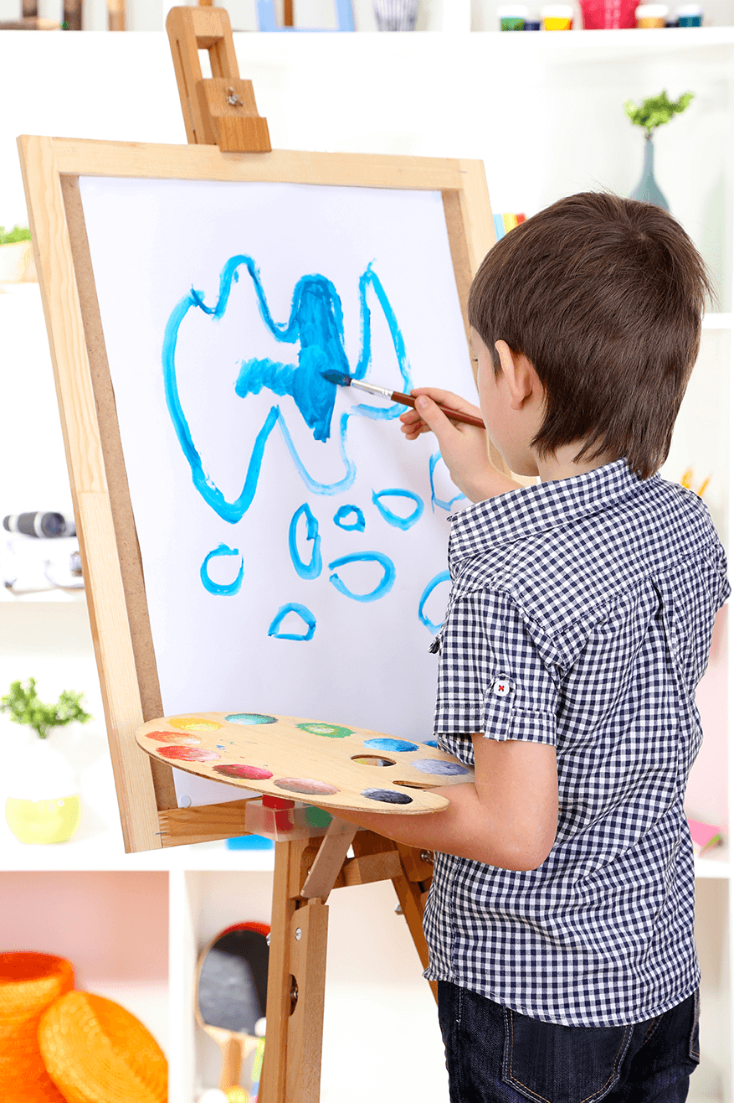
A. ☐ B. ☐ C. ☐
29. When does the girl go to the Hobby Club?

A. ☐ B. ☐ C. ☐
30. Where does the boy want to go on the weekend?
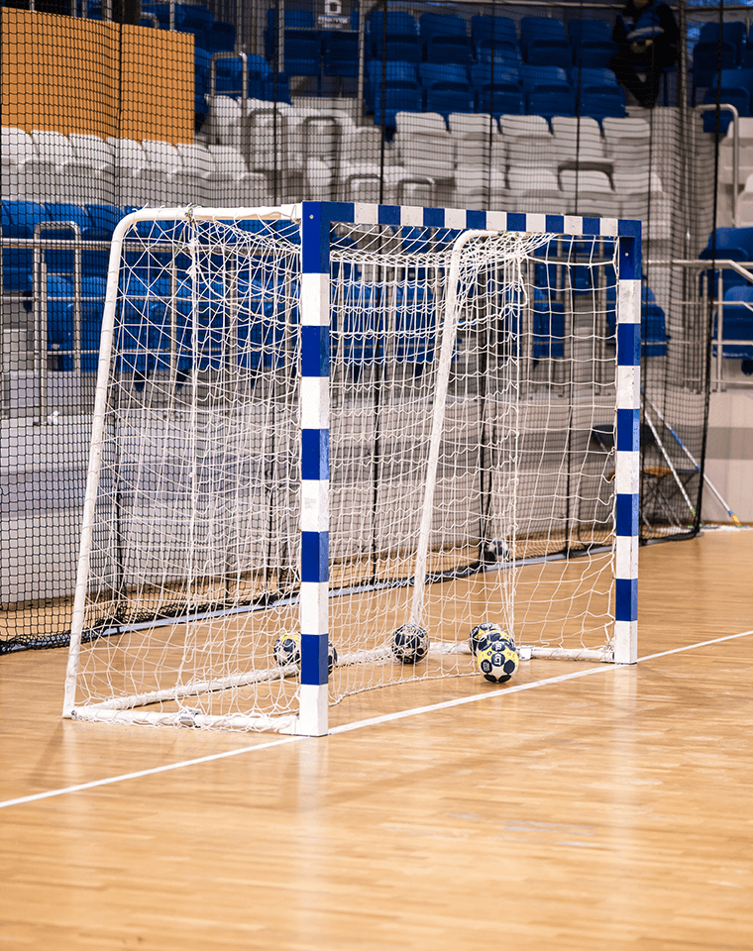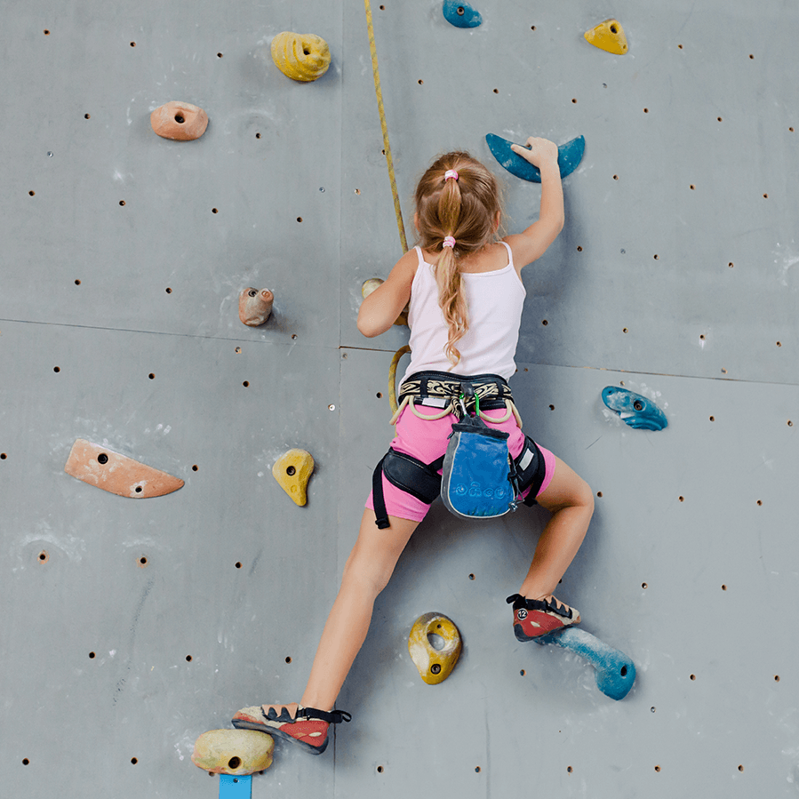
A. ☐ B. ☐ C. ☐
31. What hobby is the girl doing now?
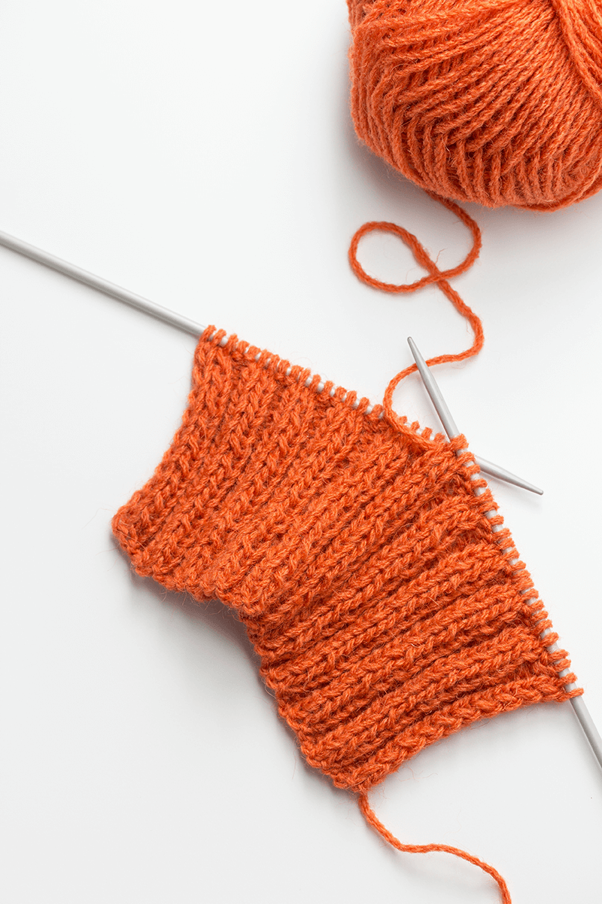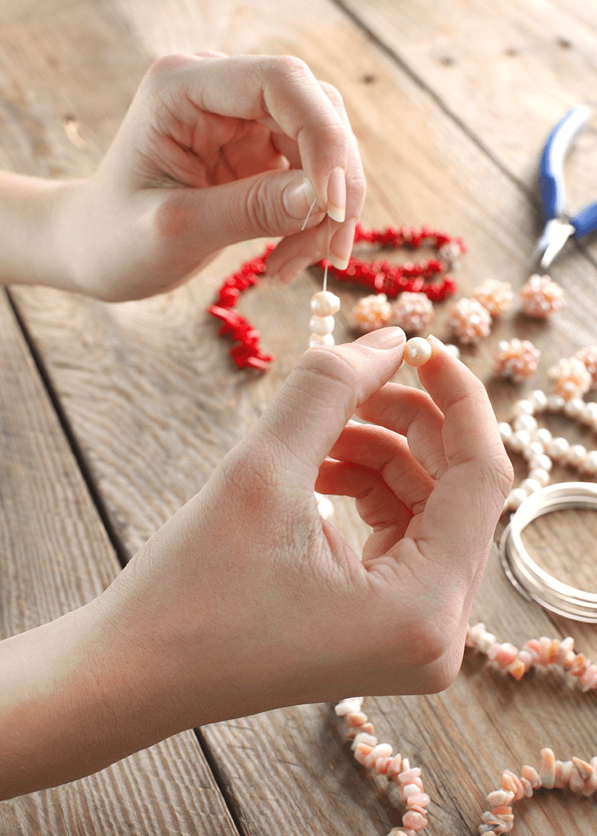
A. ☐ B. ☐ C. ☐
32. What is the most popular hobby for teenagers in the boy’s country?
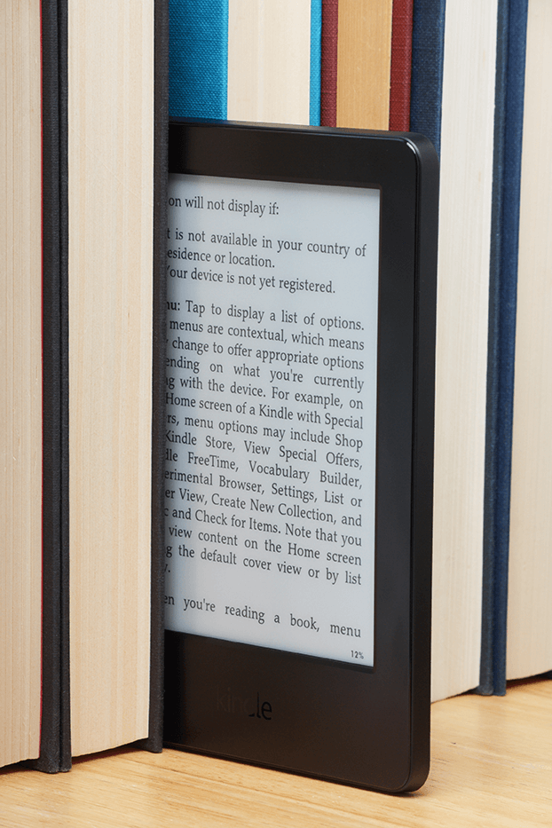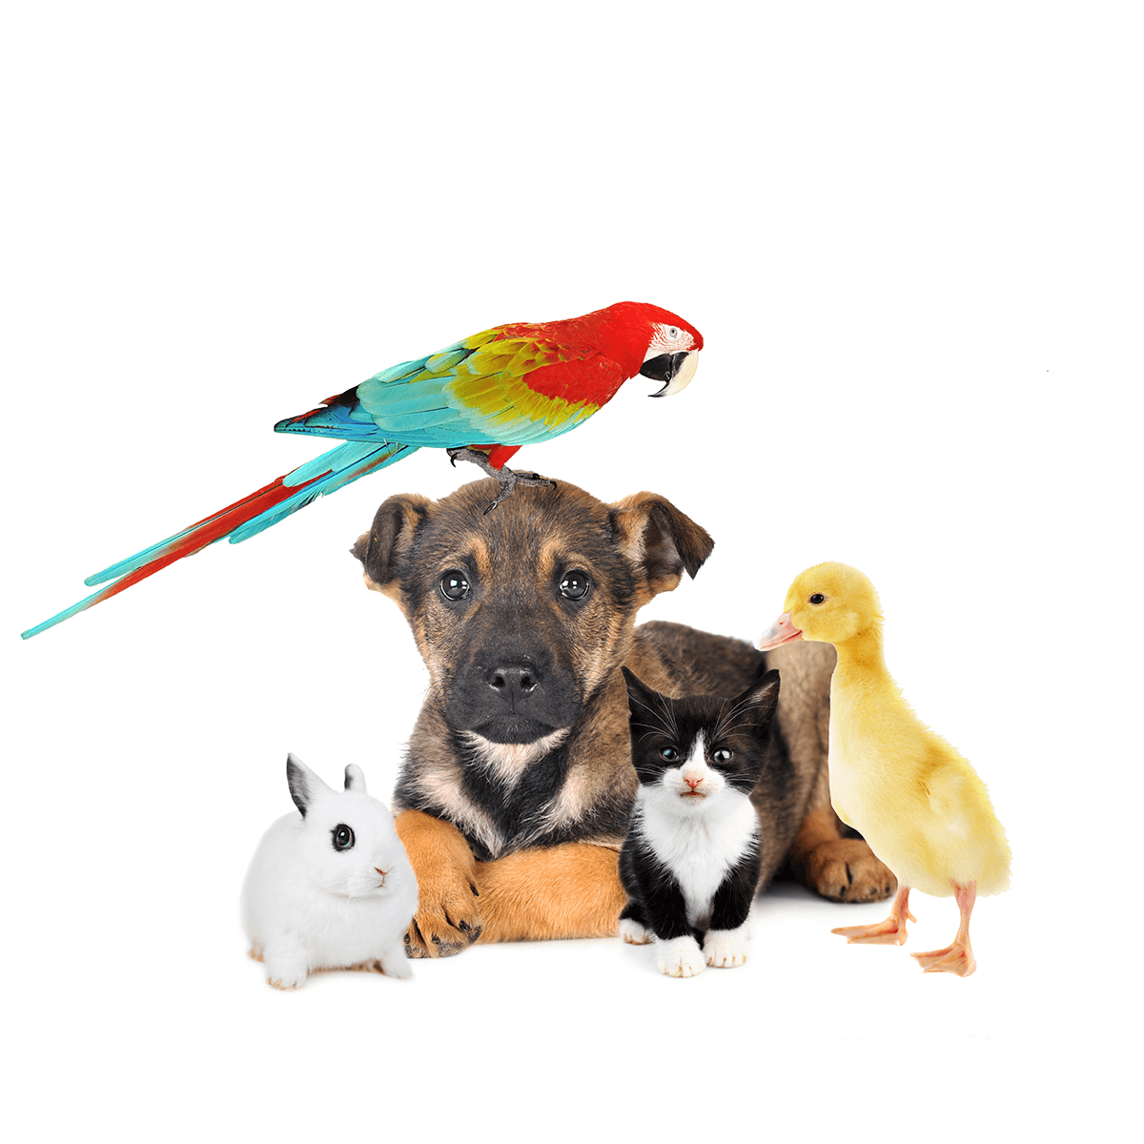
A. ☐ B. ☐ C. ☐

PART 7 WRITING (8 questions)
Rewrite the following sentence without changing its meaning. Use the given word(s) if any.
33. Sewing is Hoa's favorite activity in her free time.
→ Hoa enjoys___________
34. When is your martial arts class?
→ When do___________
35. Andy likes playing soccer. He doesn't like going swimming. (PREFERS)
→ ___________
36. I have an English class tomorrow. It finishes at 5 p.m. (UNTIL)
→ ___________
Use the given words or phrases to make complete sentence.
37. John / love / collect / old stamps.
→ ___________
38. Laura / not really like / dance / and / sing.
→ ___________
Put the words in the correct order to make correct sentence.

39. Keywords: do you/?/What time/chat with/your friends/usually
→ .......................................
40. Keywords: meet/Saturday morning/Let's/./6.45 a.m./on/at
→ .......................................
---THE END---

Tiếng anh 8 i-Learn Smart World_Unit 1.2
Time allotted: 45 ANSWER KEY

PART 1 PRONUNCIATION (5 questions)
Choose the word whose underlined part differs from the other three in pronunciation in the following question.
1. A. stops B. talks C. chats D. reads
2. A. cinemas B. games C. sports D. friends
3. A. scarf B. scene C. scissors D. scientist
Choose the word that differs from the other three in the position of the main stress in the following question.
4. A. basketball B. competition C. shuttlecock D. badminton
Choose the word whose primary stress is placed on the first syllable.
5. A. descriptive B. recipe C. supporting D. concluding

PART 2 USE OF ENGLISH (12 questions)
Choose the option that best completes the following sentence.
6. Duc Anh and his friends like to ______________ board games in their free time, and he often wins.
A. do B. go C. play D. design
7. Anna's hobby is to design ______________ from seashells.
A. jewelry B. sports C. photography D. crafts
8. The activity of making or fixing things made of cloth is called ______________
A. knitting B. sewing C. skating D. cycling
9. Rock ______________ is her favorite sport.
A. climbing B. fishing C. hanging D. chatting
10. Giang learns how to make things from paper in her ______________ and crafts club.
A. games B. hands C. lessons D. arts
11. Jess is not an active person, so she hates ______________.
A. playing sports B. watching TV C. reading books D. doing arts and crafts
12. We have English classes ______________ Tuesday and Thursday.
A. in B. on C. at D. from
13. Classes start ______________ 7.15 a.m. every day, so students have to get up early.
A. in B. on C. at D. from
14. Binh enjoys ______________ to the gym.
A. go B. goes C. going D. went
15. Our favorite TV show is from 8 p.m. ______________ 10 p.m.
A. in B. from C. on D. until
16. Photography is his hobby, so he ______________ traveling and taking photos.
A. really likes B. really like C. doesn't really like D. would like
17. Their flight to Da Lat ______________ at 6.50 a.m. tomorrow.
A. leaves B. will leave C. leave D. is leaving

PART 3 WORD FORMATION (3 questions)
Write the correct form of the given word.
18. Jane is really interested in ______________. She does it during every break at school. (KNIT) => Knitting
19. Annabelle is a very ______________ character in that horror movie. (SCARE) => Scary
20. Ms. Trang keeps her rings and necklaces in a ______________ box. (JEWEL) => Jewelry/Jewellery

PART 4 ERROR IDENTIFICATION (2 questions)
Find the underlined part that needs correction in the following question.
21. Quynh Nhu doesn’t has an English class at school tomorrow.
A. has B. an C. at D. tomorrow
22. Do you want to play shuttlecock on the schoolyard tomorrow on around 5 p.m.?
A. Do B. to C. shuttlecock D. on

PART 5 READING (5 questions)
Read the website article. Choose the best word or phrase for each space. (5 questions)
What kind of hobby do you have?
There are three main types of hobbies. In the first type, you play something, like a sport, a board game, or a video game. Many people in the USA play soccer, baseball, and basketball. In sports, people are usually in (23)___________, but sometimes one person plays against another person, in tennis, for example. Chess is a popular (24)___________ game with many people. Many teenagers and younger children love playing games on their computers. In all of these hobbies, there is a competition between people.
In the second type of hobby, people do an activity outside on their own, for example, skateboarding, cycling, or rock climbing. There is no (25)___________ here. People do the activities because they are fun.
In the third type of hobby, people make something, such as a model plane, a cake, or a piece of clothing. Most people do this kind of hobby on their own, but in the end, they can show their parents and their friends. Some people collect interesting things, like stamps or money from (26)___________ countries. They put the things in a book or in a drawer. In the past, people collected insects like butterflies in this way, but that is not a (27)___________ hobby now.
(23) A. sides B. teams C. classes D. groups
(24) A. boring B. bored C. board D. born
(25) A. competition B. play C. competitors D. players
(26) A. strange B. old C. those D. foreign
(27) A. interested B. popular C. extreme D. present

PART 6 LISTENING (5 questions)
Listen to five short texts. Choose the correct picture for each question. (5 questions)
28. What is the boy’s favorite hobby?
A. ☐ B. ☐ C. ☐
29. When does the girl go to the Hobby Club?
A. ☐ B. ☐ C. ☐
30. Where does the boy want to go on the weekend?
A. ☐ B. ☐ C. ☐
31. What hobby is the girl doing now?
A. ☐ B. ☐ C. ☐
32. What is the most popular hobby for teenagers in the boy’s country?
A. ☐ B. ☐ C. ☐

PART 7 WRITING (8 questions)
Rewrite the following sentence without changing its meaning. Use the given word(s) if any.
33. Sewing is Hoa's favorite activity in her free time.
→ Hoa enjoys sewing in her free time.
34. When is your martial arts class?
→ When do you have martial arts class?
35. Andy likes playing soccer. He doesn't like going swimming. (PREFERS)
→ Andy prefers playing soccer to going swimming./Andy prefers soccer to swimming./Andy prefers to play soccer rather than go swimming.
36. I have an English class tomorrow. It finishes at 5 p.m. (UNTIL)
→ I have an English class until 5 p.m. tomorrow.
Use the given words or phrases to make complete sentence.
37. John / love / collect / old stamps.
→ John loves collecting old stamps./John loves to collect old stamps.
38. Laura / not really like / dance / and / sing.
→ Laura doesn't really like dancing or singing./Laura doesn't really like to dance or sing./Laura does not really like dancing or singing./Laura does not really like to dance or sing./Laura does not really like to dance or to sing.
Put the words in the correct order to make correct sentence.

39. Keywords: do you/?/What time/chat with/your friends/usually
→ What time do you usually chat with your friends ?
40. Keywords: meet/Saturday morning/Let's/./6.45 a.m./on/at
→ Let's meet at 6.45 a.m. on Saturday morning ./Let's meet on Saturday morning at 6.45 a.m.
---THE END---

