UNIT 5: FOOD AND DRINK
Lesson 4: Communication

I. OBEJECTIVES
By the end of this lesson, Ss will be able to:
1. Knowledge
- Use lexical items related to the favourite food and drink in everyday life
- Understand and use ways to ask and answer about prices and favourite food and drink in English
2. Core competence
- Develop communication skills
- Be collaborative and supportive in pair work and team work
- Actively join in class activities
3. Personal qualities
- Promote pride in the values ​​of Vietnamese culture
- Develop love for family
II. PREPARATIONS
1. Teacher
- Grade 7 textbook, laptop, TV/Projector/ pictures and cards, speakers, lesson plan, sachmem.vn…
2. Students
- Grade 7 textbook, notebooks, school things….
III. TEACHING PROCEDURES
ACTIVITY 1 – WARM – UP & INTRODUCTION (5’)
a) Aims:
- To activate students’ knowledge on the topic of the unit
- To enhance students’ skills of cooperating with teammates
b) Contents: Play the game “Restaurants”
c) Products: Ss’ answers
d) Teaching steps:
Teacher’s and students’ activities | Content
Deliver the task  - Teacher asks Ss to work in small groups.  - Teacher gives each group a different type of restaurant and tells them to create a menu and include starters, main courses, side dishes, desserts and drinks. Don't forget the prices.  Implement the task  -Ss quickly write on their own board, raise the board up and say "Bingo"  Discuss  -Ss look at others' restaurant menu and say which they want to go to in turns.  Giving comments or feedback  -Teacher gives them a quick feedback. | Restaurants  - a steakhouse  - a vegetarian café  - an expensive French eatery  - a motorway service station restaurant  - a seafood restaurant  …
ACTIVITY 2 – PRESENTATION (15’)
a) Aims:
- To help students use key language more appropriately
- To introduce ways to ask and answer about prices in English.
b) Contents:
- Teach the vocabularies
- Listen and repeat the conversation. Pay attention to the questions and answers.
c) Products:
- Lists of vocabularies
- Ss’ performance
d) Teaching steps:
Teacher’s and students’ activities | Content
Deliver the task  - T asks Ss to look at the photo and answer the question.  What is this?  Implement the task  -Teacher shows and says the words aloud and asks Ss to repeat them.  - Teacher gives some words in Vietnamese and asks Ss to translate into English  -Ss say the words.  Discuss  -Other Ss correct if the previous answers are incorrect.  - Teacher gives the correct answers  Giving comments or feedback  - Teacher checks and corrects if Ss spell or pronounce the words/ phrases incorrectly.  Deliver the task  -Teacher gives Ss instructions.  Implement the task  -Ss listen carefully, watch closely and repeat as a whole class. They pay attention to the questions whenever Teacher pauses and corrects their mistakes.  Discuss  - Ss work in pairs to repeat the conversation.  Giving comments or feedback  - Teacher shows the conversation on the screen to make sure they ask the correct questions.  Audio script – Track 34:  Mark: How much is a bottle of mineral water?  Mai: It’s 5,000 dong.  Mark: And how much are two kilos of apples?  Mai: They’re 50,000 dong. | 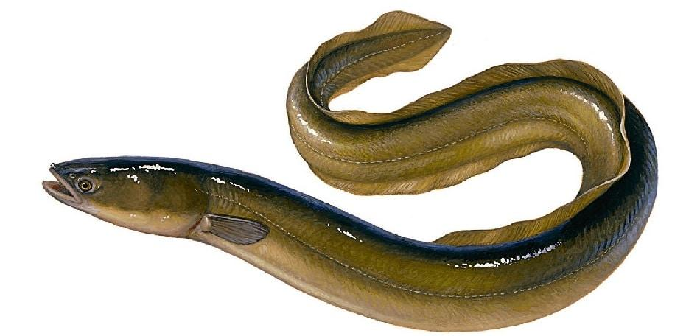  I.Vocabulary  1. eel /iːl/: con lươn  2. foreign /ˈfɒrən/: ngoại quốc  3. favourite /ˈfeɪvərɪt/: ưa thích  4. interview /ˈɪntəvjuː/: cuộc phỏng vấn  5. try /traɪ/: thử làm gì đó  Task 1. Listen and repeat the conversation. Pay attention to the questions and answers.  
ACTIVITY 3 – PRACTICE (15’)
a) Aims:
- To help Ss practise asking and answering about prices.
- To teach Ss the questions they can ask to interview someone about their favourite food and drink;
- To help Ss revise the vocabulary related to the topic.
b) Contents:
- Works in pairs. Ask and answer about the prices of the food and drink on the menu.
- Listen to the conversation and answer the questions.
c) Products:
- Ss’ ask and answer about the prices of the food and drink on the menu.
- Answer key
d) Teaching steps:
Teacher’s and students’ activities | Content
Deliver the task  -Teacher shows the menu on the screen, shows the sample of the conversation, pairs Ss and asks them to play the roles of a waiter and a customer to ask and answer about the prices of the food and drink on the menu.  Implement the task  -Ss practise for about 3 minutes.  Discuss  - Ss work with another partner and change their roles, asking and answering questions about the prices.  Giving comments or feedback  -Teacher goes around, observes, corrects their mistakes and notes some of their typical errors if necessary.  Deliver the task  - Teacher gives Ss some time to read the questions in Exercise 3, asks them to pay attention to the key words and predict the answers.  Implement the task  -Ss do the exercise step by step.  - Ss read and underline key words.  - Ss listen twice, find synonyms and paraphrases of the key words and answer the question.  Discuss  -Teacher asks Ss to swap their notebooks with each other, listen to the recording once again and peer check.  Giving comments or feedback  -Teacher gives Ss the correct answers and then asks them to repeat the conversation.  Audio script – Track 35:  Peter: Nam, can you help me with my school project? I need to interview some people about what they like to eat and drink.  Nam: Sure. What questions do you have?  Peter: What’s your favourite food, Nam?  Nam: It’s spring rolls.  Peter: What’s your favourite drink?  Nam: I like lemonade.  Peter: Interesting. What foreign food do you like?  Nam: Mmm, I like apple pie and pancakes.  Peter: How about new food? Is there anything that you’ve never had, but would like to try?  Nam: Certainly. I’d love to try hu tieu in Ho Chi Minh City.  Peter: I’d like to give it a try too. What can you cook?  Nam: Let me think... I cook omelettes, rice, and spring rolls. | Task 2. Works in pairs. Ask and answer about the prices of the food and drink on the menu.  LY'S RESTAURANT  Breakfast  Food Price  bowl of beef noodle soup 30,000 dong  bowl off eel soup 35,000 dong  toast 20,000 dong  Drink  glass of milk 9,000 dong  bottle of mineral water 8,000 dong  cup of green tea 5,000 dong  Task 3. Listen to the conversation and answer the questions  - What's Nam's favourite food?  - What's his favourite drink?  - What foreign food does he like?  - What food does he want to try?  - What food can he cook?  Key:  1. Spring rolls.  2. Lemonade.  3. Apple pie and pancakes.  4. Hu tieu (in Ho Chi Minh City).  5. Omelettes, rice, and spring rolls.
ACTIVITY 4 – PRODUCTION (7’)
a) Aims:
- To help Ss practise asking and answering about their friends’ favourite food and drink;
- To help Ss get information to report on their friends’ favourite food and drink;
- To help Ss practise reporting the results of their interviews.
b) Contents:
- Work in groups. Interview two of you friends about their favourite food and drink. Write their answers in the table.
c) Products:
- Ss’ answers
d) Teaching steps:
Teacher’s and students’ activities | Content
Deliver the task  -Teach lets Ss randomly pick the cards to choose their teams. Then, teacher gives the instruction.  Implement the task  -Ss work in groups, practise asking and answering the questions to get information about the others in their groups to complete the table.  Discuss  -Ss share the collected information in the class.  Giving comments or feedback  -Teacher listens to them, gives them comments and correct when necessary. | Task 4. Work in groups. Interview two of you friends about their favourite food and drink. Write their answers in the table.  Questions S1 S2  1. What's your favourite food?  2. What's your favourite drink?  3. What food or drink do you want to try?  4. What foreign food or drink do you like?  5. What can you cook?
IV. WRAP-UP & HOMEWORK (7’)
- Teacher has Ss say what they have learnt in the lesson:
+ Vocabulary of the favourite food and drink in everyday life
+ Ways to ask and answer about prices, and favourite food & drink in English
- Teacher asks Ss to make and a conversation, record a video and upload on given drive link. (Teacher should check the progress of students’ preparation after each lesson.)
- Teacher asks Ss to prepare the next lesson “Unit 5 – Skills 1”

V. FEEDBACK

……………………….…, ngày………….tháng…………..năm 2022
Duyệt của Tổ chuyên môn

