Đề thi Tiếng Anh lớp 2 học kỳ 1 sách Cánh Diều
- Count and write
 | 
- ______________ | - ______________
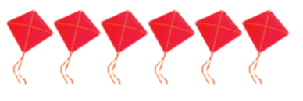 | 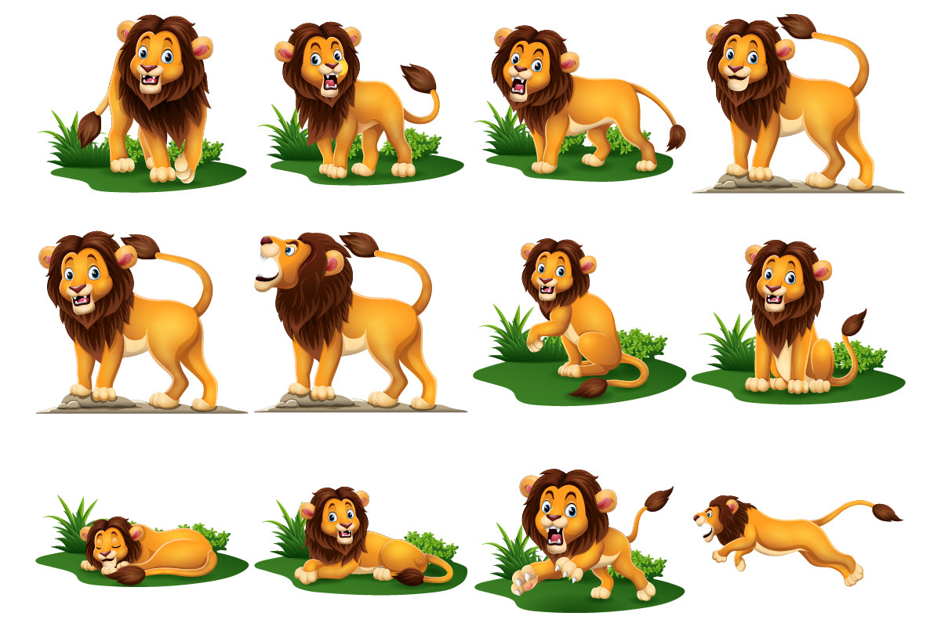
- ______________ | - ______________
- Look and complete the words
 | 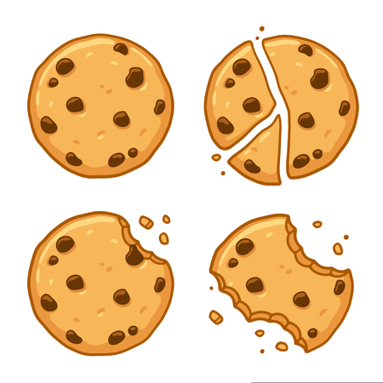
- b _ n _ _a s | - _ o o _ i e _
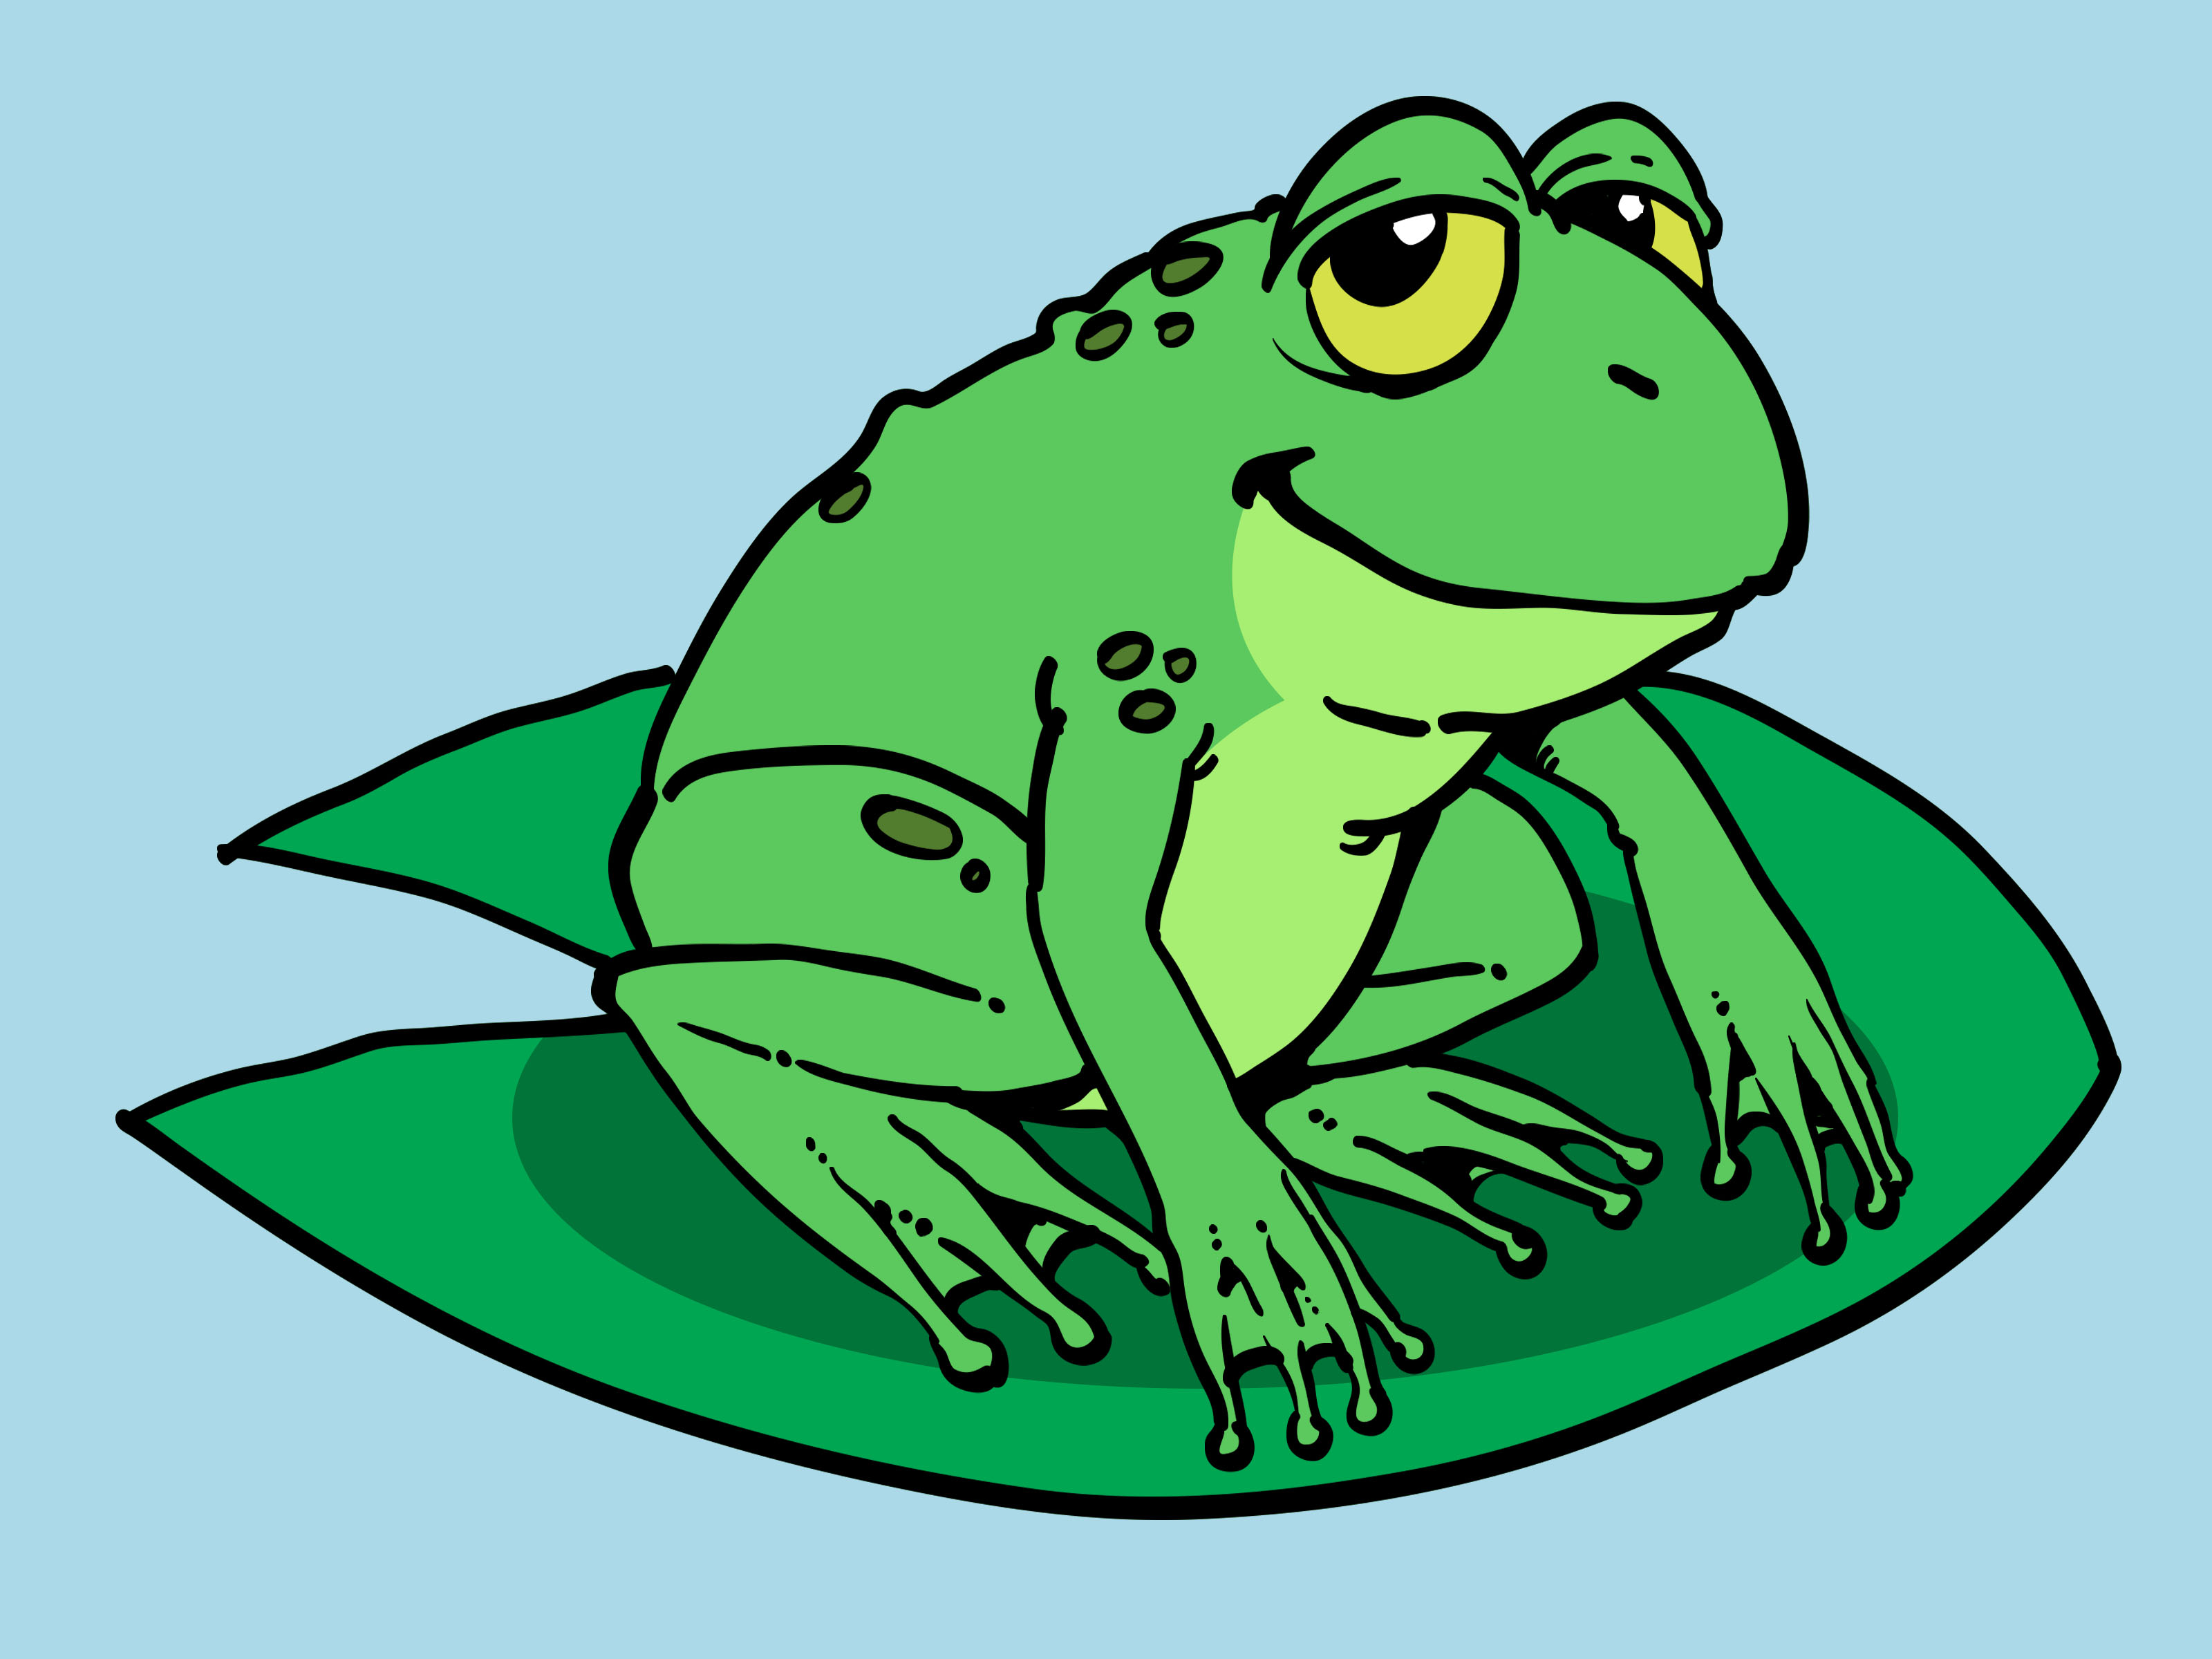 | 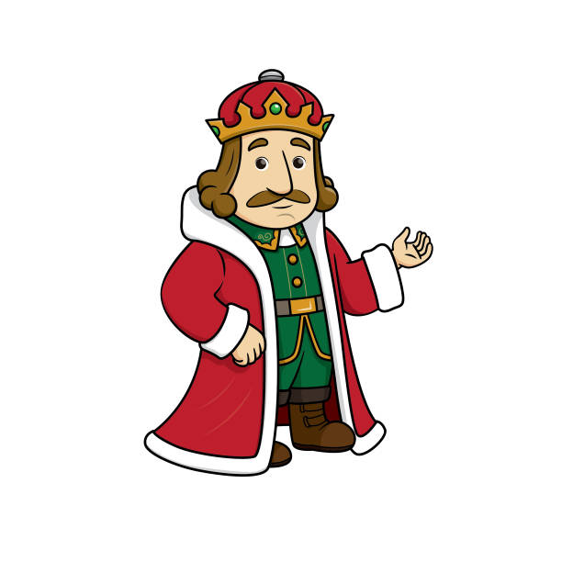
- _ r _ g | - _ i n _
- Look at the picture and answer the following questions

- How many children are there?
__________________________________
- How many girls are there?
__________________________________
- How many boys are there?
__________________________________
- Reorder these words to have correct sentences
- like/ milk/ Do/ you/ ?/
__________________________________
- No,/ noodles/ don’t/ like/ I/ ./
__________________________________
- have/ nose/ one/ I/ ./
__________________________________
-The end-
Đáp án đề thi Tiếng Anh lớp 2 học kỳ 1 sách Cánh Diều - Đề 1
- Count and write
- two | - eleven
- six | - twelve
- Look and complete the words
- bananas | - cookies
- frog | - king
- Look at the picture and answer the following questions
- Ten (children)
- Two (girls)
- Eight (boys)
- Reorder these words to have correct sentences
- Do you like milk?
- No, I don’t like noodles.
- I have one nose.

