

Tiết thứ 5
UNIT 1: HOBBIES
Lesson 4: Communication
Class | Date of teaching | Attendence
7A | ..../09/2022
7B | ..../09/2022
7C | ..../09/2022

I. OBJECTIVE: By the end of this lesson, students will be able to
1. Knowledge:
- Use the lexical items related to the topic Hobbies
- Talk about likes and dislikes
- Ask and answer about hobbies.
+ Vocabulary: - Use the lexical items related to the topic Hobbies
+ Grammar: - The form and use of present simple.(Review)
- The use of the verbs of liking: like, love, enjoy, hate + V-ing; talking about likes and dislikes.
+ Pronunciation:
2. Competence:
a) General competencies:
Students will be able to revise and learn how to use and form present simple tense.
Talking about likes and dislikes.
- Develop communication skills and creativity.
- Be collaborative and supportive in pair work and teamwork.
- Actively join in class activities.
b) Specific competencies:
- Group work and independent working, pair work, linguistic competence, cooperative learning and communicative competence.
- Ability of using Present Simple Tense, some popular verbs of liking.
- Sts can introduce themselves or one another fluently.
3. Qualities: Having benefits of their hobbies in daily life.
- Be encouraged to know more about their classmate’s hobbies; Develop self-study skills
II. PREPARATIONS
Teacher: Grade 7 text book, laptop, TV, pictures and realia, Computer connected to the Internet. Sach mem.vn
Students: Text books, pencils, pics, blank papers, realia,….
III. PROCEDURE:
In each activity, each step will be represented as following:
* Task delivering
** Task performance
*** Report and discussion
 Judgement

Activity 1. WARM UP (5’-IW) Everyday English Talking about likes and dislikes
* Aims:
- To create an active atmosphere in the class before the lesson;
- To lead into the new lesson.
* Content: Review the previous leson or have some warm-up activities to creat a friendly and relaxed atmostphere to inspire Ss to warm up to the new lesson
* Products: Having a chance to speak English and focus on the topic of the lesson..
* Implementation:Teacher’s instructions…
Teacher’s & Student’s activities | Content
+ Greeting // + Revision  - Teacher (T) asks Ss some questions about them and class.  - Show some pictures of the hobbies that Ss learnt in the previous lessons.  - Ask some Ss to make sentences about themselves, using the verbs of liking / disliking.  - Introduce the objectives of the lesson: learning how to talk about likes / dislikes and about their hobbies  - Ask Ss to open their book and introduce what they are going to study…. | 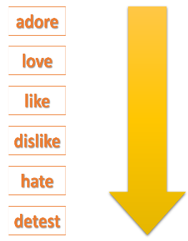
Activity 2. KNOWLEDGE FORMATION (15’ - IW)
* Aims:
- To introduce ways of talking about likes and dislikes in English;
- To help Ss practise talking about likes and dislikes.
* Content: To listen and read the conversation. Asking and answering questions about what they like and don’t like doing.
* Products: Ss can ask and answer questions about what they like and don’t like doing...
* Implementation:
Teacher’s & Student’s activities | Content
1. Listen and read the dialogue below. Pay attention to the questions and answers.  * Pre- teach vocabulary:  * Play the recording for Ss to listen and read the dialogue between Mi and Ann at the same time.  - Ask Ss to pay attention to the questions and answers.  ** Have Ss practise the dialogue in pairs.  - T calls on some Ss to give examples.  *** Teacher and students discuss the answers.   Teacher confirms the answers and gives feedback  - Teacher uses different techniques to teach vocabulary (situation, realia, translation .....) if have  2. Work in pairs. Ask and answer questions about what you like and don’t like doing.  - Ask Ss to work in pairs to make similar dialogues, using different verbs to show likes and dislikes.  - Move around to observe and provide help. Call on some pairs to perform in front of the class.  - Comment on their performance. | 1. Listen and read the dialogue below. Pay attention to the questions and answers.  - I like going to the cinema.  - She hates cleaning the floors.  Teacher: Do you love running?  Student: Yes, very much. I usually run in the park at weekends.  Audio script - Track 6:  Mi: Do you like reading books?  Ann: Yes, very much, especially books about science.  Mi: What about painting? Do you like it?  Ann: No, I don't. I'm not that interested in art.
Activity 3. PRACTICE (20’ – IW, PW, GW) All about your hobbies
* Aim: To provide practice with answering about Ss' hobbies.
* Content: Question and Answer. Do the fillings; Ask and answer questions about the things they like/ don’t like.
* Products: Ss can ask answer the questions . Filling in column A with correct answer; Ss can answer the questions correctly and fill in column B.
* Implementation:
Teacher’s Student’s activities | Content
3. Answer the questions. Fill in column A with your answers.  * T asks Ss to work individually and fill in column A  ** Ss work individually to do the task.  *** T invites some Ss to share their answers before checking with the whole class.   T gives feedback and comments. | 3. Answer the questions. Fill in column A with your answers.  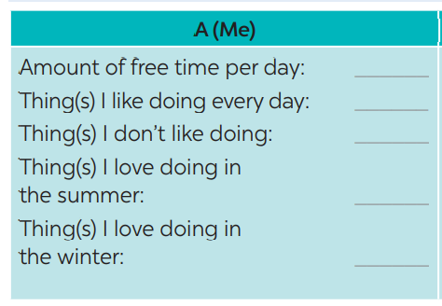
4. Now interview your friend, using the questions in 3. Write his / her answers in column B.  * T asks Ss to take turns being the person who asks the questions. This S has to note down his/ her partner’s answers to report to the class later.  ** Ss work in pairs to do the task.  *** T calls on some Ss to report the answers to the class.   T and other Ss give comments. | 4. Now interview your friend, using the questions in 3. Write his / her answers in column B.  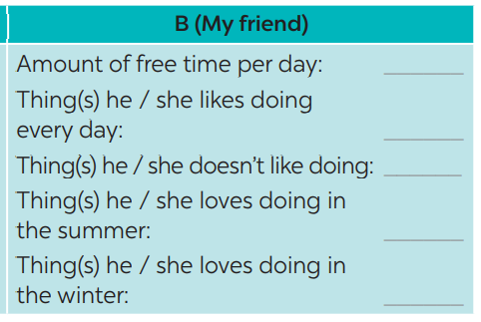
Activity 4. APPLICATION (5’-IW)
* Aim: To provide practice with comparing answers and giving a presentation about hobbies.
* Content: Further practice talking about their hobbies; Home assigment
* Products: To Improve speaking skills. Talking about their hobbies; Take note Home assigment
* Implementation:
Teacher’s Student’s activities | Content
5. Compare your answers with your friend’s. Then present them to the class.  * T asks Ss to read the example to understand how to report the answers.  ** Ss work in pairs again to compare the answers and prepare a short presentation.  *** T invites some Ss to present their work.   T and other Ss give comments.  * Home assignment  - T assigns the homework.  - Ss copy their homework.  - T explains it carefully | 5. Compare your answers with your friend’s. Then present them to the class  * Home assignment  - Practice talking about hobbies.  - Do more exercises in workbook.  - Prepare new lesson. SKIILS-1 P.₁₄

V. FEEDBACK:
With 7A ……………………………………………………………………………..…
With 7B …………………………...……………………………………..……………
With 7C ………………………………………………………………………….……

