**Have something done**

**Exercise 1. Look at Paris's list. Complete the sentences and questions with the correct form of have/get something done.**

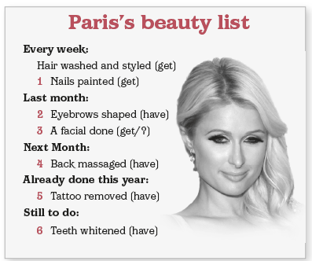

E.g.: Paris **gets her hair washed and styled** every week.

1. Paris ____________ every week.

2. Last month, she ____________.

3. ____________ she ____________ last month?

4. Next month, she ____________.

5. She ____________ already this year.

6. She ____________ yet this year.

**Exercise 2. Complete the dialogue between a TV presenter and Clara with the correct form of have something done. Use short forms.**

P: Today in the studio we have teenage author Clara Dickens, whose book Bringing up my Parents became an international bestseller. Clara, has success changed you?

C: Well, I guess I'm the same person. I have the same friends and go to the same school and still work hard. I mean I (1)____________ (not/do/homework) for me or anything, but yes, in some ways life is different now.

P: How is it different?

C: Well, I'm not like a big Hollywood celebrity or whatever, but I'm into fashion and stuff, so since my success, I (2)____________ (make/some nice clothes) for me. Oh, and I also have very big feet, so I used to find it difficult to find shoes that fit, but now I (3)____________ (design and fit/shoes) especially for me.

P: What about your parents, the subject of your book?

C: Well, I couldn't have done it without them, so I wanted to thank them, of course. At the moment, we (4)____________ (redecorate/house), and Mum is going to the dentist regularly because she (5)____________ (completely redo/ her teeth). Dad likes old motorbikes, so he (6)____________ (build/new garage) for his bikes.

P: Great. So let's talk about your new book …

**Exercise 3. Rewrite the sentences and questions using the correct form of have something done.**

1. We install a facial recognition system to protect the building after the burglary.

We ____________ to protect the building after the burglary.

1. An AI-robot is checking Isobel's eyes on Friday.

Isobel ____________ by an AI-robot on Friday.

1. Unfortunately, they didn't deliver Scott's package yesterday.

Unfortunately, Scott ____________ yesterday.

1. Is a modern robot redecorating your aunt's kitchen at the moment?

Is your aunt ____________ by a modern robot at the moment?

1. Have they repaired your bike yet, Paul?

____________

1. Linda and Beth don't whiten their teeth.

____________

.

**ANSWER KEY**

**Exercise 1.**

1. gets her nails painted 2. had her eyebrows shaped 3. Did … get a facial done

4. is going to have her back massaged 5. has had a tattoo removed

6. hasn't had her teeth whitened

**Exercise 2.**

1- don't have my homework done

2-'ve had some nice clothes made

3- have shoes designed and fitted

4- are having the house redecorated

5- is having her teeth completely redone

6- is having a new garage built

**Exercise 3.**

1. had a facial recognition system installed
2. is having her eyes checked
3. didn't have the package delivered
4. having her kitchen redecorated
5. Have you had your bike repaired yet, Paul?
6. Linda and Beth don't have their teeth whitened