School: ……………………………………….. | Date:…………………………………….
Class: ……………………………..................... | Period: ………………………….........

UNIT 4: COMMUNITY SERVICES
Lesson 3.2 – Speaking and Writing (Page 35)

I. OBJECTIVES
By the end of the lesson, Ss will be able to:
1.1. Language knowledge and skills
- know format of writing an email to describe past experiences.
- talk about environmental problems.
- write an email to a friend describing their experience of an environmental clean-up.
1.2. Competences
- improve communication, collaboration, writing and critical thinking skills.
1.3. Attributes
- be active to take part in social activities.
- help other people.
- raise awareness of protecting the environment.

II. TEACHING AIDS AND LEARNING MATERIALS
1. Teacher’s aids: Student book and Teacher’s book, class CDs, Digital Book (DCR phần mềm tương tác SB, DHA (từ vựng/ cấu trúc) phần mềm trò chơi tương tác), projector/interactive whiteboard / TV (if any), PowerPoint slides.
2. Students’ aids: Student’s book, workbook, notebook.

III. ASSESSMENT EVIDENCE
Performance Tasks | Performance Products | Assessment Tools
- Speaking: Look at the pictures of places in Greenview City. Can you see similar problems near where you live? Where? Why is there so much trash? | - Ss’ answers / presentation. | - T’s feedback/Peers’ feedback.
- Choose a place in Greenview City. Use your own ideas to fill in the tables about a clean-up there. | - Ss’ answers. | - T’s feedback/Peers’ feedback.
- Writing: Read about writing emails to describe past experiences. Then, read Jane’s email again and circle the information, answering "what?," "when?," "where?," and "who?". | - Ss’ answers. | - T’s feedback/Peers’ feedback.
- Write full sentences using the prompts. Then, number the sentences (1–4) to match them with the order in the skill box. | - Ss’ answers. | - T’s feedback/Peers’ feedback.
- Now, write an email to a friend describing your experience of an environmental clean-up. Use the Feedback form to help you. Write 60 to 80 words. | - Ss’ answers. | - T’s observation and feedback.

IV. PROCEDURES
A. Warm up: (5’)
a) Objective: Introduce the new lesson and set the scene for Ss to acquire new language; get students' attention at the beginning of the class by enjoyable and short activities as well as to engage them in the follow-up steps.
b) Content: Jumbled sentences / talking about the environmental problems.
c) Expected outcomes: Ss know about the topic that they are going to talk and write about in new the lesson.
d) Organization of the activity:
TEACHER’S ACTIVITIES | STUDENTS’ ACTIVITIES
Option 1: Speaking part a.  - Use the Speaking part a (page 35) for warm up activity.  - Have Ss look the pictures of places in Greenview City using DCR, discuss and answer the questions:  1. Can you see similar problems near where you live? 2. Where?  3. Why is there so much trash?  - Have Ss give answers.  - Give feedback and evaluation.  - Lead to the new lesson.  - Option 2: Jumbled sentences  - Have Ss close all books.  - Give Ss some sentences relating to cleaning-up the beach. These sentences are not correct in time order.  1. There were plastic bags and trash everywhere.  2. I arrived at the Pebble beach in Somerton on Tuesday morning.  3. We worked for eight hours and picked up over 5 tons of trash!  4. It was really dirty and the smell was horrible  - Have Ss rearrange the sentences in time order.  - Call Ss to read answers.  - Give feedback, show correct answers and lead to the new lesson: Writing an email about environmental clean-up. | - Work in pairs: Look and discuss.  - Give answers.  - Listen.  - Close all books.  - Read the sentences and rearrange them in time order.  - Work in pairs.  - Read answers.  - Listen.  Answer keys  2. I arrived at the Pebble beach in Somerton on Tuesday morning.  4. It was really dirty and the smell was horrible.  1. There were plastic bags and trash everywhere.  3. We worked for eight hours and picked up over 5 tons of trash!

B. New lesson (35’)
- Activity 1: Pre-Writing (Speaking) (8’)
a) Objective: Ss prepare for what they are going to write about.
b) Content:
- Speaking: Look at the pictures of places in Greenview City. Can you see similar problems near where you live? Where? Why is there so much trash?
- Choose a place in Greenview City. Use your own ideas to fill in the tables about a clean-up there.
c) Expected outcomes: Ss have more ideas and language for their writing.
d) Organization of the activity:
TEACHER’S ACTIVITIES | STUDENTS’ ACTIVITIES
Task a. In pairs: Look at the pictures of places in Greenview City. Can you see similar problems near where you live? Where? Why is there so much trash?  - Divide the class into pairs.  - Have students ask and answer using the questions.  - Go round and support Ss if necessary.  - Have some students share their ideas with the class.  - Give feedback and evaluation.  Task b. Now, choose a place in Greenview City. Use your own ideas to fill in the tables about a clean-up there.  - Have students choose a place in Greenview City, then use their own ideas to fill in the tables about a clean-up there.  - Go round and give help if necessary.  - Have some pairs read their answers.  - Give feedback and evaluation. | - Work in pairs.  - Present.  - Fill in the tables.  - Present.
- Activity 2: While - Writing (22’)
a) Objective: Students can develop their writing skill.
b) Content: - Read about writing emails to describe past experiences. Then, read Jane’s email again and circle the information, answering "what?," "when?," "where?," and "who?".
- Write full sentences using the prompts. Then, number the sentences (1–4) to match them with the order in the skill box.
- Now, write an email to a friend describing your experience of an environmental clean-up. Write 60 to 80 words.
c) Expected outcomes: Students can write an email to a friend describing their experience of an environmental clean-up, using right format and rich vocabularies.
d) Organization of the activity:
TEACHER’S ACTIVITIES | STUDENTS’ ACTIVITIES
Task a. Read about writing emails to describe past experiences. Then, read Jane’s email again (page 34) and circle the information, answering "what?," "when?," "where?," and "who?"  -Briefly explain the Writing skill box using DCR and have some Ss read it aloud.  - Have Ss read Jane’s email again (page 34) and circle the information, answering "what?," "when?," "where?," and "who?  - Have Ss check their answers with a partner.  - Call Ss to give answers.  - Check answer as a whole class using DCR.  Task b. Write full sentences using the prompts. Then, number the sentences (1–4) to match them with the order in the skill box.  - Have students read the prompts.  - Have students write full sentences using the prompts.  - Then, have students number the sentences (1–4) to match them with the order in the skill box.  - Have students check their answers with a partner.  - Check answer as a whole class using DCR.  *Let’s Write: Now, write an email to a friend describing your experience of an environmental clean-up. Write 60 to 80 words.  - Draw Ss’ attention to the feedback form using DCR.  - Have Ss use their notes in speaking part and the instruction in the Writing box to write an email to a friend describing their experience of an environmental clean-up.  - Go round, observe and give help if necessary.  - Have some Ss write their email on the board. | - Listen.  -Work in pairs.  - Exchange their answers with a partner.  - Give answers.  Answer keys  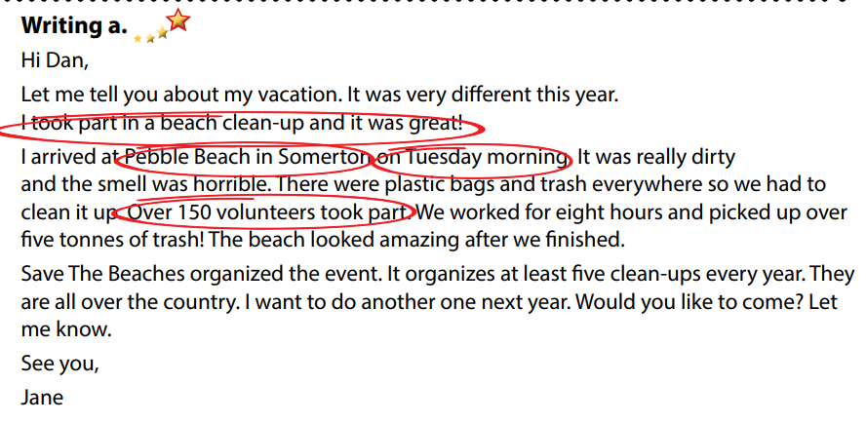  - Read the prompts and write full sentences.  - Number the sentences (1–4).  - Exchange answers.  - Read answers.  Answer keys  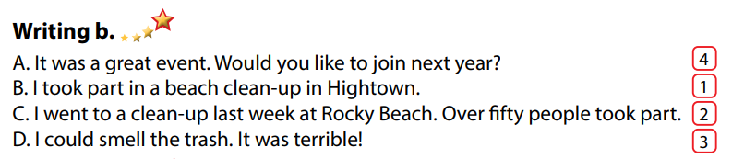  - Look and listen.  - Do the writing part.  -Write.  Suggested writing  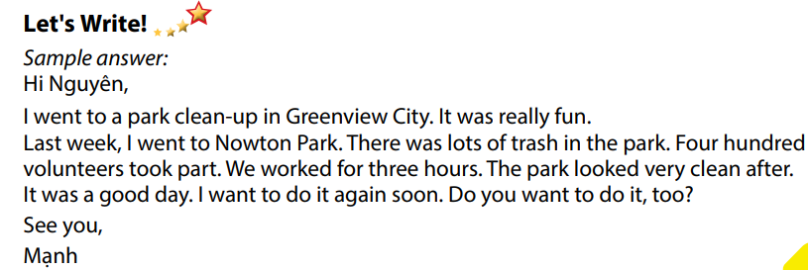

- Activity 3: Post - Writing (5’)
a) Objective: Help Ss realize their mistakes in writing and correct them.
b) Content: Correcting Ss’ writings.
c) Expected outcomes: Students know whether their writings follow the model and use the correct structures and language, whether their writings are interesting and understandable or not.
d) Organization of the activity:
TEACHER’S ACTIVITIES | STUDENTS’ ACTIVITIES
- Give feedback, correct Ss’ mistakes.  - Use the feedback form to give evaluation. Focus on:  + the format, the structures  + the understandability  + the coherence and cohesion  + the spelling | - Look, listen and correct mistakes.

C. Consolidation and homework assignments (5’)
* Consolidation:
- Writing Skill:
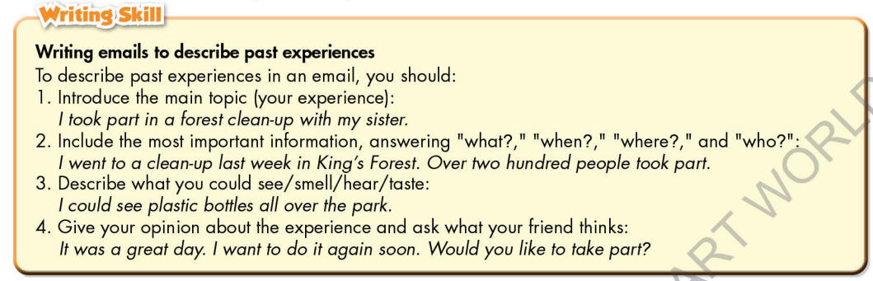

* Homework
- Remember how to write an email to describe past experiences.
- Finish the writing part.
- Do the exercises in WB: Lesson 3 – Writing (page 25).
- Complete the grammar notes in Tiếng Anh 7 i-Learn Smart World Notebook (page 27).
- Play consolation games in Tiếng Anh 7 i-Learn Smart World DHA App on www.eduhome.com.vn
- Prepare: Unit 4 – Review pages 92, 93.

D. Reflection
a. What I liked most about this lesson today:
…………………………………………………………………………………………
- What I learned from this lesson today:
…………………………………………………………………………………………
c. What I should improve for this lesson next time:
…………………………………………………………………………………………

