|  |
| --- |
| ***Chu Van An* Primary School**  **Class: 3…**  **Name: …………………………………….** |

**THE MID SEMESTER TEST**

**SUBJECT: ENGLISH – Grade 3**

**Time alloted: 40 minutes**

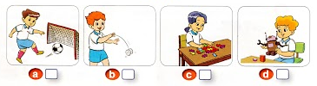***Question 1: Listen and number ( 2ms )***

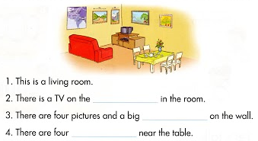 **Question 2: Read and write ( 1ms )**

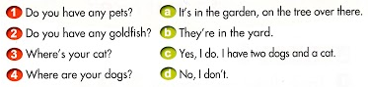 **Question 3: Read and match ( 2ms )**

**1. _____ 2. _____ 3. _____ 4. _____**

**Question 4: Read and circle ( 2ms )**

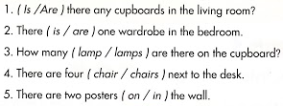

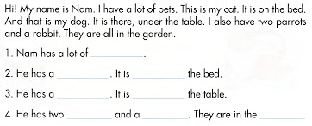**Question 5: Read and complete ( 2ms )**

**THE END**

**ANSWER KEY**

( The mid semester test )

**Part 1: Listening ( 20 minutes )**

**Question 1: Listen and number ( 1m ) –** *Unit 2 / L 2 (4 ) page 15*

1. C

2. B

3. D

4. A

**Question 2: Listen and tick ( ) Yes or No ( 1m ) –** *Unit 3 / L 1 ( 4 ) page 19*

1. A

2. B

**Question 3: Listen and match ( 1m ) –** *Unit 4 / L1 ( 1 ) page 24*

1. B
2. A

**Question 4: Listen and tick ( 1m ) –** *Unit 4 / L1 ( 4 ) page 25*

1. B
2. A

**Question 5: Listen and write ( 1m ) –** *Unit 4 / L 3 ( 2 ) page 28*

1. five
2. six

**Part 2: Reading and Writing ( 20 minutes )**

http://www.mechanical-engineering-group.org.nz/Content/black-cross-md.png **Question 6: read and tick(  ) in the box ( 1m )**

1. http://www.mechanical-engineering-group.org.nz/Content/black-cross-md.png
2. 
3. http://www.mechanical-engineering-group.org.nz/Content/black-cross-md.png
4. 

**Question 7: Read and write ( 1m** **)**

1. This / Hi ( Hello )
2. my friend / Hi ( Hello )

**Question 8: Read and match ( 1m )**

1. B
2. D
3. A
4. C

**Question 9: Read and complete ( 1m )**

1. This
2. Hello
3. that
4. isn’t

**Question 10: Read and tick ( 1m )**

1. 6
2. 8
3. 10
4. 10