**Exercise 1**

**a. Match photos A–C with descriptions 1–3. Use the photo captions to complete the texts.**

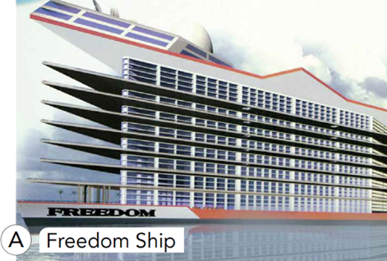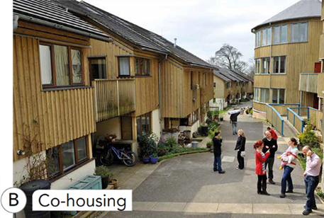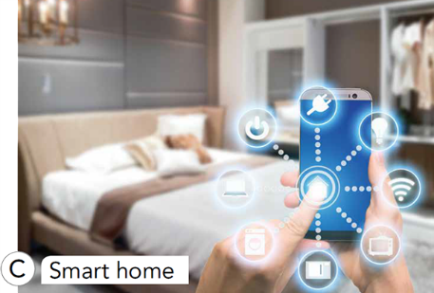

1. In the ___________ of the future, all appliances will be connected through wireless networking systems. The house and car would use power that is collected through solar panels and stored.

2. ___________ is a housing development where each household has a self-contained house or flat. People have the opportunity to eat together and meet regularly in a large communal house.

3. The ___________ is designed to be twenty-five storeys high. If the concept became reality, it would feature a casino, an art gallery, a park, a shopping centre and accommodation for 80,000 people. It would cost $12 billion to build.

**b. Listen to three recordings. In which order are places A–C from *Exercise a* mentioned?**

1-___________ 2-___________ 3-___________

**Exercise 2: Listen again. For questions 1–3, choose the correct answer A–C.**

1. Which statement is an opinion and NOT a fact?

A. Over a third of British people don't know their neighbours.

B. In Denmark, tens of thousands of people live in co-housing developments.

C. The neighbourly relations at Springhill will be 100 percent better.

2. The speakers think that the Freedom Ship project is ________.

A. unlikely to happen

B. not big enough for 80,000 people

C. a good investment opportunity

3. Choose the most appropriate headline for this news report.

A. SMART HOMES MEAN LESS SHOPPING

B. SMART HOMES SAVE TIME AND MONEY

C. SMART HOMES NEED SMART PHONES

**Exercise 3: Discuss which house in Exercise 1 you would most/least like to live in. Give reasons for your answers.**

**ANSWER KEY**

Exercise 1:

a. 1-C 2-B 3-A

b. 1-B 2-A 3-C

Exercise 2:

1-C 2-A 3-B

***Audio script:***

1.

Welcome to the Lifestyle Programme. Let’s start with the shocking results of a recent survey: thirty-five percent of British people do not know any of their neighbours. Well, it’s not a problem for residents of Springhill co-housing project in the southwest of England. Springhill is a new housing development of thirty-five homes in a typical residential area. Residents have their own self-contained flats or houses and gardens but share a common house for communal meals. The co-housing idea comes from Denmark where it is well-established, and according to the latest government housing figures, tens of thousands of Danish people live in this way. There is growing interest around the world in the model as a provider of affordable, sustainable social housing. Building materials are natural or recycled. Springhill is not only sustainable in building terms, but in human terms too, encouraging the daily social contact that we know is key to health and happiness. We’re sure there’ll be a hundred percent improvement in neighbourly relations at Springhill. And now for a look at a different kind of …

2.

*T = Tom R = Rick*

R: Come on, we’re going to be late for school. What are you reading?

T: Oh, it’s one of Dad’s business magazines. Have you seen the plans for this Freedom ship?

R: No, what is it?

T: Well, it’s just a concept at the moment, but they’re planning to build a huge ship that looks like a floating tower block with an airport on top.

R: That sounds a bit unstable if you ask me. Let’s have a look. Oh, that’s amazing. It looks like a multi-storey car park! I wouldn’t like to be on it in bad weather. Are they really going to build it?

T: Only if it can be profitable, so if you ask me, I’d be surprised. They need billions of dollars to even start, so it may never happen. It says here that there are

people with disposable income who want to invest in the project and use it as their second home, but I shouldn’t think many people would want to live on it. They want to make it nearly two kilometres long – nearly two kilometres long! That doesn’t sound possible!

R: Where will it dock?

T: According to this article, no ports will be big enough for it to enter, so it’ll just be sailing around the world non-stop with 80,000 people on board.

R: Well, I won’t be one of them! Come on, it’s time to go.

3.

Today I’m reporting from The House and Home show and I’m going to start with a question – where will you be living twenty years from now? Well, that’s pretty obvious. You’ll be living in a fully connected smart home! Smart homes and smart technology have now become reality, not the future. How do they benefit our lives? OK, a smart home can be rewired so household appliances such as fridges, light fixtures, security systems and thermostats can be controlled by the homeowner using a mobile device. One benefit is that the smart home can save energy costs – even when you’re not at home. With the tap of a finger on your mobile phone, you can switch off lights, close windows and control the heating. With the smart home you gain more hours in the day – when you’re running low on milk, your fridge can order more and it can be programmed to manage all your shopping. The fridge will even advise on recipes based on what you’ve got in stock. Domestic chores just got a lot easier! In the future such homes will be available for everybody!