|  |  |
| --- | --- |
| **Tiếng Anh 8 Friends Plus** | **FP 8 – UNIT 1 - TEST 2**  **Test for Unit**  *Thời gian làm bài: 40 phút (Không kể thời gian giao đề)*  *-------------------------* |

**I. Pronunciation (1-4)**

**Câu 1.** Which word has the underlined part pronounced differently from that of the others?

**A.** food  **B.** put  **C.** tune  **D.** rude

**Đáp án đúng**: B

**Câu 2.** Which word has the underlined part pronounced differently from that of the others?

**A.** look  **B.** book  **C.** foot  **D.** blue

**Đáp án đúng**: D

**Câu 3.** Which word has a different stress pattern from that of the others?

**A.** interview*  **B.** affirmative

**C.** amazingly  **D.** instruction

**Đáp án đúng**: A

**Câu 4.** Which word has a different stress pattern from that of the others?

**A.** expensive  **B.** continuous

**C.** important  **D.** interested

**Đáp án đúng**: D

**II. Choose the answer (A, B, C or D) that best fits the space in each question. (5-14)**

**Câu 5.** The ___________ was surrounded by fans and paparazzi.

**A.** celebrity  **B.** gadget  **C.** craze  **D.** fame

**Đáp án đúng**: A

**Câu 6.** My grandfather always tells me about how he ___________ five miles to school every day when he was a kid.

**A.** walks  **B.** used to walk

**C.** walk  **D.** walking

**Đáp án đúng**: B

**Câu 7.** Do you have a favorite clothing brand? – ‘___________’

**A.** My favorite store is nice. I visit it all the time.

**B.** I have a few clothing brands that I really like, but I wouldn't say I have a favorite.

**C.** I really like my clothing brand.

**D.** I hope they will open new branches soon.

**Đáp án đúng**: B

**Câu 8.** ___________, the concert is sold out and we can't get tickets anymore.

**A.** Technically  **B.** Hopefully

**C.** Apparently  **D.** Beautifully

**Đáp án đúng**: C

**Câu 9.** Fidget spinners and TikTok dances are some of the recent crazes ___________ youngsters.

**A.** about  **B.** for  **C.** from  **D.** at

**Đáp án đúng**: B

**Câu 10.** This shirt is so nice. I will try it ___________.

**A.** with  **B.** for  **C.** on  **D.** at

**Đáp án đúng**: C

**Câu 11.** I need to find a new ___________ for the party tonight.

**A.** theme  **B.** outfit  **C.** fashion  **D.** elegance

**Đáp án đúng**: B

**Câu 12.** 50 years ago, only rich people ___________ TVs, but most of them were black and white.

**A.** can not afford  **B.** could not afford

**C.** could afford  **D.** can afford

**Đáp án đúng**: C

**Câu 13.** What's your go-to outfit for a job interview? – ‘___________’

**A.** For a job interview, I’m always on time.  **B.** I usually wear a suit and tie.

**C.** I don’t mind changing clothes.  **D.** I like our outfit too.

**Đáp án đúng**: B

**Câu 14.** While John ___________ in the office, his boss ___________ him.

**A.** work/ called  **B.** was working/ called

**C.** was working/ calls  **D.** worked/ calling

**Đáp án đúng**: B

**III. Look at the signs. Choose the best answer (A, B, C or D). (15-16)**

**Câu 15.**

What are the things that Mom asked her kid to pick up?

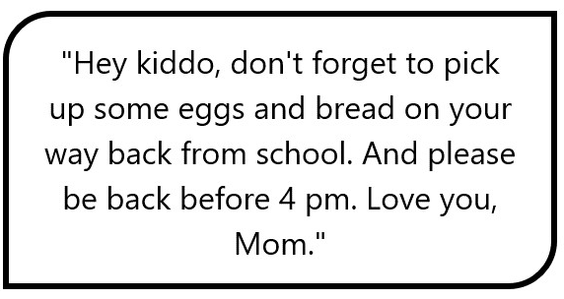

**A.** Eggs and milk  **B.** Eggs, bread, and milk

**C.** Eggs and bread  **D.** Bread and milk

**Đáp án đúng**: C

**Câu 16.**

What is true about the announcement from the library?

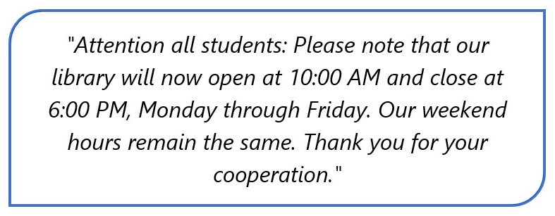

**A.** Change in the library's hours on weekends.

**B.** Change in the library's location.

**C.** Change in the library's opening and closing times on weekdays.

**D.** Change in the library's phone number.

**Đáp án đúng**: C

**IV. Read the following passage and do as direct. (17-22)**

Nowadays, teenagers are highly influenced by YouTubers, who are popular online video creators. These talented individuals use YouTube, a widely known platform, to share their passions, skills, and experiences with the world. Many teenagers enjoy watching these videos for entertainment, learning, and inspiration.

YouTubers cover a wide range of topics, such as fashion, gaming, technology, and even education. They often have a unique style, which appeals to their viewers and keeps them engaged. Teenagers feel connected to YouTubers because they relate to their stories and personalities.

Additionally, some YouTubers collaborate with other creators, providing new and exciting content for their audiences. They also communicate with their viewers through social media, making it easy for teenagers to follow their favourite creators and stay updated on their latest activities.

In conclusion, YouTubers have a significant impact on teenagers today, as they provide entertainment, knowledge, and a sense of connection through their engaging online content.

**Câu 17.** Teenagers enjoy watching YouTubers for entertainment, learning, and inspiration.

**A.** True  **B.** False

**Đáp án đúng**: A

**Câu 18.** YouTubers only cover topics related to fashion and gaming.

**A.** False  **B.** True

**Đáp án đúng**: A

**Câu 19.** YouTubers often have a unique style to appeal to their viewers.

**A.** True  **B.** False

**Đáp án đúng**: A

**Câu 20.** YouTubers rarely communicate with their viewers through social media.

**A.** True  **B.** False

**Đáp án đúng**: B

**Câu 21.** What is the main platform used by YouTubers to share their content?

**A.** YouTube  **B.** TikTok  **C.** Instagram  **D.** Snapchat

**Đáp án đúng**: A

**Câu 22.** Why do teenagers feel connected to YouTubers?

**A.** They receive free gifts from YouTubers.

**B.** They share the same favourite movies and songs.

**C.** They are required to watch them for school assignments.

**D.** They can relate to their stories and personalities.

**Đáp án đúng**: D

**V. Choose the word (A, B, C or D) that best fits the blank space in the following passage. (23-28)**

Clothing is an important part of a teenager's life because it lets them show who they are and feel good about how they look. Teenagers' fashion is always **______23______**, and popular culture, social media, and even their favorite celebrities can have a big **______24______**. People in this age group often try out different styles as they try to find their own unique **______25______**.

Teenagers often choose clothes that show what they like to do, like sports sweaters or band **______26______**. Many teens choose casual clothes like jeans, t-shirts, and sneakers for their daily activities because they are comfortable and easy to use. However, special events like proms or parties might call for more formal clothes like dresses or **______27______**.

Teenagers, who are becoming more aware of how the clothing industry affects the environment and society, are also becoming more interested in ethical and eco-friendly fashion. This makes them more likely to buy from brands that are good for the environment or even to **_____28_______**, which means to buy used clothes from thrift stores or online platforms.

In short, what teenagers wear shows what they like, what they care about, and what they believe in. It lets them show how unique they are while also letting them adapt to different situations and keep up with the latest trends.

**Câu 23.** Choose the correct answer.

**A.** change  **B.** changing  **C.** chance  **D.** to change

**Đáp án đúng**: B

**Câu 24.** Choose the correct answer.

**A.** power  **B.** impact  **C.** source  **D.** energy

**Đáp án đúng**: B

**Câu 25.** Choose the correct answer.

**A.** individuality  **B.** ID

**C.** personal  **D.** character

**Đáp án đúng**: D

**Câu 26.** Choose the correct answer.

**A.** gear  **B.** extra  **C.** software  **D.** apps

**Đáp án đúng**: A

**Câu 27.** Choose the correct answer.

**A.** uniforms  **B.** suits  **C.** costumes  **D.** outfits

**Đáp án đúng**: B

**Câu 28.** Choose the correct answer.

**A.** charity  **B.** recycle  **C.** thrift  **D.** donation

**Đáp án đúng**: C

**VI. Supply the correct form of the word given in each sentence. (29-34)**

**Câu 29.** She was ____________ dressed in the latest styles and looked very trendy. (fashion)

**Đáp án đúng**: fashionably

**Câu 30.** I felt ____________ sitting on the hard wooden chair for a long time. (comfort)

**Đáp án đúng**: uncomfortable

**Câu 31.** The movie was ____________, so I stopped watching it halfway through. (interest)

**Đáp án đúng**: uninteresting

**Câu 32.** The ____________ played beautiful music during the concert. (music)

**Đáp án đúng**: musicians

**Câu 33.** The new ice cream flavor quickly became ____________ known and loved by everyone in town. (popular)

**Đáp án đúng**: popularly

**Câu 34.** She wore a ____________ dress with colorful flowers on it. (pattern)

**Đáp án đúng**: patterned

**VII. Rearrange the groups of words in a correct order to make complete sentences. (35-36)**

**Câu 35.** outside, it / were playing / While the students / raining. / suddenly started

_____________________________________________________________

**Đáp án đúng**: While the students were playing outside, it suddenly started raining.

**Câu 36.** ride my bicycle/to school every day./When I was a/child, I used to

_____________________________________________________________

**Đáp án đúng**: When I was a child, I used to ride my bicycle to school every day.

**VIII. Rewrite each of the following sentences in another way so that it means almost the same as the sentence printed before it. (37-40)**

**Câu 37.** It took the artist two weeks to draw this painting.

The artist spent ________________________________________________

**Đáp án đúng**: The artist spent two weeks drawing this painting.

**Câu 38.** My father worked for that company. However, he now teaches math at the college.

My father used ________________________________________________

**Đáp án đúng**: My father used to work for that company, but now he teaches math at the college.

**Câu 39.** We were taking landscape photos when it started to rain.

It started ________________________________________________

**Đáp án đúng**: It started to rain while we were taking landscape photos.

**Câu 40.** Many teenagers have interest in environmental campaigns nowadays.

Many teenagers are ________________________________________________

**Đáp án đúng**: Many teenagers are interested in environmental campaigns nowadays.

**IX. Listening: listen and do as direct.**

**Câu 41.** How can games in an arcade center be played?

**A.** None of the above  **B.** Both solo and with friends

**C.** Only solo  **D.** Only with friends

**Đáp án đúng**: B

**Câu 42.** What can a visit to an arcade center help students do?

**A.** None of the above  **B.** Decrease stress

**C.** Improve grades  **D.** Increase stress

**Đáp án đúng**: B

**Câu 43.** What kind of activity can students do with their friends at an arcade center?

**A.** Play video games  **B.** Watch movies

**C.** None of the above  **D.** Play sports

**Đáp án đúng**: A

**Câu 44.** You can only play solo at an arcade center.

**A.** False  **B.** True

**Đáp án đúng**: A

**Câu 45.** The atmosphere in an arcade center is quiet and dull.

**A.** True  **B.** False

**Đáp án đúng**: B

**Câu 46.** What kind of games can be found in an arcade center?

**A.** Both classic arcade games and video games  **B.** Only video games

**C.** Board games  **D.** Only classic arcade games

**Đáp án đúng**: A

**Câu 47.** An arcade center is a great place for students to spend some fun and exciting time with their friends.

**A.** True  **B.** False

**Đáp án đúng**: A

**Câu 48.** Visiting an arcade center can help students relieve stress.

**A.** False  **B.** True

**Đáp án đúng**: B

**Câu 49.** What is the atmosphere like in an arcade center?

**A.** Boring and uneventful  **B.** Fun and exciting

**C.** Quiet and dull  **D.** None of the above

**Đáp án đúng**: B

**Câu 50.** Arcade centers only offer classic arcade games.

**A.** False  **B.** True

**Đáp án đúng**: A

**----HẾT---**