Period
LESSON PLAN
TIẾNG ANH 10 FRIENDS GLOBAL
UNIT 3: ON SCREEN
LESSON 3D: GRAMMAR – MUST, MUSTN’T
AND NEEDN’T/ DON’T HAVE TO
By the end of the lesson, Ss will be able to:
1. Knowledge:
- Understand the meaning and the different of those modal verbs
- Grammar: modal verbs (must, mustn’t, and needn’t/ don’t have to)
- main skills: listening and speaking skills
- sub skills: reading and writing skills
- Use those modal verbs properly in exercises and daily conversation
3. Quality:
- Have positive attitude in English language learning so that they can participate enthusiastically in all classroom activities, especially with the topic conducted by the teacher
- Know how to distinguish the use of different modal verbs in different situations
II. TEACHER AIDS AND LEARNING MATERIALS:
Lesson plan, PPT slides, student’s book, workbook, notebook, personal computer (if any), projector/TV, speakers, IWB software.
III. PROCEDURES:
A. Warm-up (5’)
a) Objective: Introduce the new lesson and set the scene for Ss to acquire new language; get students' attention at the beginning of the class by means of enjoyable and short activities as well as to engage them in the steps that followed.
b) Content: Gameshow “Who want to be a millionaire?” (Task 1 page 38)
c) Outcomes: Students can gain more confidence and interest in the lesson.
d) Competence: communication, collaboration, critical thinking
e) Organisation of the activity:

TEACHER’S ACTIVITIES | STUDENT’S ACTIVITIES | CONTENTS
WARM-UP. T-Ss/ S-S/ Indiv  Gameshow “WHO WANTS TO BE A MILLIONAIRE?”  - Explain the game rules and make sure students understand what they have to do  - Divide class into two groups  - If students get the correct answer, they can get bonus.  - Ask students to read the instruction again  - Ask students some questions  - Use the structure appeared in the game rules to lead in the lesson | - Listen carefully to the teacher  - Play in groups  - Volunteer to answer. With one correct answer, that group can get one bonus.  - Read the instruction again  - Volunteer to answer the questions given and check the answers with the teacher, take notes if needed  - Open the course book page 38 |   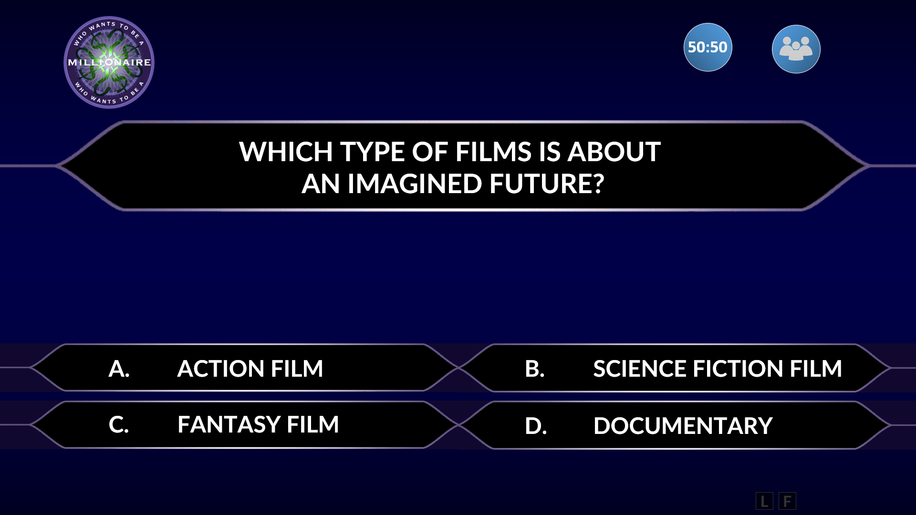  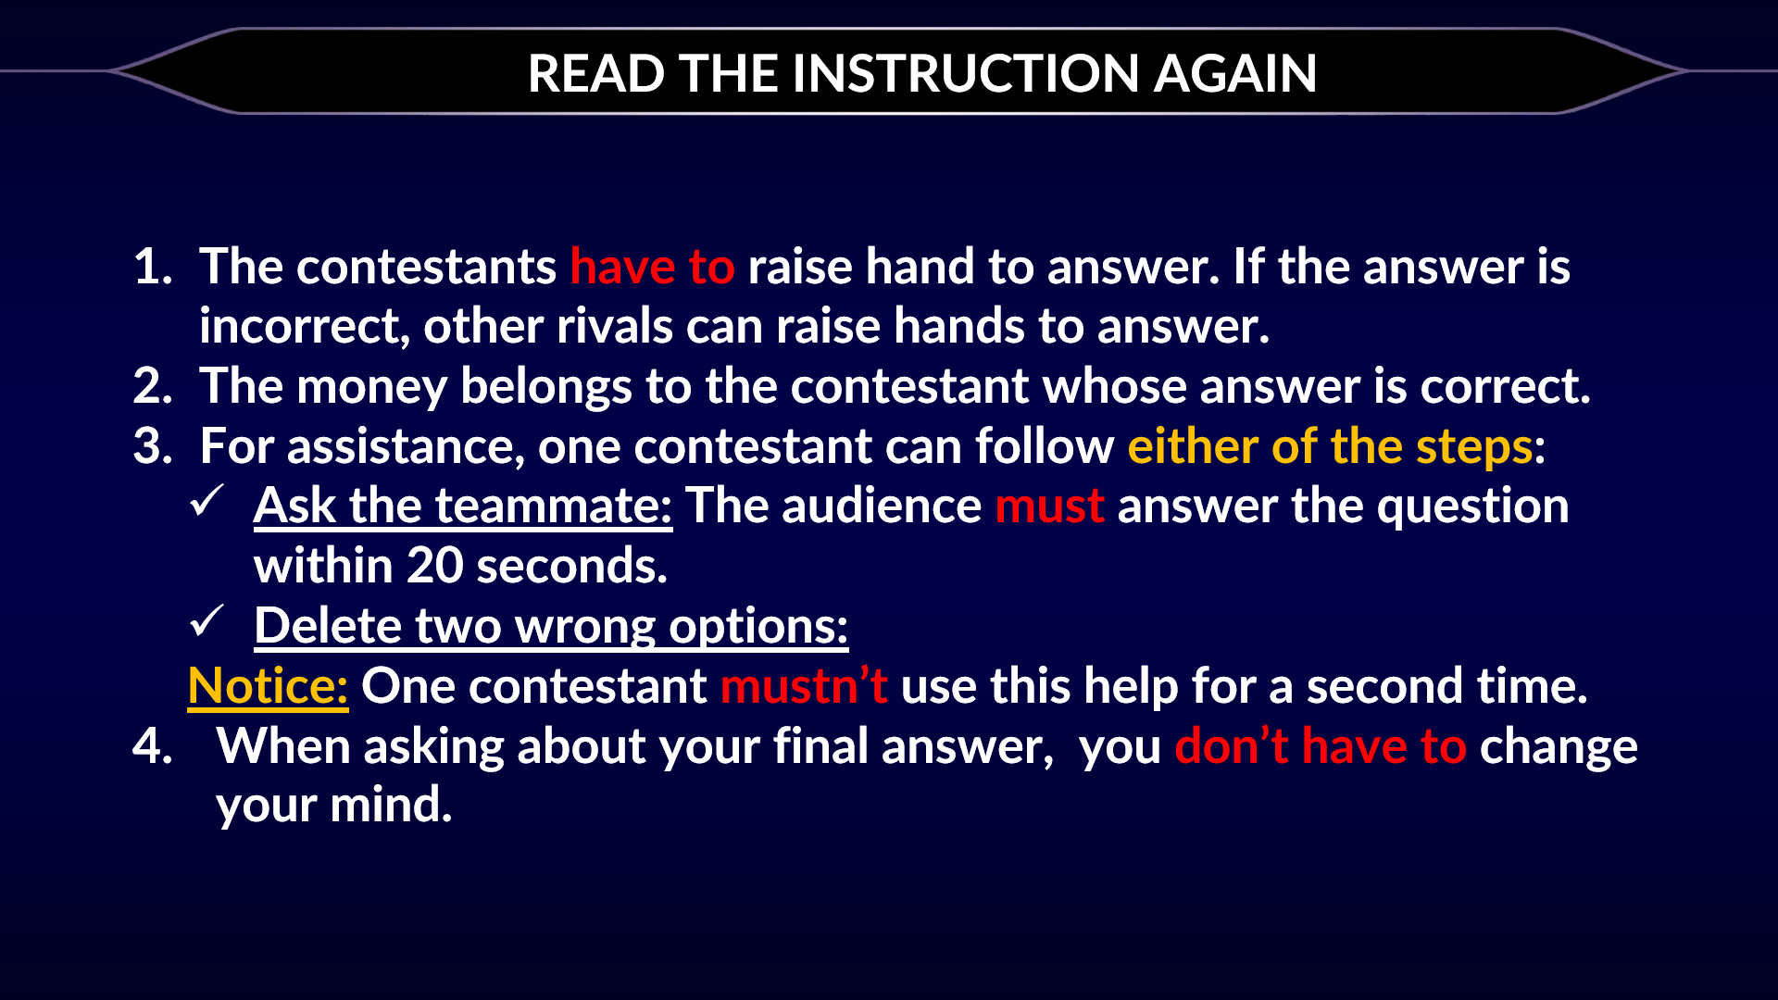  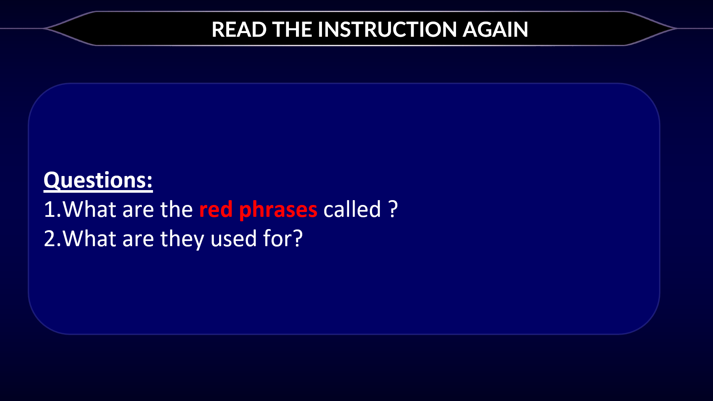  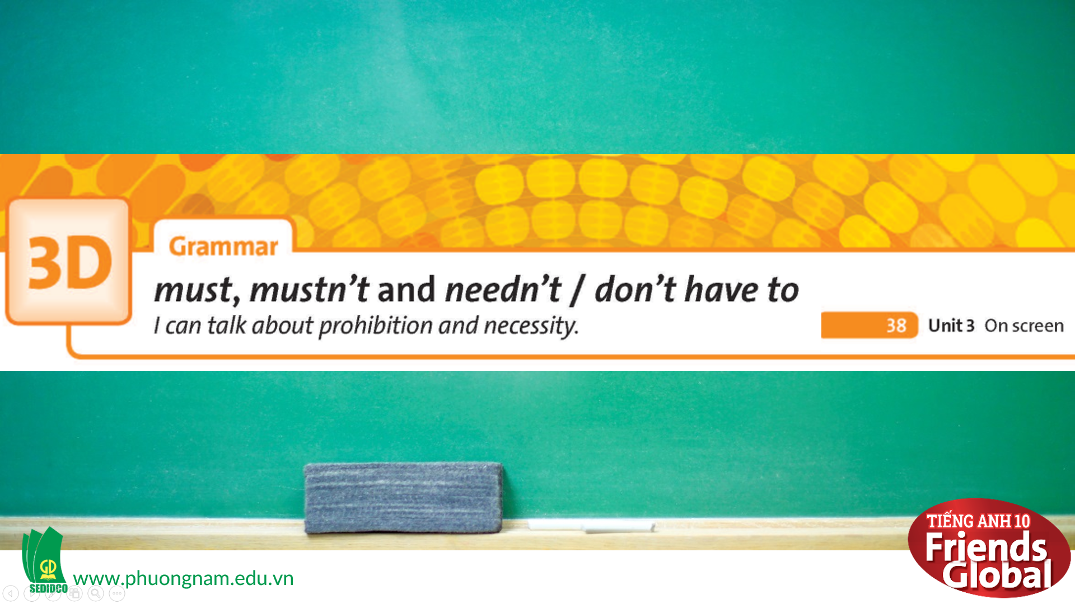
B. New lesson (35’)
- Activity 1: Presentation (10’)
a) Objective: Present to students the meaning and usages of modal verbs and help students to distinguish them
b) Content:
Listening
Grammar
c) Outcomes: Students can apply the useful language in everyday conversations.
d) Competence: communication, presentation, presentation
e) Organisation of the activity:

TEACHER’S ACTIVITIES | STUDENT’S ACTIVITIES | CONTENTS
PRESENTATION. T-Ss/ S-S/ Indiv.  Activity 1 (3’): Exercise 2 page 38  - Ask students to read the dialogue, then listen to the audio and complete the task  - Play the audio again to check the answers  - Ask students to notice all the words they have circled and guess their meaning  Activity 2 (2’): Exercise 3 page 38  - Ask students to read the Learn this! box and complete the rules  - Check the answers  Activity 3 (5’): Present the use of modal verbs and its usages  - Explain the meaning and the usages of modal verbs: must, mustn’t, and needn’t/ don’t have to  - Clarify the differences between them by giving some examples | - Read the dialogue, then listen carefully to the audio and complete the task  - Check the answers with teacher  - Listen to the teacher and answer the question, take notes  - Read the Learn this! box and complete the rules  - Check the answers with the teacher and take notes  - Listen to the teacher and take notes | 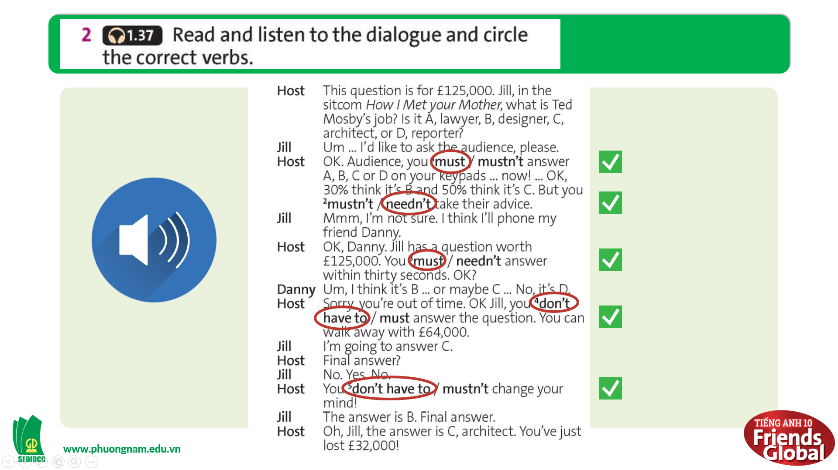  Suggested answers:  must: say something is important to do  needn’t/ don’t have to: say something is not necessary  mustn’t: say something is prohibited  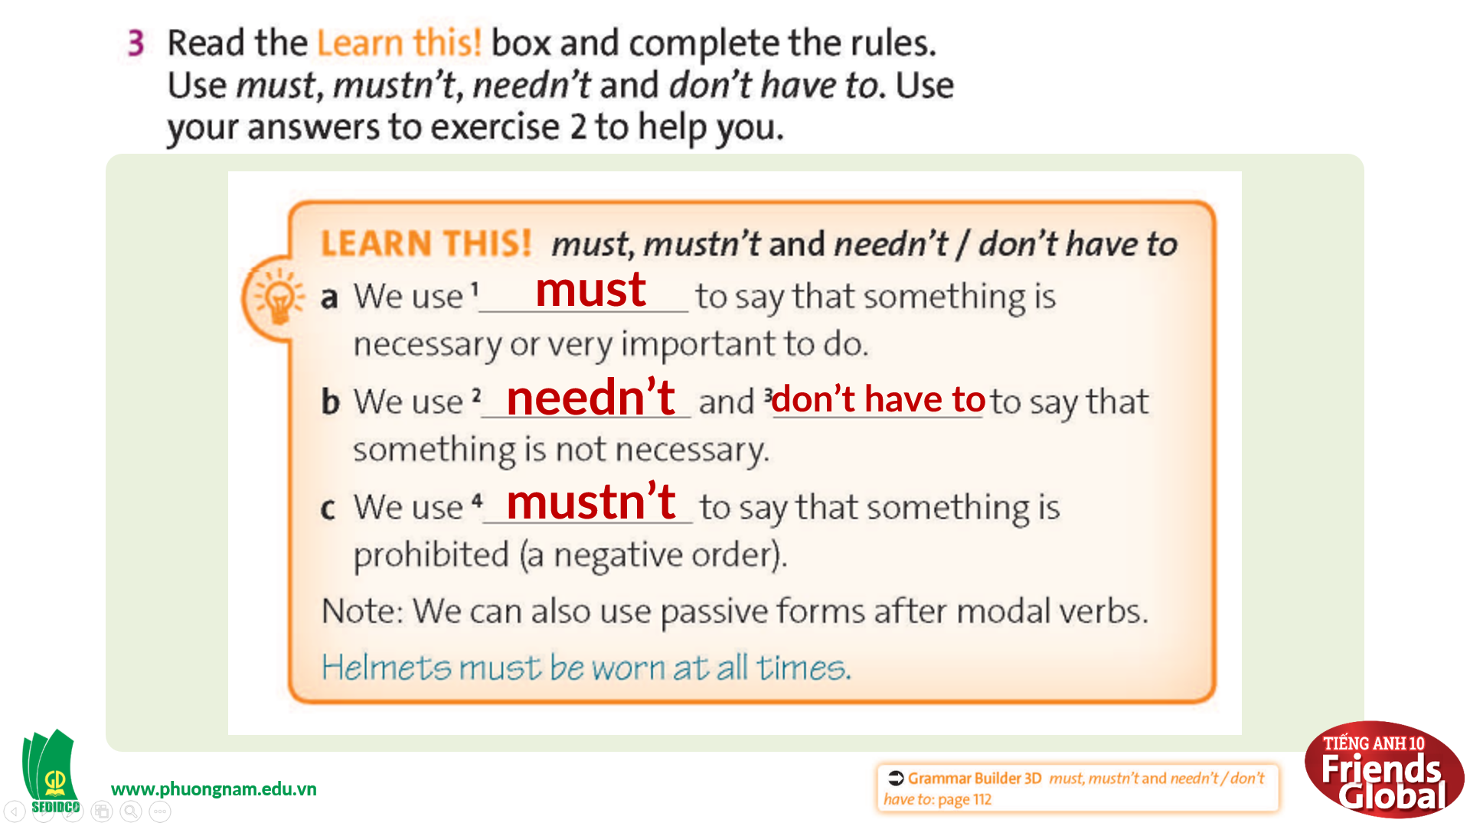  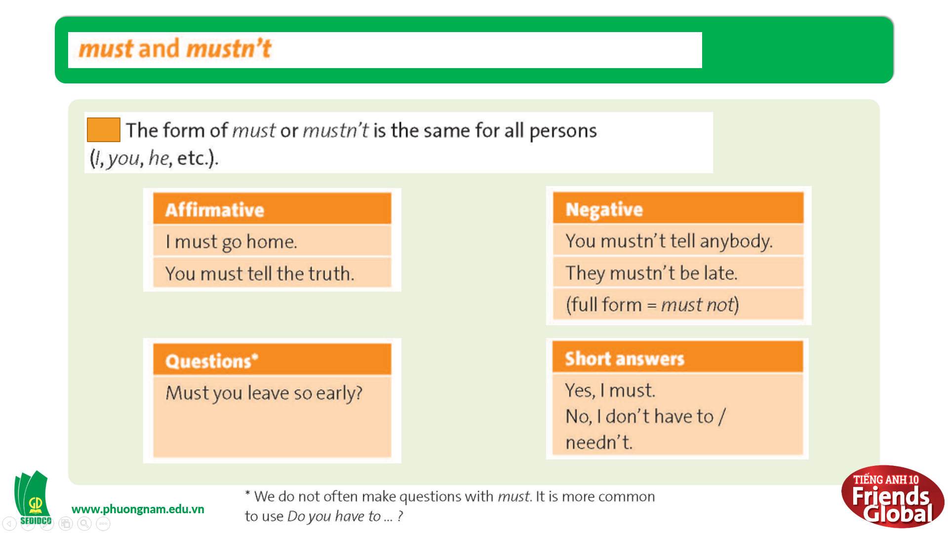  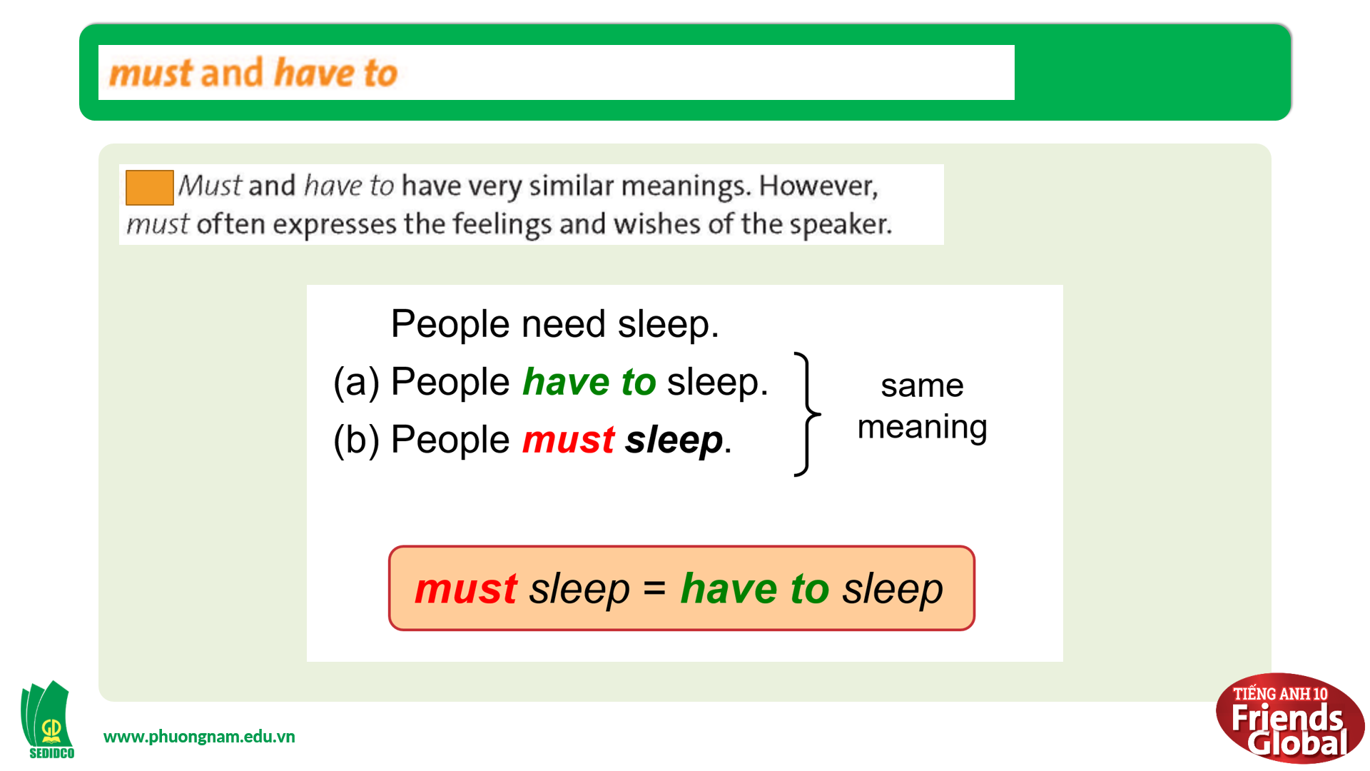  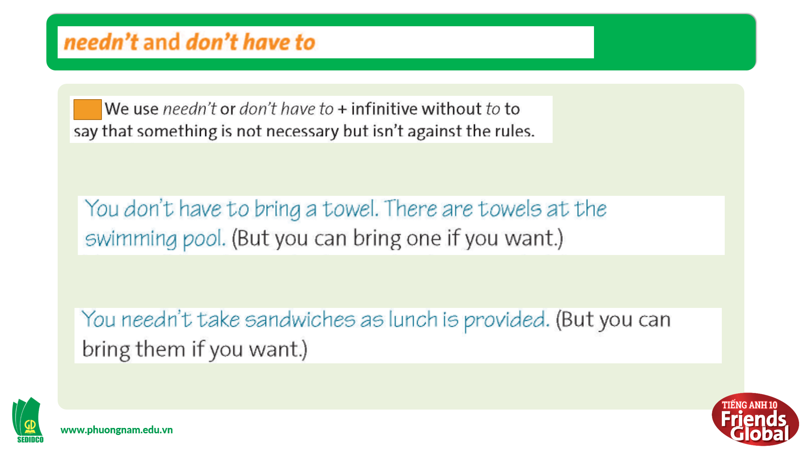
- Activity 2: Practice (15’)
a) Objective: Students know more about modal verb structures and how to use them properly
b) Content:
Speaking
Grammar
c) Outcomes: Students know how to use modal verbs in different everyday conversations.
d) Competence: communication, collaboration, presentation
e) Organisation of the activity:

TEACHER’S ACTIVITIES | STUDENT’S ACTIVITIES | CONTENTS
PRACTICE. T-Ss/ S-S/ Indiv.  Activity 1 (7’): Task 4 page 38  - Ask students to write some sentences about our school rules for using mobiles with must, mustn’t, and needn’t/ don’t have to  - Check the answers  Activity 2 (8’): Task 5 page 38  - Ask students to read the Look out! box and highlight some important information  - Explain more if needed  - Ask students to use the words in brackets and rewrite the sentences  - Check the answer | - Use the language in the box to help and complete the task  - Check the answers with the teacher  - Read the Look out! box, then highlight some important information and take notes if needed  - Listen to the teacher  - Complete the task  - Check the answers with the teacher | 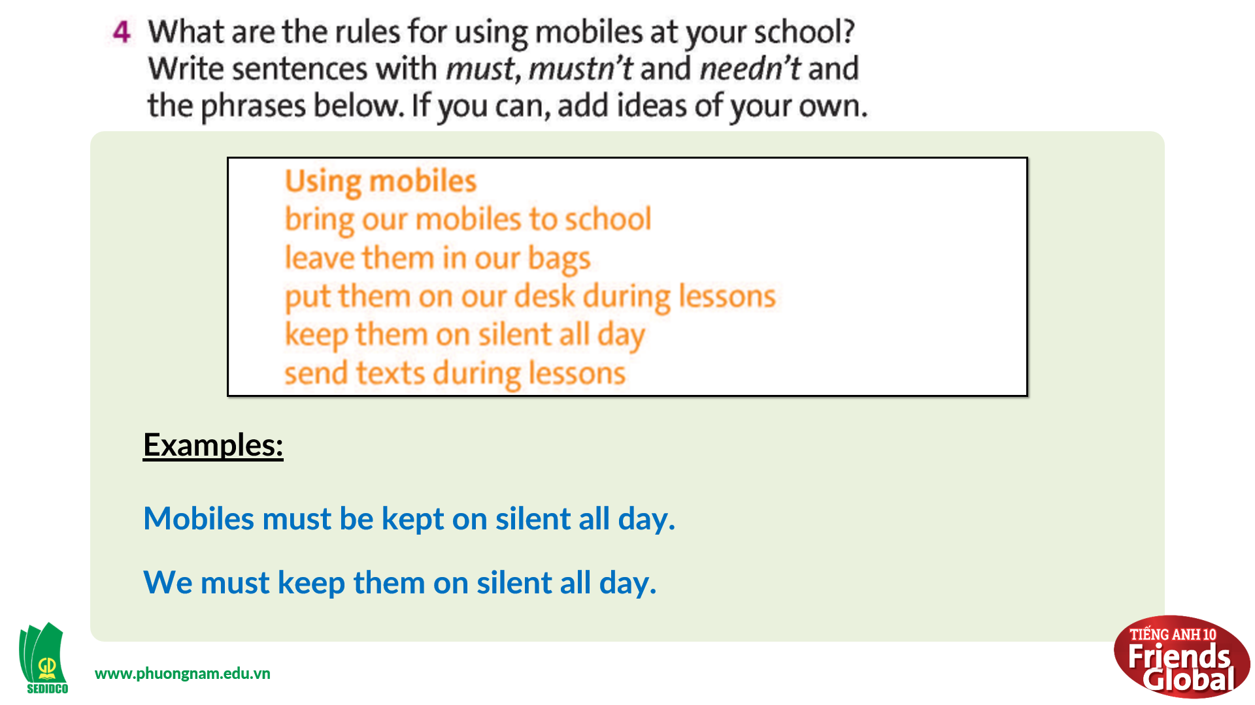  Suggested answers:  Mobiles must be kept on silent all day.  We must keep them on silent all day.  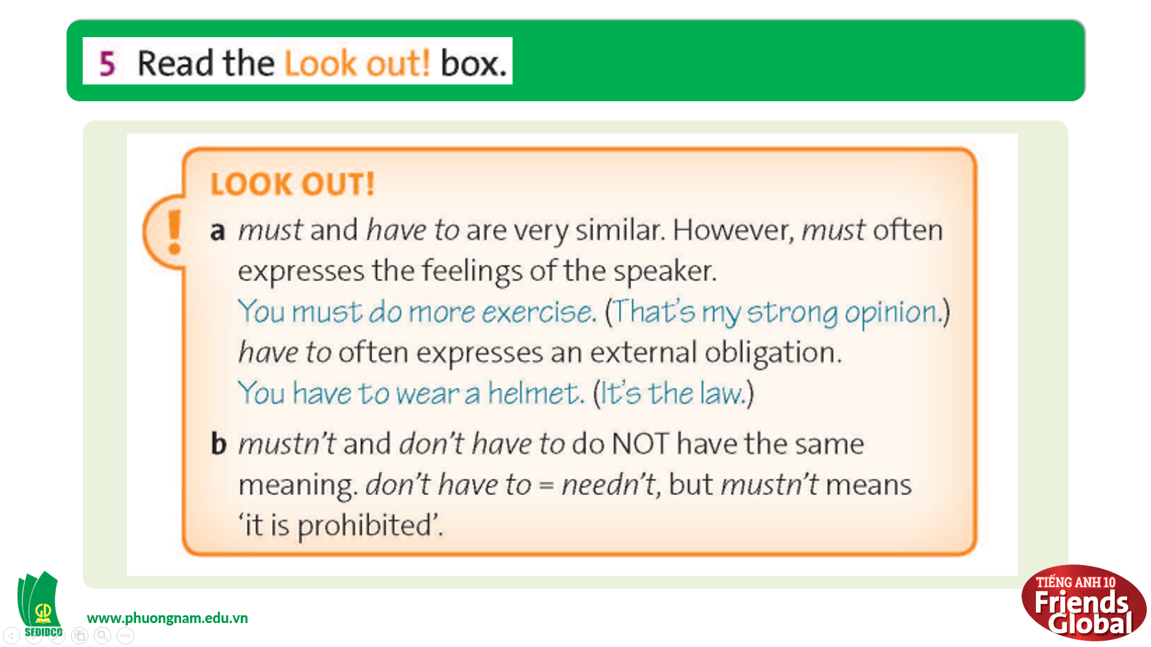  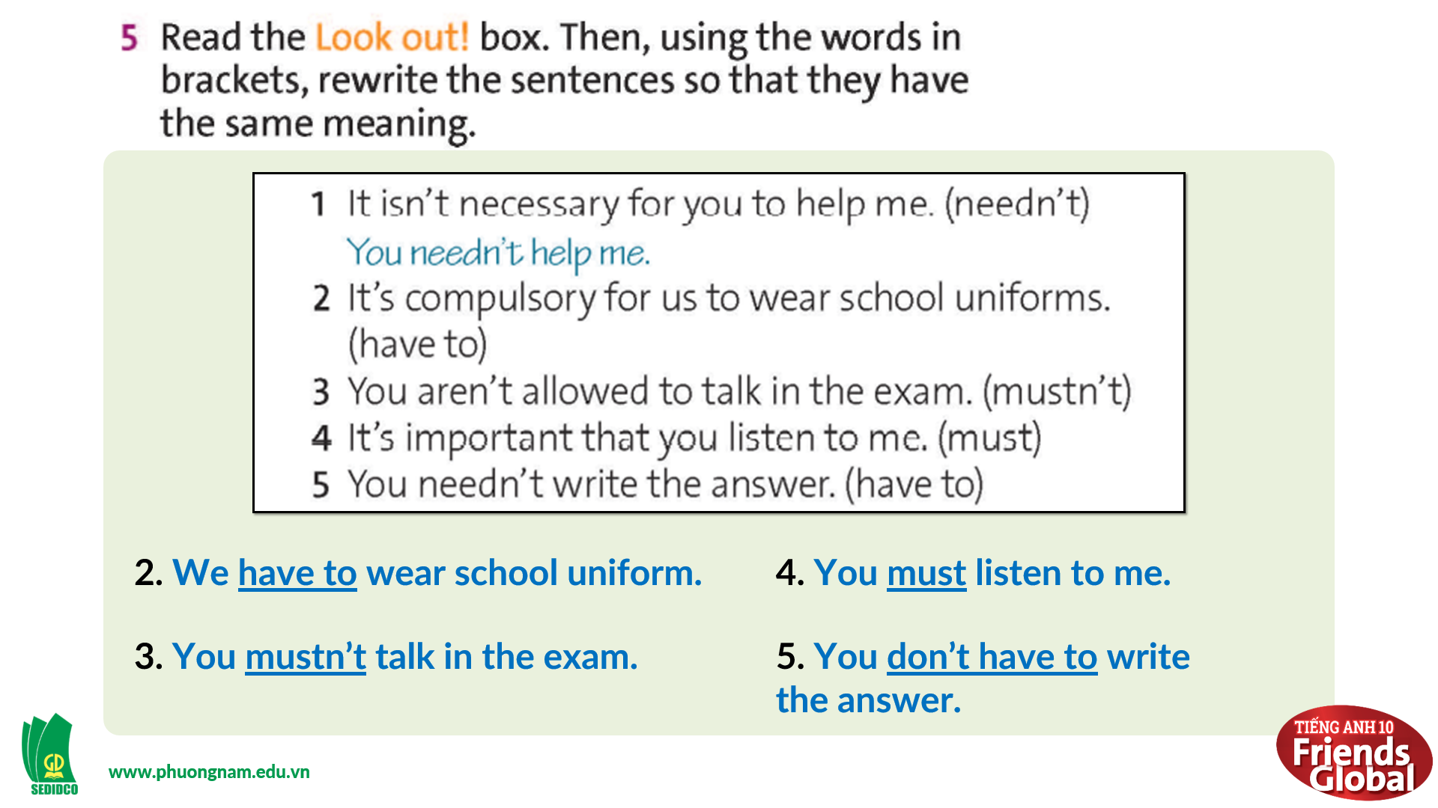  Answers:  2. We have to wear school uniform.  3. You mustn’t talk in the exam.  4. You must listen to me.  5. You don’t have to write the answer.

- Activity 3: Outcomes (10’)
a) Objective: Students listen to different gameshows’ rules and try to guess the gameshows’ names. Communication is also be practiced.
b) Content: Task 6 page 38
c) Outcomes: Ss speak and listen mutually, they can apply the structure they have learnt to their conversations.
d) Competence: Presentation, communication, guessing
e) Organisation of the activity:
TEACHER’S ACTIVITIES | STUDENT’S ACTIVITIES | CONTENTS
PRODUCT. T- Ss/ S-S/ Indiv  Exercise 6 page 38: Speaking  Game “CAN YOU NAME THESE GAME SHOWS?”  - Go through the instructions together and make sure students understand what they have to do  - Monitor and help with grammar and vocabulary where necessary  - Give students some examples  - Encourage students to talk more | - Divide into 2 groups and listen to the instruction  - Play in groups, take turns to ask and answer  - Practice speaking more | 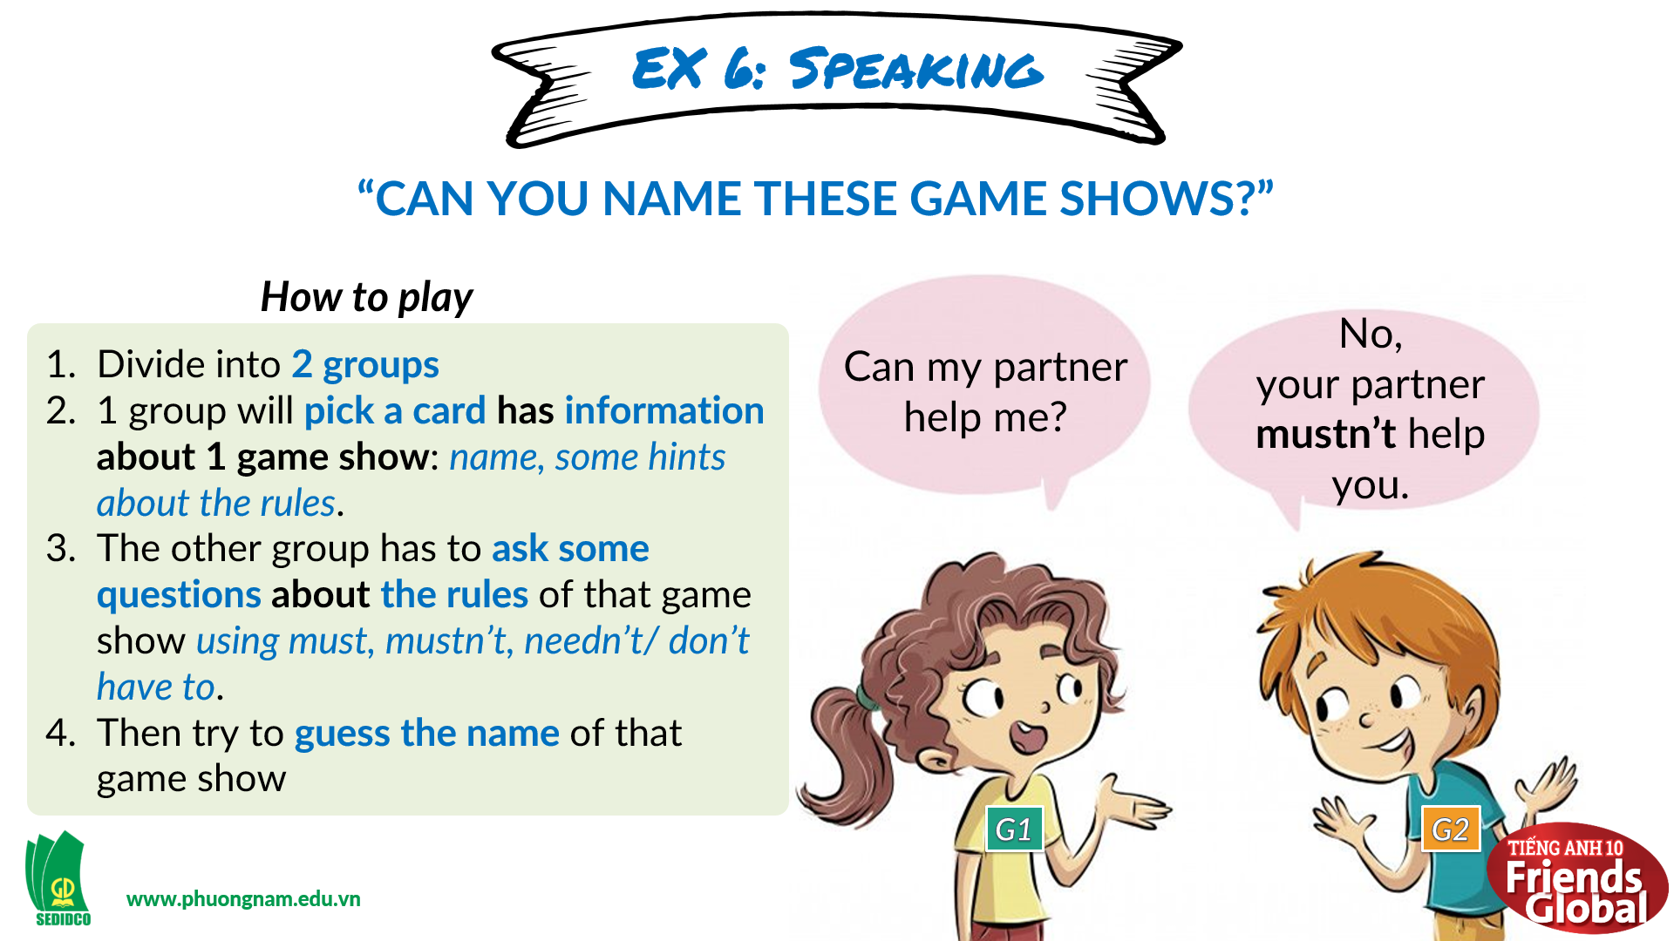  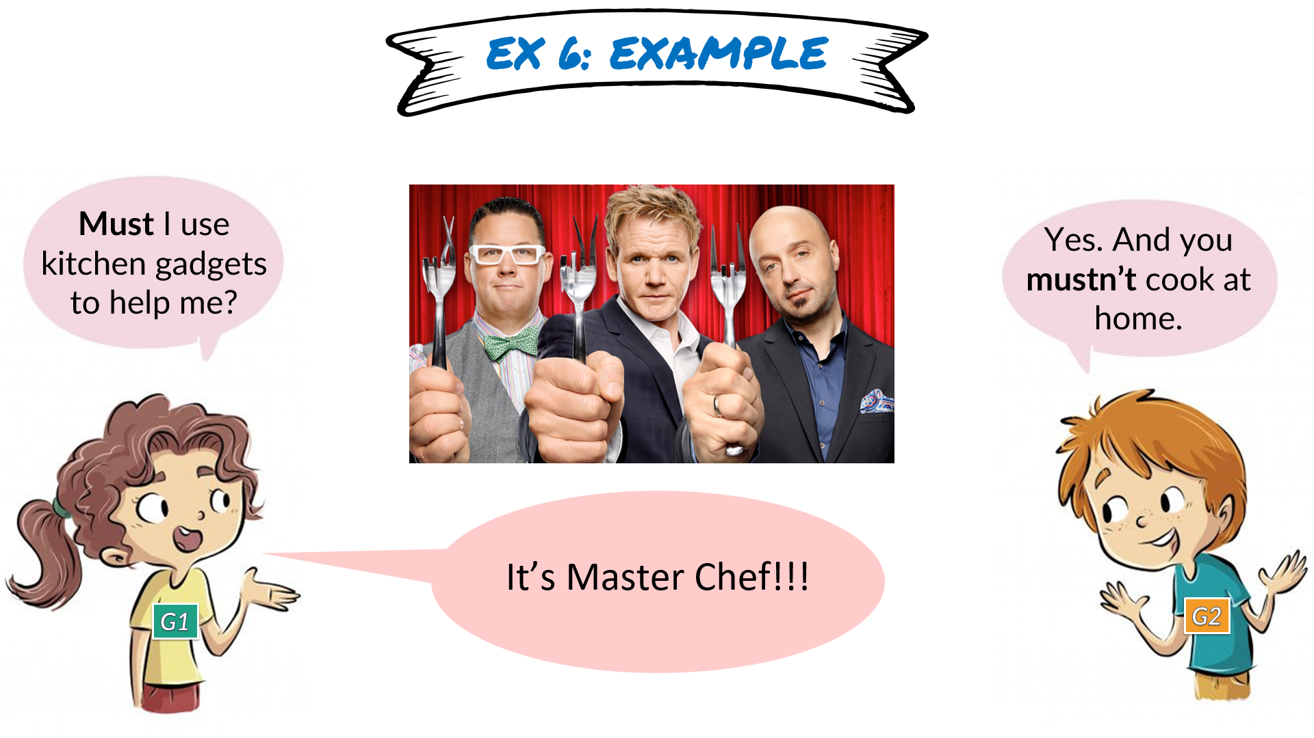
C. Consolidation (3’)
Grammar: The use of modal verbs: must, mustn’t, and needn’t/ don’t have to
D. Homework (2’)
- Learn by heart the modal verbs meaning, usages and structures
- Do exercise
- Prepare: Unit 3E: Work skills (page 39 – SB)

