School: ……………………………………….. | Date:……………………………………..
Class: ……………………………..................... | Period: 5

UNIT 1: FREE TIME
Lesson 2.1: Vocab & Listening, pages 8 & 9
1. Objectives
By the end of this lesson, students will be able to…
1.1. Language knowledge/ skills
- learn and use more vocab. for leisure activities.
- practice listening for specific information listening.
- practice functional English – starting a telephone conversation.
1.2. Competences
- improve Ss’ communication, collaboration, analytical, critical thinking skills.
1.3. Attributes
- have healthy lifestyles.
- spend free time in a good way.
2. Teaching aids and materials
- Teacher’s aids: Student’s book and Teacher’s book, class CDs, DCR– Phần mềm tương tác trực quan, DHA – Ứng dụng trò chơi tương tác, projector / interactive whiteboard /TV (if any), PowerPoint slides.
- Students’ aids: Student’s book, Workbook, Notebook.
3. Assessment Evidence
Performance Tasks | Performance Products | Assessment Tools
- Read the words and definitions, then match the words with the pictures.  - Work in pairs to talk about three activities you like or would like to try and say why.  - Listen to two people making plans and identify their relationship.  - Listen and complete the table.  - Listen to the conversation again and tick the phrases or sentences the speaker use to start their conversation on the telephone.  - Work in pairs to talk about the activities you like the most and say why. | - Ss’ answers.  - Ss’ answers.  - Ss’ answers.  - Ss’ answers.  - Ss’ answers.  -Ss’ answers. | - Observation.  - Observation.  - Observation.  - Observation.  - Observation.  - Observation.
4. Procedures
A. Warm up: 5’
a. Objective: to introduce the topic of the new lesson.
b. Content: Let’s talk!
c. Expected outcomes: Ss can talk about activities they do on the weekends.
d. Organization
Teacher’s activities | Students’ activities
Let’s talk! In pairs: Look at the picture. What plans do these kids have for the weekend? What activities do you and your friends do on weekends?  - Ask Ss to work in pairs, talking about the plans these kids have for the weekend and the activities they and their friends do on weekends.  - Pick some Ss to share their ideas.  - Give feedback. | - Talk with their partner about the picture and their own activities on the weekends.  - Share their ideas.
B. New lesson (35’)
1. Vocabulary: 15’
a. Objective: to help Ss know more vocabulary about free time activities.
b. Content: tasks a & b.
c. Expected outcome: Ss can talk about their favorite leisure activities.
d. Organization
Teacher’s activities | Students’ activities
Task a: Read the words and definitions, then match the words with the pictures. Listen and repeat.  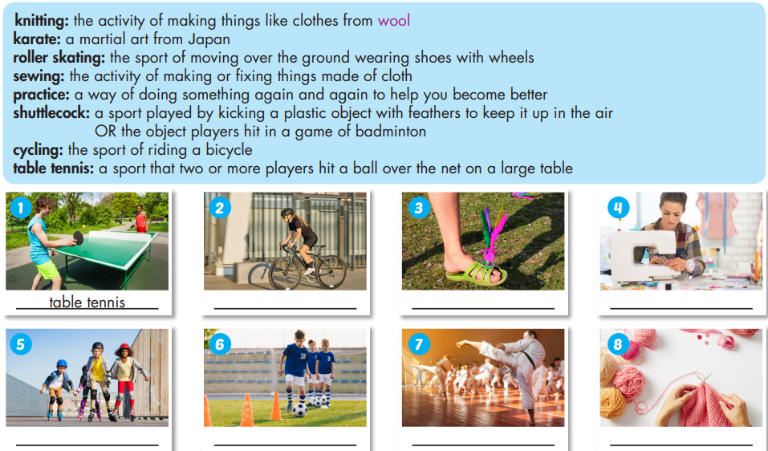  - Ask Ss to read the words and definitions, then match the words with the pictures.  - Get Ss to check with their partners.  - Pick some Ss to give their answers.  - Check their answers.  - Ask Ss to listen and repeat chorally.  - Pick some Ss to say the words and correct their pronunciation if necessary.  - Check their memory by playing a game in pairs: Student A say the definition, Student B say the word (with books closed).  Task b. In pairs: What are three activities you like or would like to try and why?  -Ask Ss to work in pairs, talking about three activities they like or would like to try and say the reasons.  - Pick some Ss to share their ideas.  - Give feedback. | - Read the words and definitions, then match the words with the pictures.  - Check with their partners.  - Give their answers.  Answer Keys:  1.table tennis 2.cycling 3.shuttlecock 4.sewing 5.roller skating 6.practice 7.karate 8.knitting  - Listen and repeat chorally.  - Say the words individually.  -Play the game in pairs.  - Talk with their partners about three activities they like or would like to try and say the reasons.  - Share their ideas.
2. Listening: 20 minutes
a. Objective: to help Ss practice listening for specific information and know how to start a conversation on the phone.
b. Content: tasks a, b, c, d, and e.
c. Expected outcomes: Ss can listen and get the information about time and activities; start a conversation on the phone smoothly.
d. Organization:
Teacher’s activities | Students’ activities
Task a: Listen to two people making plans. What is their relationship?  1. new friends  2. close friends  3. brother and sister  - Introduce the task.  - Ask Ss to listen and circle the correct answer.  - Let Ss check with their partner.  - Pick some students to give their answers.  - Check their answers. | - Listen and circle the correct answer.  - Check with their partner.  - Give their answers.  Answer Keys:  2. close friends
Task b: Listen and complete the table.  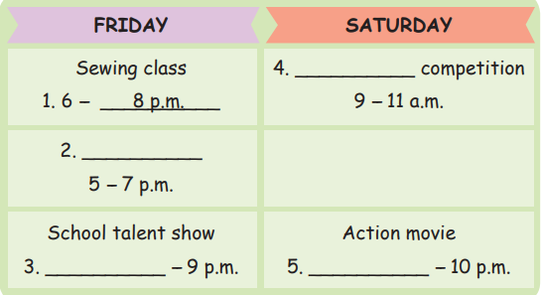  - Ask Ss to discuss with their partners to guess the missing information: time or activity.  - Pick some Ss to share their ideas.  - Give feedback.  - Ask Ss to listen and complete the table.  - Let Ss check with their partner.  - Pick some students to give their answers.  - Play the CD again and pause at the answers for Ss to check.  - Confirm the answers. | - Discuss with their partners to guess the missing information: time or activity.  - Share their ideas.  Answer keys:  1. time 2. activity 3. time 4. activity 5. Time  - Listen and complete the table.  - Check with their partner.  - Give their answers.  - Listen and check  Answer keys:  1.8 p.m. 2.English Club 3.7:30 4.Cycling 5.8:30
Task c: Read the Conversation Skill box. Then, listen and repeat.  - Ask Ss to read the Conversation Skill box and say the ways to start a conversation on the phone.  - Check their answers.  - Get Ss to listen and repeat.  Task d: Now, listen to the conversation again and tick the phrases or sentences you hear.  -Ask Ss to listen to the conversation again and tick the phrases or sentences they hear.  -Pick some students to give their answers.  -Check their answer. | -Read the Conversation Skill box and say the ways to start a conversation on the phone.  Answer keys:  Hi, (Ethan). How's it going?  Hey, what's up?  -Listen and repeat.  - Listen to the conversation again and tick the phrases or sentences they hear.  - Give their answers.  Answer keys:  Hi, (Ethan). How's it going?
Task e: In pairs: Which of the activities they mention do you like the most? Why?  - Ask Ss to work in pairs to answer the question: Which of the activities they mention do you like the most? Why?  - Pick some Ss to share their ideas.  - Give feedback. | - Work in pairs, answering the question: Which of the activities they mention do you like the most? Why?  - Share their ideas.
C. Consolidation and homework assignments: 5’
- Vocabulary: table tennis, cycling, shuttlecock, sewing, roller skating, practice, karate, knitting
- Do exercises in workbook on page 4.
- Prepare the next lesson: Lesson 2.2 - Grammar, pages 9 & 10
- Do the exercises in Tiếng Anh 8 i-Learn Smart World notebook (pages 7 & 8).

5. Reflection

a. What I liked most about this lesson today:
…………………………………………………………………………………………
b. What I learned from this lesson today:
…………………………………………………………………………………………
c. What I should improve for this lesson next time:
…………………………………………………………………………………………

