SPEAKING ASSESSMENT ENGLISH 6
UNIT 11: OUR GREENER WORLD
- Introduction - 0.4 pt (~2 ideas):
Share something about your family, school, house, friends, neighborhood,…
- Topic Speaking (Cue pictures) – 1.0 pt (~4 questions):
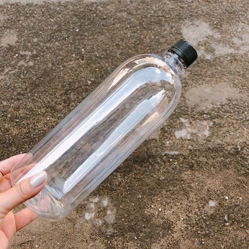  1 | 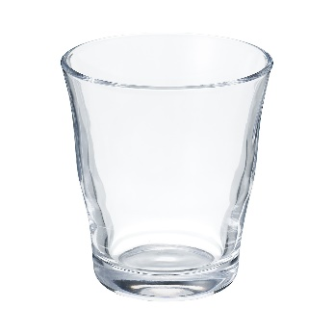  2 | 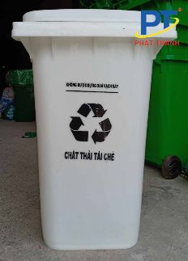  3
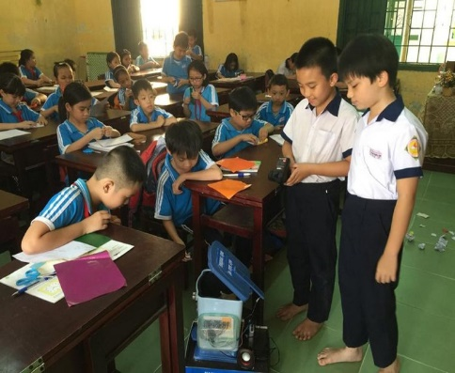  8 | - - What is this?  - What do you see in the picture?  - - How do you spell it?  - - What are they doing?  - - It’s one of the ways to protect the environment  - It’s a thing that can be recycled  8  7  - It’s a container for things that can be recycled  - It’s a thing in the classroom that student can put rubbish in | 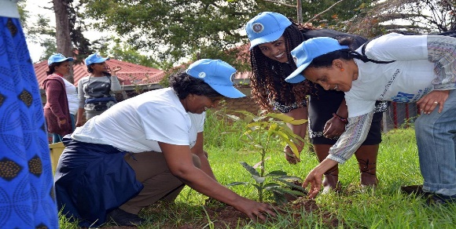  4
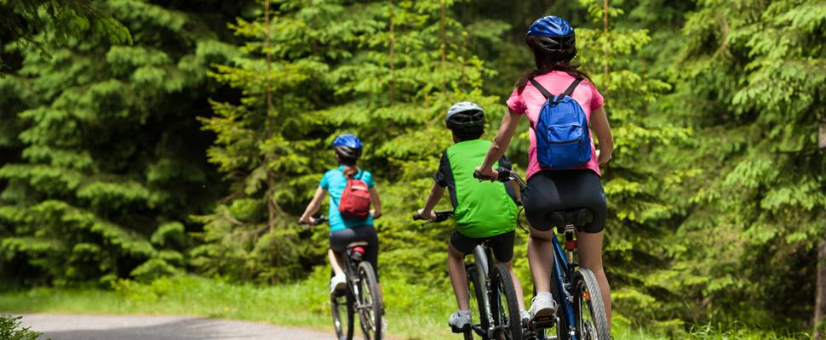  7 | 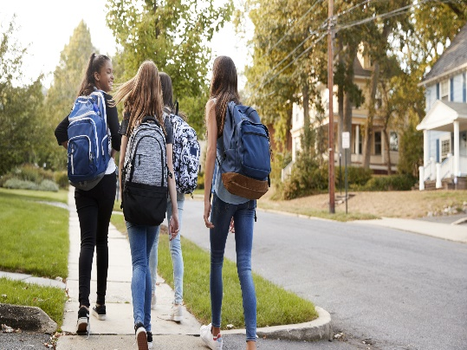  6 | 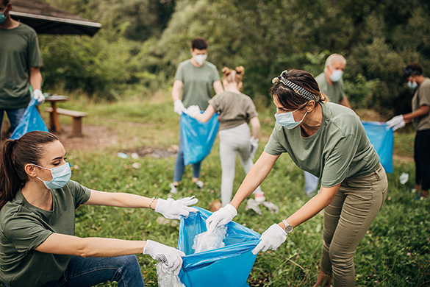  5

