School: ……………………………………….. | Date: ………………………………..
Class: ……………………………..................... | Period: ………………………..........

UNIT 6: LIFE ON OTHER PLANETS
Lesson 4 – Review (page 99)
I. OBJECTIVES
By the end of the lesson, Ss will be able to
1.1. Language knowledge and skills
- talk about possible UFO sightings in the past.
- make predictions about where humans will live in the future.
- review the target language and language skills in unit 6
- Grammar: Future Simple, Past Continuous and Past Simple
- Vocabulary: Words of the topic “life on other planets”: (Earth, Mars, Venus, oxygen, space station, gravity, temperature, appear, disappear, disk-shaped, flying saucer, huge, tiny, strange, terrified, UFO).
- practice test-taking skills.
1.2. Competences
- improve speaking, listening, reading and writing skills.
- improve the use of English.
1.3. Attributes
- have a good attitude toward learning English
- become more diligent.
- reread the previous lesson and be well-prepared for the second mid-term examination.
II. TEACHING AIDS AND LEARNING MATERIALS
1. Teacher’s aids: Student book and Teacher’s book, class CDs, Digital Book (DCR phần mềm tương tác SB, DHA (từ vựng/ cấu trúc) phần mềm trò chơi tương tác), projector/interactive whiteboard / TV (if any), PowerPoint slides, handouts.
2. Students’ aids: Student’s book, workbook, notebook.
III. ASSESSMENT EVIDENCE
Performance Tasks | Performance Products | Assessment Tools
- Vocabulary: Review. | - Ss’ answers. | - T’s feedback/Peers’ feedback.
- Vocabulary: Circle the correct words. | - Ss’ answers. | - T’s feedback/Peers’ feedback.
- Grammar: Underline the mistakes and write the correct words on the lines. | - Ss’ answers. | - T’s feedback/Peers’ feedback.
- Pronunciation: Circle the word that differs from the other three in the position of primary stress in each of the following questions. | - Ss’ answers/ presentation. | - T’s observation, T’s feedback/Peers’ feedback.
- Writing: Write about where you think people will and won't live in 100 years, and why. Write 80 to 100 words. | - Ss’ writing. | - T’s observation, T’s feedback/Peers’ feedback.

IV. PROCEDURES
A. Warm up: (5’)
a) Objective: Introduce the new lesson and set the scene for Ss to acquire new language; get students' attention at the beginning of the class by enjoyable and short activities as well as to engage them in the follow-up steps.
b) Content: Reviewing vocabulary of the topic “Life on other planets”
c) Expected outcomes: Ss are ready for the new lesson.
d) Organization of the activity:
TEACHER’S ACTIVITIES | STUDENTS’ ACTIVITIES
Review vocabulary  - Have Ss read the statements and choose the correct pictures A, B, or C.  - Call Ss to give answers.  - Check Ss’ answers and give feedback.  - Lead to the new lesson.  *Illustration:  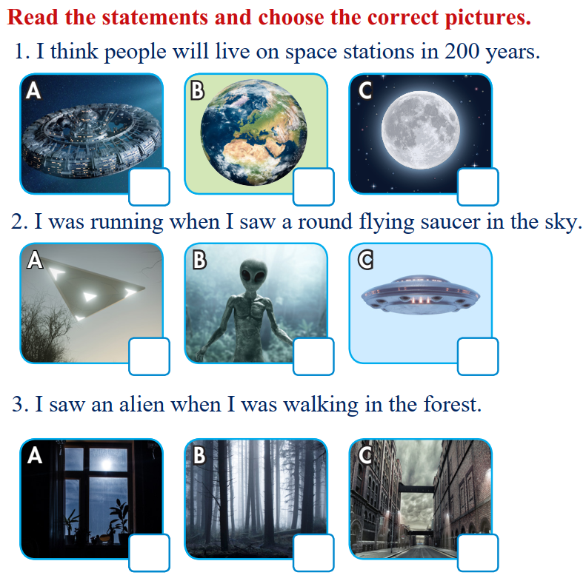 | - Read the statements and choose the correct pictures.  - Give answers.  Answer keys  1 A 2 C 3 B

B. New lesson (35’)
- Activity 1: Vocabulary (7’)
a) Objective: Ss can review vocabulary about life on other planets.
b) Content: Circle the correct words.
c) Expected outcomes: Ss produce the new language successfully, and they can use these words in speaking and writing.
d) Organization of the activity:
TEACHER’S ACTIVITIES | STUDENTS’ ACTIVITIES
Circle the correct words.  - Have Ss read the sentences.  - Ask Ss to work in pairs to circle the correct words.  - Have Ss give answers, tell the meaning of the words /phrases again.  - Check answers as a whole class. | - Read the sentences.  - Work in pairs.  - Give answers.  Answer keys  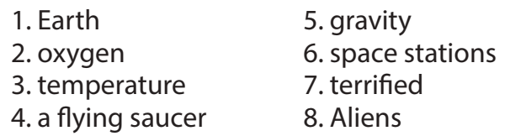

- Activity 2: Grammar (10’)
a) Objective: Ss can review the tenses: Future Simple, Past Continuous and Past Simple
b) Content: Underlining the mistakes and writing the correct answers on the lines.
c) Expected outcomes: Ss produce the language successfully, and they can use the grammar points in speaking and writing.
d) Organization of the activity:
TEACHER’S ACTIVITIES | STUDENTS’ ACTIVITIES
Underline the mistakes and write the correct words on the lines.  - Ask Ss to work individually to underline the mistakes and write the correct answers on the lines.  - Have Ss work in pairs to check each other’s work.  - Call Ss to give answers, explain for their choice.  - Check answers as a whole class using DCR. | - Work individually.  - Work in pairs.  - Give answers.  Answer keys  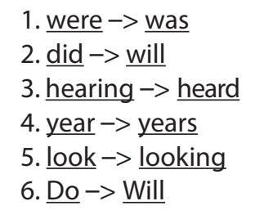

- Activity 3: Pronunciation (5’)
a) Objective: Ss can review the stress of nouns and adjectives with 2 and 3 syllables.
b) Content: Circling the word that differs from the other three in the position of primary stress in each of the following questions.
c) Expected outcomes: Ss produce the new language successfully.
d) Organization of the activity:
TEACHER’S ACTIVITIES | STUDENTS’ ACTIVITIES
Circle the word that differs from the other three in the position of primary stress in each of the following questions.  - Remind Ss some word stress rules in English, including two or three syllables.  - Ask Ss to work individually.  - Have Ss work in pairs to check each other’s work.  - Call Ss to give answers, pronounce the words again.  - Give feedback, correct Ss’ pronunciation if necessary. | - Review.  - Work individually.  - Work in pairs.  - Give answers.  Answer keys  

- Activity 4: Writing (13’)
a) Objective: Ss can review the structure and language used in a narrative.
b) Content: Writing about where you think people will and won't live in 100 years, and why.
Write 80 to 100 words.
c) Expected outcomes: Ss produce the new language successfully.
d) Organization of the activity:
TEACHER’S ACTIVITIES | STUDENTS’ ACTIVITIES
Write about where you think people will and won't live in 100 years, and why.  Write 80 to 100 words.  - Briefly remind Ss of the structures of a narrative.  - Ask Ss some questions to remind them of the structure.  How many sections are there in a narrative passage?  What do you write in the topic section?  In which section do you write about what you saw/heard/felt, the main event or the ending section?  - Have Ss write a narrative.  - Have Ss look at each other’s work (peer correction).  - Call Ss to read their writing.  - Give feedback to one S’s writing. | - Review.  - Answer the questions.  Suggested Writing  In a hundred years, I think humans will find a new place to live. I think the Earth will be too hot for humans. We will find a new home on another planet. Some people will live in a space station. They will have a great view  of the Earth, but they won't have any gravity. I don't think people will live on Venus. Its temperature is too high. I think people will live on Mars. People will build a city that is warm enough and has gravity and oxygen. I  think the future will be exciting.

C. Consolidation and homework assignments (5’)
* Consolidation:
- Grammar of Unit 6: Future Simple, Past Continuous and Past Simple
- Vocabulary of Unit 6: Words of the topic “life on other planets”: (Earth, Mars, Venus, oxygen, space station, gravity, temperature, appear, disappear, disk-shaped, flying saucer, huge, tiny, strange, terrified, UFO).
- Work in pairs.
Make three predictions of humans’ future home.
* Homework:
- Review vocabulary, grammar and language skills of unit 6.
- Do the exercises in WB: Unit 6 Review - Part 2 (page 55).
- Prepare: Unit 7 – New words and Listening (page 52 – SB).

V. Reflection
a. What I liked most about this lesson today:
…………………………………………………………………………………………
- What I learned from this lesson today:
…………………………………………………………………………………………
c. What I should improve for this lesson next time:
…………………………………………………………………………………………

