UNIT 2: MY HOUSE

Lesson 1: Getting started – A look inside

  - I. Objectives
By the end of this lesson, students will be able to:
1. Knowledge
- use the lexical items related to the topic My house
- ask and answer about where someone lives.
2. Core competence
- Develop communication skills and creativity
- Be collaborative and supportive in pair work and team work
- Actively join in class activities
3. Personal qualities
- Be ready to introduce the members in family
- Know the different types of house
II. Materials
- Grade 6 textbook, Unit 2, Getting started
- Computer connected to the internet
- Projector/ TV/ pictures and cards
- hoclieu.vn

  - Language analysis
Form | Meaning | Pronunciation | Vietnamese equivalent
1. town house (n) | a house in a town or city, usually a comfortable, expensive one in a fashionable area | /ˈtaʊn ˌhaʊs/ | nhà ở thành phố
2. country house (n) | a large traditional house in the countryside, especially one that has belonged to the same family for many years | /ˌkʌntri ˈhaʊs/ | nhà ở vùng quê
3. flat (n) | a set of rooms for living in that are part of a larger building and are usually all on one floor | /flæt/ | căn hộ

Anticipated difficulties | Solutions
1. Students may lack knowledge and experiences about the topic. | Prepare some handouts.
2. Students may have underdeveloped listening, speaking and co-operating skills. | - Play the recording many times if necessary.  - Encourage students to work in pairs, in groups so that they can help each other.  - Provide feedback and help if necessary.

  - Board Plan
Date of teaching
Unit 2: My house
Lesson 1: Getting started – A look inside
* Warm-up
Game: A hidden word
I. Vocabulary
1. town house (n)
2. country house (n)
3. flat (n)
II. Practice
Task 1: Tick the correct answers. (Ex. 2, p. 17)
Task 2: Complete the sentences. (Ex. 3, p. 17)
III. Production
Task 3: Complete the word web: Types of house. (Ex. 4, p. 17)
Task 4: Survey. (Ex. 5, p. 17)
* Homework

Stage | Stage aim | Procedure | Interaction | Time
Warm-up | To introduce the topic. | * A hidden word  - Teacher divides the class into two teams and asks a member of each team to look at the pictures and answer the questions.  - For each right answer, the team will get 1 point and 1 secret letter to help them find out the hidden word today.  - There is one picture including two secret words. The team that gets this picture will get 2 points.  - The team which has more points or can guess the hidden word first will be the winner.  M Y H O U S E  1. What is it? – It’s a _ _ _ _ . (ROOM)  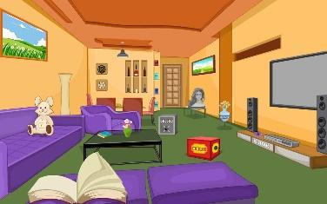  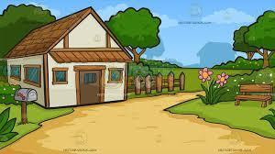  2. We have a small house in the _ _ _ _ _ _ _. (COUNTRY)  3. Where are they? – They are in the _ _ _ _ _ _ _ . (KITCHEN)  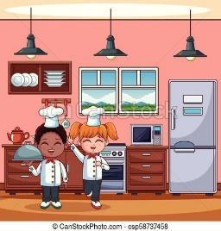  4. They have a house in the _ _ _ _ . (TOWN)    5. Which house is it? – It’s an _ _ _ _ _ _ _ _ _ . (APARTMENT)  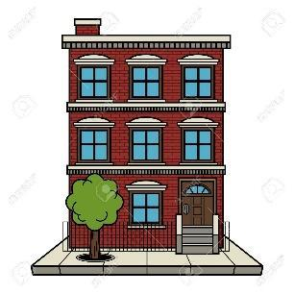 | Team work | 5 mins
Lead-in | To lead in the topic of My house. | - Teacher draws students’ attention to the pictures in the textbook and asks them some questions about the pictures.  - What are Nick and Mi doing?  - What might they talk about?  Suggested answers:  - They are talking to / discussing with each other through the Internet.  - (Students’ answers) | T-Ss | 2 mins
Presentation  (Pre-teach - Vocabulary) | To help students understand the text. | * VOCABULARY  - Teacher introduces the vocabulary by:  + showing the pictures illustrating the words  + providing the synonym or antonym of the words  + providing the definition of the words  1. town house (n): [visual]  2. country house (n): [visual]  3. flat (n): [synonym] 🡪 apartment  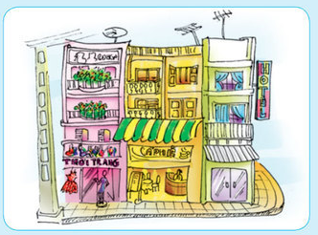  a town house  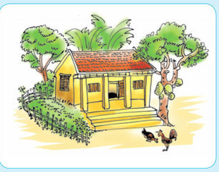  a country house  LISTEN AND READ. (p. 16)  - Teacher plays the  recording, asks students to underline the words related to the topic My house. (Teacher may check the meaning of some words if necessary.)  - Teacher can play the  recording more than once.  - Students listen and read.  - T can invite some pairs of students to read aloud.  - Then, teacher confirms the correct answer:  + They are talking about their houses.  + Mi is describing their new flat which her family was moving to. | T-Ss | 5 mins
Practice | To set the context for the listening and reading text.  To help students understand the text. | Task 1: Tick the correct answers. (Ex. 2, p. 17)  - Teacher asks students “Which family members does Mi talk about?” without reading the conversation again.  - Then, teacher tells them to read it again individually and check their answers.  - Teacher allows students to share their  answers before discussing as a class and  encourages them to give evidence.  - Teacher calls some students to check.  Answer key:  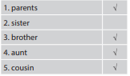  Task 2: Complete the  sentences. (Ex. 3, p. 17)  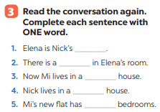  - Teacher asks students to work  independently to fill each blank with the word from the conversation.  - Teacher allows students to share their  answers before discussing as a class.  - Teacher calls some students to check. Teacher confirms the right answers and writes on the board.  Answer key:  1. sister  2. TV  3. town  4. country  5. three | T-Ss  S  Ss-Ss  T-Ss  S  Ss-Ss  T- Ss | 15 mins
Production | To develop students’ knowledge of the vocabulary about types of house.  To help students practise asking and answering about where they live. | Task 3: Complete the word web: Types of house. (Ex. 4, p. 17)  * Game: Networking  - Teacher divides the class into two teams, then writes the topic “Types of house” on the board and gives them two minutes to  discuss.  - After that time, a student from each team one by one runs to the board and writes one word.  - The team which has more correct answers is the winner.  Types of house  Suggested answers:  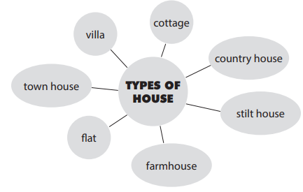  - Task 4: Survey  - Teacher asks students to work in groups of 4 or 6 to take turns to ask and answer about where they live.  - Teacher can model with one student.  - Teacher moves around to observe and offer help when needed.  - By the end of the activity, one student from each group can stand up and  report to the class.  Suggested answers:  In my group, Linh lives in a flat, Lan and Huong live in a country house, etc…. | Team work  Group work  T-S  T-Ss  Ss-Ss | 15 mins
Consolidation | To consolidate what students have learnt in the  lesson. | Teacher asks students to talk about what they have learnt in the lesson. | T-Ss | 2 mins
Homework | To prepare for the next lesson. | Prepare the vocabulary for the next lesson: A closer look 1. | T-Ss | 1 min

UNIT 2: MY HOUSE

Lesson 2: A closer look 1

  - I. Objectives
By the end of this lesson, students will be able to:
1. Knowledge
- Vocabulary:
+ use the lexical items related to the topic My house;
+ use the vocabulary and structures to talk about the names of rooms and
furniture pieces in the house.
- Pronunciation: pronounce and recognize the sounds /s/ and /z/
2. Core competence
- Develop communication skills
- Be collaborative and supportive in pair work and team work
- Actively join in class activities
3. Personal qualities
- Be ready to know the different rooms and furniture in the house
- Develop self-study skills
  - II. Materials
- Grade 6 textbook, Unit 2, A closer look 1
- Computer connected to the internet
- TV/ Projector/ Pictures/ Cards
- hoclieu.vn

  - Language analysis
Form | Meaning | Pronunciation | Vietnamese equivalent
1. hall (n) | the area just inside the main entrance of a house, apartment, or other building that leads to other rooms and usually to the stairs | /hɔːl/ | đại sảnh
2. chest of drawers (n) | a piece of furniture with drawers in which you keep things such as clothes | /ˌtʃest əv ˈdrɔːz/ | tủ ngăn kéo
3. sink (n) | a bowl that is attached to the wall in a kitchen or bathroom in which you wash dishes or your hands, etc. | /sɪŋk/ | bồn rửa
4. dishwasher (n) | a machine that washes dirty plates, cups, forks, etc. | /ˈdɪʃˌwɒʃər/ | máy rửa bát
5. cupboard (n) | ​a piece of furniture or a space for storing things, with a door or doors and usually with shelves. | /ˈkʌbəd/ | tủ (có ngăn)

Anticipated difficulties | Solutions
1. Students may lack knowledge about some  lexical items. | Provide students with the meaning and pronunciation of some lexical items.
2. Students may have underdeveloped listening, speaking and co-operating skills. | - Play the recording many times if necessary.  - Encourage students to work in pairs, in groups so that they can help each other.  - Provide feedback and help if necessary.
3. Some students will excessively talk in the class. | - Define expectation in explicit detail.  - Have excessive talking students practise.  - Continue to define expectations in small chunks (before every activity).

  - Board Plan
Date of teaching
Unit 2: My house
Lesson 2: A closer look 1
* Warm-up
Jumbled words and matching
I. Vocabulary: Rooms and furniture pieces in the house
1. hall (n)
2. chest of drawers (n)
3. sink (n)
4. dishwasher (n)
5. cupboard (n)
Task 1: Name the thing in each room in Ex. 1. (Ex. 2, p. 18)
Task 2: Guessing game
II. Pronunciation: /s/ and /z/
Task 3: Listen and write the words in the correct column. Then listen and repeat. (p. 18)
Task 4: Listen and repeat. Pay attention to the underlined words. (p. 18)
III. Production
Whispering game
* Homework

Stage | Stage aim | Procedure | Interaction | Time
Warm-up | To activate students’ prior knowledge and  vocabulary  related to the topic, the targeted  vocabulary and its  pronunciation. | - Teacher asks students to work independently to rearrange letters to find out the correct word, then match the word with the picture.  - Teacher tells students to compare their answers with their partners.  - Teacher corrects and confirms the answers.  - Teacher explains the new words.  * Jumbled words  1. tchekin  2. thraobom  3. rodeomb  4. lngivi moro  5. lahl  * Matching  Answer key:  * Jumbled words  1. kitchen  2. bathroom  3. bedroom  4. living room  5. hall  * Matching  a. hall  b. living room  c. bedroom  d. bathroom  e. kitchen | S  Ss-Ss  T-Ss | 5 mins
Lead-in | To lead in the lesson about vocabulary and  pronunciation. | Teacher leads students into the lesson by telling them that “In today lesson, we are going to learn more words to describes rooms and furniture and two sounds /s/ and /z/.” | T-Ss | 2 mins
Presentation  (Vocab-  pre-teach) | To revise / teach the names of rooms in the house. | VOCABULARY  - Teacher introduces the vocabulary by:  + providing the synonym or antonym of the words  + providing the pictures of the words  1. hall (n): [visual +  [explanation]  2. chest of drawers (n): [visual]  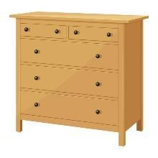  3. sink (n): [visual]  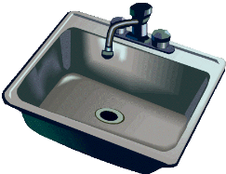  4. dishwasher (n): [visual]    5. cupboard (n): [visual]  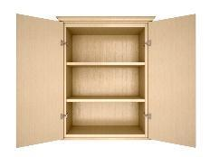  * Checking technique: Slap the board | T-Ss | 5 mins
Practice | To revise / teach the names of  furniture pieces.  To help students  practise asking and answering about the  furniture in a room. | - Task 1: Name the things in each room in Ex. 1.  (Ex. 2, p. 18)  - Teacher asks students to work in pairs to do this activity.  - Teacher writes the names of the rooms on the board in different places, then calls on students from different pairs to go to the board and write the name of the furniture under these rooms.  - Remind students that one piece of furniture can belong to more than one room.  - Teacher asks other students to comment and asks them if they can add some more things to each room.  Suggested answers:  - Bedroom: lamp, picture, chest of drawers  - Living room: lamp, sofa, picture  - Hall: picture  - Kitchen: fridge, cupboard, dishwasher, sink  - Bathroom: shower, sink, toilet  Other words: chair, fan, air conditioner, cooker, etc.  Task 2: Guessing game  - Teacher models this activity with a student.  - Teacher asks students to work in pairs: one student thinks of a room in his / her house; the other asks questions to guess the room.  - Teacher calls some pairs to practise in front of the class.  - Teacher comments on their performance.  Example:  Ss 1: What’s in your room?  Ss 2: A lamp and a chest of drawers.  Ss 1: Is it the bedroom?  Ss 2: Yes. | Pair work  T-Ss  T-S  Ss-Ss  T-Ss | 15 mins
Presentation  (Pre-teach the sounds /s/ and /z/) | To help students identify how to pronounce the final sounds /s/ and /z/ at the end of the words. | PRONUNCIATION  - Teacher introduces 2 sounds s/ and /z/ to students and lets them listen and repeat the words in Ex. 4 (p. 18).  - Teacher has students comment on how to pronounce these two sounds at the end of the words.  - Teacher quickly explains the rules:  + Final –s is pronounced /s/ after voiceless sounds (/t/, /p/, /k/, /f/, /θ/).  + Final –s is pronounced /z/ after voiced sounds (/b/, /d/, /g/, /n/, /m/, /l/, etc.) and any vowel sounds.  - Teacher asks students to give some words they know containing these sounds.  Suggested answers:  - /s/: cats, lamps, books, months  - /z/: beds, dogs, cans, rooms, videos, cookers, bees | T- Ss | 5 mins
Practice | To help students  practise pronouncing these sounds in words.  To help  students  pronounce the final sounds /s/ and /z/  correctly in context. | - Task 3: Listen and write the words in the correct column. Then listen and repeat. (p. 18)  - Teacher asks students to read and listen again the words, then put them in the correct column.  - Students work individually.  - Teacher plays the recording for students to listen, repeat and check their answers.  Answer key:  /s/ /z/  lamps, sinks, flats, toilets, cupboards, sofas, kitchens, rooms  - Task 4: Listen to the  conversation. Underline the final “s” in the words and put them into the correct column. (p. 18)  - Have students quickly read the conversation and underline the final “s” in the words. Now play the recording for students to listen to the conversation and write /s/ or /z/ under each “s” that they have underlined.  - Tell them to put the words with the final “s” in the correct column according to the sound of “s”. Have them work in pairs to compare their answers. Check students’ answers. Ask them to explain their answers.  Answer key:  /s/: chopsticks, lamps  /z/: bowls, things, homes  - Play the recording again for students to repeat each line of the conversation. Ask students to work in pairs to practice the conversation. Call some pairs to practise the conversation. Comment on their pronunciation of the final “s”. | T-Ss  S  T- Ss  T- Ss | 5 mins
Production | To give students a chance to apply what they have learnt. | Game: Whispering  - Teacher divides the class into 4 big groups and asks students to stand in four lines.  - The member in the last place will make a sentence containing at least a word and a sound they have learnt; then, whisper the sentence to the next member of the group. They will continue until the member in the first place and this member will say the sentence aloud.  - The fastest group will win the game.  Suggested sentences:  - There are two bedrooms in my house.  - My living room has a TV, two lamps, some pictures and a sofa.  - The toilets in my school are clean. | Group work | 5 mins
Consolidation | To consolidate what students have learnt in the lesson. | Teacher asks students to talk about what they have learnt in the lesson. | T-Ss | 2 mins
Homework | To revise what they have learnt. | Find 5 more words with the sound /s/ and 5 more words with the sound /z/. Write them down and practice  pronouncing the words. | T-Ss | 1 min

UNIT 2: MY HOUSE

Lesson 3: A closer look 2

Possessive case & Prepositions of place

  - I. Objectives
By the end of this lesson, students will be able to:
1. Knowledge
know how to use the possessive case and prepositions of place correctly.
2. Core competence
- Develop communication skills
- Be collaborative and supportive in pair work and team work
- Actively join in class activities
3. Personal qualities
Be responsible and hard working
  - II. Materials
- Grade 6 textbook, Unit 2, A closer look 2
- Computer connected to the internet
- TV/ Projector/ Pictures, sets of word cards
- hoclieu.vn

  - Language analysis
Form | Meaning
+ ’s after a proper name.  Eg: Nam’s pen  + ‘s after a singular noun  Eg: teacher’s book | A possessive case is used to show  possession.

Anticipated difficulties | Solutions
1. Students may lack knowledge and experiences about the topic. | Prepare some hand-outs.
2. Some students will excessively talk in the class. | - Define expectation in explicit detail.  - Have excessive talking students practise.  - Continue to define expectations in small chunks (before every activity).

Board Plan

Date of teaching
Unit 2: My house
Lesson 3: A closer look 2
* Warm-up
Memory game
I. Grammar focus 1: The possessive case
🡪 name’s + noun = Polly’s sock.
🡪 singular noun’s + noun = teacher’s book.
* Practice:
Task 1: Choose the correct answer.
Task 2: Complete the sentences with the correct possessive forms.
II. Grammar focus 2: Prepositions of place
on, in, at, under, …
* Practice:
Task 3: Write the correct preposition in the box under each picture.
Task 4: Decide True or False statements.
III. Further practice: Memory challenge
* Homework

Stage | Stage aim | Procedure | Interaction | Time
Warm-up | To activate students’ prior knowledge and  vocabulary related to the targeted grammar of possessive case, preposition of place and to increase  students' interest. | * Game: Memory game  - Teacher divides the class into 4 groups.  - Teacher tells students the rules of the game:  + Students have to study the picture of 3 people (Jack, Polly and Greg) and try to remember the things belonging to each person in 30 seconds without writing down in their notebooks.  + After 30 seconds, T shows the things of Jack, Polly and Greg and a member of each team has to answer quickly the question “Whose is it?”  + The group with more correct sentences will be the winner.  Answer keys:  1. Whose jumper is it?  – It’s Polly’s jumper.  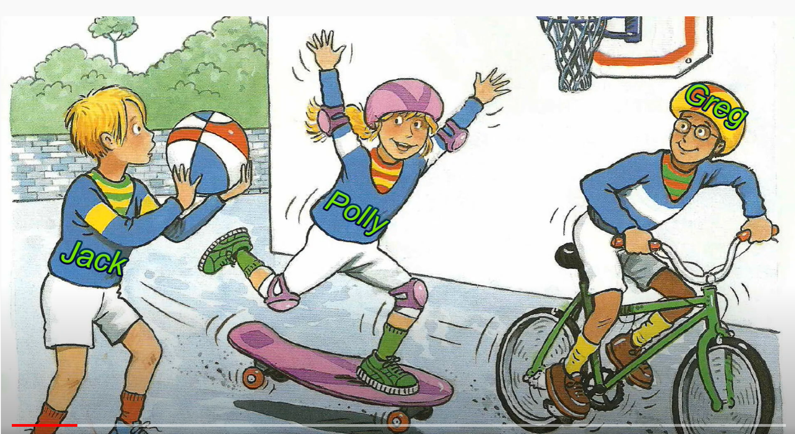  2. Whose T-shirt is it  – It’s Greg‘s T-shirt.    3. Whose ball is it?  – It’s Jack’s ball.    4. Whose sock is it?  – It’s Jack’s sock.    5. Whose shoes is it?  – It’s Greg’s shoes.  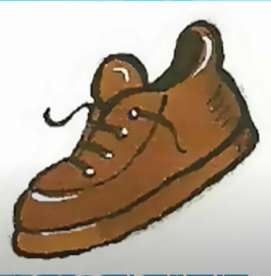  6. Whose sock is it?  – It’s Polly’s sock.  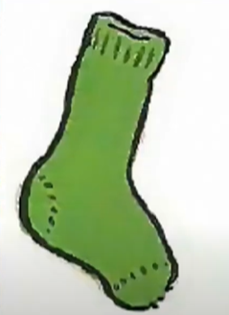  7. Whose jumper is it?  – It’s Greg’s jumper.  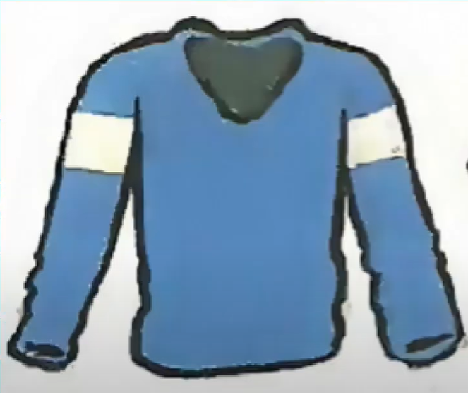  8. Whose T-shirt is it?  – It’s Polly’s T-shirt.   | Group work | 5 mins
Lead-in | To introduce the targeted grammar of the lesson. | Teacher says: “This lesson today is going to tell you one way to express the possessive and how to use the preposition of place correctly.” | T-Ss | 1 mins
Presentation | To introduce students the form of  possessive case. | THE POSSESSIVE CASE  - Teacher draws students’ attention to the words in the answers from the Warm-up “Greg ‘s T- shirt, Jack’s ball, Polly’s sock” and asks them whether they know the meanings of these words.  - Teacher provides or confirms the answers and lead in the grammar focus of the lesson:  🡪 We use “‘s” to show possession.  - Teacher writes the form of the possessive case on the board:  🡪 name’s + noun = Polly’s sock.  🡪 singular noun’s + noun = teacher’s book. | T-Ss  Ss-Ss | 5 mins
Practice | To help  students identify the correct form of possessive case.  To help  students practise  forming the correct form of possessive case. | Task 1: Choose the correct answer.  - Teacher asks students to do the exercise  - individually and then compare their answers with a classmate.  - Check the answers as a class.  - Teacher confirms the correct answers.  Answer key:  1. grandmother’s  2. sister’s 3. cousin’s  4. Nam’s 5. An’s  Task 2: Complete the  sentences with the correct possessive forms.  - Teacher has students do this exercise individually and calls on two  students to write their answers on the board.  - Teacher draws all  students’ attention to the board and checks the answers together.  - Teacher confirms the correct answers.  Answer key:  1. Mi’s 2. teacher’s  3. Nick’s 4. father’s  5. brother’s | S  T – Ss  T – Ss | 8 mins
Presentation | To help  students identify  different prepositions of place and use them  correctly to describe where  people or things are. | PREPOSITIONS OF PLACE  - Teacher asks students what prepositions of place they know. Encourage students to say as many as possible.  - Have them look at the Remember box to see if the prepositions they have mentioned are the same.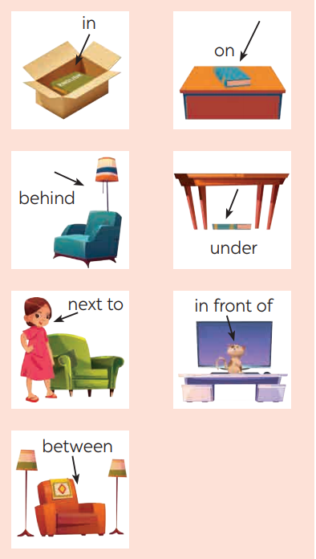  - Teacher confirms how to use prepositions of place.  🡪 We use prepositions of place to describe where people or things are. | T - Ss | 5 mins
Practice | To help  students practice using prepositions of place  correctly to describe where people or things are. | Task 3: Write the correct preposition in the box  under each picture.  - Teacher has students do this exercise 3 in pairs, then asks for students’ answers and confirms the correct answers.  - Teacher has students work in pairs to say sentences describing the pictures. Move around to offer help if needed.  - Teacher calls on some students to say their entences. If there is time, ask some students to write their sentences on the board.  Answer key:  1. on 2. next to  3. behind 4. in  5. in front of 6. between  7. under  1. The dog is on the chair.  2. The dog is next to the armchair.  3. The cat is behind the TV.  4. The cat is in the  wardrobe.  5. The dog is in front of the kennel / doghouse.  6. The cat is between the lamp and the armchair.  7. The cat is under the  table.  Task 4: Decide True (T) or False (F) statements.  - Teacher has students look at the picture of the room and asks them to describe the room briefly, then has them read each sentence, look at the picture and decide if each sentence is true or false. If it is false, ask them to correct it.  - Teacher has students do this exercise individually before they share their answers with a partner. Ask some students to read out their answers.  - Teacher confirms the correct ones.  Answer key:  1. T  2. F (The school bag is  under the table.)  3. F (The clock is between the two pictures.)  4. T  5. F (The cap is on the  pillow.) | Pair work  T- Ss  T- Ss | 10 mins
Production | To help  students practise  asking and answering about the  position of things. | * Memory challenge  - Teacher has students work in pairs to play the game Memory challenge.  - Students look at the  picture in Exercise 4 for 30 seconds and then cover it.  - They ask and answer questions about the  position of the things in the picture.  - Teacher invites some pairs to perform in front of the class.  Example:  A: Where are the books?  B: They’re on the table. | T-Ss  Ss-Ss  T-Ss | 8 mins
Consolidation | To consolidate what  students have learnt in the lesson. | Teacher asks students to talk about what they have learnt in the lesson. | T-Ss | 2 mins
Homework | To revise what they have learnt. | Do exercises in the workbook. | T-Ss | 1 min

UNIT 2: MY HOUSE

Lesson 4: Communication

  - I. Objectives
By the end of this lesson, students will be able to:
1. Knowledge
- learn how to give suggestions;
- practise using some grammar points and vocabulary related to the topic
2. Core competence
- Develop communication skills
- Be collaborative and supportive in pair work and team work
- Actively join in class activities
3. Personal qualities
- Be benevolent and responsible
- Introduce/ decorate the different types of house, the different rooms in the house
- Learn about the structures: Suggestions
+ How about + V-ing
+ Let’s + V (inf.)
  - II. Materials
- Grade 6 textbook, Unit 2, Communication
- Computer connected to the internet
- TV/ Pictures/ Projector
- hoclieu.vn

Language analysis

Anticipated difficulties | Solutions
1. Students may lack knowledge about the topic. | Provide students with information about the knowledges they do not know.
2. Students may have underdeveloped reading, speaking and co-operating skills. | - Encourage students to work in pairs, in groups so that they can help each other.  - Provide feedback and help if necessary.
3. Some students will excessively talk in the class. | - Define expectation in explicit detail.  - Have excessive talking students practise.  - Continue to define expectations in small chunks (before every activity).

Board Plan
Date of teaching
Unit 2: My house
Lesson 4: Communication
*Warm-up
Pictures decribing
I. Everyday English: Giving suggestions
  - Structure: How about + V-ing?
Let’s + V.
Task 1: Listen and read the dialogue.
Task 2: Make similar dialogues.
II. Living places
Task 3: Look at the picture and complete the sentences.
Task 4: Find the differences between the two houses.
Task 5: Draw a simple picture of your house.
* Homework

Stage | Stage aim | Procedure | Interaction | Time
Warm-up | To introduce the lesson. | * Pictures describing: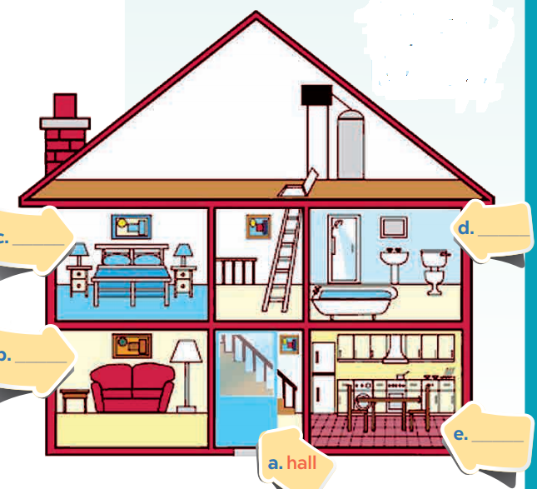  - Teacher shows the  picture of Nam’s house and asks students to describe as many things in the picture as  possible.  - Students give their answers.  - Teacher checks the answers.  Suggested answers:  - This is Nam’s house.  - There are 4 rooms in his house.  - In the living room, there is a lamp, a picture, a table and a sofa.  - In the kitchen, there is a fridge, a dishwasher and a sink.  - … | T-Ss | 3 mins
Lead-in | To lead in the lesson. | Teacher leads students into the lesson by telling what they are going to learn: “We are going to learn how to give suggestions and  practice describing a house”. | T-Ss | 2 mins
* EVERYDAY ENGLISH
Presentation | To introduce two ways to give suggestions. | Task 1: Listen and read a dialogue.  * Giving suggestions:  - Teacher plays the recording for students to listen and read the dialogue between Elena and her mum at the same time.  - Teacher asks students to pay attention to the highlighted sentences.  - Teacher elicits the structures to give  suggestions from students.  Structure:  🡪 How about + V-ing?  🡪 Let’s + V.  - Teacher has students practise the dialogue in pairs. Call some pairs to practise the dialogue in front of the class. | T-Ss | 5 mins
Practice | To help  students practise giving suggestions. | Task 2: Make similar dialogues.  - Teacher give students some situations to practice:  Situation 1: You want to buy some furniture for their homes.  Situation 2: You want to do some activities at the weekend with your friend.  Situation 3: You want to buy some new school things  - Teacher asks students to work in pairs.  - Teacher moves around to observe and provide help.  - Teacher calls some pairs to practise in front of the class, then comments on their performance.  Suggested answers:  A: I am so bored.  B: How about going to the cinema this weekend?  A: Great idea! | Pair work  T-Ss | 5 mins
* LIVING PLACES
Presentation | To give students a sample of a house  description  To help students practise using some grammar points and vocabulary related to the topic. | Task 3: Complete the sentences.  - Teacher has students look at the picture and try describing Mi’s grandparents’ country house.  - Teacher encourages students to say full sentences.  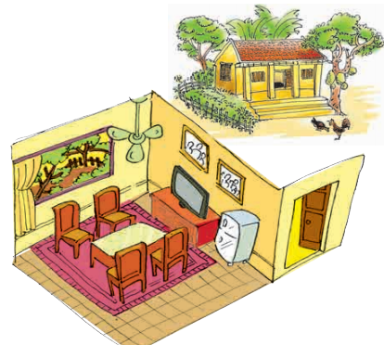  - Then ask students to work in pairs to  complete the given sentences.  - Teacher moves around to observe and provide help.  - After that, T invites students to share their answers.  - Teacher confirms the correct answers.  Answer key:  1. country 2. are 3. is 4. chairs 5. on | T- Ss  Pair work  T-Ss | 5 mins
Practice | To help  students practise asking and answering about the differences between two houses. | Task 4: Find the differences between the two houses. 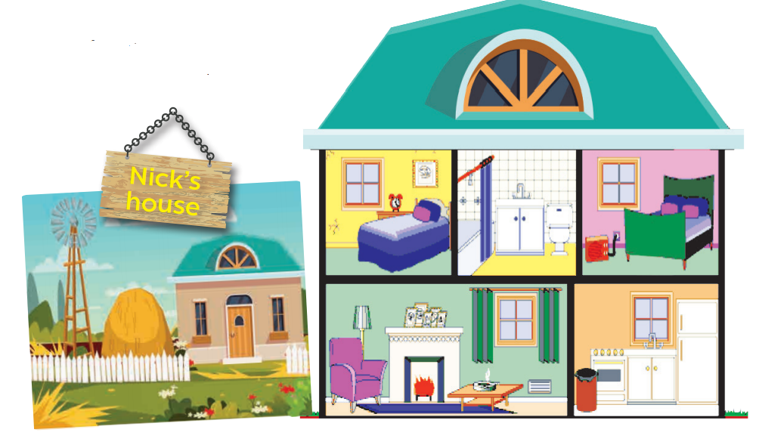  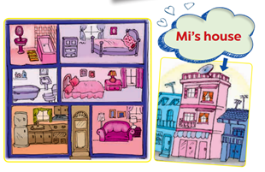  - Teacher models with a student.  Suggested conversation:  T (look at Nick’s house): Nick lives in a country house. Where does Mi live?  S (look at Mi’s house): She lives in a town house.  T: How many rooms are there in Mi’ house?  S: There are six rooms. What about in Nick’s house?  T: …  - Teacher asks students in each pair not to look at each other’s picture and make similar conversations.  - Teacher reminds students to note down the differences between the two houses.  - After some minutes, the pair which has the most differences will be the winner. Ask some pairs to act out the conversation. Other pairs listen and add more differences if there are any. | T-S  Pair work | 5 mins
Production | To help students practise describing their house. | Task 5: Drawing a simple picture of your house.  - Teacher gives students 5 – 7 minutes to draw a simple picture of their house, then asks  students work in pairs to tell each other about their house. If time  allows, teacher can ask them to note down the differences between their houses.  - Teacher calls some  students to describe their friend’s house to the class.  - Students may also  present the differences between their house and their friend’s. Other students and teacher listen and give comments. The group with higher scores will win the game. | S  Pair work  T-Ss | 7 mins
Consolidation | To consolidate what  students have learnt in the lesson. | Teacher asks students to talk about what they have learnt in the lesson. | T-Ss | 2 mins
Homework | To prepare for the next lesson:  Skills 1. | Do exercises in the workbook. | T-Ss | 1 min

UNIT 2: MY HOUSE

Lesson 5: Skills 1

  - I. Objectives
By the end of this lesson, students will be able to gain:
1. Knowledge
+ Reading:
- understand the description of a room at the Crazy House Hotel in Da Lat;
- describe one room (in their imagination) in that hotel.
+ Speaking:
Imagine/ create/ draw/ show/ describe the new room
2. Core competence
- Develop communication skills
- Be collaborative and supportive in pair work and team work
- Actively join in class activities
3. Personal qualities
Be benevolent and responsible
  - II. Materials
- Grade 6 textbook, Unit 2, Skills 1
- Computer connected to the internet
- TV/ Pictures, cards
- hoclieu.vn

  - Language analysis
Form | Meaning | Pronunciation | Vietnamese equivalent
1. strange (adj) | unusual and unexpected, or difficult to understand | /streɪndʒ/ | lạ
2. wardrobe (n) | a tall cupboard in which you hang your clothes | /ˈwɔːdrəʊb/ | tủ quần áo
3. desk (n) | a type of table that you can work at, often one with drawers | /desk/ | bàn học, bàn làm việc

Anticipated difficulties | Solutions
1. Students may lack knowledge about some lexical items. | Provide students with the meaning and pronunciation of words.
2. Students may have  underdeveloped reading,  speaking and co-operating skills. | - Let students read the text again (if needed).  - Create a comfortable and encouraging environment for students to speak.  - Encourage students to work in pairs, in groups so that they can help each other.  - Provide feedback and help if necessary.
3. Some students will excessively talk in the class. | - Define expectation in explicit detail.  - Have excessive talking students practise.  - Continue to define expectations in small chunks (before every activity).

  - Board Plan
Date of teaching
Unit 2: My house
Lesson 5: Skills 1
* Warm-up
Shark attack
I. Reading:
1. Reading skills: Predicting
2. Vocabulary
Task 1: Read the text and answer the questions. (Ex. 2, p. 22)
Task 2: Circle the things in the Tiger Room. (Ex. 3, p. 22)
Task 3: Retelling
II. Speaking:
Task 4: Create a new room for the hotel. (Ex. 4, p. 22)
Task 5: Describe your plan. (Ex. 5, p. 22)
* Homework

Stage | Stage aim | Procedure | Interaction | Time
Warm-up | To introduce the topic of reading. | *Shark attack  - Teacher divides the class into 2 teams.  Then, teacher lets students play “Shark attack” to find the hidden words. C R A Z Y  - The team which finds the word first will be the winner. | Group work | 5 mins
Lead-in | To lead in the lesson about Skills 1. | READING SKILL:  PREDICTING  - Teacher asks students to read the “Reading skill” box and explains any words that students do not know.  - Teacher tells students that predicting is an important reading skill that can help them have a general understanding of the text.  * Set the scene: 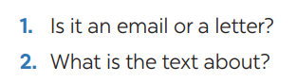  - Teacher tells students to quickly look at the text, the pictures and answer the questions.  - Teacher asks for students’ answers.  - Then teacher tells them to read the text quickly to check their prediction.  - After that, teacher confirms the correct answers.  Answer key:  1. It’s an email.  2. The text is about Nick’s room at the Crazy House Hotel.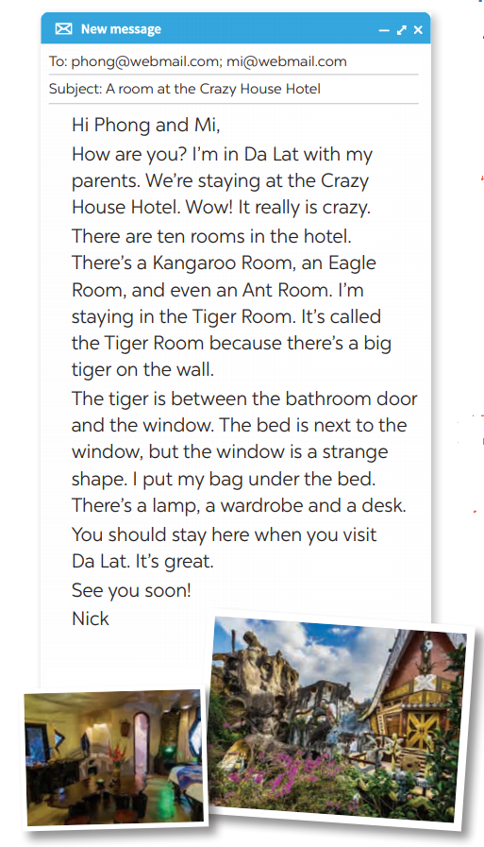 | T-Ss | 2 mins
Pre-Reading (Pre-teach  vocabulary) | To provide students with some lexical items before reading the text again. | VOCABULARY  - Teacher introduces the vocabulary by:  + Providing the synonym or antonym of the words.  + Providing the pictures of the words.  + Providing the definition of the words:  1. strange (adj) [explanation]  2. wardrobe (n) [visual]  3. desk (n) [visual] | T-Ss | 5 mins
While-Reading | To help students develop their reading skill for specific information (scanning).  To help students further develop their reading skill for specific information (scanning). | Task 1: Read the text and answer the questions. (Ex. 2, p. 22)  - Teacher lets students look at Ex. 2 on p. 22 and tells them how to do this kind of exercise:  + Read the questions.  + Underline the key words.  + Locate the key words in the text.  + Read that part and answering the  questions.  - Teacher has students read the text in detail to answer the  questions and tells them to underline parts of the email that help them with the answers.  - Teacher tells them to compare their answers in pairs before giving the answers to the teacher.  - Teacher asks them to give evidence when giving the answers.  Answer key:  1. He’s in Da Lat with his parents.  2. There are ten rooms.  3. Because there’s a big tiger on the wall.  4. It’s under the bed.  Task 2: Circle the things in the Tiger Room.  (Ex. 3, p. 22)  - Teacher asks students to read through the words given and then locate them in the text. If they find a similar word in the text, they should circle it in the list.  - Teacher has students compare their answers.  - Teacher checks and confirms the correct answers.  Answer key:  a window  a lamp  a wardrobe  a desk | T- Ss  Ss-Ss  T-Ss  T-Ss  Ss-Ss  T-Ss | 10 mins
Post-Reading | To check students’  reading comprehension. | Task 3: Retelling  - Ask students what to include when they want to describe a room in the hotel. Here are some things:  • Name of the room  • Reason for the name  • Position of things in the room  - Write these points on the board and retell “Tiger room” to their partners. | T-Ss  Ss-Ss | 5 mins
Pre-Speaking | To help students prepare ideas for the next activity. | Task 4: Create a new room for the hotel. Draw a plan for the room. (Ex. 4, p.22)  - Teacher tells each student to create a new room for the hotel and draw a plan for the room.  - Teacher sets a time limit for students to do it.  - Teacher asks students to give the room a name and bear in mind the organisation of the room including the things in the room and their position.  - Have them note down quickly these ideas. | T-Ss | 5 mins
While-  Speaking | To provide an opportunity for students to practise describing the hotel room they have designed. | Task 5: Describe your plan. (Ex. 5, p. 22)  - Have students work in pairs and show the plan to their partner. Ask students to take turns to describe their rooms.  - Remind them to focus on the three points on the board. Move around to observe and offer help.  - Call on some students to show their plan to the whole class and describe it. Other students and the teacher listen and vote for the best plan. | Ss-Ss | 7 mins
Post-Speaking | To help students improve next time. | - Have students give comments on their friends and vote for the most interesting and informative presentation.  - Teacher gives feedback and comments. | T-Ss  Ss-Ss | 3 mins
Consolidation | To consolidate what students have learnt in the lesson. | Teacher asks students to talk about what they have learnt in the  lesson. | T-Ss | 2 mins
Homework | To prepare for the next lesson Skills 2. | Do exercises in the workbook. | T-Ss | 1 min

UNIT 2: MY HOUSE

Lesson 6: Skills 2

  - I. Objectives
By the end of this lesson, students will be able to:
1. Knowledge
+ Listening
- use the lexical items related to the topic My house;
- listen to get information about rooms and houses.
+ Writing: write an e-mail to a friend.
2. Core competence
- Develop communication skills
- Be collaborative and supportive in pair work and team work
- Actively join in class activities
3. Personal qualities
Be benevolent and responsible
  - II. Materials
- Grade 6 textbook, Unit 2, Skills 2
- Computer connected to the internet
- Pictures
- hoclieu.vn

Anticipated difficulties | Solutions
1. Students may lack knowledge and experiences about the topic. | Prepare some hand-outs.
2. Students may have underdeveloped listening, writing and co-operating skills. | - Play the recording many times if any necessary.  - Encourage students to work in pairs, in groups so that they can help each other.  - Provide feedback and help if necessary.
3. Some students will excessively talk in the class. | - Define expectation in explicit detail.  - Have excessive talking students practise.  - Continue to define expectations in small chunks (before every activity).

Board Plan
Date of teaching
Unit 2: My house
Lesson 6: Skills 2

* Warm-up
Game: Lucky number
I. Listening
Task 1: Name the pieces of furniture. (Ex. 1, p. 23)
Task 2: Prediction. (Ex. 1, p. 23)
Task 3: True or False statements. (Ex. 2, p. 23)
Task 4: Summarize the information and talk about Mai’s room.
II. Writing: An email to a friend
* Necessary parts of an email:
• Part 1: Subject
• Part 2: Greeting
• Part 3: Introduction
• Part 4: Body
• Part 5: Conclusion
Task 5: Answer the questions. (Ex. 3, p. 23)
Task 6: Write an email to Mira, your pen friend and tell her about your house. (Ex. 4, p. 23)
* Homework

Stage | Stage aim | Procedure | Interaction | Time
Warm-up | To revise the content of the previous lesson. | * Game: Lucky number  - Teacher divides the class into 2 teams.  - Each team chooses the number they like, then tries to answer the question correctly.  - The team which chooses a lucky number will get two points  without answering any questions.  - The team which has more points will be the winner.  Questions:  1. What is the name of the room where Nick is staying? (Tiger)  2. How many rooms are there in the hotel? (10)  3. Is there a wardrobe in Nick’s room? (Yes)  4. Where is that Crazy House Hotel? (In Da Lat)  5. Are the rooms named after different flowers? (No)  6. Lucky number  7. Where is the bed in Nick’s room? (Under the window)  8. Why is the room called the Tiger room?  (Because there’s a big tiger on the wall).  9. Who is Nick staying with? (With his  parents)  10. Lucky number. | T-Ss  Group work | 5 mins
Lead-in | To introduce the new lesson. | - Teacher introduces students the content of the lesson today: “In the previous lesson, you already read about Nick’s room at the Crazy House Hotel. In the listening lesson  today, we are going to listen to Mai talking about her house.” | T-Ss | 1 min
Pre-Listening | To prepare students for the listening text. | Task 1: Name the pieces of furniture. (Ex. 1, p. 23)  - Ask students to look at the pieces of furniture and parts of the house and name them.  - Call on some students to read the words out loud.  - Ask some students to write the words on the board.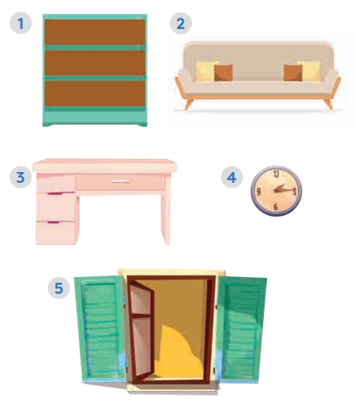  Answer key:  1. bookshelf  2. sofa  3. desk  4. clock  5. window  Task 2: Prediction. (Ex. 1, p. 23)  - Have students guess if these things are  mentioned in the  listening text. If they say yes for a thing, put a tick next to the word.  - Play the recording once for students to check their guesses. | T-Ss | 3 mins
While-  Listening | To help students  develop their skill of listening for specific information. | Task 2: Prediction. (Ex. 1, p. 23, cont.)  Teacher confirms the correct answers for their prediction.  Answer key:  Things mentioned in the listening text: bookshelf, desk, clock, window.  Task 3: True or False statements. (Ex. 2, p. 23)  - Have students look at the sentences in this activity. Ask them how to do it. Give them some strategies to do the exercise (e.g. reading the sentences, underlining the key words, listening to the text paying attention to the key words, deciding if each sentence is true or false).  - Play the recording twice for students to do Exercise 2. For a better class, ask students to take notes of the  information to explain why a sentence is false.  - Have students share their answers in pairs.  - Invite some pairs to give their answers and confirm the correct ones.  - Play the recording again if needed, stopping at the place where students find it difficult to hear.  - For a better class, ask students to correct the false sentences.  Audio script:  My name’s Mai. I live in a town house in Ha Noi.I live with my parents. There are six rooms in our house: a living room, a kitchen, two bedrooms, and two bathrooms. I love our living room best because it’s bright. It’s next to the kitchen. I have my own bedroom. It’s small but beautiful. There’s a bed, a desk, a chair, and a bookshelf. It also has a big window and a clock on the wall. I often read books in my bedroom.  Answer key:  1. F (There are three people.)  2. F (There are six rooms.)  3. T  4. T  5. F (She reads books.)  * Retelling  Invite one or two students to briefly  describe Mai’s house, focusing on the type of house, the number of rooms and her favourite room. | T-Ss | 10 mins
Post-Listening | To develop students’ speaking skill, using the available information and their background knowledge. | Task 4: Summarize the information and talk about Mai’s room.  - Students work in groups of four.  - Teacher asks students to summarize the information in the listening tasks and talk about it.  - Students can add more information based on their background knowledge.  - Teacher goes round and helps if needed. | Group work | 5 mins
Pre-Writing | To help students identify the form of an email. | * Necessary parts of an email  - Show this sample email on the slide / on the board or give each student a handout with this sample.  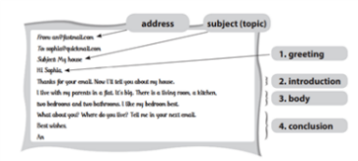  - Ask them several questions:  1. How many parts are there in the email? (5 parts)  2. What is the subject of the email? Where can you find it? (My house – We can find it in the “Subject line”)  3. What does An write about in the first paragraph of the email? (The  introduction)  4. What does An write about in the second paragraph? (The subject(s) of the email)  - Teacher can use the information in this box when explaining how to write an email to students.  How to write email to friend?  1. In the subject line, write briefly, what the email is about.  2. Begin the email with a greeting (Dear/ Hi/ Hello).  3. The introduction is the first  paragraph. Ask about his/ her health, thank him/ her for the  previous email or write the reasons for the email, etc.  4. In the body, write the subject(s) of the email. Write each subject in a new paragraph.  5. The conclusion is the last paragraph. Say goodbye, ask your friend to write back, etc. | T-Ss | 5 mins
While-Writing | To help students brainstorm ideas for their email. | Task 5: Answer the questions. (Ex. 3, p. 23)  - Tell students that now they are going to focus on the body of the email only.  - Tell them that answering the guiding questions is one way to help them brainstorm as well as organise ideas for their writing.  - Have students answer the questions  individually, encouraging them to write the answers in full sentences.  - Move around to offer help.  - Invite some students to share their answers to the class. Comment on their answers.  Task 6: Write an email to Mira, your pen friend and tell her about your house. (Ex. 4, p. 23)  - Ask students to write the body of their email individually.  - Ask one or two students to write their email on the board. | T-Ss  Ss  T-Ss  T-Ss | 10 mins
Post-Writing | To peer check, cross check and  final check students’ writing. | - Teacher asks students to exchange their textbooks to check their friends’ writing.  - Teacher then gives feedback as a class discussion.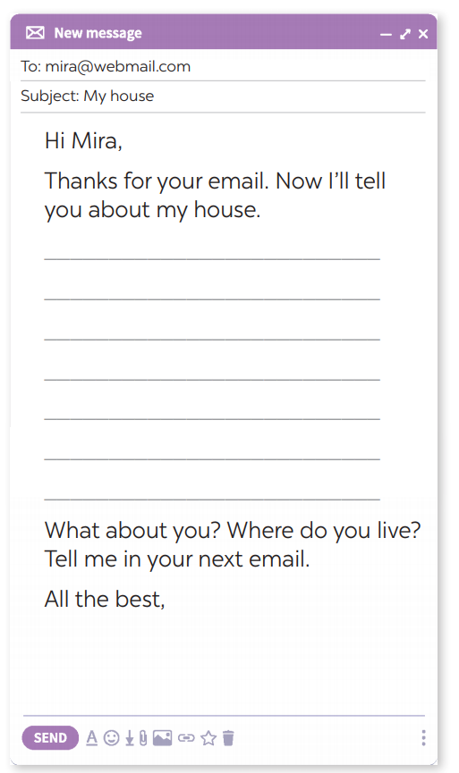 | Ss-Ss  T-Ss | 2 mins
Consolidation | To consolidate what students have learnt in the lesson. | Teacher asks students to talk about what they have learnt in the lesson. | T-Ss | 2 mins
Homework | To allow students  finalize their emails after being checked by friends and the teacher. | Rewrite the email on the notebook. | T-Ss | 1 min

UNIT 2: MY HOUSE

Lesson 7: Looking back & Project

  - I. Objectives
By the end of this lesson, students will be able to:
1. Knowledge
- review the vocabulary and grammar of Unit 2
- apply what they have learnt (vocabulary and grammar) into practice through a project.
2. Core competence
- Develop communication skills and creativity
- Be collaborative and supportive in pair work and team work
- Actively join in class activities
3. Personal qualities
- Be benevolent and responsible
- Develop self-study skills
  - II. Materials
- Grade 6 textbook, Unit 2, Looking back & Project
- Computer connected to the internet
- TV/ Pictures, A0 paper
- hoclieu.vn

Anticipated difficulties | Solutions
1. Students may have  underdeveloped speaking, writing and co-operating skills when doing project. | - Encourage students to work in pairs, in groups so that they can help each other.  - Provide feedback and help if necessary.
2. Some students will excessively talk in the class. | - Define expectation in explicit detail.  - Have excessive talking students practise.  - Continue to define expectations in small chunks (before every activity).

Board Plan

Date of teaching
Unit 2: My house
Lesson 7: Looking back & Project

* Warm-up
Brainstorming: Types of house, rooms and pieces of furniture.
I. Looking back
Task 1: Complete the second sentence with the correct possessive form.
(Ex. 2, p. 24)
Task 2: Make sentences using prepositions of place (Ex. 3, p. 24)
Task 3: Write three sentences to describe your favorite room. (Ex. 4, p. 24)
II. Project
Strange houses
Task 4: Survey
Task 5: Presentation
* Homework

Stage | Stage aim | Procedure | Interaction | Time
Warm-up | To help students  revise the vocabulary items they have learnt in the unit. | * Brainstorming  - Teacher divides the class into 3 big groups.  - Each group will be assigned a name.  - Teacher asks students to brainstorm all words related to types of house, rooms and furniture.  - The group having the most suitable and correct answers is the winner.  Suggested answers:  - Types of house: flat, town house, country house, stilt house, villa, cottage, farmhouse, bungalow, …  - Rooms: hall, living room, bedroom, bathroom, kitchen, dining room, guest room, utility room, …  - Furniture: chest of drawers, sink, fridge, dishwasher, cupboard,  microwave, air conditioner, stool, armchair,… | Group work | 5 mins
Looking back | To help students  revise the possessive case.  To help students  revise the prepositions of place.  To help students  revise the way to  describe their  favourite room using the prepositions of place. | Task 1: Complete the second sentence with the correct possessive form. (Ex. 2, p. 24)  - Have students say how to form the possessive form with proper names and singular nouns.  - Ask students to do the exercise  individually and then exchange their answers with a classmate.  - Call on some students to write their answers on the board. Other students give comments.  - Confirm the correct answers.  Answer key:  1. teacher’s  2. brother’s  3. Elena’s  4. grandfather’s  5. Vy’s  Task 2: Make sentences using  prepositions of place. (Ex. 3, p. 24)  - Ask students to say the prepositions of place they have learnt.  - Have students look at the pictures and do this exercise  individually. Ask some students to write the sentences on the board.  - Check students’ answers.  Answer key:  1. The cat is on the table.  2. The dog is in front of the kennel / doghouse.  3. The cat is between the bookshelf and the sofa.  4. The cat is behind the computer.  5. The girl is on the sofa.  6. The boy is next to the sofa.  Task 3: Write three sentences to describe your favourite room. (Ex. 4, p. 24)  - Ask one student what room in the house is his / her favourite.  - Encourage him / her to say one or two sentences about it.  - Have students write three sentences to describe their  favourite room.  - Remind students to use prepositions of place.  - Students share their sentences with their partners.  - Some students are asked to write their sentences on the board.  - Teacher and other students give  feedback. | T-Ss  S  Ss-Ss  T-Ss | 16 mins
Project | To allow students to apply what they have learnt (vocabulary and grammar) into practice through  a project. | Task 4: Survey  - Students work in groups. One student in each group asks other group members question “Which one would you like to live in? Why?” and fill the information in the following table.  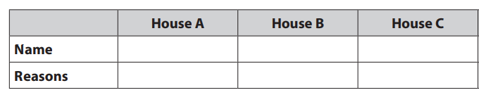  - This student then summarises their group members’ answers and reports the result to the whole class.  Task 5: Presentation  - Have students work in groups to draw their own strange house.  - Ask them to practise describing their house in groups before telling the class about their house.  - The class vote for the best strange house. | Group work | 20 mins
Consolidation | To consolidate what students have learnt in the lesson. | Teacher asks students to talk about what they have learnt in the lesson. | T-Ss | 3 mins
Homework | To prepare for the next lesson. | Prepare for the next lesson: Unit 3 – Lesson 1: Getting started. | T-Ss | 1 min
* Pictures' source: From Internet

