|  |  |  |  |
| --- | --- | --- | --- |
| |  |  | | --- | --- | | **Mã đề 6.2.74** | **ĐỀ KIỂM TRA CUỐI HỌC KÌ II**  **NĂM HỌC 202…-202…**  **MÔN: TIẾNG ANH 6 (Right on)**  *Thời gian làm bài: 60 phút*  *(Đề gồm 4 trang)* | |  |

**A. LISTENING: (2.0 points)**

**Part 1: *Listen to five short recordings and for each recording you have to choose the best of three pictures (A, B or C).***  (1.0pts)

1. What is Sarah’s dad going to give her?

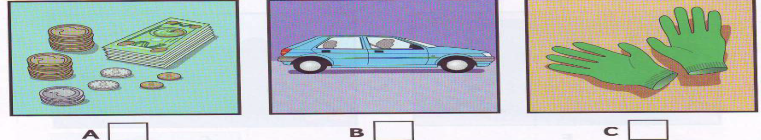

2. How many friends is Sarah going to go out with?

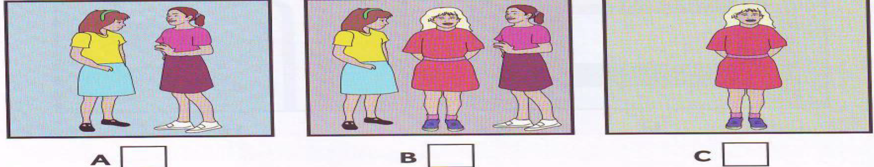

3. What’s the film about?

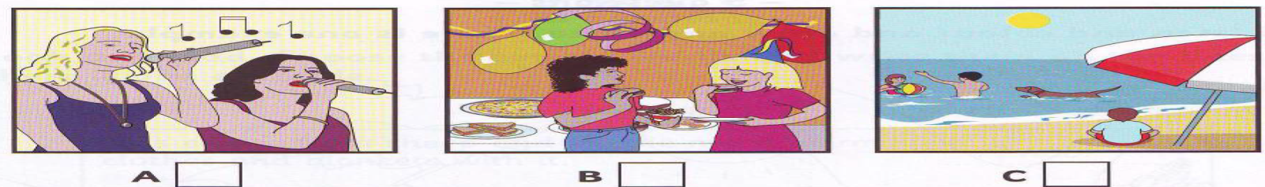

4. What will Sarah have for dinner?

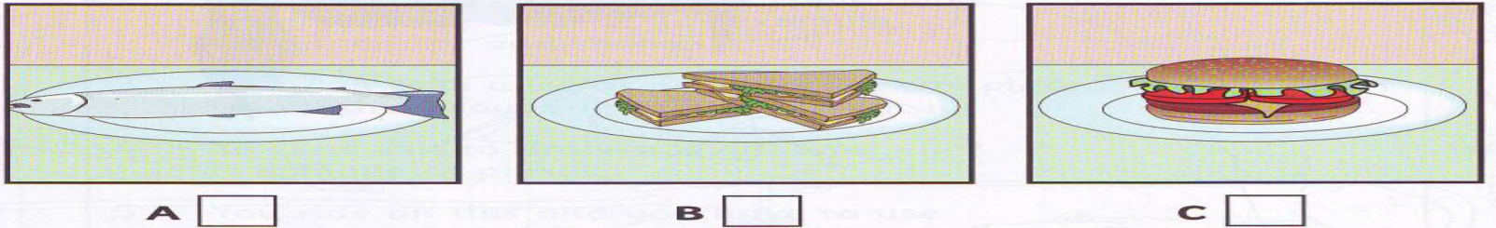

5. What’s Betty’s phone number?



**Part 2:** **Listen and write no more than one words or number** (1.0pts)

**OUR NEW TEACHER**

Will start on: ***Tuesday***

1. Will teach us:
2. Name: Mrs
3. Classroom number:
4. Classroom is next to: school
5. Colour of teacher’s car:

**B. Vocabulary- Grammar- Language function (2.0 points)**

1. Unless you........................., you..........................the final exams.(Thông hiểu)

|  |  |  |  |
| --- | --- | --- | --- |
| A. study/ will fail | B. won't study/ fail | C. don't study/ fail |  |

2. I enjoy watching the news ______I want to know what is happening around the world.(Thông hiểu)

A. because B. so C. but

3. That novel was so........................that my sister couldn't stop reading it.(Nhận biết)

|  |  |  |  |
| --- | --- | --- | --- |
| A. interesting | B. interested | C. boring |  |

4. Yesterday, I ......................... around by car with my cousins and we ..................... lots of interesting places.(Nhận biết)

|  |  |  |  |
| --- | --- | --- | --- |
| A. travel/ visit | B. travelled/ visited | C. travels/ visits |  |

5. Marie Curie is famous ....................... her contribution to science.(Nhận biết)

|  |  |  |  |
| --- | --- | --- | --- |
| A. in | B. of | C. for |  |

6. You ...............swim in that water. It's very dangerous.(Nhận biết)

|  |  |  |  |
| --- | --- | --- | --- |
| A. should | B. shouldn’t | C. might |  |

7. OK, I'm going home. I ..........................you later.(Thông hiểu))

|  |  |  |  |
| --- | --- | --- | --- |
| A. will call | B. am going to call | C. called |  |

8. We have no more milk. - Oh, I.............. some on the way home.(Thông hiểu)

|  |  |  |  |
| --- | --- | --- | --- |
| A. am going to buy | B. bought | C. buys |  |

9. It's rather hot in here. - That's Ok. I................. the window.(Thông hiểu)

|  |  |  |  |
| --- | --- | --- | --- |
| A. won't open | B. opens | C. will open |  |

10. *Choose the word that has the underlined part pronounced differently from the rest*.(Nhận biết)

A. designed B. received C. rewarded

**C. Reading (2 points)**

**Part 1. Read and choose a sentence in column A which is suitable to the sign/ notice in column (1.0pts)**

Television is one of man’s most important (1)_____ of communication. It brings pictures and sounds from around the world into millions of homes. Through television, home viewers can see and learn (2)_____ people, places and things in faraway lands. TV even takes its viewers out of this world. It brings them coverage of America’s astronauts as the astronauts explore (3)_______ space. In addition to all these things, television brings its viewers a steady stream of programmes that are (4)______ to entertain. In fact, TV provides many (5)_____ entertainment programs than any other kind. The programmes include dramas, comedies, sports, and (6)______ pictures.

1. a. ways b. means c. ranges d. shows (Nhận biết)

2. a. at b. in c. for d. about(Nhận biết)

3. a. deep b. large c. outer d. open(Thông hiểu)

4. a. happened b. designed c. composed d. guided (Thông hiểu)

5. a. more b. even c. most d. hardly (Nhận biết)

6. a. lovely b. clear c. motion d. full (Nhận biết)

***Part 2. Read the passage and choose the best answer (A, B or C)for the question (1.0 pts)***

**ELIZABETH 1: THE GOLDEN AGE**

Friday Review by Scott Kerry

I watched the movie Elizabeth I: The Golden Age last Thursday with a group of friends. We watched it for a history project we're doing at school. It is a drama about Queen Elizabeth I. She was born in 1533 and became Queen of England in 1558. She was a really strong leader. Her ships won battles against Spanish ships in 1588. Before I watched it, I didn't know if I would like it. I don't like many dramas but this was fantastic. The story of the movie was really interesting and so many exciting things happened. It was great! All my friends loved it too. You really should watch it!

1. **When did Scott watch the movie?(NB)**

A. Thursday B. Wednesday C. Saturday

1. **Why did Scott watch the movie? (TH)**

A. He likes dramas. B. For a history project C. His friends wanted to him

1. **Who was Elizabeth I? (NB)**

A. a Spanish queen B. a movie C. an English queen

1. **Why didn't Scott want to watch the movie?(TH)**

A. He was busy B. He doesn't like many dramas C. He was excited about it

**5. What did Scott think about the movie? (NB)**

A. It had an interesting story B. It was boring C. He didn't like it

**D. Writing (2.0 points)**

***Part 1. Rearrange the words given to make completed sentences (1.0 pts)***

**1.** Mike /to/watch/football/match/too/are /over/coming/and/Peter/the(TH)

→ ……………………………………………………….

**2.** I/like/at/the/shows/with/a /prize/end (TH)

→ ……………………………………………………….

**3.** It/film/boring/I/have/seen/ever/was/most/the (TH)

→ ……………………………………………………….

**4.** I/like/show/future/watching/in/the/set (TH)

→ ……………………………………………………….

**5.** watch/you/Do/?/want/to/show/game/the (TH)

→ ……………………………………………………….

***Part 2. Rewrite the following sentences as the words given. (1.0 pt)***

1. Living on Mars sounds very exciting.(VD)

=>It’s ……………………………………………………….

1. Maybe Peter won’t come to the party tonight.(VDC)

=>Peter ……………………………………………………….

1. Very few cities in Vietnam are as rich as Da Nang.(VDC)

=>Da Nang is one of the ……………………………………………………….

1. Although it was noisy, we continued to study our lesson.(VDC)

=>In spite of ……………………………………………………….

1. You should work hard, or you won’t pass the exam.(VD)

=>If ……………………………………………………….

**E. SPEAKING (2.0pts)**

**Task 1 :** Introduce yourself. (Name, age, address, school, class, hobby) ***(0.5 pts)***

**Task 2**: ***(1.5 pts)***

**Topic: 1. Talk about your last holiday**

1. Where/ when did you go?

2. Where/ how long did you stay there?

3. What kind of the place did you visit?

4. What is it famous for?

5. How do you feel after the trip?

**Topic: 2. Talk about your favourite TV programme.**

1. What is your favourite TV programme?

2. Is it interesting?

3. What channel is it on?

4. What is it about?

5. How often do you watch it?

**Topic: 3. Talk about the place you want to visit**

1. Which place do you want to visit?

2. What is it about (landmark, historical building….)?

3. Where is it?

4. How do you get there? How long does it take you?

5. Why do you like to go there? How do you feel?

**ANSWER KEYS:**

1. **LISTENING: (2.0 points)**

**Part 1. (1.0 pts)**

1. A 2. B 3. A 4. C 5. A

**Part 2. (1.0 pts)**

1. science 2. Shaker (correct spelling)

3. 15/fifteen 4. kitchen 5. black

**B. Vocabulary- Grammar- Language function (3.0 points)**

1. Unless you........................., you..........................the final exams.

|  |  |  |  |
| --- | --- | --- | --- |
| A. study/ will fail | B. won't study/ fail | C. don't study/ fail |  |

2. I enjoy watching the news ______I want to know what is happening around the world

A. because B. so C. but

3. That novel was so...............................that my sister couldn't stop reading it.

|  |  |  |  |
| --- | --- | --- | --- |
| A. interesting | B. interested | C. boring |  |

4. Yesterday, I ......................... around by car with my cousins and we ..................... lots of interesting places.

|  |  |  |  |
| --- | --- | --- | --- |
| A. travel/ visit | B. travelled/ visited | C. travels/ visits |  |

5. Marie Curie is famous ....................... her contribution to science.

|  |  |  |  |
| --- | --- | --- | --- |
| A. in | B. of | C. for |  |

6. You ...............swim in that water. It's very dangerous.

|  |  |  |  |
| --- | --- | --- | --- |
| A. should | B. shouldn’t | C. might |  |

7. OK, I'm going home. I ..........................you later.

|  |  |  |  |
| --- | --- | --- | --- |
| A. will call | B. am going to call | C. called |  |

8. We have no more milk. - Oh, I.............. some on the way home.

|  |  |  |  |
| --- | --- | --- | --- |
| A. am going to buy | B. bought | C. buys |  |

9. It's rather hot in here. - That's Ok. I................. the window.

|  |  |  |  |
| --- | --- | --- | --- |
| A. won't open | B. opens | C. will open |  |

10. *Choose the word that has the underlined part pronounced differently from the rest*.

A. designed B. received C. rewarded

**C. Reading (3 points)**

**Part 1. Read and choose a sentence in column A which is suitable to the sign/ notice in column (1.0pts)**

Television is one of man’s most important (1)_____ of communication. It brings pictures and sounds from around the world into millions of homes. Through television, home viewers can see and learn (2)_____ people, places and things in faraway lands. TV even takes its viewers out of this world. It brings them coverage of America’s astronauts as the astronauts explore (3)_______ space. In addition to all these things, television brings its viewers a steady stream of programmes that are (4)______ to entertain. In fact, TV provides many (5)_____ entertainment programs than any other kind. The programmes include dramas, comedies, sports, and (6)______ pictures.

1. a. ways b. means c. ranges d. shows

2. a. at b. in c. for d. about

3. a. deep b. large c. outer d. open

4. a. happened b. designed c. composed d. guided

5. a. more b. even c. most d. hardly

6. a. lovely b. clear c. motion d. full

***Write your answer:***

1. ….. 2- ….. 3- ….. 4- ….. 5- …..

***Part 2. Read the passage and choose the best answer (A, B or C)for the question (1.0 pts)***

**ELIZABETH 1: THE GOLDEN AGE**

Friday Review by Scott Kerry

I watched the movie Elizabeth I: The Golden Age last Thursday with a group of friends. We watched it for a history project we're doing at school. It is a drama about Queen Elizabeth I. She was born in 1533 and became Queen of England in 1558. She was a really strong leader. Her ships won battles against Spanish ships in 1588. Before I watched it, I didn't know if I would like it. I don't like many dramas but this was fantastic. The story of the movie was really interesting and so many exciting things happened. It was great! All my friends loved it too. You really should watch it!

1. **When did Scott watch the movie?**

A. Thursday B. Wednesday C. Saturday

1. **Why did Scott watch the movie?**

A. He likes dramas. B. For a history project C. His friends wanted to him

1. **Who was Elizabeth I?**

A. a Spanish queen B. a movie C. an English queen

1. **Why didn't Scott want to watch the movie?**

A. He was busy B. He doesn't like many dramas C. He was excited about it

**5. What did Scott think about the movie?**

A. It had an interesting story B. It was boring C. He didn't like it

**C. Writing (2.0 points)**

***Part 1. Rewrite the following sentences as the words given. (1.0 pt)***

1. Living on Mars sounds very exciting.

It’s very exciting to live on Mars.

1. Maybe Peter won’t come to the party tonight.

Peter may not/ might not come to the party tonight.

1. Very few cities in Vietnam are as rich as Da Nang.

Da Nang is one of the richest cities in Vietnam.

1. Although it was noisy, we continued to study our lesson.

In spite of the noise, we continued to study our lesson.

1. You should work hard, or you won’t pass the exam.

If you don’t work hard (harder), you won’t pass the exam./ If you work hard(harder), you will pass the exam.

***Part 2. Rearrange the words given to make completed sentences (1.0 pts)***

**1.** Mike /to/watch/football/match/too/are /over/coming/and/Peter/the

→ Mike and Peter are coming over to watch the football match too.

**2.** I/like/at/the/shows/with/a /prize/end

→ I like show with a prize at the end.

**3.** It/film/boring/I/have/seen/ever/was/most/the

→ It was the most boring film I have ever seen.

**4.** I/like/show/future/watching/in/the/set

→ I like watching shows set in the future.

**5.** watch/you/Do/?/want/to/show/game/the

→ Do you want to watch the game show ?