Tiếng Anh 7 – RIGHT ON

SEMESTER 2 - MIDTERM TEST
Note: Each correct answer earns 0.2 points.

I. PRONUNCIATION (0.8 points)
A. Choose the word whose underlined part is pronounced differently.
1. A. design B. repair C. service D. express
2. A. games B. drones C. consoles D. messages
B. Choose the word that has a different stressed syllable from the rest.
3. A. canoe B. manage C. software D. speakers
4. A. electric B. underground C. department D. mechanic

II. VOCABULARY AND GRAMMAR (2.4 points)
Choose the best option (A, B, C or D) to complete each of the following questions.
5. I think it’s easier to write emails with a __________ than on a touchscreen.
A. tower B. keyboard C. router D. USB flash drive
6. We went to the new __________ on Saturday because I needed a new dress and my mum wanted to buy some make-up.
A. department store B. clothes shop C. hairdresser’s D. chemist’s
7. Online gaming is __________ hobby for teenage boys.
A. popular B. more popular C. the most popular D. much popular
8. I prefer using my tablet to watch films because the screen is __________ a smartphone screen.
A. the biggest B. big C. as big as D. bigger than
9. How many text messages do you usually __________ in a day?
A. send B. make C. take D. interact
10. People can drive __________ the Thủ Thiêm Tunnel to get to the other side of the Sài Gòn River.
A. over B. onto C. across D. through
11. Last year, I travelled around the Greek islands by ______. It was really nice to sit on the deck, see the blue sea and enjoy the fresh air.
A. train B. ship C. bus D. helicopter
12. The children were really excited when they saw the plane __________ and flew higher and higher.
A. got off B. sailed off C. took off D. logged off
13. I think we should __________ a taxi because it might be difficult to find a parking spot near the theatre.
A. get on B. take C. drive D. ride
14. Person A: Excuse me, could you tell me how to get to the nearest bank?
Person B: _________
A. I don’t like going to the bank.
B. You shouldn’t catch a bus.
C. There’s a bank in my neighbourhood.
D. Go along King Street. The bank is on your right, next to the post office.
15. What does the sign mean?
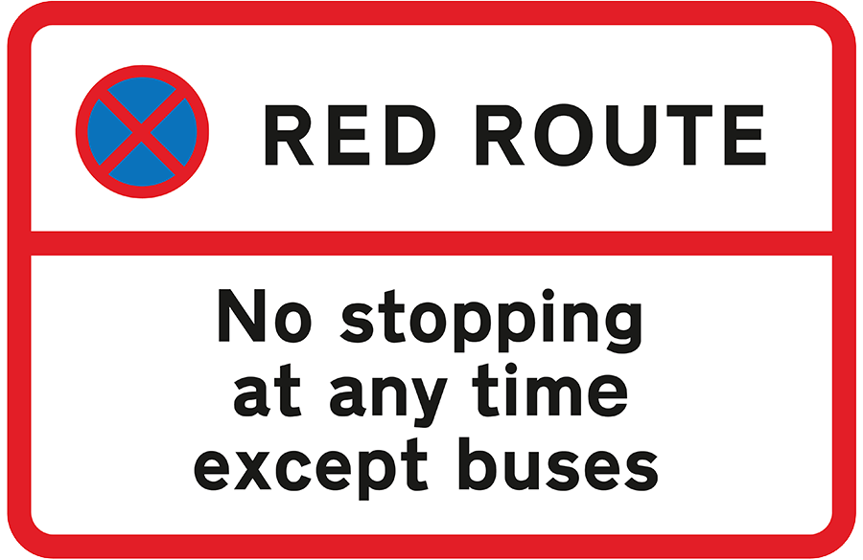 | A. No vehicle can stop in this area.  B. Only buses can stop here to pick up and drop off passengers.  C. Drivers must stop along the red route.  D. People can stop their vehicles when the route is red.

16. What does the sign mean?
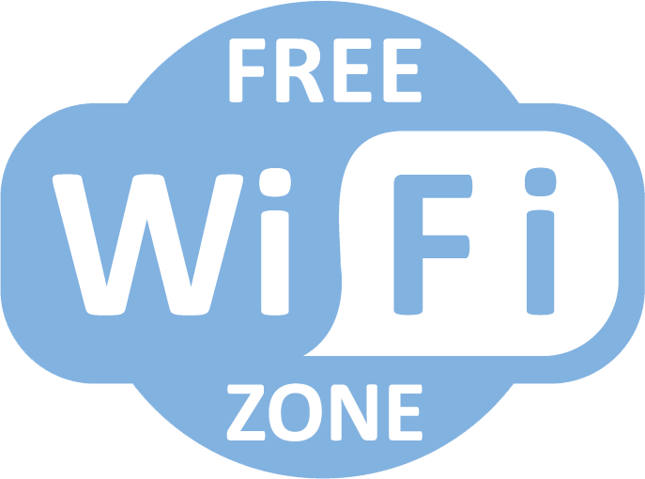 | A. You can get wireless internet access here, free of charge.  B. You shouldn’t pay to use the Wi-Fi here.  C. You have to ask for free internet connection.  D. You need to use the free Wi-Fi network here.

III. WORD FORMATION (1.2 points)
Write the correct form of the words in brackets.
17. Students must ask for __________ before they use the printer in the library. (PERMIT)
18. Drones were very __________ during the Covid pandemic. People used them to monitor public spaces and delivered medical supplies. (USE)
19. I’m totally into virtual ___________ games because they give me the impression of actually being inside the games. (REAL)
20. There are some basic internet __________ tips that you need to follow whenever you go online. (SAFE)
21. I think students should ride their bikes to school because it’s more __________ friendly. (ENVIRONMENT)
22. You should take the double-decker bus. It’s the best way to visit famous tourist __________ in Hà Nội, such as Thăng Long Imperial Citadel, Hồ Chí Minh Mausoleum, etc. (ATTRACT)

IV. LISTENING (2 points)
A. You will listen to Jordan talking about his unusual journey to go to school. For each question, decide whether the statements are True (T) or False (F).

23. Jordan lives far away from his school.
24. It takes 20 minutes for Jordan to get to school.
25. During his boat trip, he enjoys talking to other passengers.
26. Jordan will have to live at his secondary school on weekdays.
27. Jordan can go to his new school by boat or by plane.

B. You will hear Josh talking about different technological devices. For each question, complete the notes with the correct information. Write NO MORE THAN TWO WORDS.

28. Josh does many things with his ____________.
29. Josh ____________ makes phone calls, but he texts a lot.
30. Josh’s grandfather prefers making video calls from a computer because it has got a(n) ____________.
31. Josh’s father works as a(n) ____________.
32. Josh wants to have a(n) ____________ when he grows up.

V. READING (2 points)
A. Read the following passage. For each question from 33 to 37 choose the correct option A, B, C or D.

My name is Sylvia and my favourite gadget is my e-book reader, Kindle. I got it on my last birthday. It’s smaller and lighter than a tablet. The battery even lasts longer. In fact, it can run for weeks on a single charge. Besides, it hasn’t got an LCD colour display like a tablet or smartphone, so it doesn’t cause eye strain even when you read for long hours. I love my Kindle because I always have lots of books to read on the bus. I can store up to 1,500 books on it, but I only have forty-five. I’m never bored with my Kindle. Last Christmas, my grandparents gave my brother and me a hoverboard. It’s like an electronic skateboard, which is really cool. At first, it was difficult for me to keep my balance on the hoverboard. My brother rode it better than me. We use it to travel around the neighbourhood and in the park. Hoverboards work better on flat and straight surfaces than on gravel, grass or dirt. You have to wear a helmet when riding a hoverboard to avoid injuries. And it’s not a good idea to travel by hoverboard when it’s rainy because it is very dangerous. My mum said she would give me a games console if I pass my exam, so I’m doing my best.

33. What does Sylvia like most?
A. the tablet B. the hoverboard C. the e-book reader D. the games console
34. Sylvia’s Kindle _____.
A. was a birthday present
B. is as light as a tablet
C. has got 1,500 books on it
D. causes eye strain when she uses it for a long time
35. Who gave Sylvia the hoverboard?
A. her brother B. her mother C. her parents D. her grandparents
36. The hoverboard ______.
A. is difficult to keep balance on B. runs better on flat and straight surfaces
C. doesn’t work on grass or dirt D. can cause injuries
37. You shouldn’t _____.
A. wear a helmet when riding the hoverboard
B. use the hoverboard on a rainy day
C. use the hoverboard on a gravel surface
D. travel by hoverboard in the park

B. Read the following passage. Complete each question from 38 to 42 with a suitable word in the box. There are THREE words that you don’t need.

BUT RANDOM LINKS THEREFORE
USE KEEP EASY INSTALL

Like computers, your smartphone is an incredibly useful tool. You use it to do online shopping, entertain, (38) _________ in touch with family and friends, and store important stuff like photos, contacts and financial information – all at the touch of a few buttons. (39) _________, it’s important to know how to protect your smartphone. Firstly, (40) _________ firewall software and anti-virus software on your phone to protect it, set it to perform regular scans, and make sure you update it on schedule. Viruses can’t attack your computer with the right protection. Secondly, you mustn’t tell anyone your password and you must create a strong password. For example, use letters, numbers and special characters that are important to you, and make it as (41) _________ as you can. You can also use facial recognition or a fingerprint to access your device. Besides, public Wi-Fi can provide an opportunity for hackers to access your device. You should use a public network you know and trust, and never send personal or sensitive details via text messages. You shouldn’t open attachments, click (42) _________ from unknown sources. If you are in doubt, ask a grown-up to help you.

VI. WRITING (1.6 points)
A. Rewrite the following sentences without changing their meaning. Use the given word(s) if any.
43. I never take the bus because buses are slower than any other transport in my city.
→ I never take the bus because buses are the .
44. It’s the rule to wear a helmet when you travel by motorbike. (RIDE)
→ You .
45. I advise you not to share your personal information online.
→ You .
46. Michael’s dream is becoming a mechanic when he grows up.
→ Michael wants .
B. Use the given words or phrases to make complete sentences.
47. Travel / train / for long distances / comfortable / than / bus.
→
48. you / have / type in / username / password / log in / account.
→
49. I / prefer / use / tablet / because / it / light / than / laptop.
→
50. Mr. Davison / decide / buy / the / expensive / smartphone / the shop.
→

***End – Of – Test***

