SPEAKING ASSESSMENT ENGLISH 6
UNIT 6: OUR TET HOLIDAY
- Introduction - 0.4 pt (~2 ideas):
- Topic Speaking (Cue pictures) – 1.0 pt (~4 questions):
  1 | 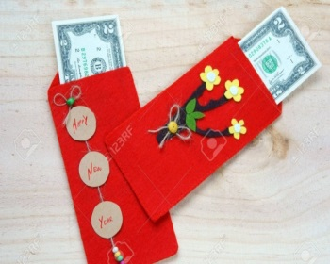  2 | 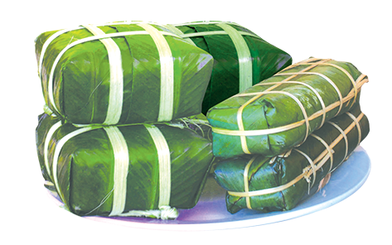  3
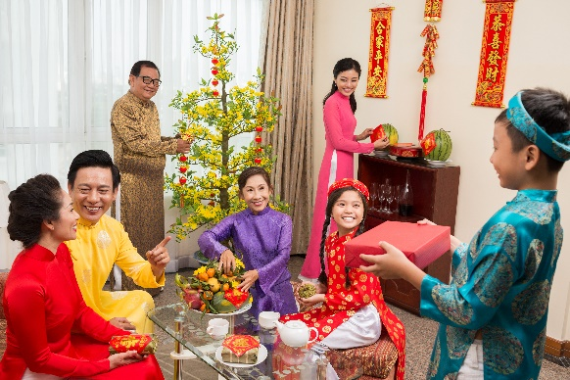  8 | - What is this? How do you spell it?  - Tet is a time for family………  3. How does your family often prepare for Tet?  4. What do you feel when you receive lucky money? |   4
  7 | 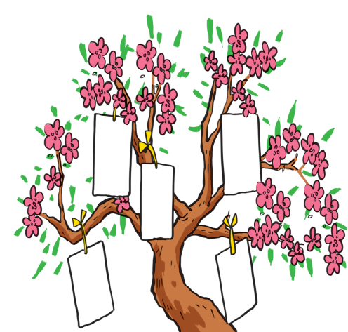  6 |   5

